5904640405
5904640736
5904641882
sommonlaya@gmail.com

An inequality of commerce on online platforms between foreign and local sellers: Case of Lazada, Qoo10 and Amazon

Introduction
When the world is growing at an unprecedented rate, E-commerce is an alternative platform that people are interested in since there is a lower barrier to entry into this market. Especially in Thailand, the country’s e-commerce market is expanding with rapid growth which is the highest growth among ASEAN countries and its value will hit US$13 billion in the next 5 years, said Jenny Hui from Ebay company (Bangkok post). The number of players in the e-commerce market is climbing up substantially due to the confidence in e-payment and convenience of the logistics system. At a global-level competition, obviously, the local sellers have a high possibility of facing more challenging hindrance with the larger number of competitors. This paper plans to understand those trade agreements, examines whether they put local sellers in disadvantaged positions, examines potential impacts of those agreements, and proposes solutions.
In Thailand, even if the e-commerce trend currently comes to dominate the large market share, the local sellers are suffering from government policy as they give more privilege toward foreigners. Compared to those incumbent countries, the United States and Singapore, they keep one step ahead with regard to trade operation management and international trade policy. (Figure1)

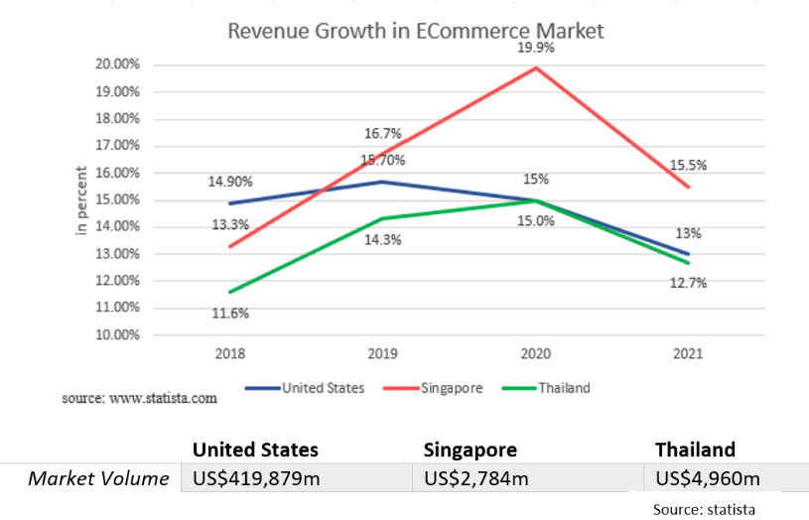
Figure 1: Revenue Growth in E-Commerce Market

This thesis can find a better explanation for government action by studying the tax structure and the impact of policy that influences the sellers on both domestic and international situations. Since there are various formal online platforms in the world, Lazada website is selected to be observed in this thesis focusing on Apparel and Cosmetics for the case of Thailand, Amazon of United States, and Qoo10 of Singapore. This approach should explain the reasons behind the defect of the imposed policy which leads to an equality of E-commerce in Thailand. We will adapt what we observed to the case of Thailand in order to improve the e-commerce sector.

Industry Background
The Online Marketplace Industry
The United States
Bigcommerce (2017), mentioned that online shopping websites have the common cross-border commerce which is the online selling of goods to consumers in different countries. The author said that Amazon, which was founded by Jeff Bezos in 1994, is the pioneer of cross-border e-commerce and when the time passed, Amazon is not the only company which transforms communication platforms between producers and sellers through the internet and creates the occasion for 24 hours global shopping experience.
With quick and easy start-up, this third-party selling service attracts sellers from both local and international to expand the reputation of the brand and reach more potential market shares. According to Appendix 1, there are a few remarkable issues which international suppliers differ from local suppliers. Both foreign and local sellers, who have more than $20,000 in unadjusted gross sales and more than 200 transactions, have to complete the tax interview whether they are taxpayers or not. Furthermore, sales tax, additional fees (such as referral rate in (Table1) and shipping credits (Table2) should be taken into account and the rate will be dependent on the location of warehouses, the selling plan features and the destination.

Table 1: Referral rates on selected products
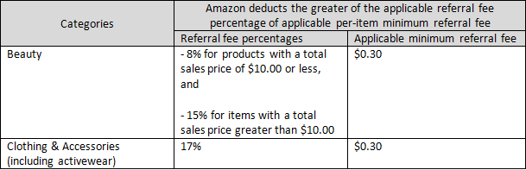

Table 2: The rate of shipping credits
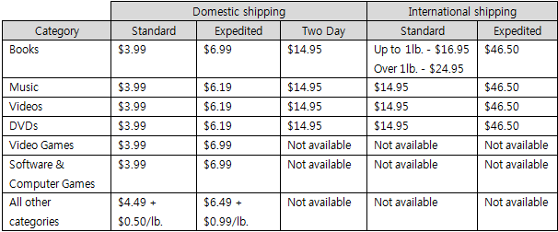

Singapore
Qoo10 is an online marketplace, founded in 2010 by Ku Young Bae. The company’s aim is to dominate the localized e-commerce platform in Asean region and remain in the top position as No.1 in Singapore. According to Straitstime (2019), the founder of Qoo10 adapted the strategy which he had used in Gmarket, the Korea online shopping mall. With the successful financial system (QuuBe), Qoo10 spent less time on climbing up to be the biggest online mall which can be guaranteed by the quadrupled growth approximately 38% from 2013 to 2018 (Euromonitor) and was able to fend off the large international rivals.
Qoo10 allows both local sellers and international sellers to sell with no listing fee and the policy about service fees which charged on all sellers in order to accomplish the sales and to boost the overall transaction activity in Qoo10.
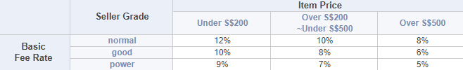
Table 3: Commission fees computed from the service fees and seller grade requirements

Moreover, Qoo10 is obligated to charge and collect GST. Hence, invoices for the service fees including GST will be issued. Customs are various by the countries of buyers who are the importers of record and have to follow all regulations of their countries. In the era of growing online marketplace, Qoo10 has a Qoo10 Sales Management (QSM) which helps sellers about listing items, checking inventories, communicating with customers, and upgrading its platform to be beyond others.

Thailand
Lazada Group is an international e-commerce company founded by Maximilian Bittner with the backing of Rocket Internet in 2012. Lazada Group (2017) claims that Lazada has become the top e-commerce site in ASEAN countries in Asean, especially in Thailand. Moreover, due to the cooperation with the government, the success of SME 4.0 initiative involves multiple stakeholders across government units affecting positively both on our country and Lazada company. From Appendix 2, it shows that Lazada is the leader of the market in the aspect of monthly active users, number of applications downloaded (Techsauce, 2019), numbers of website visits (Iprice insight,2019), and annual income. Longtunman (2019), mentions that Lazada’s income was continuously growing in the last 6 years by income. The sellers of Lazada are categorized into three selling models which are local, Lazmall, and LazGlobal sellers. The criteria and policy imposed are different for each group of sellers. (Appendix 3).
Thai sellers in the group of local sellers only bear the cost of Financial transaction tax(FTT) 2% and VAT of 7% while the Lazmall sellers(Appendix 4) have the additional commision fee Financial transaction tax(FTT). For the LazGlobal(Appendix 5), the cost includes VAT, commision fee, FTT, and Shipping fee.
Currently, Amazon does not have full purchasing services available to Thai customers the same as other 18 countries. Thus, Thais can only purchase products from abroad through the Amazon store. However, Bangkok post (2019) stated that Amazon recently opened a new office in Thailand in order to help Thai sellers to expand their businesses into the global market. Their strategies include offering training services to e-commerce sellers on how to use the platform and attract foreign customers. Furthermore, Amazon wants to develop a one-stop solution provider for sellers in Thailand by forming its own in-house logistics operations rather than shipping products to a third-party service provider network.
In the case of Qoo10, Thailand is one of the planned destinations but Qoo10 is currently not available. Due to more appropriate economic conditions, Australia, the Philippines, Vietnam and Thailand are more attractive to expand their businesses. Additionally, Most of those countries’ people have sufficient income even if the size of the consumer market is not that large. The founder stated that the company was in a process of merging local Qoo10 sites in foreign countries into a single online market. Moreover, the executives had a project to expand cross-border logistics investment, Qxpress, in Southeast Asian countries operating in 8 countries in order to achieve 11 delivery centers.

Trade Tariff
The United States
The cross-border business must take the custom tax into account since the export and import policies are the main consideration for business operation. The tariff rates are different classified by the country of origin and type of products. With various trade agreements, some countries can import goods to the United States with the free of charges. The organization that has responsibility to deal with this part is the United States Customs and Border Protection (“CBP”).
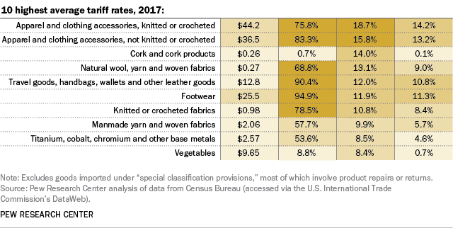
Table 4: The average tariff rate,2017

If the value is under $2,500 USD, Customs and Border Protection will normally allow you to enter into the country without a formal entry. The tariff rate computation is based on the Harmonized Tariff Schedule which provides information about the rate for each imported product into the United States. The current average customs duty rate for all imported goods into the United States is about 1.4%. Apparel and clothing accessories are one of the charged products which have a high rate approximately 16%. On the other hand, some types of goods from some countries have the exemption with the zero customs duty but they must be declared such as cosmetics. (for more information Appendix 6)
After the trade war between China and the United States was raising tension for 2 years, both countries agreed to sign an agreement aimed to compromise and lessen the serious conflicts. As a result, the latest agreement, known as a “phase one” deal, has been signed on 15th January 2020. The deal was conducted to deduct some tariffs on imported goods from China for the sake of Chinese’s promise for purchasing American goods like agricultural products, manufactured goods and energy. According to U.S. tariffs on Chinese goods, the average tariff rate dramatically climbed up to 19.3% in 2020 approximately sixfold from 2018 (3.1%). The United States claimed that they will deduct by half of only the imported rate on the $120 billion list of Chinese goods, which was imposed on September 1st 2019, to 7.5% while the other tariff of 25% on the $250 billion list will remain the same. A $250 billion list includes various intermediate inputs and capital or machinery. Therefore, the phase one deal could be a nightmare for American manufacturing firms who rely on Chinese intermediate goods and may experience the reduction in employment with the higher input costs. However, this issue could be the negotiation on the second phase agreement. Obviously, there are limited players who benefit from this deal such as those U.S. apparel and footwear firms with reduction in tariff.
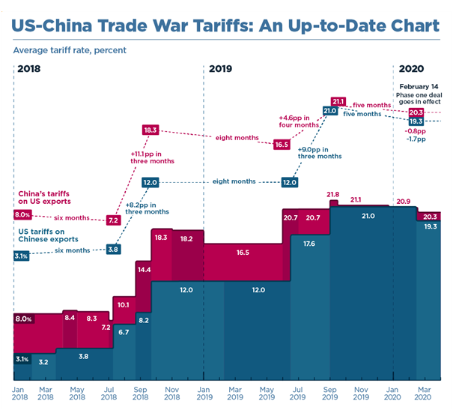
Figure 2: United States and China trade war tariffs from Jan 2018 to Mar 2020

Singapore
Singapore imposed Goods and services tax(GST) on the supply of goods and services within the country and all imported commodities. The current GST rate of Singapore is 7% which are levied on the customs value of imports. The goods will be subject to GST only if the entire sum of CIF value is more than $400. Not only local consumption tax as VAT/GST that the sellers need to take into consideration when shipping internationally, but also the import tax which differs based on product category. Fortunately, all kinds of products imported into Singapore are currently tax exempt. (Figure 3)
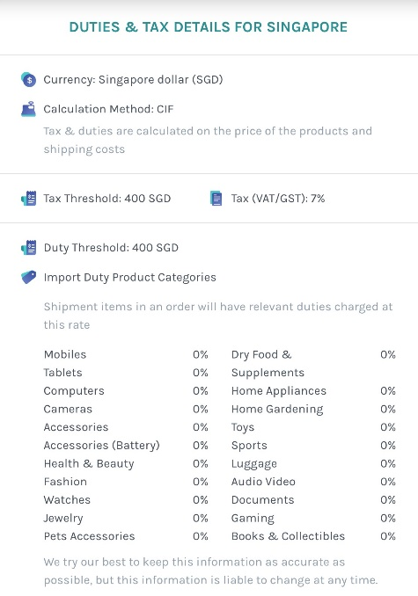
Figure 3: Duties & Tax details of imported goods in Singapore

Singapore signed a trade agreement with Republic of China under the ACFTA, Asean-China Free Trade Agreement. China-based importers benefit from an elimination of import duties on many products and services. Furthermore, Singapore does the CSFTA, China-Singapore Free Trade Agreement, in January 2009 which is the first comprehensive bilateral FTA concluded by China with an Asian country and has recently been upgraded in 2018(International Enterprise Singapore). Dezshira 2018 states that this upgraded CSFTA also includes an E-commerce part, it will facilitate E-Commerce for business and protect consumers from the commitment in online consumer and personal information protection. The CSFTA allowed all goods originating from China to be tax-exempted when exported to Singapore, 95% of Singapore exports to China are duty free, and allows for third-party invoicing of goods. The results can be explained in the 3 key aspects which are protection for Singapore investments in China, eliminating barriers for investment in China, and improving Singapore firms’ access to China’s service sector.

Thailand
Magcarzine (2019) argued that Thai government has an incentive to protect the local sellers by creating a high burden on imported goods. Moving to the nature of imported tax in Thailand, Goods that are imported into Thailand generally subject to some kind of taxes. The degrees varied based on the type of product, its origin, and trade agreement. According to Thai customs (2015), the goods arriving in Thailand are classified into three types. First category is goods which are no more than 1,500 baht or samples with no commercial value will be exempted from duty. Second category is goods imported by international post which its value is not exceeding 40,000 baht will have a liability for duty. Last category are those goods not classified under category 1 and 2 will be handed over to be stored at Thailand customs department.
However, these incentives are imposed for high volume imports normally for business purposes rather than individual. The personal consumer goods are subject to different kinds of tax under the Customs Tariff Decree B.E.2530 (1987), which classified the categories of goods with varying import tax rates. For instance, products in the category of personal care and cosmetics will face 5% in Thailand import taxes, unlike tax on clothing and apparel which will be collected for 30%. Not only import tax which will be collected, but also Value added tax (VAT) are necessary for sellers to take into account. Thus, import goods value higher than 1,500 baht and below 40,000 baht will face both import tax and VAT of 7%.

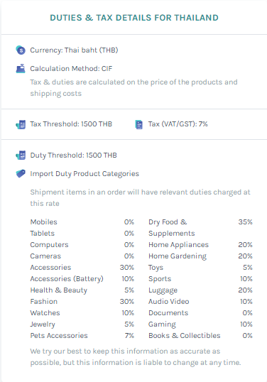
Figure 4: Duties & Tax details of imported goods in Thailand

In 1976, Thailand started trade relations with China after the official establishment of diplomatic relations between two countries. The first trade agreement was signed in 1978 and then established the Thailand-China joined trade committee (JTC) to host the trade conference alternately in order to develop Economic, Investment, trade, and tourism between Thailand and China. Furthermore, Thailand also entered into a Free trade agreement with China begun in October 2003, according to the ASEAN-China FTA which is the trade agreement between China and ASEAN-6(the Philippines, Indonesia, Brunei, Singapore, Malaysia, and Thailand). Consequently, the duties on fruits and vegetables were eliminated under the agreement of the Early Harvest Program, as well as the reduction on general goods. The key export of Thailand to China included computers and components, rubber and rubber products, finished oil, plastic pellets, and chemicals while major imports of Thailand from China were computers and components, electric machines and parts, home electric appliances, machinery, and iron, steel and steel products.

Figure 5: import taxes summary
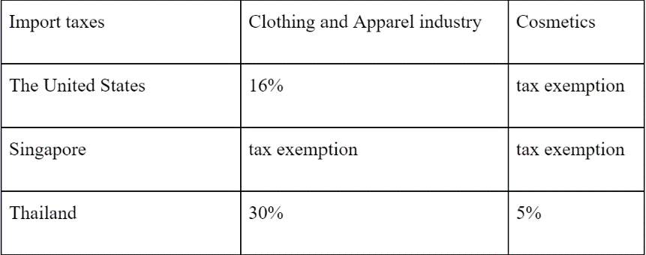

Obviously, there is a huge barrier on clothing goods with 30% from the real value while the cosmetics tariff is 5% which is relatively low. So, what is the reason behind the large high charges on imported goods in Thailand?

Literature Review
Import tax exists when there is foreign trade between countries. D.M. Parry(1908) stated that the country imposes a tariff as a tool to correct the market system of industry which has a surplus of production aboard, as well as giving privilege to firms which cannot sustain themselves against foreign competition in the local market. Many authors (e.g. Simpson K.,1929; Culbertson, W., & Harding, W.,1924) pointed out that tariff implies the change of profit for the industries which engage in international trade. The Ministry of Economy, Trade and Industry(2007) also said that the tariffs will affect the primary three functions which are the source of revenue, the protection of local industries and trade distortions. In the past, governments gained large funding from the imported tariffs and it was the significant reason for imposing this tax. However, only some developing countries remained to keep this tariff revenue while those developed countries reduced the importance. Moreover, the changes in normal characteristics of trade commonly remedy by imposing countervailing duties. The tariffs have been used as a policy tool to encourage the local industries since the domestic firms can benefit from the competitive advantage from the existence of tariffs. According to Rup Khadka (2015), “Import duties are also as protective duties to guard domestic infant industry for a certain period of time, till it reaches a certain size and can face international competition”.
According to Ahmad Medhat (2018), the tariffs will influence the price of imported goods. Even if this policy aims to hurt the foreigners and protect the infant industries, it is admittedly hurting some local consumers instead. The foreign country does not pay the burden directly since they have an incentive to pass this cost to their customers. Therefore, many authors (e.g. Global Health Council;2007, William Hill;1893) also stated that those consumers, who are highly dependent on the foreign imported goods such as those imported retailers and some local producers who use the imports of raw materials, are suffering due to the higher cost. On the other hand, the tariffs also achieve its missions on some groups of producers. If the local producers can search for another tariff-free source or if they could produce domestically, the one who hurts will be the foreigners.
Yunling, Z. (2012) found that a country should apply a low import tariff rate or tariff exemption when there are some weaknesses in the national economy. Precisely, some goods cannot be produced domestically or whose production cannot meet demand of the country. Additionally, the country may rely on other countries comparative advantage to form a production as shown by Kai, L. (2012). Thus, Joel, C. (1971) claimed that “exemption on raw materials and intermediate goods reduces the cost of production and improves local industries’ competitive position in relation to imports”. Furthermore, these exemptions are favored to foreign sellers as the tax benefit they get from the local demand for their goods. From the Economic Report of the President (2009), in the term of foreign companies, the open trade policy generates their larger market shares and the volume of exports. Locals also may have exposure to the new variety of products and the market will be more competitive. Although the free trade or low import tariff rate may have negative effects for locals, the drawbacks do not outweigh the social benefits from the open trade.

Theoretical Framework
To analyze this industrial organization, the Structure-Conduct-Performance (SCP) framework has been selected. This paradigm assumed the relationship between the market structure and market conduct which resulted in the market performance (Roth, 2005). In this thesis, the authors aim to understand the basic SCP framework of the e-commerce retail industry and study further about the effect of trade policy.
Firstly, we focus on the overall market structure of the e-commerce retail industry. With technological development, the internet shopping is dominating the retail sector. The diffusion of e-commerce platforms affects not only the prices but also the market structures, producer type and the number of sellers. The reduction of searching cost for consumers leads to the larger market share of those lower-cost firms since consumers always prefer the cheaper price and create the more opportunity for those firms to enter the market. In contrast, it is unfortunate for higher cost firms so they may exit the market. Even if some researchers said that it’s more competitive, the competitiveness in this market is still obscure but it is obvious that the type of producers have been altered.
Secondly, market conduct which is the firms’ behavior within the given structure that is related to price or non-price competition. Those conducts differ in a different product diversity, content, and quality. In this e-commerce retail industry, conducts can be determined by business goals, pricing policies, marketing, and R&D in order to give better outcomes. Lastly, market performance represents the result of structure and conduct. The performance of firms along the industry can be measured through the level of price and profit margin. However, this paper mainly focuses on the effect of tax on e-commerce retail industry. Thus, it directly influences the whole SCP framework of this industry.
The tax incidence may cause both consumers’ behavior and structure of firms to change their conduct and performance. Even if the tax is excised on the sellers, those people respond by avoiding the taxes and increasing the price of goods. Therefore, consumers will hurt from the more expensive price and less consume as well as the firms will alter their behavior to reduce burden. As a result of tax incidence, the market structure may become less competitive and the number of sellers will reduce as well because of the higher barriers created by taxes. We clarify more in the result part.
The consequences from the tax incidence can differ in each country depending on economic strengths. In this thesis, the authors rely on the competitive advantages and comparative advantages in order to predict the effect on each country. According to Alexandra Twin (2019) states about the competitive advantage which is the condition that allows a country to generate more sales by producing goods or services of equal value at a lower price. Besides, Gilbert Faccarello (2015) claimed that the principle of comparative advantages plays the major role in international trade. This theory can explain the gain of one country over other countries from participating in the international exchange. To clarify precisely, “when the country can produce goods and services at the lower opportunity cost than other countries” said by The balance (2020).
In order to examine the effect of tax incidence on supplier and consumer of each country, we construct the graphs according to the cases of each country which are affected from the different imposed tariff rate on local or foreign sellers, ceteris paribus. The levying of taxes would shift the supply curve to the left as the cost of production increases. Moreover, there are two main economic effects which are the tax revenue (purple rectangular) and deadweight loss (blue triangle). According to the graph, tax burden is splitted between consumer and producer but they still gain some surpluses which green triangle is consumers’ and pink triangle is producers’ although they are less than the case without tax incidence. For the further details of each country will be discussed in the result part.
Figure 6: Import tax incidence graph in Thailand
Apparel case
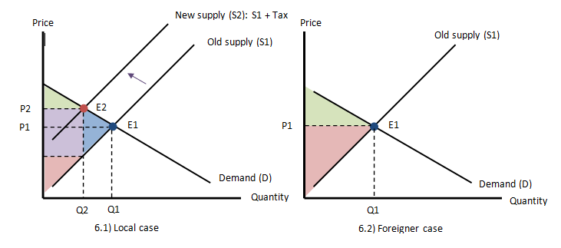
Cosmetics case
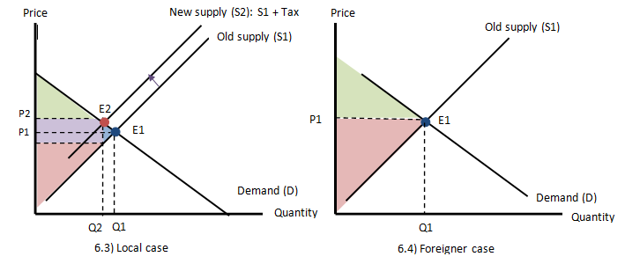

Figure 7: Import tax incidence graph in Singapore
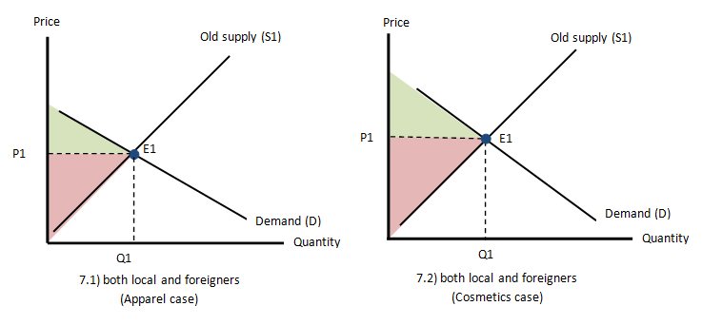
Figure 8: Import tax incidence graph in The United States
Apparel case
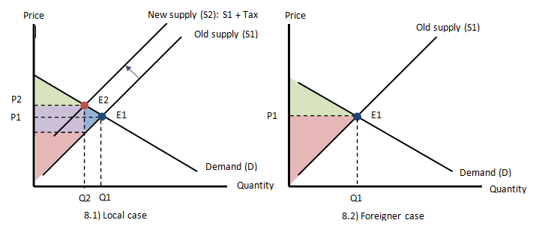
Cosmetics case
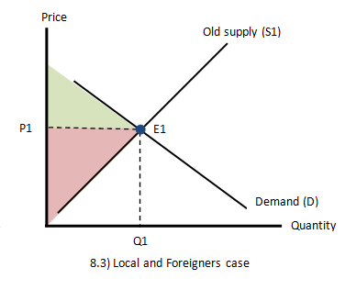

Results
- compare three countries by using comparative and competitive advantages & SCP
- describe the inequality between local and foreign by the graph (each policy incidence)
- the realistic situation of the market condition (demand and supply curve)
- recommendation for Thailand case & solution for Thailand
- Ajarn ka, can you give any recommendations for the results part?

Conclusion
- Tariffs which favor local sellers/producers
- Tariffs which favor foreign sellers/produce

Methodology
To deal with these challenges, this study is based on secondary data that are collected from various sources. Secondary research is the method from collecting the existing data through available sources online which were written by various researchers from all over the world. Gathering the information both internal data, which are the information obtained from the organization and external data that are acquired from the outside sources, collated to increase the overall effectiveness of the research. Furthermore, it showed an initial understanding of the collected data that related to the topic.
Secondary research is an appropriate method for us since we have limited time, resources and cost saving. The selected topic covers data at the international level so it is impossible for us to apply the primary research on the thesis. For the assortment of secondary data, we have used published data which are collected from i) different reports of the foreign or local governments from chosen countries which are the United states, Republic of china and Thailand. (e.g., reports of Revenue Department and Custom), ii) different research reports are prepared by research scholars, universities, etc., in different fields, iii) different sources from university libraries, iv) technical and trade journals, and v) websites.
There are some limitations from using this approach since we try to obtain the information at international level. Firstly, the language barrier can create a difficulty for understanding, especially for studying the case of the Republic of China. Moreover, the main search engine that we use to find out the secondary data is google and most of the research reports on google website are written in English. Therefore, some research may be biased information one and we can come up with a poor-quality thesis. Secondly, some websites may not allow foreigners to access because of the security concern in terms of information between nations. Not only the global level but also the local one, we as the general people cannot acquire data for the reason that only the insiders are permitted. Lastly, when gathering the information, we need to compare with many sources in order to conclude the most correct one so we need to analyze them carefully. Although there are many limitations, we have tried our best to introduce gathered and criticize information in order to be the most quality research which can be easily and beneficial for people to use.

