
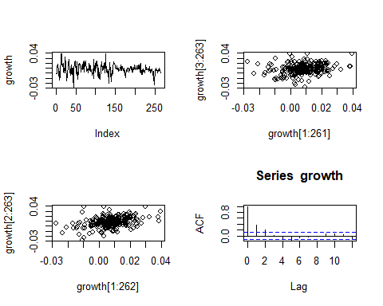
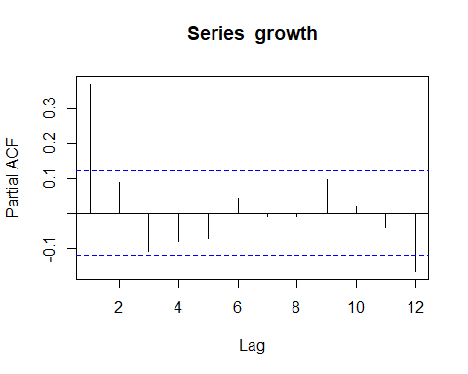
#1.B
#given H0 : p1 = p2 = ... = p12 = 0 and H1 : pi != 0
Box.test(growth,lag=12,type='Ljung')
##
## Box-Ljung test
##
## data: growth
## X-squared = 64.259, df = 12, p-value = 3.737e-09
The calculated p-value = 3.737e-09 is less than 0.05. Therefore, we can reject null hypothesis H0 : p1 = p2 = … = p12 at 95 percent confidence interval.

#1.C
t.test(growth)
##
## One Sample t-test
##
## data: growth
## t = 12.786, df = 262, p-value < 2.2e-16
## alternative hypothesis: true mean is not equal to 0
## 95 percent confidence interval:
## 0.006573382 0.008966545
## sample estimates:
## mean of x
## 0.007769964
#since the p-value < 2.2e-16, we can reject null hypothesis H0 : u = 0 at 95 percent confidence interval

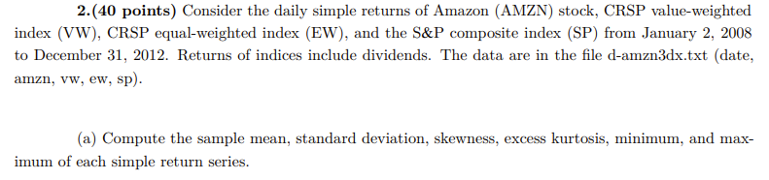
table.Stats(returnAMZN)
##
## Observations 1258.0000
## NAs 0.0000
## Minimum -0.2160
## Quartile 1 -0.0227
## Median -0.0006
## Arithmetic Mean 0.0000
## Geometric Mean -0.0009
## Quartile 3 0.0231
## Maximum 0.2676
## SE Mean 0.0012
## LCL Mean (0.95) -0.0023
## UCL Mean (0.95) 0.0023
## Variance 0.0017
## Stdev 0.0418
## Skewness 0.2556
## Kurtosis 5.0515
table.Stats(returnVW)
##
## Observations 1258.0000
## NAs 0.0000
## Minimum -0.1239
## Quartile 1 -0.0116
## Median -0.0006
## Arithmetic Mean 0.0000
## Geometric Mean -0.0003
## Quartile 3 0.0116
## Maximum 0.1322
## SE Mean 0.0007
## LCL Mean (0.95) -0.0013
## UCL Mean (0.95) 0.0014
## Variance 0.0006
## Stdev 0.0246
## Skewness 0.5377
## Kurtosis 6.1186

table.Stats(returnEW)
##
## Observations 1258.0000
## NAs 0.0000
## Minimum -0.1091
## Quartile 1 -0.0104
## Median -0.0004
## Arithmetic Mean 0.0000
## Geometric Mean -0.0002
## Quartile 3 0.0111
## Maximum 0.1196
## SE Mean 0.0006
## LCL Mean (0.95) -0.0012
## UCL Mean (0.95) 0.0012
## Variance 0.0005
## Stdev 0.0216
## Skewness 0.4616
## Kurtosis 5.2125
table.Stats(returnSP)
##
## Observations 1258.0000
## NAs 0.0000
## Minimum -0.1211
## Quartile 1 -0.0114
## Median -0.0005
## Arithmetic Mean 0.0000
## Geometric Mean -0.0003
## Quartile 3 0.0110
## Maximum 0.1421
## SE Mean 0.0007
## LCL Mean (0.95) -0.0013
## UCL Mean (0.95) 0.0014
## Variance 0.0006
## Stdev 0.0248
## Skewness 0.5276
## Kurtosis 6.6460
logAMZN = log(1+AMZN)
logVW = log(1+VW)
logEW = log(1+EW)
logSP = log(1+SP)

table.Stats(logAMZN)
##
## Observations 1259.0000
## NAs 0.0000
## Minimum -0.1368
## Quartile 1 -0.0133
## Median -0.0005
## Arithmetic Mean 0.0008
## Geometric Mean 0.0004
## Quartile 3 0.0145
## Maximum 0.2374
## SE Mean 0.0008
## LCL Mean (0.95) -0.0008
## UCL Mean (0.95) 0.0024
## Variance 0.0008
## Stdev 0.0287
## Skewness 0.6279
## Kurtosis 7.2656
table.Stats(logVW)
##
## Observations 1259.0000
## NAs 0.0000
## Minimum -0.0941
## Quartile 1 -0.0063
## Median 0.0008
## Arithmetic Mean 0.0001
## Geometric Mean -0.0001
## Quartile 3 0.0073
## Maximum 0.1088
## SE Mean 0.0005
## LCL Mean (0.95) -0.0009
## UCL Mean (0.95) 0.0010
## Variance 0.0003
## Stdev 0.0167
## Skewness -0.3177
## Kurtosis 6.2095
table.Stats(logEW)
##
## Observations 1259.0000
## NAs 0.0000
## Minimum -0.0815
## Quartile 1 -0.0064
## Median 0.0012
## Arithmetic Mean 0.0004
## Geometric Mean 0.0003
## Quartile 3 0.0077
## Maximum 0.1020
## SE Mean 0.0004
## LCL Mean (0.95) -0.0005
## UCL Mean (0.95) 0.0013
## Variance 0.0002
## Stdev 0.0154
## Skewness -0.3338
## Kurtosis 5.2061
table.Stats(logSP)
##
## Observations 1259.0000
## NAs 0.0000
## Minimum -0.0947
## Quartile 1 -0.0063
## Median 0.0007
## Arithmetic Mean 0.0000
## Geometric Mean -0.0002
## Quartile 3 0.0070
## Maximum 0.1096
## SE Mean 0.0005
## LCL Mean (0.95) -0.0009
## UCL Mean (0.95) 0.0009
## Variance 0.0003
## Stdev 0.0166
## Skewness -0.2424
## Kurtosis 6.9679
#2.C
t.test(logAMZN)
##
## One Sample t-test
##
## data: logAMZN
## t = 0.97705, df = 1258, p-value = 0.3287
## alternative hypothesis: true mean is not equal to 0
## 95 percent confidence interval:
## -0.0007975567 0.0023801007
## sample estimates:
## mean of x
## 0.000791272
#since the calculated p-value = 0.9915 exceed 0.05, we cannot reject null hypothesis at 95 percent confidence interval that is H0 : u = 0

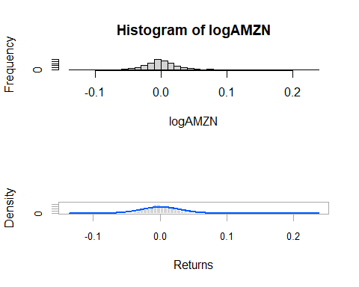
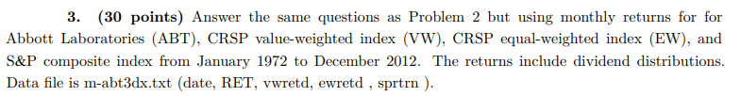
table.Stats(ABT)
##
## Observations 492.0000
## NAs 0.0000
## Minimum -0.2341
## Quartile 1 -0.0242
## Median 0.0141
## Arithmetic Mean 0.0141
## Geometric Mean 0.0120
## Quartile 3 0.0558
## Maximum 0.3823
## SE Mean 0.0029
## LCL Mean (0.95) 0.0083
## UCL Mean (0.95) 0.0198
## Variance 0.0042
## Stdev 0.0648
## Skewness 0.0974
## Kurtosis 2.4923
table.Stats(VW2)
##
## Observations 492.0000
## NAs 0.0000
## Minimum -0.2254
## Quartile 1 -0.0172
## Median 0.0126
## Arithmetic Mean 0.0090
## Geometric Mean 0.0079
## Quartile 3 0.0395
## Maximum 0.1656
## SE Mean 0.0021
## LCL Mean (0.95) 0.0049
## UCL Mean (0.95) 0.0131
## Variance 0.0021
## Stdev 0.0463
## Skewness -0.5570
## Kurtosis 2.0943
table.Stats(EW2)
##
## Observations 492.0000
## NAs 0.0000
## Minimum -0.2722
## Quartile 1 -0.0207
## Median 0.0144
## Arithmetic Mean 0.0116
## Geometric Mean 0.0099
## Quartile 3 0.0445
## Maximum 0.2993
## SE Mean 0.0026
## LCL Mean (0.95) 0.0065
## UCL Mean (0.95) 0.0167
## Variance 0.0033
## Stdev 0.0573
## Skewness -0.2006
## Kurtosis 3.3137
table.Stats(SP2)
##
## Observations 492.0000
## NAs 0.0000
## Minimum -0.2176
## Quartile 1 -0.0189
## Median 0.0091
## Arithmetic Mean 0.0064
## Geometric Mean 0.0054
## Quartile 3 0.0353
## Maximum 0.1630
## SE Mean 0.0020
## LCL Mean (0.95) 0.0024
## UCL Mean (0.95) 0.0104
## Variance 0.0020
## Stdev 0.0448
## Skewness -0.4457
## Kurtosis 1.9097
logABT = log(1+ABT)
logVW2 = log(1+VW2)
logEW2 = log(1+EW2)
logSP2 = log(1+SP2)
table.Stats(logABT)
##
## Observations 492.0000
## NAs 0.0000
## Minimum -0.2668
## Quartile 1 -0.0245
## Median 0.0140
## Arithmetic Mean 0.0119
## Geometric Mean 0.0098
## Quartile 3 0.0543
## Maximum 0.3238
## SE Mean 0.0029
## LCL Mean (0.95) 0.0062
## UCL Mean (0.95) 0.0176
## Variance 0.0041
## Stdev 0.0643
## Skewness -0.2980
## Kurtosis 2.0258
table.Stats(logVW2)
##
## Observations 492.0000
## NAs 0.0000
## Minimum -0.2554
## Quartile 1 -0.0173
## Median 0.0125
## Arithmetic Mean 0.0079
## Geometric Mean 0.0068
## Quartile 3 0.0387
## Maximum 0.1532
## SE Mean 0.0021
## LCL Mean (0.95) 0.0038
## UCL Mean (0.95) 0.0120
## Variance 0.0022
## Stdev 0.0467
## Skewness -0.8421
## Kurtosis 3.0278
table.Stats(logEW2)
##
## Observations 492.0000
## NAs 0.0000
## Minimum -0.3178
## Quartile 1 -0.0209
## Median 0.0143
## Arithmetic Mean 0.0099
## Geometric Mean 0.0082
## Quartile 3 0.0435
## Maximum 0.2618
## SE Mean 0.0026
## LCL Mean (0.95) 0.0048
## UCL Mean (0.95) 0.0150
## Variance 0.0033
## Stdev 0.0575
## Skewness -0.6643
## Kurtosis 4.0045
table.Stats(logSP2)
##
## Observations 492.0000
## NAs 0.0000
## Minimum -0.2454
## Quartile 1 -0.0191
## Median 0.0090
## Arithmetic Mean 0.0054
## Geometric Mean 0.0043
## Quartile 3 0.0347
## Maximum 0.1510
## SE Mean 0.0020
## LCL Mean (0.95) 0.0014
## UCL Mean (0.95) 0.0094
## Variance 0.0020
## Stdev 0.0451
## Skewness -0.7134
## Kurtosis 2.6821
t.test(logABT)
##
## One Sample t-test
##
## data: logABT
## t = 4.1143, df = 491, p-value = 4.555e-05
## alternative hypothesis: true mean is not equal to 0
## 95 percent confidence interval:
## 0.006229721 0.017618849
## sample estimates:
## mean of x
## 0.01192429
#since the calculated p-value = 4.555e-05 less than 0.05, we can reject null hypothesis H0:u = 0 at 95 percent confidence interval
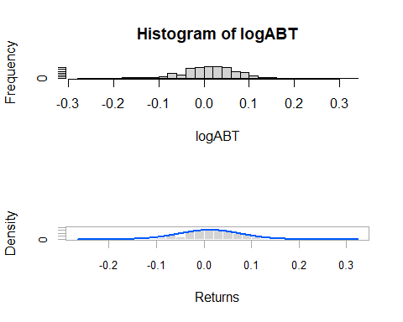
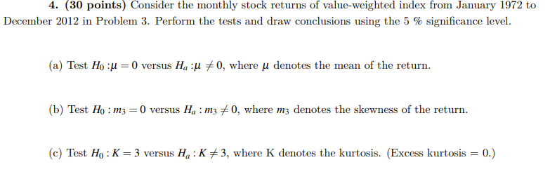
4.A
t.test(VW2)
##
## One Sample t-test
##
## data: VW2
## t = 4.3172, df = 491, p-value = 1.912e-05
## alternative hypothesis: true mean is not equal to 0
## 95 percent confidence interval:
## 0.004914667 0.013124406
## sample estimates:
## mean of x
## 0.009019537
#since the calculated p-value = 1.912e-05 less than 0.05, we can reject null hypothesis H0 : u = 0 at 95 percent confidence interval
4.B
T1=length(VW2)
VW2_s3=skewness(VW2)
VW2_s3
## [1] -0.5570388
TST=VW2_s3/sqrt(6/T1)
TST
## [1] -5.044201
PV1=2*pnorm(TST)
PV1
## [1] 4.55421e-07
The calculated p-value is less than 0.05, we can reject null hypothesis that is H0 : m3 = 0 at 95% confidence interval
4.C
VW2_k3=kurtosis(VW2)/sqrt(24/T)
VW2_k3
## [1] 0.4275063
PV2=2*(1-pnorm(VW2_k3))
PV2
## [1] 0.6690106
The calculated p-value is greater than 0.05, we cannot reject null hypothesis H0 : k = 3 at 95% percent confidence interval. Therefore, the monthly stock return does not contains excess kurtosis(excess kurtosis=0)

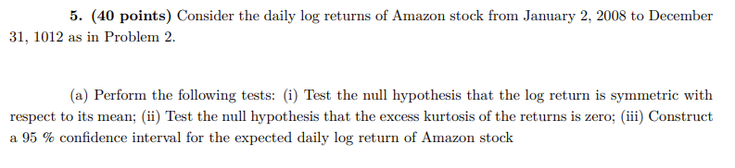
(i)
T2=length(logAMZN)
AMZN_S3=skewness(logAMZN)
AMZN_S3
## [1] 0.6278955
TST2=AMZN_S3/sqrt(6/T2)
TST2
## [1] 9.095459
PV3=2*(1-pnorm(TST2))
PV3
## [1] 0
The calculated p-value = 0, less than 0.05. Therefore, we can reject null hypothesis at 95% confidence interval. That is the log return is not symmetric with respect to its mean.
(ii)
AMZN_K3=kurtosis(logAMZN)
AMZN_K3
## [1] 7.26559
TST3=AMZN_K3/sqrt(24/T2)
TST3
## [1] 52.62331
PV4=2*(1-pnorm(TST3))
PV4
## [1] 0
The calculated p-value is less than 0.05, we can reject null hypothesis at 95% confidence interval. Therefore, the log return data contains kurtosis problem.

(iii)
t.test(logAMZN)
##
## One Sample t-test
##
## data: logAMZN
## t = 0.97705, df = 1258, p-value = 0.3287
## alternative hypothesis: true mean is not equal to 0
## 95 percent confidence interval:
## -0.0007975567 0.0023801007
## sample estimates:
## mean of x
## 0.000791272
#since the calculated p-value = 0.3287 exceed 0.05, we cannot reject null hypothesis at 95% confidence interval. Thus, the expected daily log return of Amazon stocks is equal to 0
#5.B
par(mfcol=c(2,1))
acf(logAMZN, lag=12)
pacf(logAMZN, lag=12)

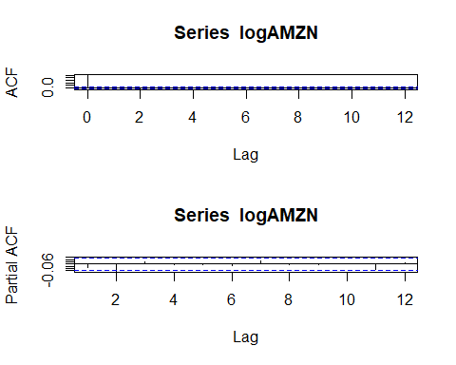
The second lag term lies outside of 95% confidence interval, thus we can reject null hypothesis H0 = p1 =p2 = … = p12 at 95% confidence interval.
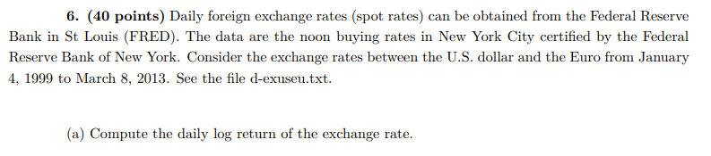
da3=read.table("d-exuseu.txt")
FX=da3[-1,4]
FX <- as.numeric(FX)
logFX=log(FX)
logreturnFX=diff(logFX)
logreturnFX
ps. The data is in Rstudio report, the data is too long

table.Stats(logreturnFX)
##
## Observations 3566.0000
## NAs 0.0000
## Minimum -0.0300
## Quartile 1 -0.0036
## Median 0.0000
## Arithmetic Mean 0.0000
## Geometric Mean 0.0000
## Quartile 3 0.0038
## Maximum 0.0462
## SE Mean 0.0001
## LCL Mean (0.95) -0.0002
## UCL Mean (0.95) 0.0002
## Variance 0.0000
## Stdev 0.0065
## Skewness 0.1168
## Kurtosis 2.0610

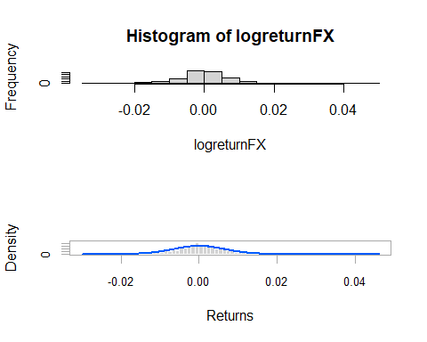
t.test(logreturnFX)
##
## One Sample t-test
##
## data: logreturnFX
## t = 0.24489, df = 3565, p-value = 0.8066
## alternative hypothesis: true mean is not equal to 0
## 95 percent confidence interval:
## -0.0001870737 0.0002404769
## sample estimates:
## mean of x
## 2.670158e-05
#since the calculated p-value = 0.8066 is greater than 0.0, we cannot reject null hypothesis at 95 percent confidence interval

