
1) Discuss one Insurance product and comment on its benefits

Thai life insurance, One of the leading insurance company for 72 years, has an interested product called Suppunpol (ทรัพย์ปันผล มีเงินปันผล) which gives option for a person who is looking forward to save funds for children or a future capital.
An interesting features are 1. receive a refund every year 2% of the money on the date of the second policy 2.3 Can choose to save in 3 phases 10 years, 15 years or 20 years 3. Additional protection like health insurance 4. Refund 110% of the total money at the maturity 5. if die during the contract will receive sum of the money
If consider the benefits of this insurance in terms of money received, it has a refund every year which benefits a person so he or she can( or in some case need to use) use some amount of money every year. In this case a person will get returns every year and sum of money at the end of maturity. In term of time, the insurance benefits a person by giving a choice of choosing to save in 10 years, 15 years and 20 years which a person can choose according to their financial goals. if a person wants to save for their children’ education they can choice of 3 phases depending on their kids age and financial goals.
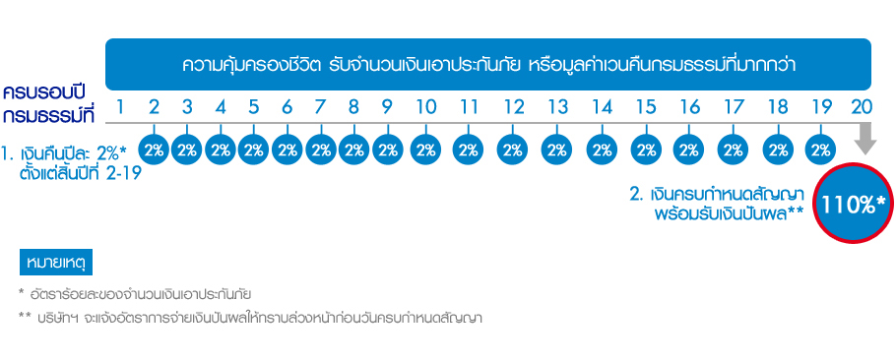
In conclusion this insurance benefits customers in the sense of receiving the money and every year and the total money at the end of maturity but the customers have to notice that it is not mention(according to the website) that insurance premium could be use as the tax refund.

2) Which mortgage would result in higher total payments?

Mortgage A: $970 a month for 30 years

Mortgage B: $760 a month for 5 years and $1005 for 25 years

Mortgage A: $970 a month for 30 years
- Total Payment = $970 x 360 = $349,200
Mortgage B: $760 a month for 5 years and $1005 for 25 years
- Total Payment = ($760 x 60) + ($1005 x 300) = ($45,600 + $301,500) = $347,100

3.What are two main type of consumers credit?

- Noninstallment Credit is the type of credit that makes a lump sum payment before or at the end of the credit period usually comes in short term. It could be secured or unsecured.
- Installment Closed-End Credit is a type of credit that specified the amount of loan for example the price of goods. The full amount of principal and interest rate must be paid over a time of period. This kind of credit usually would be offers to the customers for buying if types of product for example a car loan.

4. general rules

- Debt payments to income ratio- simply addition of all monthly expenses not including mortgages divided by monthly income should be greater than twenty percent
- Debt to equity ratio is calculated by total liabilities divided by net worth.

5) A few years ago, Michael Tucker purchased a home for $100,000. Today, the home is worth $150,000. His remaining mortgage balance is $50,000. Assuming that Michael can borrow up to 80 percent of the market value, what is the maximum amount he can borrow?

- Market value of home: $150,000
Maximum Home credit line based on market value (maximum 80%):​
= $120,000​
Less balance of remaining mortgage – $50,000​
Maximum credit limit on Home credit line: ​ $70,000

http://www.chegg.com/homework-help/1-two-general-rules-measuring-credit-capacity-calculated-2-m-chapter-5-problem-3cc-solution-9780073382425-exc?adobe_reloaded=true
http://smallbusiness.chron.com/three-types-consumer-credit-1886.html
http://bankruptcy-law.freeadvice.com/bankruptcy-law/credit_problems/consumer_credit.htm
https://www.allbestessays.com/Miscellaneous/What-Are-the-Two-General-Rules-of-Measuring/12953.html

