Aphivich Tiyaboonchai
5704640100
FN281: Individual work 1
- Discuss one insurance product and comment on its benefits
Insurance product: AIA 15PAY30 life insurance
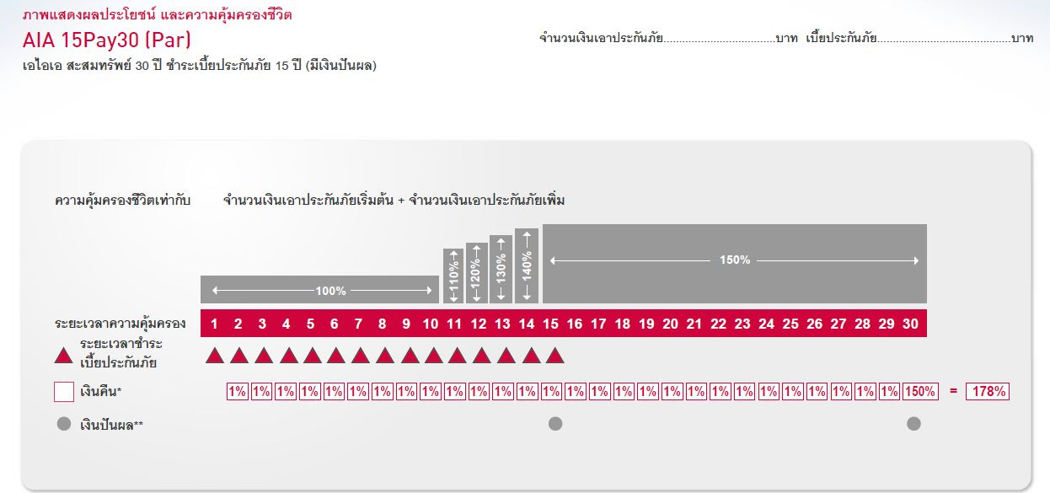
Cash flow timeline:

Payments (per ฿1,000 sum insured):
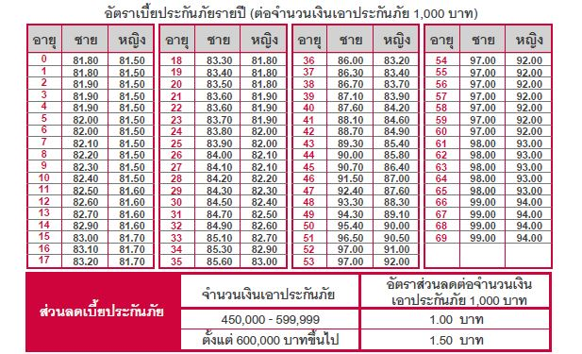

AIA 15PAY30 is a life insurance program proposed by AIA company Thailand. The program requires 15 years from year 1 to year 15. It payouts 1% of the total sum insured from year 2 to year 29 of the contract, and 150% of the total sum insured at the end of contract. Also, this program also offers two dividend payouts from AIA investments.
Insurer can choose to pay the program either monthly or annually, and the payment per year is depended on insurer’s age and total sum insured as can be seen in the table above.
There are a lot of benefits that the insurer will receive from this program. First is the life insurance that this program provides, in case of death, or fully disabled, inheritor will receive compensation from AIA accordingly to the sum insured. In which, the death compensation will grow overtime from 100% of sum insured during the first 10 years to 110%, 120%, 130%, and 140% of sum insured on the 11th, 12th, 13th, and 14th year of the contract. Eventually, the compensation will grow up to the maximum of 150% at year 15 until the end of contract.
Other than the benefit of death compensation, the insurer will also receive the benefit of tax reduction, as mention in Thai law, at 10% of the annual insurance payment and maximum reduction of THB 100,000.
Here, I assume 3 levels of income to calculate the tax benefit as follow;
Income Tax without Life Insurance | Income: 15,000 Bath/month | Income: 30,000 Bath/month | Income: 45,000 Bath/month
Assessable Income | 180,000 | 360,000 | 540,000
Less: Personal Expense | 60,000 | 60,000 | 60,000
Less: Allowance(s)
- Personal | 30,000 | 30,000 | 30,000
- Life Insurance | 0 | 0 | 0
Net Income before Tax | 90,000 | 270,000 | 450,000
Tax Calculation
Bracket 1 (0-150,000) | 0 | 0 | 0
Bracket 2 (150,001-300,000) | 0 | 6,000 | 7,500
Bracket 3 (300,001-500,000) | 0 | 0 | 15,000
Bracket 4 (500,001-750,000) | 0 | 0 | 0
Bracket 5 (750,001-1,000,000) | 0 | 0 | 0
Bracket 6 (1,000,001-2,000,000) | 0 | 0 | 0
Bracket 7 (2,000,001-4,000,000) | 0 | 0 | 0
Total Tax per year | 0 | 6,000 | 22,500
Income Tax with Life Insurance | Income: 15,000 Bath/month | Income: 30,000 Bath/month | Income: 45,000 Bath/month
Assessable Income | 180,000 | 360,000 | 540,000
Less: Personal Expense | 60,000 | 60,000 | 60,000
Less: Allowance(s)
- Personal | 30,000 | 30,000 | 30,000
- Life Insurance | 41,750 | 41,750 | 41,750
Net Income before Tax | 48,250 | 228,250 | 408,250
Tax Calculation
Bracket 1 (0-150,000) | 0 | 0 | 0
Bracket 2 (150,001-300,000) | 0 | 3,912.5 | 7,500
Bracket 3 (300,001-500,000) | 0 | 0 | 10,825
Bracket 4 (500,001-750,000) | 0 | 0 | 0
Bracket 5 (750,001-1,000,000) | 0 | 0 | 0
Bracket 6 (1,000,001-2,000,000) | 0 | 0 | 0
Bracket 7 (2,000,001-4,000,000) | 0 | 0 | 0
Total Tax per year | 0 | 3,912.5 | 18,325

Tax Benefit | 0 | 2,087.5 | 4,175

Furthermore, we can calculate the IRR from this program which depends on the age of insurer and the sum insured. For example, suppose the insurer is 30 years who earns THB 45,000 a month. The total sum insured is THB 500,000. By using financial calculator, the computed IRR is 2.37972%.
Lastly, the insurer can also reinvest the annual payout which AIA offers 2.75% interest rate. With this option, the insurer will enjoy a higher return rate from the program.
In my opinion, the IRR alone is not very attractive for long-term investment. But, considering the benefits of death compensation, tax reduction, and dividend payouts, this life insurance is a decent alternative of fixed savings which offer similar return rates.

- Which mortgage would result in higher total payments?
Mortgage A: $970 a month for 30 years
Mortgage B: $760 a month for 5 years and $ 1005 for 25 years
Answer: In order to compare the two payment alternatives, we have to compute the present value of these two payments using the same discount rate. Suppose the discount rate is 12% per year.
PV of mortgage A: PMT: -970 N: 360 I/Y: 1 CPT PV: 94,301.78
PV of mortgage B: CF0: 0 CF1: 760 F1: 60 CF2: 1,005 F2: 300 I: 1 CPT NPV: 86,690.44
- Mortgage A results in higher total payment.

- What are two main types of consumer credits?
Answer: They are closed-end and open-end credit.
Closed-end credit is used for specific purpose, amount, and period of time. For example, a mortgage which is used when a consumer wants to loan to buy a house and it has certain amount of loan and a certain period of time to be repaid.
Open-end credit is given by the creditor to the borrower that has the maximum limit the borrower can borrow from the creditor, but doesn’t specify the amount that the borrower will borrow. It has a specific due date at every period, for example, credit card.
- What are general rules of measuring credit capacity?
Answer: First, the creditor usually divides the monthly debt payment (excluding mortgage) by monthly income. The rate should be at around 15%, with maximum at 20%. Second rule is debt to equity. The debt to equity ratio will show the borrower’s current leverage level, which can be used to estimate the default risk of borrower. The debt to equity ratio should not be too high.
- A few years ago, Michael Tucker purchased a home for $100,000. Today, the home is worth $150,000. His remaining mortgage balance is $50,000. Assuming that Michael can borrow up to 80 percent of the market value, what is the maximum amount he can borrow?
Answer: Market value = $150,000 Therefore, he can borrow up to 150,000*.8 = $120,000 But, he already has $50,000 outstanding mortgage balance, so he can only borrow $70,000 more.

