Suggested answer key.

Question 1
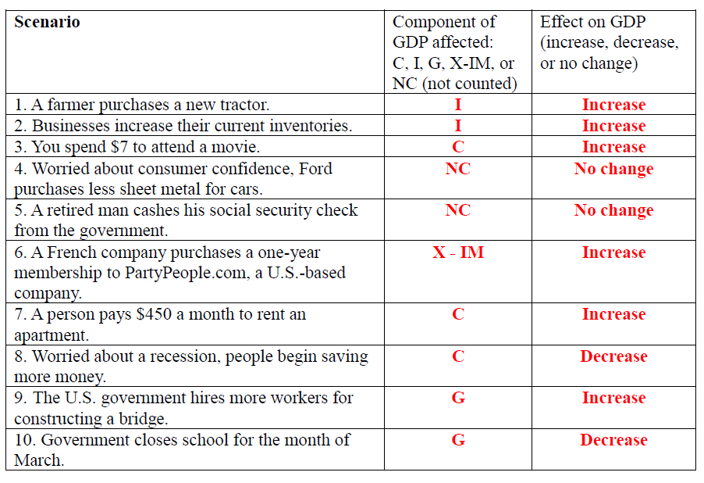

Question 2:
SOLUTION: Without more information, we can say nothing about inflation as measured by the GDP deflator and real GDP. Nominal GDP can increase because of changes in the price level and/or changes in real output. All that we know from the given information is that nominal GDP rose from 2011 to 2012 by 7%: this may mean that this economy is actually producing more, producing the same, or even producing less.

Question 3
3.1
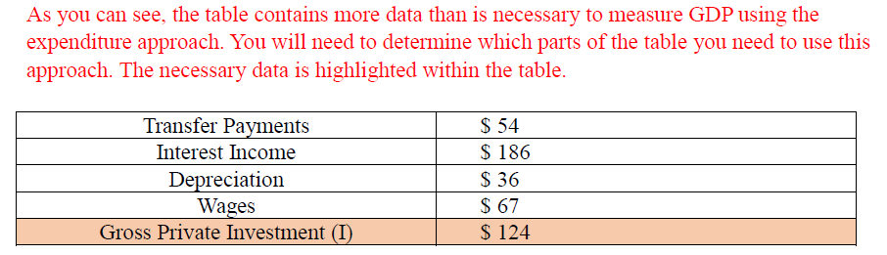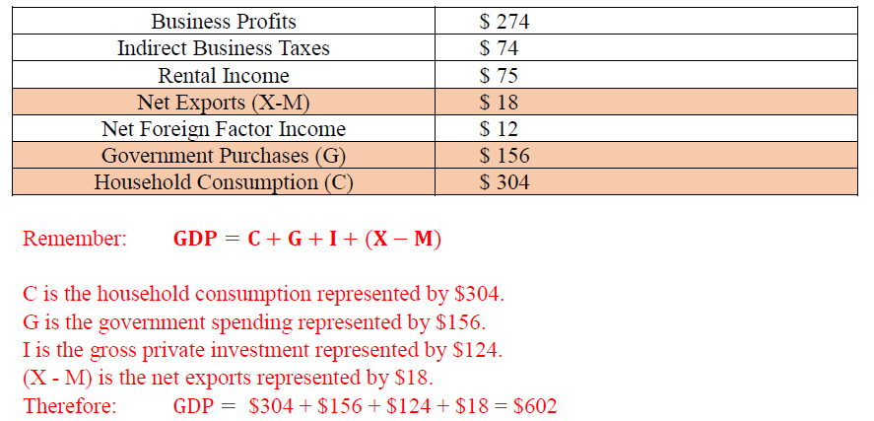

3.2
According to the definition,
NI = Rental income + Business profits + Wage + Interest income + Business indirect tax
= 75 + 274 + 67 + 186 + 74 = 676
If you interpret transfer payments as government transfer, the item won’t be counted at NI. But if you interpret it as business transfers, the item will be included. This depends on your reasoning. I will disregard the item, and interpret it as government transfers.

GNP = GDP + Net Factor income from abroad

Net factor income from abroad
= Payment to factors owned by Cocoland from abroad - Payment to foreign factor in Cocoland
= Net foreign factor income = 12

GNP = GDP + 12

NNP = GNP – depreciation
= GDP + 12 - 36
= GDP – 24

NNP = NI + statistical discrepancy
GDP – 24 = NI + Statistical discrepancy
GDP = NI + 24 + Statistical discrepancy
= 676 + 24 + Statistical discrepancy
= 700 + Statistical discrepancy

Given the calculation, if the stat disc is equal to zero, the two GDP figures will be different. This normally occurs because of the errors in data collection. As a result, the statistical discrepancy must be used to adjust both GDP equals. If we use the GDP expenditure as the reference, the statistic discrepancy should be equal to “ - 24 ”.

Question 4:
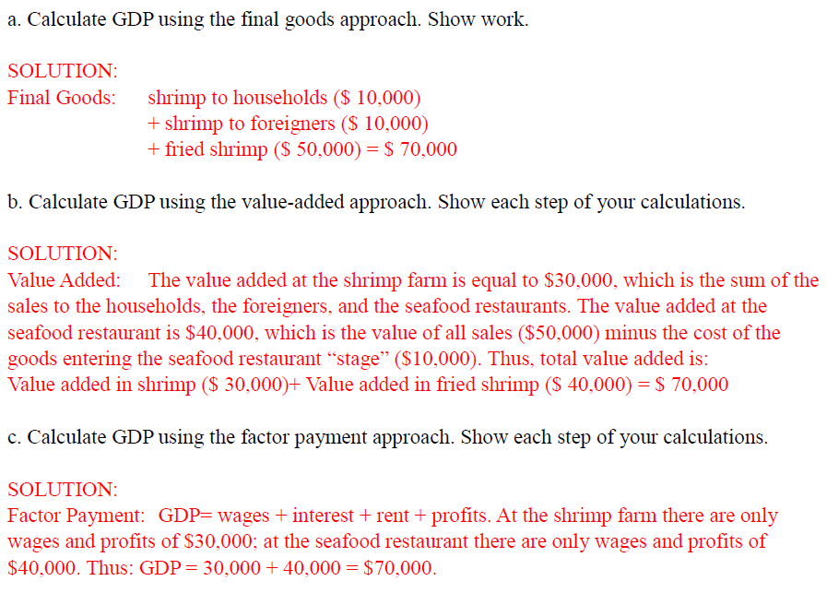

Question 5
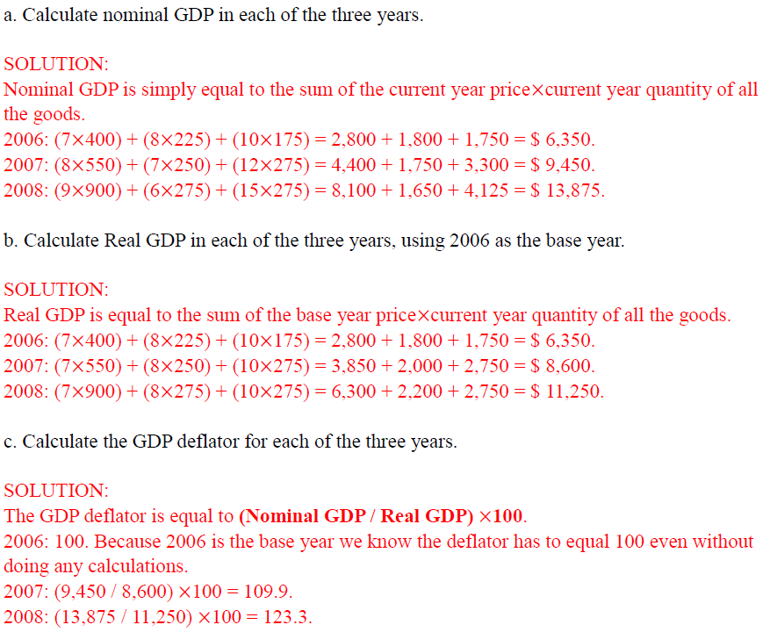
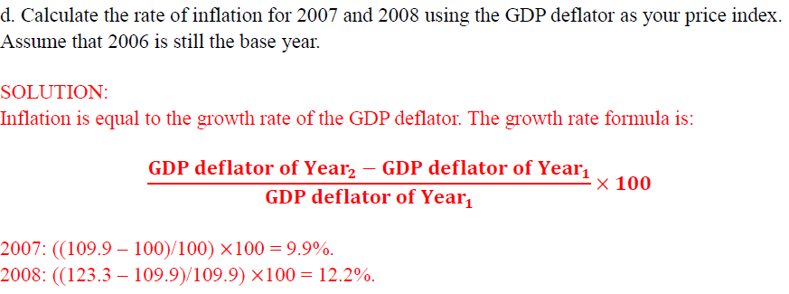

Question 6

6.1)
AE = 176 + 0.8 Y
Y* = 880

6.2)
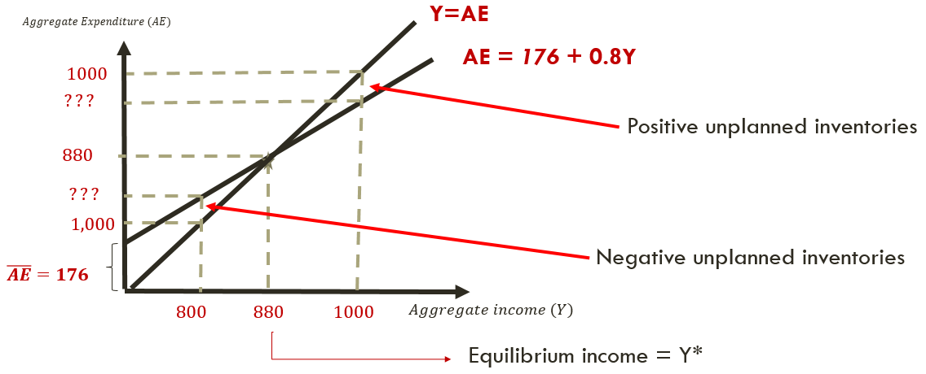

6.3
AE = 172 + 0.8 Y
Y* (new) = 860

