TMB SET50 Dividend Fund : TMB50DV and Bualuang Top - Ten Fund (BTP)
In term of investment, TMB SET50 fully invests in SET50 index using passive management strategy in order to generate investment return along with SET50 index. On the other hand, Bualuang Top-Ten focuses on investing in medium-to-long-term investment in listed companies that have good fundamental. These companies are the ones that Fund Manager expects to have total returns in the Top 10. The fund will not hold securities of listed companies not less than 65% of NAV.
TMB50DV invests 98.65% in Equity, the top 5 holding sectors are Energy and Utilities 22.68%, Banking 18.68%, Information & Comminication Tech 10.43%, Transportation&Logistics 8.64% and Commer 7.31%.
The top holding assets are in PTT Plc. 11.09%, Siam Cement 6.5% and Airports of Thailand, Siam Commercial Bank and CP All around 5%.
The current management fee of TMB50DV is 0.4206% with no front-end and back-end fee with current transaction cost of 0.10%
Bualuang Top-Ten Fund invests 90.34% in common shares of listed companies, 7.77% in Bond and 2.04% in Deposit. The top holding assets are 14.09% NAV in common shares of BEM PLC and around 10% NAV in SCC PLC and BANPU PLC.
The actual management fee of Bualuang Top-Ten is 1.5% of NAV per year while there presents Back-end fee not more than 1% of unit value.
We would choose to invest in Bualaung Top-Ten since its last year 5 performances are all better than the benchmark which is the SET Index with the 3-month performance of 9.68% and 4.89% Standard Deviation. The TMB has 3-month performance of 3.98% with 8.22% standard deviation.
 | 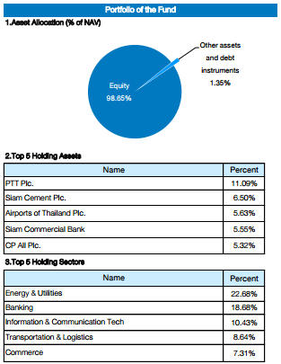  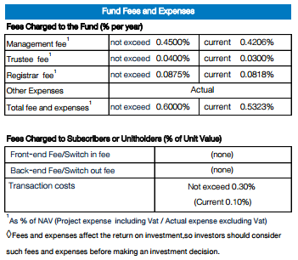  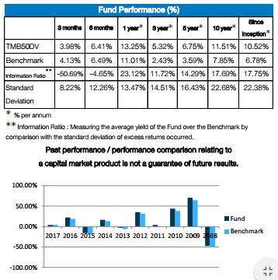 | 

