AC 201 Fundamental Accounting
Chapter 7 Reporting and Interpreting Cost of Goods Sold and Inventory

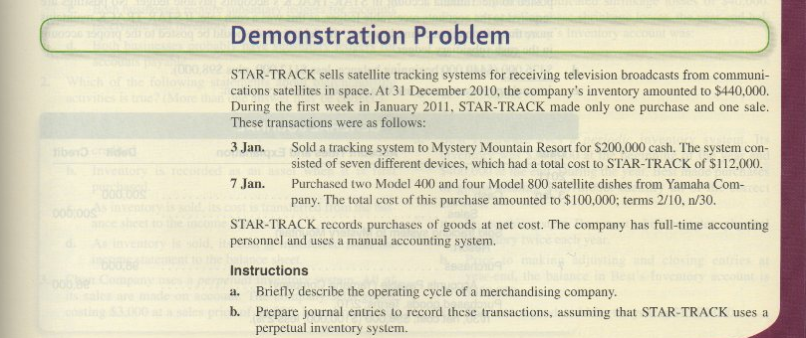

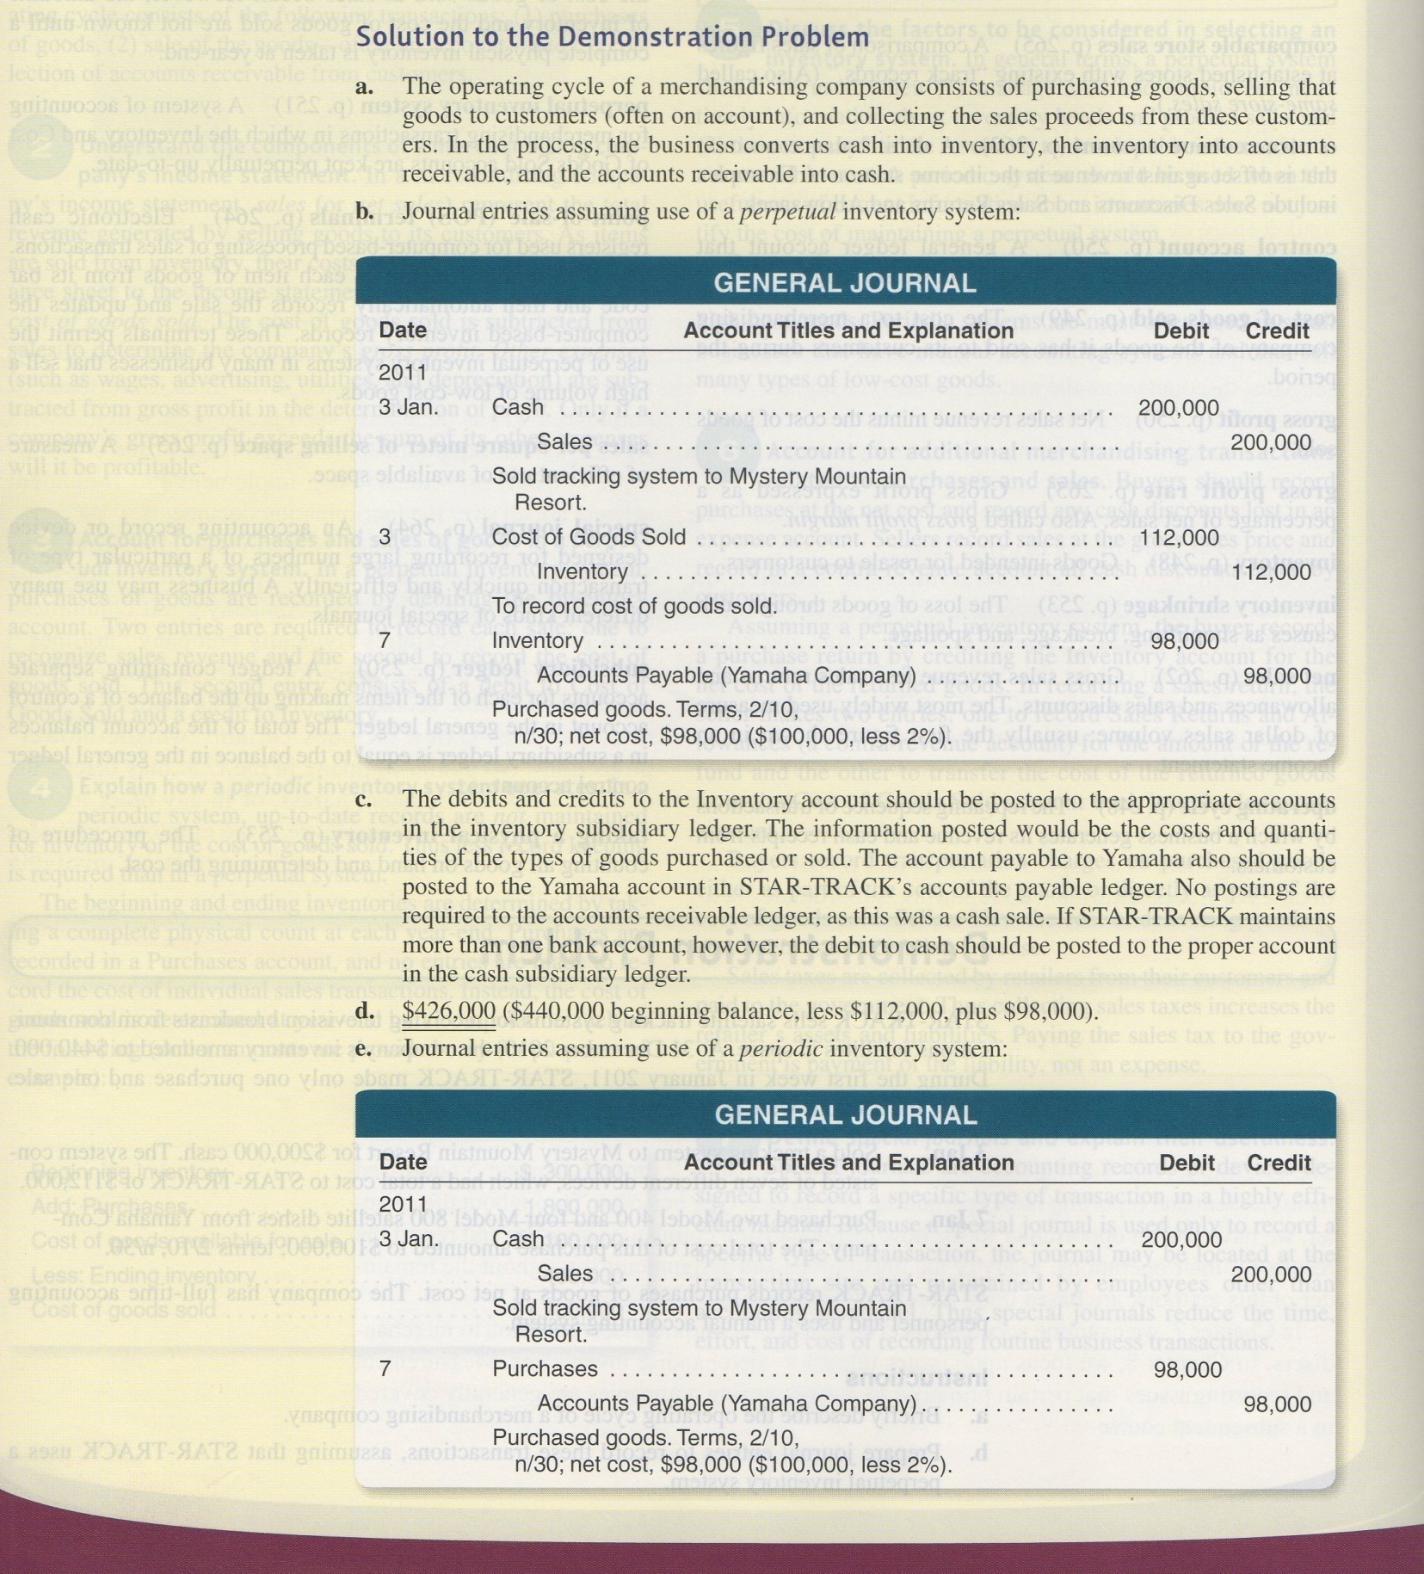
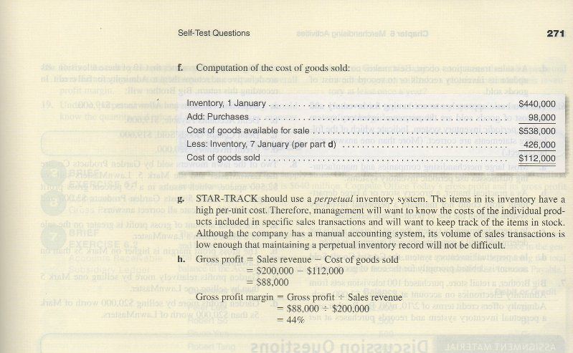
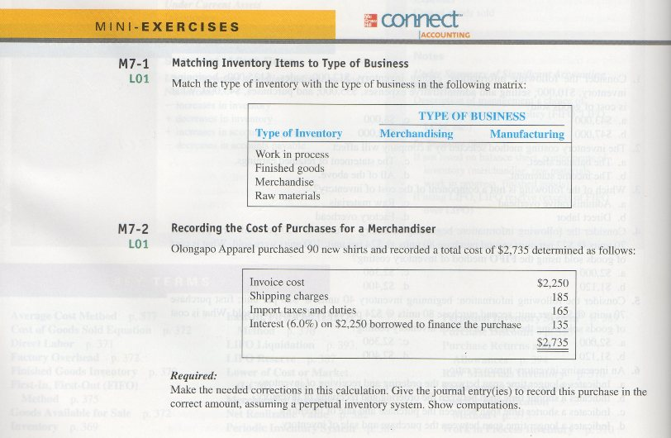
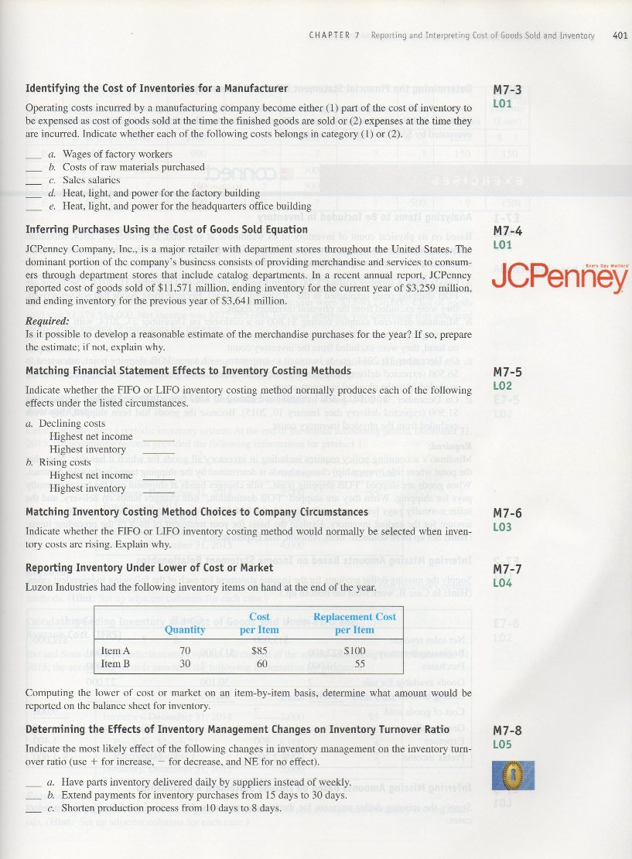
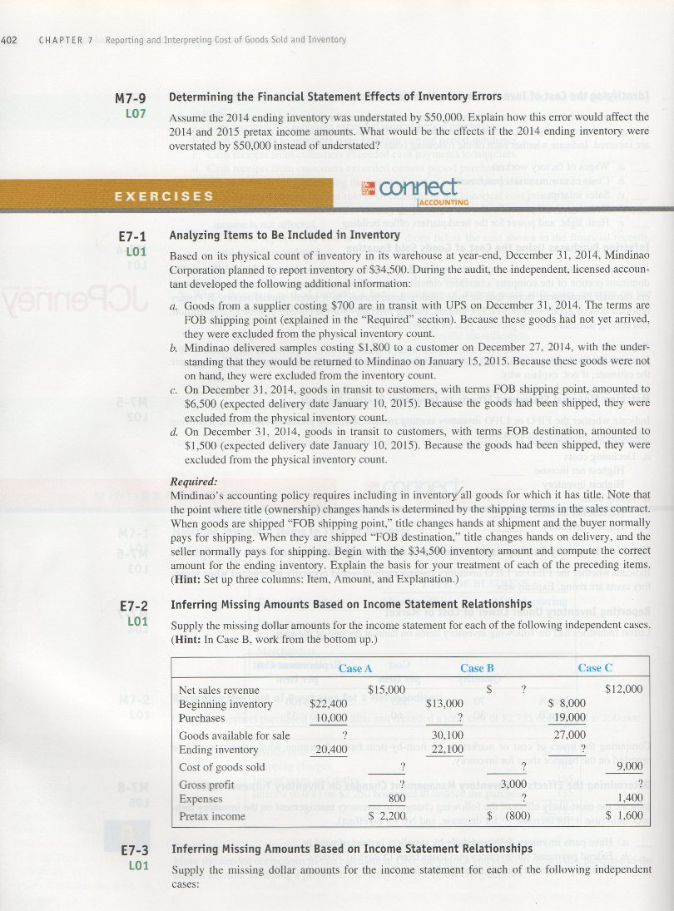
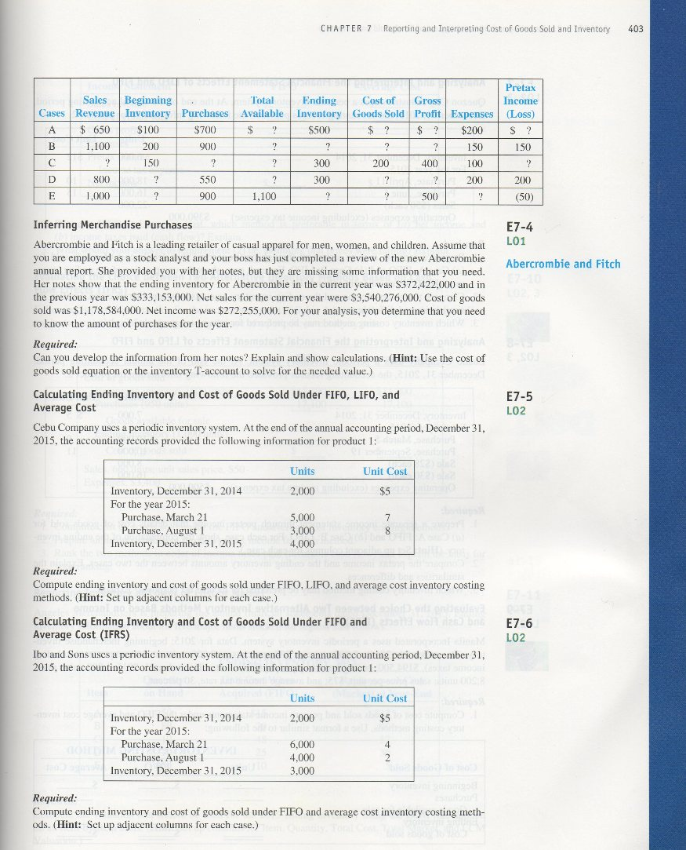
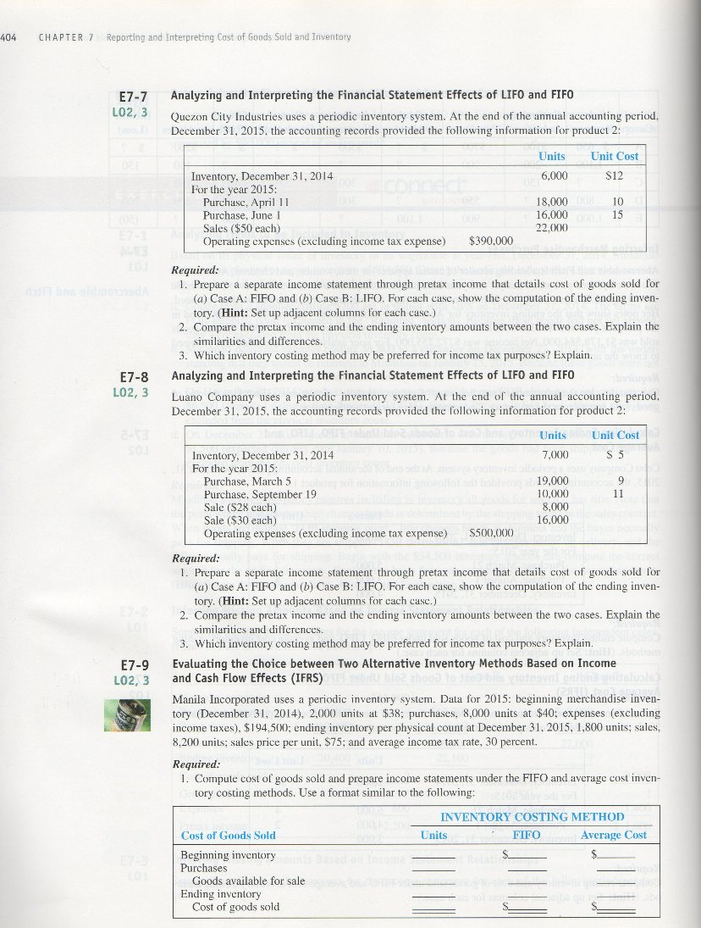
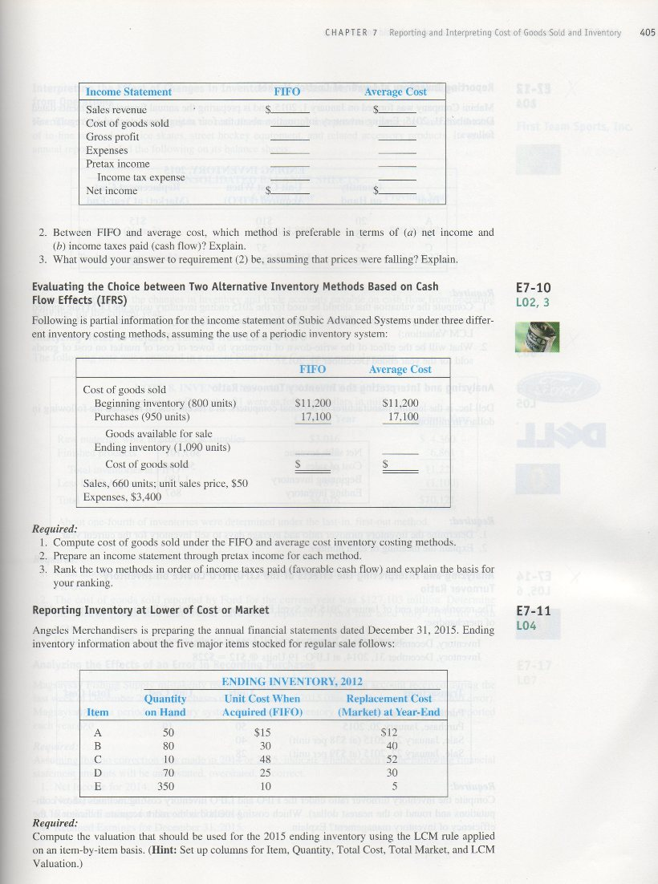
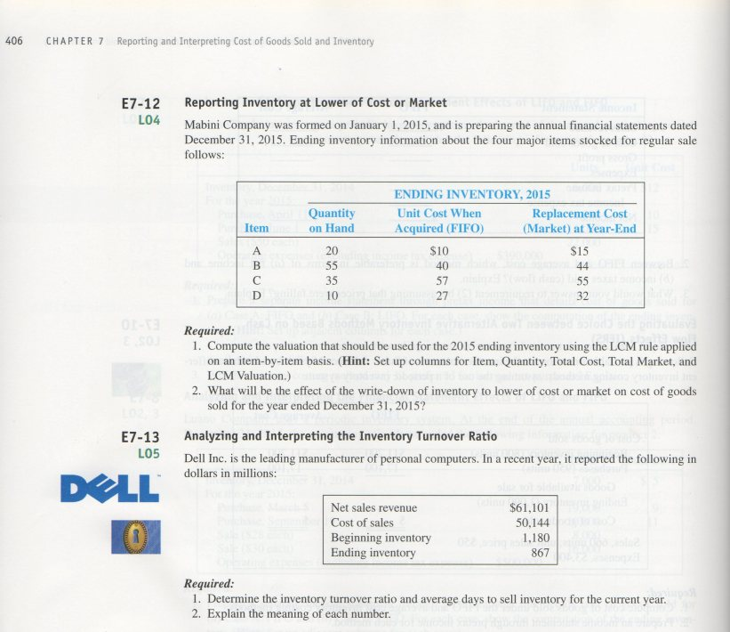
MINI-EXERCISES

M7–1.
Type of Business
Type of Inventory Merchandising Manufacturing
Work in process X
Finished goods X
Merchandise X
Raw materials X

M7–2.

To record the purchase of 90 new shirts in accordance with the cost principle (perpetual inventory system):

Inventory (+A) 2,600
Cash (−A) 2,600

Cost: $2,250 + $185 + $165 = $2,600.

The $135 interest expense is not a proper cost of the merchandise; it is recorded as prepaid interest expense and later as interest expense.

M7–3.

 | (1) Part of inventory | (2) Expense as incurred
a. Wages of factory workers | X
b. Costs of raw materials purchased | X
c. Sales salaries |  | X
d. Heat, light, and power for the factory building | X
e. Heat, light, and power for the headquarters office building |  | X

M7–4.

Computation: Simply rearrange the basic inventory model (BI + P – EI = CGS):

Cost of goods sold $11,571 million
+ Ending inventory 3,259 million
– Beginning inventory (3,641) million Purchases $11,189 million

M7–5.

(a) | Declining costs
 | Highest net income | LIFO
 | Highest inventory | LIFO
(b) | Rising costs
 | Highest net income | FIFO
 | Highest inventory | FIFO

M7–6.

LIFO is often selected when costs are rising because it reduces the company’s tax liability which increases cash and benefits shareholders. However, it also reduces reported net income.

M7–7.

 | Quantity | Cost per  Item | Replacement Cost per Item | Lower of Cost or Market | Reported on Balance Sheet
Item A | 70 | $ 85 | $100 | $85 | 70 x $85 = $5,950
Item B | 30 | 60 | 55 | 55 | 30 x $55 = $1,650
Total |  |  |  |  | $7,600

M7–8.

+ | (a) | Parts inventory delivered daily by suppliers instead of weekly.
NE | (b) | Extend payments for inventory purchases from 15 days to 30 days.
+ | (c) | Shorten production process from 10 days to 8 days.

M7–9.

Understatement of the 2014 ending inventory by $50,000 caused 2014 pretax income to be understated and 2015 pretax income to be overstated by the same amount. Overstatement of the 2014 ending inventory would have the opposite effect; that is, 2014 pretax income would be overstated by $50,000 and 2015 pretax income understated by $50,000. Total pretax income for the two years combined would be correct.

EXERCISES

E7–1

Item |  | Amount | Explanation
Ending inventory (physical count on December 31, 2014) |  | $34,500 | Per physical inventory.
a. | Goods purchased and in transit | + 700 | Goods purchased and in transit, F.O.B. shipping point, are owned by the purchaser.
b. | Samples out on trial to customer | + 1,800 | Samples held by a customer on trial are still owned by the vendor; no sale or transfer of ownership has occurred.
c. | Goods in transit to customer |  | Goods shipped to customers, F.O.B. shipping point, are owned by the customer because ownership passed when they were delivered to the transportation company. The inventory correctly excluded these items.
d. | Goods sold and in transit | + 1,500 | Goods sold and in transit, F.O.B. destination, are owned by the seller until they reach destination.
Correct inventory, December 31, 2014 |  | $38,500

E7–2.
(Italics for missing amounts only.)

Case A Case B Case C

Net sales revenue $15,000 $11,000 $12,000
Beginning inventory $22,400 $ 13,000 $ 8,000
Purchases 10,000 17,100 19,000
Goods available for sale 32,400 30,100 27,000
Ending inventory 20,400 22,100 18,000
Cost of goods sold 12,000 8,000 9,000
Gross profit 3,000 3,000 3,000
Expenses 800 3,800 1,400
Pretax income $ 2,200 $ (800) $ 1,600
E7–3.

(Italics for missing amounts only.)
Case | Sales Revenue | Beg. Inven-tory | Pur-chases | Total Avail-able | Ending Inventory | Cost of Goods Sold | Gross Profit | Ex-penses | Pretax Income or (Loss)
A | $ 650 | $100 | $700 | $800 | $500 | $300 | $350 | $200 | $150
B | 1,100 | 200 | 900 | 1,100 | 300 | 800 | 300 | 150 | 150
C | 600 | 150 | 350 | 500 | 300 | 200 | 400 | 100 | 300
D | 800 | 150 | 550 | 700 | 300 | 400 | 400 | 200 | 200
E | 1,000 | 200 | 900 | 1,100 | 600 | 500 | 500 | 550 | (50)

E7–4.

Computations:

Simply rearrange the cost of goods sold equation
BI + P – EI = CGS
P = CGS – BI + EI

Cost of goods sold $1,178,584,000
– Beginning inventory (333,153,000)
+ Ending inventory 372,422,000
Purchases $1,217,853,000

E7-5
Average
Units FIFO LIFO Cost
Cost of goods sold:
Beginning inventory ($5) 2,000 10,000 10,000 10,000
Purchases (March 21) ($7) 5,000 35,000 35,000 35,000
(August 1) ($8) 3,000 24,000 24,000 24,000
Goods available for sale 10,000 69,000 69,000 69,000
Ending inventory* 4,000 31,000 24,000 27,600
Cost of goods sold 6,000 38,000 45,000 41,400

*Ending inventory computations:
FIFO: (3,000 units @ $8) + (1,000 units @ $7) = $31,000.
LIFO: (2,000 units @ $5) + (2,000 units @ $7) = $24,000.
Average: [(2,000 units @ $5) + (5,000 units @ $7) + (3,000 units @ $8)] =
$69,000 ÷ 10,000 units = $6.90 per unit.
4,000 units @ $6.90 = $27,600.

E7–6

Average
Units FIFO Cost
Cost of goods sold:
Beginning inventory ($5) 2,000 $10,000 $10,000
Purchases (March 21) ($4) 6,000 24,000 24,000
(August 1) ($2) 4,000 8,000 8,000
Goods available for sale 12,000 42,000 42,000
Ending inventory* 3,000 6,000 10,500
Cost of goods sold 9,000 $36,000 $31,500

*Ending inventory computations:
FIFO: (3,000 units @ $2) = $6,000.
Average: [(2,000 units @ $5) + (6,000 units @ $4) + (4,000 units @ $2)] =
$42,000 ÷ 12,000 units = $3.50 per unit.
3,000 units @ $3.50 = $10,500.

E7–7.

Req. 1
QUEZON CITY INDUSTRIES
Income Statement
For the Year Ended December 31, 2015

Case A Case B
FIFO LIFO

Sales revenue1 $1,100,000 $1,100,000
Cost of goods sold:
Beginning inventory $ 72,000 $ 72,000
Purchases 420,000 420,000
Goods available for sale2 492,000 492,000
Ending inventory3 260,000 192,000
Cost of goods sold 232,000 300,000
Gross profit 868,000 800,000
Expenses 390,000 390,000
Pretax income $478,000 $410,000

Computations:
(1) Sales: (22,000 units @ $50) = $1,100,000
E7–7. (continued)

(2) Goods available for sale (for both cases):

Units Unit Cost Total Cost
Beginning inventory 6,000 $12 $ 72,000
Purchase, April 11, 2015 18,000 10 180,000
Purchase, June 1, 2015 16,000 15 240,000
Goods available for sale 40,000 $492,000

(3) Ending inventory (40,000 available – 22,000 units sold = 18,000 units):

Case A FIFO:
(16,000 units @ $15 = $240,000) +
(2,000 units @ $10 = $20,000) = $260,000.

Case B LIFO:
(6,000 units @ $12 = $72,000)+
(12,000 units @ $10 = $120,000) = $192,000.

Req. 2

Comparison of Amounts
Case A Case B
FIFO LIFO

Pretax Income $478,000 $410,000
Difference $68,000

Ending Inventory 260,000 192,000
Difference 68,000

The above tabulation demonstrates that the pretax income difference between the two cases is exactly the same as the inventory difference. Differences in inventory have a dollar-for-dollar effect on pretax income.

Req. 3

LIFO may be preferred for income tax purposes because it reports less taxable income (when prices are rising) and hence (a) reduces income tax and (b) as a result reduces cash outflows for the period.
E7–8.

Req. 1
LUANO COMPANY
Income Statement
For the Year Ended December 31, 2015

Case A Case B
FIFO LIFO

Sales revenue1 $704,000 $704,000
Cost of goods sold:
Beginning inventory $ 35,000 $ 35,000

Purchases 281,000 281,000
Goods available for sale2 316,000 316,000
Ending inventory3 128,000 80,000
Cost of goods sold 188,000 236,000
Gross profit 516,000 468,000
Expenses 500,000 500,000
Pretax income $16,000 $(32,000)

Computations:
(1) Sales: (8,000 units @ $28) + (16,000 units @ $30) = $704,000
(2) Goods available for sale (for both cases):

Units Unit Cost Total Cost

Beginning inventory 7,000 $5 $ 35,000
Purchase, March 5, 2015 19,000 9 171,000
Purchase, September 19, 2015 10,000 11 110,000
Goods available for sale 36,000 $316,000

(3) Ending inventory (36,000 available – 24,000 units sold = 12,000 units):

Case A FIFO:
(10,000 units @ $11 = $110,000) +
(2,000 units @ $9 = $18,000) = $128,000.

Case B LIFO:
(7,000 units @ $5 = $35,000)+
(5,000 units @ $9 = $45,000) = $80,000.

E7–8. (continued)

Req. 2

Comparison of Amounts
Case A Case B
FIFO LIFO

Pretax Income $16,000 $(32,000)
Difference $48,000

Ending Inventory 128,000 80,000
Difference 48,000

The above tabulation demonstrates that the pretax income difference between the two cases is exactly the same as the inventory difference. Differences in inventory have a dollar-for-dollar effect on pretax income.

Req. 3

LIFO may be preferred for income tax purposes because it reports less taxable income (when prices are rising) and hence (a) reduces income tax and (b) as a result reduces cash outflows for the period.
E7–9.

Req. 1
Average
Units FIFO Cost
Cost of goods sold:
Beginning inventory 2,000 $ 76,000 $ 76,000
Purchases 8,000 320,000 320,000
Goods available for sale 10,000 396,000 396,000
Ending inventory* 1,800 72,000 71,280
Cost of goods sold 8,200 $324,000 $324,720

Average
Income statement FIFO Cost
Sales revenue $615,000 $615,000
Cost of goods sold 324,000 324,720
Gross profit 291,000 290,280
Expenses 194,500 194,500
Pretax income 96,500 95,780
Income tax expense (30%) 28,950 28,734
Net income $ 67,550 $ 67,046

*Ending inventory computations:
FIFO: 1,800 units @ $40 = $72,000.
Average: [(2,000 units @ $38) + (8,000 units @ $40)] ÷ 10,000 units =
$396,000 ÷ 10,000 units = $39.60 per unit.
$39.60 x 1,800 units = $71,280.

Req. 2

FIFO produces a more favorable (higher) net income because when prices are rising it gives a lower cost of goods sold amount. FIFO allocates the old (lower) unit costs to cost of goods sold.

Average cost produces a more favorable cash flow than FIFO because, when prices are rising, it produces a higher cost of goods sold amount and lower taxable income and, therefore, lower income tax expense for the period. Cash outflow is less under average cost by the amount of income tax reduction. Average cost causes these comparative effects because it allocates the higher average unit costs to cost of goods sold.

Req. 3

When prices are falling, the opposite effect occurs–Average cost produces higher net income and less favorable cash flow than does FIFO.
E7–10.

Req. 1
Average
FIFO Cost
Cost of goods sold:
Beginning inventory (800 units @ $28) $22,400 $22,400
Purchases (950 units @ $36) 34,200 34,200
Goods available for sale 56,600 56,600
Ending inventory (1,090 units)* 38,120 35,250
Cost of goods sold (660 units) $ 18,480 $ 21,350

*Computation of ending inventory:
FIFO: (950 units x $36) + (140 units x $28) = $38,120

Weighted Average: Units Cost
800 $22,400
950 34,200
1,750 $56,600 = weighted-average unit cost of $32.34.

1,090 units x $32.34 = $35,250

Req. 2
Average
FIFO Cost

Sales revenue ($50 x 660) $33,000 $33,000
Cost of goods sold 18,480 21,350
Gross profit 14,520 11,650
Expenses 3,400 3,400
Pretax income $ 11,120 $ 8,250

Req. 3

Ranking in order of favorable cash flow: The higher rank is given to the method that produce the lower income tax expense because the lower the income tax expense the higher the cash savings.

(1) Weighted average–produces the lowest pretax income.

(2) FIFO–produces the highest pretax income and as a result the highest income tax. This result causes the lowest cash savings on income tax.

The above comparative effects occurred because prices were rising. If prices were falling the two methods would have produced the opposite ranking.

E7–11.

Item | Quantity | Total Cost |  |  |  | Total Market |  |  |  | LCM Valuation
A | 50 | x | $15 | = | $ 750 | x | $12 | = | $600 | $600
B | 80 | x | 30 | = | 2,400 | x | 40 | = | 3,200 | 2,400
C | 10 | x | 48 | = | 480 | x | 52 | = | 520 | 480
D | 70 | x | 25 | = | 1,750 | x | 30 | = | 2,100 | 1,750
E | 350 | x | 10 | = | 3,500 | x | 5 | = | 1,750 | 1,750
 | Total |  |  |  | $8,880 |  |  |  | $8,170 | $6,980

Inventory valuation that should be used (LCM) $6,980

E7–12.

Req. 1

Item | Quantity | Total Cost |  |  |  | Total Market |  |  |  | LCM Valuation
A | 20 | x | $10 | = | $ 200 | x | $15 | = | $300 | $200
B | 55 | x | 40 | = | 2,200 | x | 44 | = | 2,420 | 2,200
C | 35 | x | 57 | = | 1,995 | x | 55 | = | 1,925 | 1,925
D | 10 | x | 27 | = | 270 | x | 32 | = | 320 | 270
 | Total |  |  |  | $4,665 |  |  |  | $4,965 | $4,595

Inventory valuation that should be used (LCM) $4,595

Req. 2

The write-down to lower of cost or market will increase cost of goods sold expense by the amount of the write-down, $70:

Total Cost − LCM Valuation = Write-down
$4,665 − $4,595 = $70 Write-down

E7–13.

Req. 1

Inventory turnover | = | Cost of Goods Sold | = | $50,144 | = | 48.99
 |  | Average Inventory |  | ($1,180+$867)/2

Average days to sell inventory = 365 / inventory turnover = 365 / 48.99 = 7.5 days

Req. 2

The inventory turnover ratio reflects how many times average inventory was produced and sold during the period. Thus, Dell produced and sold its average inventory nearly 49 times during the year.

The average days to sell inventory indicates the average time it takes the company to produce and deliver inventory to customers. Thus, Dell takes an average of about 7.5 days to produce and deliver its computer inventory to its customers.

