

Final Project Research Paper

Zika Virus and Public Health Availability

Submitted by

Sirinda Manprasart 6204640012
Pojthawan Somjit 6204640343
Chanika Prasurtying 6204640756
Nannaphat Charoenwipak 6204641911

Present
Ajarn Thanasak Jenmana

Contemporary Economic Issues (EE406) Semester 1/2020
Thammasat University

Table of Contents

Table of contents 2
Abstract 3
Introduction 4
Body 5-10
1. Overview of ZIKA epidemic, including public health policies deployed against it.
2.The major ZIKA epidemics since first time founded(the 1940s) until second spreading(2013-2014)
Figure1.1: Suspected and Confirmed Autochthonous ZIKA Diseases Cases Reported by Countries and Territories in the Americas, 1 January 2015 to 9 March 2017.

3.The general impact of ZIKA especially on economic and healthcare availability.
Figure1.2:The short-term economic costs of Zika in Latin America and the Caribbean (LCR).
Figure1.3:The Reproductive health care lacking in Latin America and the Caribbean(LCR)
4.Public health care and global healthcare perspectives associated with ZIKA.
Conclusion & Discussion 10-12
- Discuss WHO responses and consider whether it is the most effective response compared to current technology.
- Today Epidemiological Updates and Prevention and Control of ZIKA Virus

References 12-15

Abstract
Zika seems to play an important role in changing the world perspectives in health availability and prevention, and also create a short-term negative impact on the economy in a severe infection rate area. Zika virus (ZIKV) is spread by Aedes aegypti mosquitoes, which bite during the day. The first major spreading of the ZIKA virus was in 2007 causing the confirmed infected cases out of 73% of the population. The second major spreading was during 2013 and 2014. Brazil was the country that had the largest confirmed cases. Moreover, the most continents which had the largest number of Zika confirmed infected cases was South America accounted for 70% of the reported cases. For the government policy during the Zika epidemic, the most effective policy is to control the mosquito population in all life stages by removing the standing water and using backpack pesticide sprayers. The World Bank emphasizes that economies of countries that depend signiﬁcantly on tourism could drastically suffer from the ZIKV spread, and the drop in their GDP can reach 1.6% because of decreasing tourism. The ﬁscal pressures can reach up to 0.3% of GDP in several countries such as Belize, making things even more complicated for local governments since they are already facing a severe shortage of ﬁscal space and subdued economic growth. The World Bank estimated the loss from the Zika epidemic for 2016 in the Latin American and the Caribbean(LCR) at about billions and considers three main types of costs. First, the direct outlays and loss from death. Second, lost productivity, and Third, the impact of avoidance Some ZIKA facts raise concerns about the disease by first, a ZIKV infection is asymptomatic and second, several studies during the outbreak identified other possible mechanisms of transmission. The warning signs for the Zika outbreak are raising concerns internationally. Therefore, public health workers should be vigorously monitored among humans and the carrier population, and adequate measures should be taken to control mosquitoes.

Introduction

Zika virus, a disease carried by mosquitoes, was something that impacted an entire country and stunned the World with its efficiency in treating neurological disorders in its victims.
This hazardous virus ”ZIKA” was first recognized in the 1940s(Phyllis KanKi,2017) before it became widespread in 2016 with 30,000 cases discovered in Brazil. The spreading of ZIKA spiraled and came to a head when it reached 164,237 cases. It hit Bahia, Venezuela, the Dominican Republic, El Salvador, Honduras, Colombia, and Suriname as well as Brazil. (Amjad Ali, Braira Wahid, Shazia Rafique, Muhammad Idrees, 2017) The Infection during pregnancy presents many serious hazards for mother and child (Center for Disease Control and Prevention, National Center for Emerging and Zoonotic Infectious Diseases(NCEZID), Division of Vector-Borne Diseases(DVBD),2019)Zika virus can be transmitted from mother to child during pregnancy because of Microcephaly. Microcephaly can occur because a baby’s brain has not grown enough pending pregnancy or has stopped developing after birth which can mean that the baby’s head is smaller than expected when compared to babies of the same age and sex. There is also some evidence suggesting that breast milk can transmit the virus by breastfeeding from mother to child. The Major economy changed after ZIKA spreading.ZIKA has a high epidemic potential that could negatively affect the emergent economies of LCR and may foster overstatements on the actual risk of infections in healthy young adults, such as Olympic athletes and tourists (Attaran et al., 2016). A more judicious appraisal of the true epidemic potential is needed and this includes a careful dissection of the different types of economic impact that the ZIKA epidemic could cause (Zumla et al.,2016).
Household perspective included costs of lost productivity, travel costs, and the need to borrow money and pay interest. Economic consequences of CZS (congenital Zika syndrome) are also likely to be important. Parents of children with CZS will incur direct (e.g. payment for medicines) and indirect costs (e.g. lost productivity). This impact is potentially exacerbated by the fact that ZIKV disproportionately affects poor people, who are less able to cope with this economic burden. How the government attempted to preserve the anonymity and protect women who may have made statements about abortion

The impact on health availability. When a Zika epidemic occurs, the government becomes aware of people's health, which has led to the introduction of policies to prevent and deter the spread of ZIKA, particularly in vulnerable countries such as Africa, the EU, and the USA, where the main policies are mosquito control, public communication, clinical awareness, surveillance, and laboratory capacity (Vaccine). (European center for disease prevention and control, 2016) Measures are selected carefully that can be prepared to diminish the risk of Zika virus spreading. The main reason for this is to protect pregnant women and women who wish to become pregnant. As well as this, WHO also takes action to counter Zika through close collaboration with 60 other partners and facilitates information sharing with risky countries. (World Health Organization, 2017). The objectives of our exploratory study are
1.) How can Zika impact healthcare availability and damage the economy of a place with a severe infection rate? 2.) After it was recognized and spread, what policies were adapted to control the viruses and sanitary-cordons. 3.) Discuss WHO responses and consider whether it is the most effective response compared to current technology.

BODY

1. Overview of ZIKA epidemic, including public health policies deployed against it.

Zika virus (ZIKV) is a mosquito-borne flavivirus that was first isolated in Uganda in 1947 in monkeys. (World Health Organization, 2018) After that, ZIKV was identified in humans in the United Republic of Tanzania and Uganda in 1952. Zika virus is related to other globally relevant arthropod-transmitted human pathogens including dengue, yellow fever, West Nile, Japanese encephalitis, and tick-borne encephalitis viruses (Lazear and Diamond, 2016). This virus is spread by Aedes aegypti mosquitoes, which bite during the day.
The time from exposure to symptoms of Zika virus disease is estimated to be 3–14 days. (World Health Organization, 2018) Symptoms are generally mild including fever, rash, muscle, and joint pain, red eyes, and headache. The symptoms can last for 2-7 days. Since the symptoms are generally mild and there is no specific treatment for the Zika virus, most people don’t go to the hospital, and they rarely die from ZIKV. Once a person has been infected with Zika, they are likely to be protected from future infections. (Centers for Disease Control and Prevention, 2016) On the other hand, infection during pregnancy can cause serious birth defects such as microcephaly, and other severe fetal brain defects. Therefore, pregnant women should not travel to areas with a Zika outbreak and avoid mosquito bites for the safety of the baby. ZIKV is transmitted to humans primarily through the bite of infected mosquitoes, but it can also be transmitted from mother to child during pregnancy or spread through sexual contact, breastfeeding, or blood transfusion.
As Zika virus is transmitted by Aedes mosquitoes, controlling the number of mosquitoes before people start getting sick is what the government is interested in. The effectiveness of mosquito control depends on the professional of the local government to reduce the mosquito population in all life stages, egg, larvae, and adult. To solve the problem at the root cause is removing places where mosquitoes lay eggs. Aedes mosquito is laying their eggs in standing water, so removing the standing water will reduce mosquito larvae before they become adult biting mosquitoes. Another way to control the virus is by reducing the number of adult mosquitoes by using backpack pesticide sprayers where it lives. Eventually, to make sure that the previous control activities are effective, the government has to monitor the programs which manage the inhabitants of mosquitoes. (Centers for Disease Control and Prevention, 2019)
Some organizations take care of public health care during the epidemic. The Brazilian Primary Health Care (BPH) network had been expanding the coverage of access to health services throughout the country. The actions of health teams facilitated access to the network and enabled the accomplishment of health inspection measures and actions, such as early detection of suspected cases of diseases in the country, in addition to carrying out actions on maternal and child health in the assigned territories. (Paulo Cesar Peite, 2020) Moreover, Health Care Networks (HCN) was established by focusing on the care and development of the children and their families, thus playing a role of accompanying, to reduce morbidity and mortality in places of difficult access to health resources.

2.The major ZIKA epidemics since first time founded(the 1940s) until second spreading(2013-2014)
Zika virus or ZIKV is the potential neurological and auto-immune complications related to Zika virus infection with reports of Guillain-Barré Syndrome, and birth defects including microcephaly (World Health Organization, 2016). The symptoms include fever, headache, conjunctivitis, and a skin rash. At the beginning, the Zika virus was first found in Uganda in 1947 in monkeys which is a mosquito-borne flavivirus transmitted by Aedes mosquitoes. The first infection of the Zika virus in humans was between 1952 and 1954 in Uganda, Tanzania, and Nigeria (World Economic Forum, 2017). In the 1950s, the experiment showed how the virus causes neural cell death. (N Engl J Med, 2016). During the 1940s, ZIKV has been known in Asia and Africa; however, the dramatically expanded Zika virus occurred during 2007. In 2007, the Zika virus first emerged from Africa and Asia continents which caused the huge epidemic in the island of Yap United States of Micronesia followed by Pacific Islands: Easter Island, Cooks Island, Tahiti, French Polynesia, and New Caledonia (Asian Pacific Journal of Tropical Medicine, 2017). Additionally, Guillain-Barré Syndrome was reported and linked with the Zika virus.
The second major ZIKV epidemic was reported in French Polynesia between 2013 and 2014 which approximated 11% of the population. Nevertheless, the Zika virus emerged in North East Brazil in 2015, and the virus has been confirmed that the clinical sign can be caused by underdevelopment of the brain. (N Engl J Med, 2016). The cause of Zika virus transmission was the imported cases of ZIKV from the travelers returning from the infected regions: Europe, the Americas, and Asia. Similarly in 2013, from Thailand to French Polynesia, the virus spread to the countries of South and Central America which reported the infected case of around million people. The infection is mostly transient, but it is strongly neurotropic and causes teratogenic outcomes in the fetus. The Americas have been reported that there were at least 20 countries was infected by Zika virus since May 2015. On July 2016, this epidemic has been reported in 65 countries where microcephaly and other neural defects has verified in 13 countries. Moreover, the rising frequency of Guillain Barré Syndrome has confirmed in 15 countries. There were 30,000 infected cases confirmed in Brazil in January 2016. Furthermore, there were 164,237 cases confirmed from the infection of Zika virus in Brazil, Bahia, Venezuela, the Dominican Republic, El Salvador, Honduras, Colombia, and Suriname during April 1, 2015 to March 21, 2016; 198,346 infected cases of ZIKV and 2,569 infected cases of microcephaly were verified during January 2015 to January 2017 (Asian Pacific Journal of Tropical Medicine, 2017). Additionally, Pan American and Health Organization reported about the suspected and confirmed autochthonous ZIKA disease cases by the countries and territories in the Americas from 1 January 2015 to 9 March 2017. With 754,460 suspected cases, Brazil was reported that there was the largest number of confirmed cases which was 46%. Then, Colombia and Venezuela had 14% and 8% of infected cases, respectively. Another report was reported by the infected cases in each region. The largest percentage of infected and confirmed cases was South America which had 70% reported cases, and the least confirmed cases was in North America which had only 1% of reported cases (The Journal of Infectious Diseases, 2017).

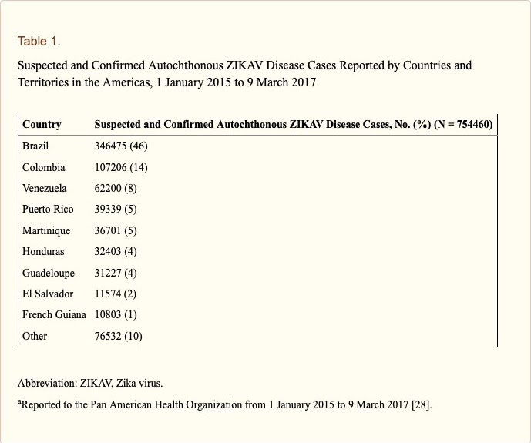

Figure1.1: Suspected and Confirmed Autochthonous ZIKA Diseases Cases Reported by Countries and Territories in the Americas, 1 January 2015 to 9 March 2017.
During the spreading of Zika virus epidemic, the main areas which were infected by this virus were not only in the Americas and the West Pacific, but also in Africa and Southeast Asia (N Engl J Med, 2016). However, on January 16, 2016, there were 60 countries and territories were reported the continuing of Zika virus epidemic: 46 countries experience the first spreading of Zika virus since 2015 with ongoing of the transmission by mosquitoes and 14 countries have evidenced of the transmission of Zika virus with the ongoing transmission between 2007 and 2014 (World Health Organization, 2016).

3.The general impact of ZIKA especially on economic and healthcare availability.
With regard to ZIKV economic implications, the World Bank estimates that the short-term impact of the ZIKV outbreak for 2016 in the Latin American and Caribbean Countries (LCR) is about US$3.5 billion. On the other hand, the ﬁscal impact (the revenues foregone caused by a reduction in revenues or income caused by the outbreak) would be limited to US$420 million. However, the Word Bank emphasizes that economies of countries that depend signiﬁcantly on tourism could drastically suffer from the ZIKV spread, and the drop in their GDP can reach 1.6% because of decreasing tourism. As a consequence, the ﬁscal pressures can reach up to 0.3% of GDP in several countries such as Belize, making things even more complicated for local governments since they are already facing severe shortage on ﬁscal space and subdued economic growth. (World Bank 2016).In its estimate, the World Bank considers three main categories of costs. First, the direct outlays and loss from death: which includes payments for extra doctors, nurses, drugs and prophylactic treatments.
Currently, much of Zika’s direct outlay has been spent trying to control mosquitoes. Furthermore, since only a relatively small number of babies have been infected so far, the World Bank does not include any estimates for death or severe impairment in its US$3.5 billion estimate. Second, lost productivity: the World Bank assumes about four million people will be infected with ZIKV in 2016. Since roughly 20% of the infected get sick, the Bank assumes 800,000 people in LCR would lose one week of paid work. Third, the impact of avoidance, in fact, most of the US$3.5 billion impact the World Bank estimates is related to loss of tourism in LCR countries associated with the virus outbreak.

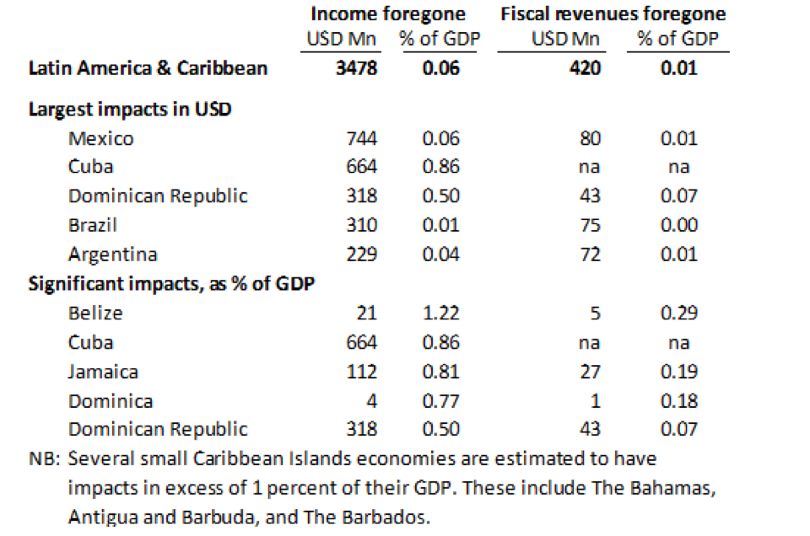

Figure1.2:World Bank (2016). The short-term economic costs of Zika in Latin America and the Caribbean (LCR).

Women in areas of the Americas with endemic Aedes mosquito populations are at risk for exposure to Zika virus, which can cause fetal brain abnormalities and associated congenital microcephaly. Individual health care providers may encounter health systems barriers to providing evidence-based care.Guidance for health care providers that do not acknowledge or address the health system constraints, challenges, and deficiencies in which they must operate will have a limited impact. Women across the globe, with or without Zika, need access to contraception to prevent unintended pregnancy, and providers require functioning health systems that offer the support to ensure access is a reality.
The provision of long-term care for affected children and families remains a substantial need of healthcare systems and community-based programs.According to Marrs et al. (2016), until all possible forms of transmission are known, universal precautions are required. Thus, current research suggests that the best way to prevent Zika virus infection is to avoid mosquito bites (Hennessey et al., 2016; Higgs, 2016; Oster et al., 2016). In the present study, pregnant women have adopted new customs in their everyday life to avoid potential Zika virus infection. Among the main precautions are: (1) Restriction from areas of risk, (2) Use of particular clothing and (3) Use of repellent.
The use of repellent may be sufficiently effective to protect against mosquito bites when pregnant women are exposed to open air (Hennessey et al., 2016; Higgs, 2016; Schuler-Faccini et al., 2016). Schuler-Faccini et al. (2016) and Marrs et al. (2016) added that clothes and accessories should be treated with permethrin. These habits seem to have been incorporated by some of the pregnant women.It is worth saying that the regular use of repellent according to the instructions on the label is recommended for pregnant women, in particular, but only certain brands are allowed, depending on the gestational period.
Zika has brought the issue into sharp focus and highlights weaknesses in health systems that make it difficult for women to access and use contraception if they want to delay births in the context of widespread Zika infection. Women have limited access to abortion services, so a serious focus on expanding access to contraception is essential. To implement CDC and WHO counseling guidance on Zika transmission, risks to the fetus, and pregnancy options including delaying pregnancy, governments and public health systems across Zika-affected areas in the Americas need to acknowledge and act on the clear links between mosquito-borne disease, poverty, access to health services overall, and comprehensive reproductive health services in particular. These issues are larger than Zika, but Zika has clarified the links. Women across the globe need real access to contraception to prevent unintended pregnancy, and individual providers require functioning health systems that offer the guidance, training, supplies, and other means to make sure access is a reality.
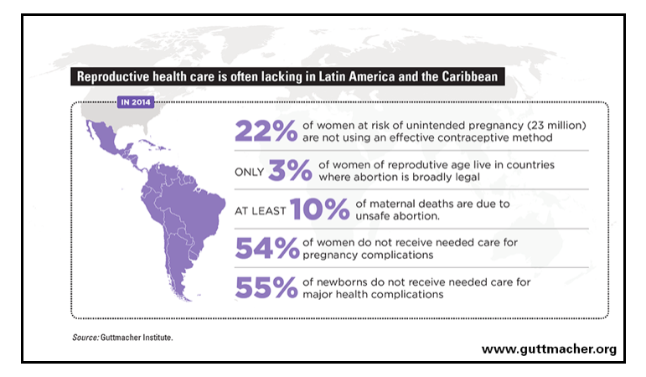

Figure1.3: The Reproductive healthcare lacking in Latin America and the Caribbean

4.Public health care and global healthcare perspectives associated with ZIKA.
The emergence of Zika shocked the world and created a burden on the health systems of affected countries. While there are major concerns related to differential diagnosis and the difficulties in managing ZIKA outbreaks, public health preparedness, robust health systems, and adherence to global norms will help to fight and prevent disease outbreaks.
In the past, it seemed that many people around the world believed that the ZIKA virus was newly discovered. Reports of Zika virus infection have never been featured in local news outlets, families would not sit around the dinner table worried about symptoms, and even health care professionals see it as a rare disease of academic importance only. There has been very little research on the Zika virus since its first discovery in 1947, and Zika virus infection is thought to be a mild and self-resolving disease, most of which are in Africa. The perspective has changed dramatically for a few years. What is rarely observed for more than half a century will have such devastating global impacts and will force the global health community to mobilize large amounts of time and resources. The disease would affect people from almost every continent and would see the tireless efforts of health workers from all over the world, from local and national health organizations to the World Health Organization.
Some ZIKA facts raise concerns about the disease. First of all, in most cases, a ZIKV infection is asymptomatic, which may go unnoticed and not straightforward. Second, several studies during the outbreak identified other possible mechanisms of transmission, such as sexual orientation, laboratory performances through blood transfusion products, or after monkey bites. This is especially effective if there is the intention of getting pregnant. Another fact that hinders case management is the differential diagnosis of dengue ZIKV, which is transmitted by the same mosquito and is often prevalent in most countries. A differential diagnosis is required to confirm ZIKV infection but is not available in low resource settings. The most important fact to consider is the possibility of transmission from infected tourists returning from ZIKA-endemic areas to non-endemic areas. Several imported ZIKA cases have been described in ZIKV-free countries and appropriate vector controls should be in place to reduce the risk of developing the disease. The warning signs for the Zika outbreak are raising concerns internationally. Therefore, public health workers should be vigorously monitored among humans and the carrier population, and adequate measures should be taken to control mosquitoes.
Recent studies from WHO has provided new information on the incidence, prevalence, and patterns of ZIKV transmission worldwide. For example, in Indonesia, a population-based retrospective zero survey found that approximately 9% of children had early evidence of ZIKV infection at age 5 years. In the Lao People's Republic, an assessment of samples from asymptomatic adult blood donors in 2015 found nearly 10% of evidence of previous ZIKV infection. Thailand demonstrated seasonal patterns of ZIKV transmission similar to the dengue virus, which is associated with 6 Indian mosquitoes, reported the 2018 outbreak of ZIKV in Rajasthan. New evidence indicates that the ZIKV strain found in the Americas has spread to Angola and is associated with Group microcephaly in 2017-2018 cases of malfunction Congenital Zika-related, microcephaly, and fetal death have been identified in various Asian countries. Globally, 61 countries and territories in six WHO regions have evidence of identifying capable Aedes aegypti vectors. (World Health Organization, 2019) However, the transmission of ZIKV has not been recorded, so there is a risk that ZIKA will spread to additional countries. Some of these countries may have or have had an undetected transmission, or report. All areas where the previous transmission of ZIKV transmission has the potential for re-emergence or re-introduction. (World Health Organization, 2019)

Conclusion & Discussion
When Zika disease carried by mosquitoes occurs, it affects almost the entire world, especially countries at risk, affecting the well-being of the people of the country, as well as the economy and the healthcare availability dealing with this epidemic. Zika affected the economy in short-term economic impacts. The World Bank estimated the loss from the Zika epidemic for 2016 in the Latin American and the Caribbean(LCR) at about billions and considers three main types of costs. First, the direct outlays and loss from death. The World Bank speculated that about a million people were infected with ZIKA in 2016. People in LCR will lose one week of paid jobs. Thirdly, the loss of tourists is the most common reason affected by the Zika. It can be concluded that the countries whose income depends on the number of tourists will be severely affected.
In healthcare availability, when Zika's first occurred, people had not been so concerned about a disease, so many reports about Zika had not been seen much since the outbreak in 1974, but as the number of infections continued to increase, the outcome was realized by the Long-term impacts on the health of children and their families. So, WHO and other organizations have issued a report on disease prevention measures that the best way to prevent Zika is to avoid mosquito bites, as well as countries at risk from this disease, various policies have been established to control the epidemic.
This epidemic brought in the government's awareness on public health. Since, zika virus is transmitted by Aedes mosquito, mosquito control is one of the important policies to prevent the virus. To tackle all life stages of the Aedes mosquito, egg, larva, and adult, by spraying or fogging where the mosquito lives, elimination of larva in standing water breeding sites. Mosquito control is more effective with personal protection from mosquito bites. Eventually, mosquito control is an important example of how the federal, state, and local governments share authority to respond to a public health threat.
A public health threat in the long-term for family and society. WHO provides care and support to individuals, families and communities affected by Zika and related complications. WHO also collaborates with more than 60 partners to share useful information among them and other countries to manage Zika’s complications, prevent, and control the virus.
Discuss on WHO responses and consider whether it is the most effective response compared to current technology.
Health Emergencies Programme is the new system which gathers the expertises and resources from the entire organization based at the World Health Organization (WHO) Headquarters. The global response to Zika virus is WHO will engage immediately with UN partners when there is an epidemic which provides monthly coordination meetings with the UN at the principal level for the system coordination and information sharing and holds the meeting with the partners of the Inter-Agency Standing Committee. Providing the effective public health respond needs to concern about human right and both men and women needs to have rights to be informed, have access to, safe, effective, affordable and acceptable methods of contraception without discrimination. Moreover, the effective health care should include safe abortion service, after abortion service, emergency contraception, and maternal healthcare. To access the recommendation of healthcare and prevention of the Zika virus faster and accurately, WHO is encouraging the researchers to publicize their study and experiment as soon as they can by WHO developed the key research question with technical research partners. For instance, in Tonga, the Ministry of Health and its partners sprayed in and around houses and handed out mosquito nets to pregnant women. In Singapore, the National Environmental Agency detected and destroyed about 130 mosquito breeding habitats to stop the cycle of transmission between mosquitoes and people. (Raman Velayudhan,WHO,2017). The reason why they adapt mosquito control exists at the state and local levels because Aedes mosquito is the carrier of ZIKA virus and it is the day-biting mosquito which may affect daily routine.

Recommendation
In our opinion, the responses from the World Health Organization (WHO) are still not completely effective compared to current technology. Since ZIKA has been firstly found for about 60 years ago with a large jump in medical technology and research. However, we still have only simple restrictions and protocols without any vaccine development since 2016. What the world and WHO should look at is not only how we can link the ZIKA real time updates but also need to put more focus on ZIKA’s vaccination. After the vaccine has been approved to use globally, we recommended to have a global policy for applying a vaccine by giving a vaccine to any women who planned to be pregnant at least one-month before having sex without any charged. The main reason for why we need to give the vaccine to this group of women without a charge is we need to reduce the number of ZIKV infants and increase health availability for women. Since Zika virus is an epidemic and the majority of people infected with Zika virus do not develop symptoms. Symptoms are generally mild and usually last for 2–7 days.(World Health Organization, 2018) For general public people who would like to apply a vaccine with an amount of charging they can apply at public health services.

Today Epidemiological Updates and Prevention and Control of ZIKA Virus
The update on prevention of Zika virus is there was the experiment of Zika virus vaccine in the guinea pigs in 2016. The vaccine results showed that in infected guinea pigs, the animals would have the immunity to prevent the virus for more than or equal to 2 months compared to the guinea pigs which did not receive the vaccine. However, the vaccine has not been tested in humans because the immunity which protects the body from Zika virus may cause a negative effect on people who have Dengue fever. Due to these two viruses being very similar to each other, the antibody of Zika virus can lead to more dangerous Dengue Fever.
The prevention and control of the Zika virus nowadays are only basic concepts: avoiding the place where there are lots of mosquitoes especially Aedes mosquito and the prevention of sexual transmission. Additionally, it is very important for the pregnant woman to protect herself from mosquito biting because it will be dangerous for the infants which leads to the congenital brain abnormalities. Therefore, the pregnant women should have the measures which protect them from the virus such as giving the repellent lotion and a treated mosquito net which they can use for sleeping during the day (World Health Organization, 2016)
On the other hand, prevention of sexual transmission is also important. The sexual transmission of Zika virus is more likely from men to women than women to men. Also, the 7sexual transmission is from the returning travellers from the areas ongoing Zika virus transmission. The suggestion are all women and men should be offered a full range of contraceptives and be counselled to be able to make an informed choice; moreover, the pregnant women and their sexual partners should use condoms correctly and consistently or abstain from sex for the whole duration of the pregnancy to prevent the Zika virus. Furthermore, all sexual partners are recommended to have safer sexual practices following the concept that promotes the reduction of sexual risk-taking behavior and preventing from the infection of Zika virus (World Health Organization, 2020).

REFERENCES
Attaran A., Caplan A., Gaffney C., Igel L. (2016). Open Letter to Dr. Mar-
garet Chan, Director-General, WHO http://www.rioolympicslater.org

Zumla A., McCloskey B., Bin Saeed A.A., Dar O., Al Otabi B., Perlmann S., et
al. (2016). What is the experience from previous mass gathering events?
Lessons for Zika virus and the Olympics 2016. Int J Infect Dis. 47, 1-4.

Estimating Contraceptive Needs and Increasing Access to Contraception in Response to the Zika Virus Disease Outbreak--Puerto Rico, 2016.Tepper NK, Goldberg HI, Bernal MI, Rivera B, Frey MT, Malave C, Renquist CM, Bracero NJ, Dominguez KL, Sanchez RE, Shapiro-Mendoza CK, Rodriguez BR, Simeone RM, Pesik NT, Barfield WD, Ko JY, Galang RR, Perez-Padilla J, Polen KN, Honein MA, Rasmussen SA, Jamieson DJ
MMWR Morb Mortal Wkly Rep. 2016 Apr 1; 65(12):311-4.

Marrs, C., Olson, G., Saade, G., Hankins, G., Wen, T., Patel, J., & Weaver, S. (2016). Zika virus and pregnancy: A review of the literature and clinical considerations. American Journal of Perinatology, 33, 625–639.

Dreweke J. Countering Zika Globally and in the United States: Women’s Right to Self-Determination Must Be Central. Guttmacher Policy Review. 2016;19:23–8.

Aiken ARA, Gomperts R, Trussell J, Worrell M, Aiken CE. Requests for Abortion in Latin America Related to Concern about Zika Virus Exposure. New England Journal of Medicine. 2016;375:368–98.

Hennessey, M., Fischer, M., & Staples, J. E. (2016). Zika virus spreads to new areas – Region of the Americas. Morbidity and Mortality Weekly Report, 65, 55–58.10.15585/mmwr.mm6503e1

Higgs, S. (2016). Zika virus: Emergence and emergency. Vector-Borne and Zoonotic Diseases, 16, 75–76.10.1089/vbz.2016.29001.hig

Schuler-Faccini, L., Ribeiro, E. M., Feitosa, I. M., Horovitz, D. D., Cavalcanti, D. P., Pessoa, A., … Sanseverino, M. T. (2016). Possible association between Zika virus infection and microcephaly – Brazil, 2015. Morbidity and Mortality Weekly Report, 65, 59–62.10.15585/mmwr.mm6503e2
World Health Organization. (2016). ZIKA Strategic Research Plan Quarterly Update. Retrieved October 25, 2016, from https://apps.who.int/iris/rest/bitstreams/1063449/retrieve

World Health Organization. (2020). WHO guidelines for the prevention of sexual transmission of Zika virus. Retrieved June 15, 2020, from https://apps.who.int/iris/rest/bitstreams/1282517/retrieve

World Health Organization. (2016). Vector control operation framework for Zika virus. Retrieved May 29, 2016, from https://apps.who.int/iris/rest/bitstreams/920354/retrieve

Amjad Ali, Braira Wahid, Shazia Rafique, Muhammad Idrees. (2017). Advances in research in Zika virus. Asian Pacific Journal of Tropical Medicine 2017; 10(4): 321-331
Nathalie Broutet, M.D., Ph.D., Fabienne Krauer, M.Sc., Maurane Riesen, M.Sc., Asheena Khalakdina, Ph.D., Maria Almiron, M.Sc., Sylvain Aldighieri, M.D., Marcos Espinal, M.D., Nicola Low, M.D., and Christopher Dye, D.Phil. (2016). Zika Virus as a Cause of Neurologic Disorder. N Engl Med 2016- 374:1506-1509.

World Economic Forum. (2017). Zika has been in Sfica since the 1940s, so why do we know so little about it?. Retrieved July 12, 2017, from
https://www.weforum.org/agenda/2017/07/understanding-zika-s-silent-presence-in-africa-is-key-to-tackling-the-next-epidemic/

World Health Organization. (2016). Zika Virus Research Agenda. Retrieved October, 2016, from https://apps.who.int/iris/bitstream/10665/250615/1/WHO-ZIKV-PHR-16.1-eng.pdf?ua=1

Florencia Luna. (2017). Public health agencies’ obligations and the case of Zika. Retrieved September 13, 2017, from Wiley Online Library: https://onlinelibrary.wiley.com/doi/full/10.1111/bioe.12388

Anne Wilson, PhD, MN, BN, RN, RM, FACN and Thi Ngoc Minh Nguyen, RN, BN, MNSc. (2017). The Zika Virus Epidemic: Public Health Roles for Nurses. Retrieved January 1, 2017, from OJIN the online journal of issues in nursing: http://ojin.nursingworld.org/MainMenuCategories/ANAMarketplace/ANAPeriodicals/OJIN/TableofContents/Vol-22-2017/No1-Jan-2017/The-Zika-Virus-Epidemic.html

World Health Organization. (2019). Zika Epidemiology Update. Retrieved July, 2019, from https://www.who.int/emergencies/diseases/zika/zika-epidemiology-update-july-2019.pdf?ua=1

World Health Organization. Countries and territories with current or previous Zika virus transmission. Updated July 2019. Accessible at: https://www.who.int/emergencies/diseases/zika/countries-with-zika-and-vectors-table.pdf

Scott C., Federico C., Mariano A., Albert I., Guilherme S., George S., Pei-Yong S., Nikos V. (2016). Zika Virus: History, Emergence, Biology, and Prospects for Control. 2016 Jun; 130: 69–80.

Mark R., Tai-Ho Chen., W. Thane Hancock., Ann M., Jacob L., Robert S., Moses P., Maria M., Stacey H., Christine D., Laurent G., Anne G., et al. (2009). Zika Virus Outbreak on Yap Island, Federated States of Micronesia. 2009; 360:2536-2543

Dawn P., Matthew P. Public health report. Legal Authority for Mosquito Control and Pesticide Use in the United States. [Online] 2016. Available from: https://journals.sagepub.com/doi/10.1177/0033354917704628

Centers for Disease Control and Prevention, (2016). Integrated Mosquito Management for Aedes aegypti and Aedes albopictus mosquitoes. Retrieved August 13, 2019, from https://www.cdc.gov/zika/vector/integrated_mosquito_management.html

Jonathan J., Jennifer G.,Amber M., Estefania F., Omar H., Charise G., Michelle N., Robyn S., Kevin K., Indira U., Michael S. (2016). Cell. Zika Virus Infection during Pregnancy in Mice Causes Placental Damage and Fetal Demise. Volume 165, Issue 5, 19 May 2016, Pages 1081-1091

Paulo C., Rafael d., Martha C., Marcos N., et al. (2020). Zika epidemic and microcephaly in Brazil: Challenges for access to health care and promotion in three epidemic areas. 2020; 15(7): e0235010.

World Health Organization.(2018). Zika virus fact sheets.Updated July 2018. Accessible at:
https://www.who.int/en/news-room/fact-sheets/detail/zika-virus

Susan L Hills, Marc Fischer, Lyle R Petersen (2017). Epidemiology of Zika Virus Infection. Retrieved 16 December, 2016, from The Journal of Infectious Diseases: https://www.ncbi.nlm.nih.gov/pmc/articles/PMC5853392/

