FN221/281 Group Assignment 1
1) Research current economic conditions (interest rates, inflation) using The Wall Street Journal, other library resources, or the World Wide Web. Based on current economic conditions, what actions would you recommend to people who are saving and borrowing money?
Thailand is dubbed a 'Developing Country' therefore the moniker of a 'land of opportunity' comes with such a term with alleged fortunes to be made. According to Thailand 5 years historical economic trend 2011-2016, Thailand GDP consecutively decreasing since 2013 and lowest in the first half of 2014 by -0.5 million USD. However, on the second half of 2014, Thailand GDP was slightly increasing and continuously growing with small fluctuation on following years until this year 2016.
The fluctuation of GDP and Thai’s current economy came from many factors including political conflict which take huge part on perspective of both domestic investors and foreign investors see our economy. The global economic stumbled in 2015, falling aggregate demand and consumer price of commodity result in downside risk growth rate all over the world. The main risk to growth is the slowdown in China, which poses the potential impact, varies greatly. The stagnant could also lead to demand shock later among Malaysia Singapore and Thailand hardest. Economic growth declined further in the terminal quarter of 2015 as demand from China continually falling and the region’s overall economic condition remains soft.
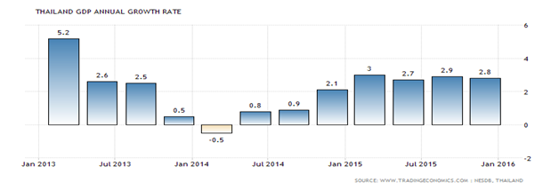
In addition, other potential threats suffer from interest rate rises in the United States, which mean slowing in productivity growth across much of Emerge Asia (the ten ASEAN members plus China and India) since the global financial crisis. Average global inflation proceeded to decline persistently, and projected to fall to 2.6 percent which is the lowest level since 2009.
On the other hand, if we take a look up on historical Thailand balance of trade. Balance of Trade determine different between the value of exports and imports of the country. Thailand is highly exposed to external economic shocks, which lower demand for Thai products, thus affecting the trade balance. Thailand major exports are electronics, vehicles, machinery and equipment. The country mainly imports fuel, electrical and machinery appliances. Main trading partner are Japan (10 percent of total exports and 20 percent of total imports) and China (12 percent of total exports and 15 percent of total imports). Others include: the European Union, the United States and Malaysia. Thailand 5 years historical trend of BOT was mostly deficit mean we imports more than we exports except the last 2 years 2014 to beginning of 2016, Thailand has managed to stimulate, promote and help exports sector to exports more on domestic products which lead to BOT surplus as it show in the illustration.
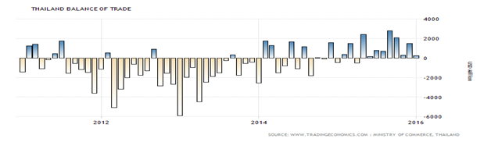
Thailand’s economy was changed after undertaken by military coup in 2014, Thai government stimulus budget spending by accelerating in an effort for farmers and businesses.
As a result, the economic benefit from an accommodative monetary policy, sadly, just a short period. Meanwhile, there is uncertainty and suspect among people regarding to the government control in economy and constitution system.
Thailand also suffers from a weak global demand, merchandise exports covenanted due to the slowdown in Chinese and ASEAN economies as well as a decrease in Thai’s export product including slumps in global oil prices. As a result, inflation remained negative due to mainly the decline in energy price following the unemployment rate slightly declined due to an improvement in non-farm employment such as service sectors.
Overall economic activity gradually recovers and improves to accelerated public spending, private consumption and the tourism sector after the bombing incident in Bangkok.
In addition to headline inflation became more positive as the high-base effect of oil prices preceding reduce. However, those were weighed down if we compare to the unemployment rate remained at a low level as well as the value of export price drops significantly as well as a decline in aggregate domestic quantity due to the economic slowdown in China and ASEAN countries.
Policy Interest Rate (1-day repurchase) at 1.50%
Headline Inflation (an annual average) at 2.5 +/- 1.5%
Last Inflation: January 2016
Core 0.59
Headline -0.53
GDP Growth 2014 at 0.9, 2015 at 2.8, 2016 at 3.5

According to low 1-day repo rate nowadays, It’s hard to suggest that invest your money in profitable type of deposit (other deposit which not include demand deposit) is a good idea.
Also for debt security such as repo or government bond, since 1-day repo rate is very low. It is decreasing from 3.5% in 2011 to 1.5% nowadays. Therefore, deposit and debt security are not preferable investment right now.
The other type of investment which is not related with interest rate for example stock or derivative such as gold future might look more interesting to invest. However, due to bad situation of world economic from slowdown in China. It will unconditionally affect Thai economic growth. Many companies will suffer from this situation and value of their stock might go down especially export sector. China and other country economic slowdown will decrease demand for import Thai product. Therefore, our exporter can export less and price of export go down. This make export become not interesting sector to invest. However the unemployment rate slightly declined due to an improvement in non-farm employment such as service sectors. So invest your money in domestic service sector might be good choice of investment today.
In other hand, lower interests refer to lower cost of borrowing. Both individual and Business firm need to pay lower interest than it used to be. Moreover, interest rate in the United States is rising make domestic borrowing become more attractive than borrowing from abroad. Our groups recommend borrowing money today. So you can paid less interest rate. However, due to bad economic situation your project might not be successful as you thought. So you need to make sure that you can generate enough income to pay back loan or other type of borrowing or it might be the job of creditor to lend the money to good credit borrower or it will lead to bad debt problem. Many borrowers will not have enough money to pay back the debt.
In conclusion, you can still saving and borrowing. Although Thailand is facing downside economic situations. Our group recommend you to just carefully about your borrowing and saving. You should put your saving in the right investment for situation and spend you money from borrowing carefully to make sure that you can pay back your debt in time. If you follow this suggestion you will not have problem with saving and borrowing in this bad economic situation. Moreover, you gain benefit from this bad situation.

2) Collect advertisements and promotional information from several financial institutions, or locate the Websites of financial institutions. Create a list of factors that a person might consider when comparing costs and benefits of various savings plans.
2.1) The Government Housing Bank
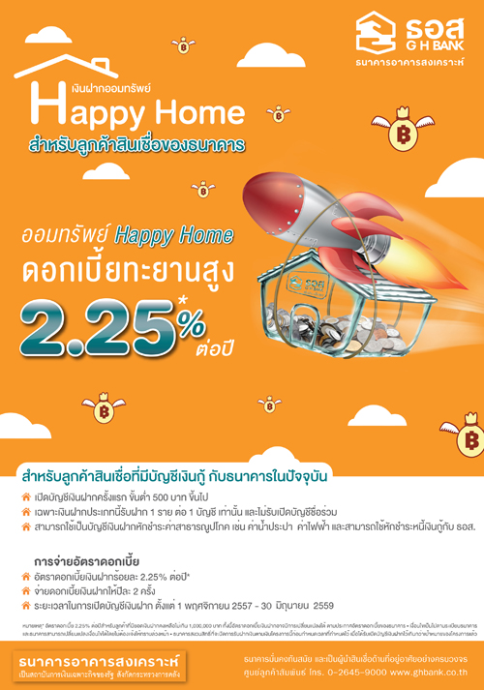
More information: http://www.checkraka.com/news/saving/1503233/
http://www.checkraka.com/price/saving-account-2-220/%E0%B8%98%E0%B8%99%E0%B8%B2%E0%B8%84%E0%B8%B2%E0%B8%A3%E0%B8%AD%E0%B8%B2%E0%B8%84%E0%B8%B2%E0%B8%A3%E0%B8%AA%E0%B8%87%E0%B9%80%E0%B8%84%E0%B8%A3%E0%B8%B2%E0%B8%B0%E0%B8%AB%E0%B9%8C-GHB-%E0%B8%9A%E0%B8%B1%E0%B8%8D%E0%B8%8A%E0%B8%B5%E0%B9%80%E0%B8%87%E0%B8%B4%E0%B8%99%E0%B8%9D%E0%B8%B2%E0%B8%81%E0%B8%AD%E0%B8%AD%E0%B8%A1%E0%B8%97%E0%B8%A3%E0%B8%B1%E0%B8%9E%E0%B8%A2%E0%B9%8C-Happy-Home-1443192/
Factors need to concern and benefit
- The remaining amount in the deposit account should be less than one million baht corresponding with 2.25 % interest rate per year.
- Considering more than one million baht remaining in the account will receive interest rate less than 2.25 %, which the depositors will get 0.75% per year instead.
- The bank paid interest rate twice a year but they do not inform specific date.
- Even the higher interest rate compared to other banks, interest rate could be changed at any time according to the bank’s condition.
- The benefit of deposit money in this promotion can be used to disburse bills from Baac automatically.
- Minimum of initial deposit amount is 500 baht.
- The Government Housing Bank has less branches compared to others and it might have to concern that when this promotion is offered, the depositors have to reserve the right in a specific branch and deposit the money in another branch. And it might not be convenient to go to another branch while you have one that is near to your home. Therefore, it is not convenient for depositors.
- The withdrawal conditions informed that the depositor could withdraw the money any moment and he/she will get interest rate as the time they withdraw.
- The depositors do not have to deposit money every month.
2.2) Muang Thai Life Assurance
More information: https://www.muangthai.co.th:1767/product/detail/HighSpeed4G
Factors need to concern and benefit
- A person who is interesting in this insurance has to consider the insurance precisely about conditions which are not included in the insurance such as congenital diseases, suicide, accident from plastic surgery etc.
- The person will get benefit when receiving the treatment from the hospitals that insurance company has agreement with so, there will charge no fee during the treatment but a person need to have a Health Care Card or Easy PA Credit card every time
- The company offer options to pay premium annually, monthly, quarterly depending on our decision and the premium payment period is 20 years
- This type of insurance could be used to deduct from the personal income tax
- This type of insurance must be considered by the insurance company itself that not everyone could apply
- Have to concern the financial status of the company
- Have to concern your income compare to the premium you paid
- Normally, the buying insurance is same as buying fund. At the end of the period, there will be dividend or some amount of money that you will receive, but sometimes there is no dividend at all. However, this insurance is not informed about this conditions, therefore a person need to find more information before applying for this
2.3) TMB Bank

More information: https://www.tmbbank.com/accounts/savings/tmb-no-fixed-account.html, https://www.tmbbank.com/newsroom/tvc/view/alex-no-fixed.html
Factors need to concern and benefit
- The return on saving is at 2%. Take into account that this is not a time deposit, the return is considered to be pretty high relatively to other banks. However, this 2% consists of normal rate of 1.5% and bonus rate of 0.5%. Should the depositors withdraw the money making current account balance less than previous month, they will not receive the bonus rate of 0.5%.
- No minimum deposit requirement. Depositors could deposit any amount and also no extra charge when the account balance becomes zero.
- The interest is computed on daily basis and depositors will receive interest payment twice a year on June and December.
- No tax on interest received less than 20,000 baht.
- Any transactions should be made at the bank only but transactions between TMB bank accounts could be done through internet banking free of charge. This means that depositors will not be able to use ATM machine or pay bills. In addition, TMB has less than 250 branches in Bangkok alone. This could be very inconvenient to go to the bank every time depositors want to do any transactions.
- Free transaction cost for the first two times per month. Transactions make later will be charged at 50 baht per time, which is a bit expensive. This is appropriated to depositors who wouldn’t withdraw much.
- Current financial status of TMB is stable.

2.4) Kasikorn Bank
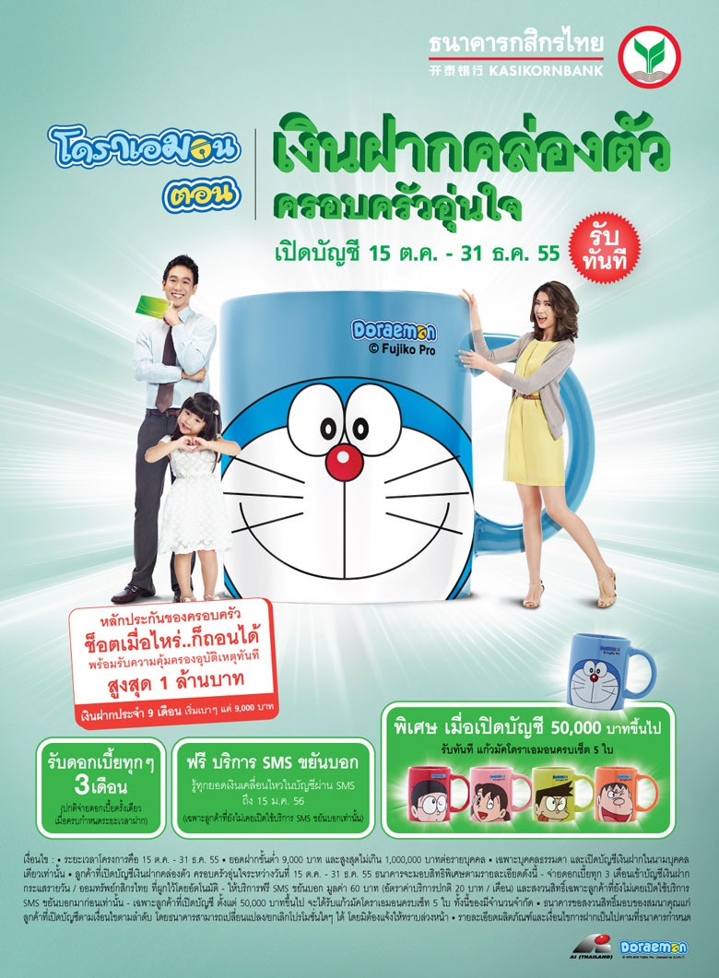
More information: http://www.kasikornbank.com/TH/Personal/BankAccounts/Fixed/Pages/ReadyToUseTimeDeposit.aspx
Factors need to concern and benefit
- Deposit must be between 9,000 Baht and 1,000,000 Baht per depositor
- Age limitation from 16-70 years old. If the depositor ages more than 70 years the insurance will be expired.
- The promotion is about providing both saving and insurance. It is distinguished from other financial institutions that it gives the 24-hour accident coverage worldwide. Including protection against loss of life, total permanent disability, motorcycle-related accident and against murder or intended physical assaults
- Coverage limit: 2 times your remaining balance in the Flexible Fixed Deposit plus Family Protection account and not - in excess of 1,000,000 Baht per depositor.
- Accident insurance coverage equals to 2 times your remaining balance in the Flexible Fixed Deposit plus Family Protection account and up to 1,000,000 Baht per depositor.
- An interest rate of 3-month fixed deposit (at the minimum deposit for individuals) for deposits of less than 3 months
- An interest rate of 6-month fixed deposit (at the minimum deposit for individuals) for deposits of 3 months but less than 6 months
- An interest rate of 6-month fixed deposit (at the minimum deposit for individuals) + 0.25 percent, p.a. for deposits of 6-months but not reach the maturity date
- Only one individual per account is allowed
- The Bank reserves the right not to provide the accident insurance coverage if the remaining balance in the Ready-to-use Time Deposit account is less than 9,000 Baht per depositor one day prior to the account owner’s death or accident under the terms and conditions related to the personal accident coverage of this service.
2.5) Kiatnakin Bank

For more information: http://www.kiatnakin.co.th/promotion-detail.php?id=36
Factor need to be concern and benefit
- Individual aged more than 55 years old
- Deposit must be between 5,000-1,000,000 Baht per depositor and it has 2 options which are 12 months or 24 months
- Interest rate pays monthly
- Depositors must have Kiatnakin current account or saving account to get the interest rate.
- If the depositors require to withdraw, they have to withdraw all of the amount and the bank will not pay interest. If the depositors get interest and then they withdraw, the bank will charge those interest amount.
- An interest rate for 12-month is 2.05% per year and for 24-month is 2.15% per year.
- The interest rate is lower than fixed deposit but depositors can get interest rate per month so they can have liquidity.
2.6) CIMB Thai Bank

More information: http://www.cimbthai.com/CIMB/personal/product/deposit/senior_fixed_deposit/
Factors need to concern and benefit
- A fixed deposit account requires depositors to deposit equal or more amount of money at certain time period. Depositors need to have stable earnings to be able to enter such commitment and will not be able to withdraw in the term of deposit.
- Suitable for people reaching retirements or already retired and have money from pension or savings to earn monthly tax-free high interest for daily spending.
- Term of deposit of 1 year or 12 months.
- The interest is constant or fixed at 2.15% throughout the term of deposits. Interest payments are made monthly or upon maturity. For monthly payments, depositors would need to have CIMB account.
- Tax from interest received is only exempt if the amount does not exceed 30,000 baht within the same fiscal year. The exceeding amount will be deducted by 15%.
- No need to deposit every month. Depositors don’t have to concern much about making deposits monthly.
- Depositors need to be 55 years old or older at the time of opening an account.
- Minimum initial deposit of 10,000 baht, which is quite low that most retiring people would already had, and maximum of 1,000,000 baht.
- In case of emergency or that depositors would like to withdraw money, depositors will not receive any interest payment for less than three months old account.
- CIMB has stable financial status and is one of the financial institutions where depositors are protected.

Reference
http://www.forbes.com/sites/brucemccain/2016/01/03/five-key-economic-trends-to-watch-in-2016/#144e6625f177
http://www.focus-economics.com/countries/thailand
http://www.tradingeconomics.com/thailand/balance-of-trade
http://www.cimbthai.com/CIMB/personal/product/deposit/senior_fixed_deposit/
http://www.kiatnakin.co.th/promotion-detail.php?id=36
http://www.kasikornbank.com/TH/Personal/BankAccounts/Fixed/Pages/ReadyToUseTimeDeposit.aspx
http://www.checkraka.com/news/saving/1503233/

Group Member
- Ornpreeya Manovilas 5504640912
- Peerada Kusalangkulwat 5604641076
- Pongsakorn Taksintaveesup 5604641281
- Pornpan Panyavetchawat 5604641299
- Sirabhumi Sirirangsi 5604641547
- Paksiri Supasiri 5704641447

