บช. 201 การบัญชีชั้นต้น
แบบฝึกหัด บทที่ 12
ผศ. ดร. อรพรรณ ยลระบิล

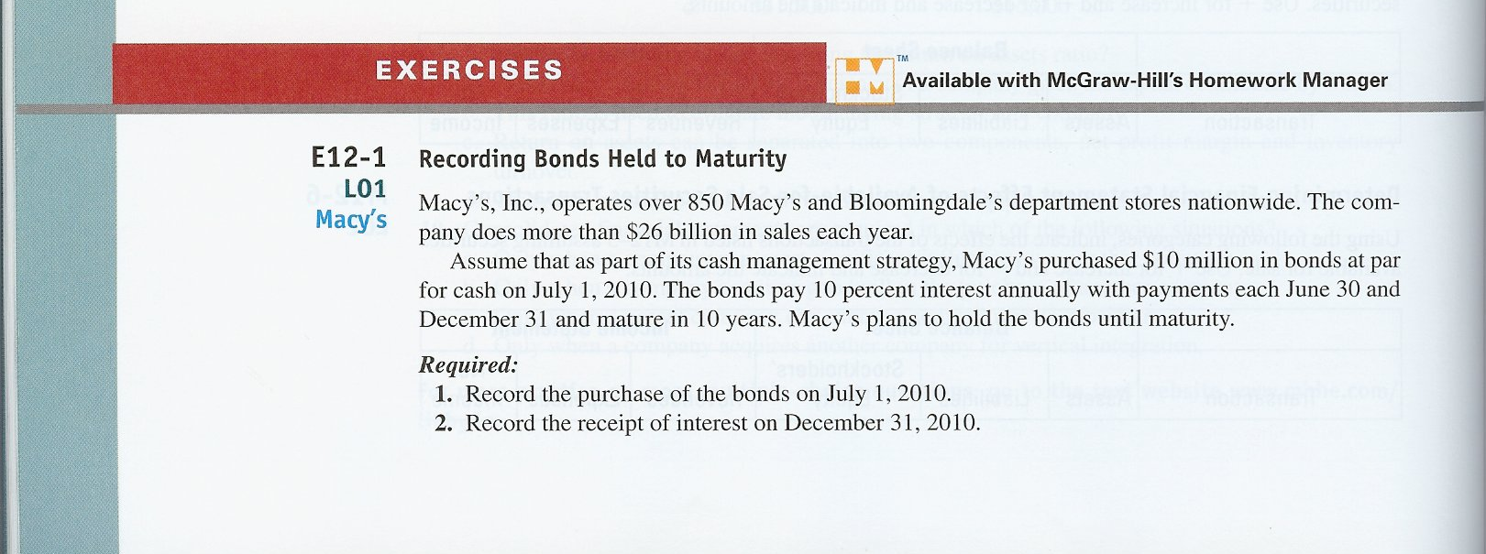
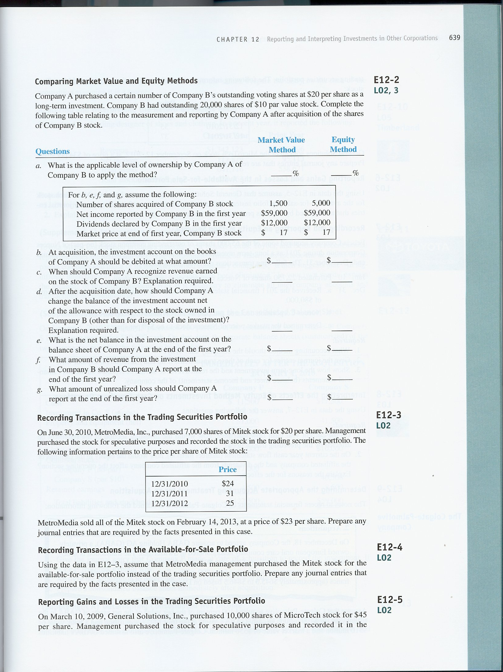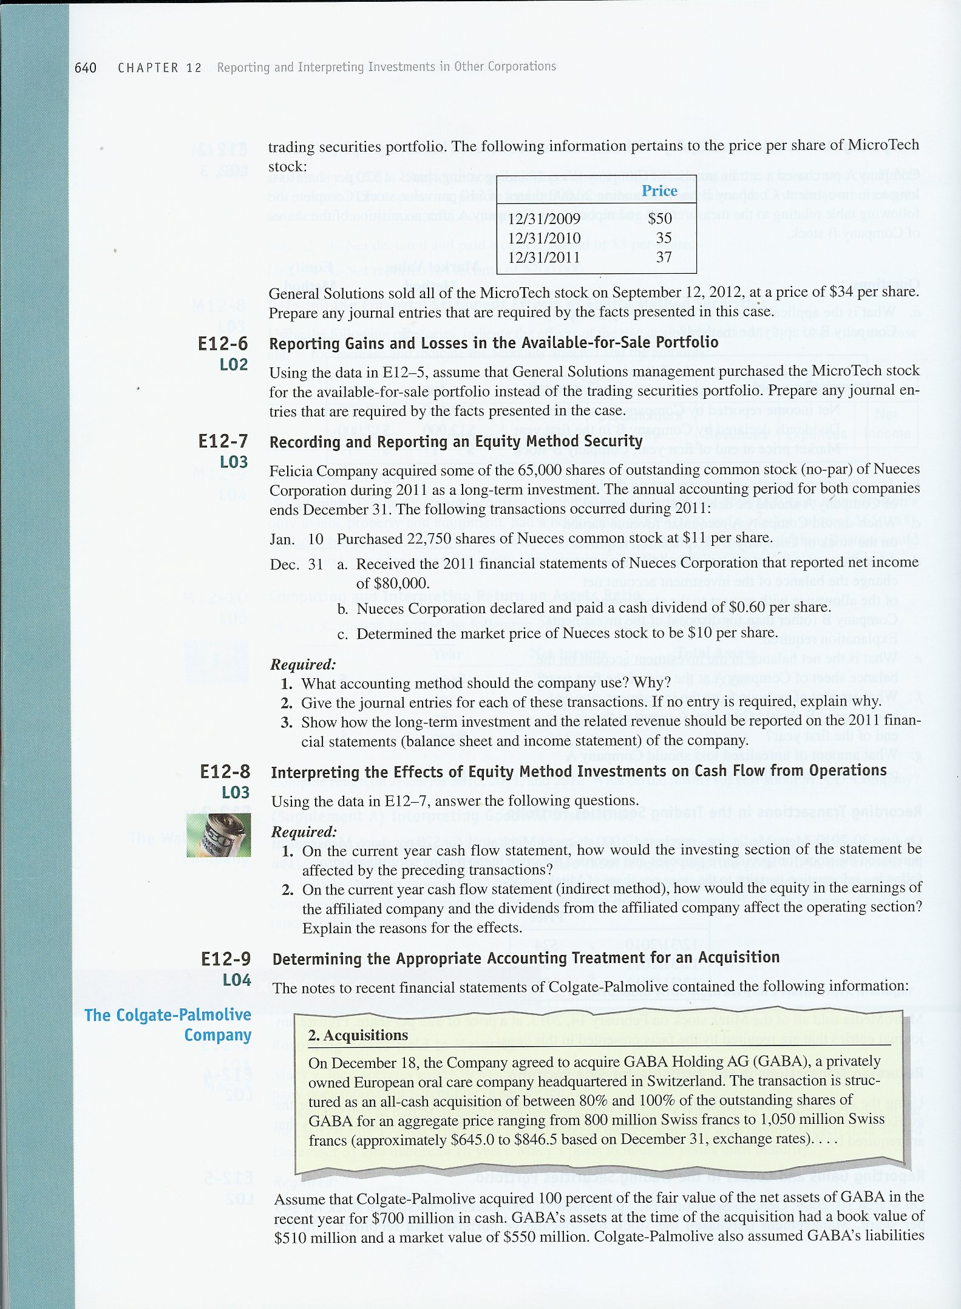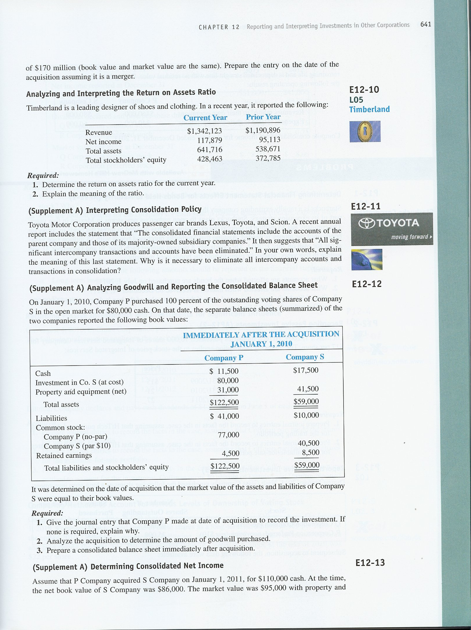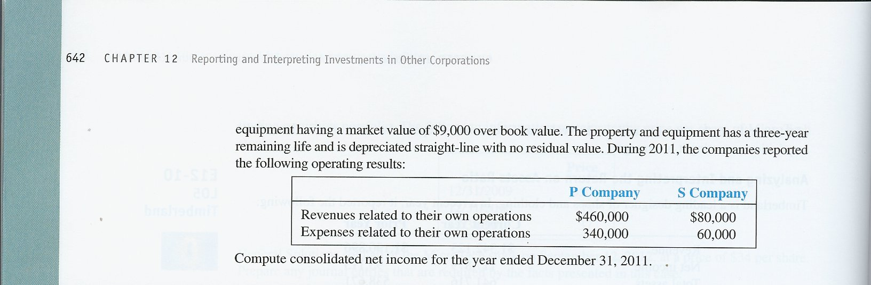

EXERCISES

E12–1.
Req. 1
July 1, 2010:
Investment in bonds (+A) | 10,000,000
Cash (–A) |  |  | 10,000,000

Req. 2
Dec 31, 2010:
Cash (+A) | 500,000
Interest revenue (+R, +SE) |  |  | 500,000
($10 million x 10% x 6/12 of a year)

E12–2.
Questions | Method of Measurement
 | Market Value Method | Equity Method
a | Less than 20%. | At least 20% but not more than 50%.
b | At cost: 1,500 shares x $20 = $30,000. | At cost: 5,000 shares x $20 = $100,000.
c | When Co. B declares a cash dividend; not for any holding gains and losses on securities-available-for-sale. | When Co. B reports income or loss for the period; not when dividends are declared or paid.
d | Record increases and decreases based on stock price changes through the valuation allowance. | Increase the investment account for proportionate part of income, less proportionate part of dividends and losses of Co. B.
e | 1,500 shares x $17 = $25,500  market value. | Cost of $100,000 plus $14,750 ($59,000 x 25%) equity in investee’s earnings minus $3,000 ($12,000 x 25%) dividends received equals $111,750.
f | Company A owns 7.5% of Company B (1,500 shares ÷ 20,000 shares outstanding). $12,000 dividends declared x 7.5% = $900 dividend revenue for Company A. | $59,000 Company B net income x 25% = $14,750 equity in earnings of investee.
g | 1,500 x ($20 – $17) = $4,500 reported in stockholders’ equity. | None.
E12–3.
June 30, 2010:
Investment in TS (+A) | 140,000
Cash (–A) |  |  | 140,000
(7,000 shares x $20 per share)
Dec 31, 2010:
Allowance to value at market – TS (+A) | 28,000
Net unrealized loss/gain – TS (+Gain, +SE) |  |  | 28,000
Dec. 31, 2011:
Allowance to value at market – TS (+A). | 49,000
Net unrealized loss/gain – TS (+Gain, +SE) |  |  | 49,000
Dec. 31, 2012:
Net unrealized loss/gain – TS (+Loss, –SE) | 42,000
Allowance to value at market – TS (–A) |  |  | 42,000

Computations:
Year Market − Cost = Allowance Balance − Unadjusted Balance = Adjustment
2010 $168,000 $140,000 +$28,000 $0 +$28,000
2011 217,000 140,000 + 77,000 + 28,000 + 49,000
2012 175,000 140,000 + 35,000 + 77,000 − 42,000

Feb. 14, 2013:
Cash (+A) (7,000 shares x $23) | 161,000
Loss on sale of investment (+Loss, –SE) | 14,000
Investment in TS (–A). |  |  | 140,000
Allowance to value at market – TS (–A) |  |  | 35,000

Note: The net unrealized loss/gain is an income statement account. This item is reported on the current income statement and affects the computation of net income. It is closed to Retained Earnings at the end of each year.

E12–4.
June 30, 2010:
Investment in SAS (+A) | 140,000
Cash (–A) |  |  | 140,000
Dec. 31, 2010:
Allowance to value at market – SAS (+A).. | 28,000
Net unrealized loss/gain – SAS (+SE) |  |  | 28,000
Dec. 31, 2011:
Allowance to value at market – SAS (+A). | 49,000
Net unrealized loss/gain – SAS (+SE) |  |  | 49,000
Dec. 31, 2012:
Net unrealized loss/gain – SAS (–SE) | 42,000
Allowance to value at market – SAS (–A). |  |  | 42,000

Computations:
Year Market − Cost = Allowance Balance − Unadjusted Balance = Adjustment
2010 $168,000 $140,000 +$28,000 $0 +$28,000
2011 217,000 140,000 + 77,000 + 28,000 + 49,000
2012 175,000 140,000 + 35,000 + 77,000 − 42,000

Feb. 14, 2013:
Cash (+A) (7,000 shares x $23). | 161,000
Net unrealized loss/gain – SAS (–SE) | 14,000
Allowance to value at market – SAS (–A). |  |  | 14,000
Investment in SAS (–A). |  |  | 140,000
Gain on sale of investment (+Gain, +SE) |  |  | 21,000
Note: The net unrealized loss/gain account is a balance sheet account. It does not affect the computation of net income each year. Because it is a balance sheet account, it maintains its balance from year to year. Therefore, the decline in stock price that occurs in 2012 is reported as an adjustment to the net unrealized loss/gain account. When the stock is sold in 2013, the net unrealized loss/gain is closed along with the Allowance to Value at Market account, and the difference between the purchase price (original cost) and the selling price is reported as a gain on the income statement.
E12–5.
March 10, 2009:
Investment in TS (+A) | 450,000
Cash (–A) |  |  | 450,000
(10,000 shares x $45 per share)
Dec. 31, 2009:
Allowance to value at market – TS (+A) | 50,000
Net unrealized loss/gain – TS (+Gain, +SE) |  |  | 50,000
Dec. 31, 2010:
Net unrealized loss/gain – TS (+Loss, –SE) | 150,000
Allowance to value at market – TS (–A) |  |  | 150,000
Dec. 31, 2011:
Allowance to value at market – TS (+A) | 20,000
Net unrealized loss/gain – TS (+Gain, +SE) |  |  | 20,000

Computations:
Year Market − Cost = Allowance Balance − Unadjusted Balance = Adjustment
2009 $500,000 $450,000 +$50,000 $0 +$50,000
2010 350,000 450,000 −100,000 + 50,000 − 150,000
2011 370,000 450,000 − 80,000 −100,000 + 20,000

Sept. 12, 2012:
Cash (+A) (10,000 shares x $34) | 340,000
Allowance to value at market – TS (+A) | 80,000
Loss on sale of investment (+Loss, –SE) | 30,000
Investment in TS (–A) |  |  | 450,000
Note: The net unrealized loss/gain is an income statement account. This item is reported on the current income statement and affects the computation of net income. It is closed to Retained Earnings at the end of each year.

E12–6.
March 10, 2009:
Investment in SAS (+A) | 450,000
Cash (–A) |  |  | 450,000
Dec. 31, 2009:
Allowance to value at market – SAS (+A) | 50,000
Net unrealized loss/gain – SAS (+SE) |  |  | 50,000
Dec. 31, 2010:
Net unrealized loss/gain – SAS (–SE) | 150,000
Allowance to value at market – SAS (–A) |  |  | 150,000
Dec. 31, 2011:
Allowance to value at market – SAS (+A) | 20,000
Net unrealized loss/gain – SAS (+SE) |  |  | 20,000

Computations:
Year Market − Cost = Allowance Balance − Unadjusted Balance = Adjustment
2009 $500,000 $450,000 +$50,000 $0 +$50,000
2010 350,000 450,000 −100,000 + 50,000 −150,000
2011 370,000 450,000 − 80,000 −100,000 + 20,000

Sept. 12, 2012:
Cash (+A) (10,000 shares x $34) | 340,000
Allowance to value at market – SAS (+A) | 80,000
Loss on sale of securities (+Loss, –SE) | 110,000
Investment in SAS (–A) |  |  | 450,000
Net unrealized loss/gain – SAS (+SE) |  |  | 80,000
Note: The unrealized loss/gain account is a balance sheet account. It does not affect the computation of net income each year. Because it is a balance sheet account, it maintains its balance from year to year. Therefore, the decline in stock price that occurs in 2010 is reported as an adjustment to the net unrealized loss/gain account and the increase in stock price that occurs in 2011 is also reported as an adjustment to the net unrealized loss/gain account. When the stock is sold in 2012, the net unrealized loss/gain is closed along with the Allowance to Value at Market account, and the difference between the purchase price and the selling price is reported as a loss on the income statement.
E12–7.
Req. 1
The equity method must be used because the company owns 35% (22,750 ÷ 65,000) of the total shares outstanding of Nueces Corporation. The equity method must be used when there is at least 20% but not more than 50% ownership in existence. The Felicia Company must use the equity method because it can exercise significant influence, but not control, over the operating and financing policies of Nueces Corporation.

Req. 2
January 10, 2011:
Investment in affiliated companies (+A) | 250,250
Cash (–A) |  |  | 250,250
(22,750 shares x $11 per share) -- 35% of the voting common stock
December 31, 2011:
Investment in affiliated companies (+A). | 28,000
Equity in investee earnings (+R, +SE) |  |  | 28,000
($80,000 x 35% = $28,000)
December 31, 2011:
Cash (+A) | 13,650
Investment in affiliated companies (–A). |  |  | 13,650
(22,750 shares x $.60 = $13,650)
No entry is made under the equity method to record changes in market value.

Req. 3
Balance Sheet—At December 31, 2011
Long-term Investments:
Investment in affiliated companies (equity basis*) | $264,600
Income Statement—For the Year Ended December 31, 2011
Equity in investee earnings | $ 28,000

* Investment in Affiliated Companies
Cost 250,250
% Investee’s net income 28,000 | 13,650 % Investee’s dividends declared
264,600

E12–8.
Req. 1 Investing activities
Purchase of investments in affiliated companies –250,250

Req. 2 Operating activities
Net Income
Adjusted for:
Equity in earnings of affiliated companies –28,000
(no cash received)
Dividends received from affiliated companies +13,650
(cash received)

E12–9.
(in millions)
Assets (+A, not detailed). | 550
Goodwill (+A) | 320
Liabilities (+L, not detailed) |  |  | 170
Cash (–A) |  |  | 700

E12–10.
Req. 1
Return on Assets = Net Income
Average Total Assets

$117,879 = .20 (20%)
($538,671 + $641,716) ÷ 2
Req. 2
ROA measures how much the firm earned for each dollar of investment. It is the broadest measure of profitability and management effectiveness, independent of financing strategy.

E12–11.
Consolidation is an accounting process that brings together financial information from two or more companies to make it appear as if there is a single economic entity. These companies may have engaged in transactions with each other during the year (these transactions are called intercompany transactions). Some examples are lending money or selling merchandise. During consolidation, intercompany transactions are eliminated or reversed so that on the consolidated statements, it appears as if the transactions never took place.
It is necessary to eliminate intercompany transactions because a single economic entity cannot logically do business with itself. It makes no sense, for example, to report as a liability an amount that an entity owes itself.

E12–12.
Req. 1
Investment in Co. S (100%) (+A) | 80,000
Cash (–A) |  |  | 80,000

Req. 2
Purchase price for 100% interest in Co. S | $80,000
Market value of Company S net assets purchased equaled book value ($59,000 – $10,000) | 49,000
Goodwill purchased | $31,000

Req. 3

COMPANY P AND ITS SUBSIDIARY, COMPANY S (100% OWNED)
Consolidated Balance Sheet
January 1, 2010 (immediately after acquisition)
 | Separate Balance Sheets
 | Company P |  |  | Company S |  |  | Eliminations |  |  |  |  | Consolidated  Balance Sheet
Assets:
Cash |  | $ 11,500 |  |  | $17,500 |  |  |  |  |  |  |  | $ 29,000
Investment in Co. S (at cost) |  | 80,000 |  |  |  |  |  |  | – | 80,000
Property and equipment (net) |  | 31,000 |  |  | 41,500 |  |  |  |  |  |  |  | 72,500
Goodwill |  |  |  |  |  |  |  |  | + | 31,000 |  |  | 31,000
Totals |  | $122,500 |  |  | $59,000 |  |  |  |  |  |  |  | $132,500
Liabilities:
Liabilities |  | $ 41,000 |  |  | $10,000 |  |  |  |  |  |  |  | $ 51,000
Stockholders’ Equity:
Common stock, Co. P |  | 77,000 |  |  |  |  |  |  |  |  |  |  | 77,000
Common stock, Co. S |  |  |  |  | 40,500 |  |  |  | – | 40,500
Retained earnings, Co. P |  | 4,500 |  |  |  |  |  |  |  |  |  |  | 4,500
Retained earnings, Co. S |  |  |  |  | 8,500 |  |  |  | – | 8,500
Totals |  | $122,500 |  |  | $59,000 |  |  |  |  |  |  |  | $132,500

E12–13.
Goodwill calculation:
Purchase price $110,000
Market value of net assets 95,000
Goodwill $ 15,000
Additional Depreciation ($9,000 ÷ 3 years) $ 3,000

Revenues ($460,000 + 80,000) | $540,000
Expenses ($340,000 + $60,000 + $3,000) | 403,000
Net Income | $137,000

