- [IDSDS, psNE and msNE] Consider the following simultaneous-move game played by player 1 (in rows) and player 2 (in columns).

 | Player 2
 | x | y | z
a
a | 2, 3 | 1, 4 | 3, 2
Player 1 b
Player 1 b | 5, 1 | 2, 3 | 1, 2
c
c | 3, 7 | 4, 6 | 5, 4
d
d | 4, 2 | 1, 3 | 6, 1

- Which strategy pairs survive the application of iterative deletion of strictly dominated strategies (IDSDS)?

For player 2 (column player), strategy z is strictly dominated by y. We can then delete column z, leaving us with the following reduced-form matrix.

 | Player 2
 | x | y
a
a | 2, 3 | 1, 4
Player 1 b
Player 1 b | 5, 1 | 2, 3
c
c | 3, 7 | 4, 6
d
d | 4, 2 | 1, 3

For player 1 (row player), strategy a is strictly dominated by b. After deleting the row corresponding to a, we obtain

 | Player 2
 | x | y
b
b | 5, 1 | 2, 3
Player 1 c
Player 1 c | 3, 7 | 4, 6
d
d | 4, 2 | 1, 3

At this point, we cannot delete any more strategies for players 1 or 2 if we re-strict them to use pure strategies. However, if we allow player 1 to randomize between the strategies that provide the highest payoff, b and c. In particular, assigning a probability p to strategy b and the remaining probability 1- p to strategy c, player 1’s expected payoff when player 2 chooses strategy x (in the left-hand column of the above matrix) is

5p + 3(1–p) = 2p + 3

which is larger than player 1’s payoff from strategy d, 4, as long as 2p + 3 > 4, or solving for p, if p >$\frac{1}{2}$ . Similarly, when player 2 chooses straegy y (in the right-hand column of the above matrix), player 1’s expected payoff from randomizing between b and c becomes

2p + 4(1–p) = 4–2p

which is larger than player 1’s payoff from strategy d, 1, as long as 4 2p > 1, or solving for p, if p < $\frac{3}{2}$ This condition holds by assumption since probability p must be a number between 0 and 1. Therefore, any randomization between strategies b and c that assigns more than 50% probability on strategy b (that is
, p > 1/2) yields a expected utility larger than the utility player 1 receives from strategy d. We can therefore claim that strategy d is strictly dominated, and delete the bottom row of the above matrix, leaving us with the followed reduced-form matrix.

 | Player 2
 | x | y
Player 1 b
Player 1 b | 5,1 | 2, 3
c
c | 3, 7 | 4, 6

At this point, we cannot delete any further strategies for players 1 or 2. Then, the strategy profiles surviving IDSDS are those in the four cells of the above matrix:

IDSDS = $\left\{\left(b,x\right),\left(b,y\right),\left(c,x\right),(c,y)\right\}$

- Using your results from part (a), show that there is no pure strategy Nash equilibrium (psNE) in this game.
Using the strategy profiles that survived IDSDS, we can next underline best response payoffs, as depicted in the matrix below.

 |  | Player 2
 |  | x |  |  |  |  | y
Player 1 b
Player 1 b | 5, 1 |  |  |  |  | 2,3
c
c | 3,7 |  |  |  |  | 4,6

Since there is no cell where both players’ payoffs are underlined, we can claim that there is no pure strategy Nash equilibrium in this game. There is, however, a mixed strategy Nash equilibrium, as we show in the next part of the exercise!

- Using your results from part (a), find a mixed strategy Nash equilibrium (msNE) in this game.
Player 1. If player 1 is randomizing, he must be indifferent between pure strategies b and c. His expected utility from choosing b (in the top row of the above matrix) is

$${EU}_{1}\left(b\right)=5q+2\left(1-q\right)=3q+2$$

while his expected utility from selecting c (in the bottom row of the matrix) is
$${EU}_{1}\left(c\right)=5q+4\left(1-q\right)=4-q$$

Then, player 1 is indifferent between b and c if and only if ${EU}_{1}\left(b\right)={EU}_{1}\left(c\right)$, which implies that

$$3q+2=4-q$$
and, after rearranging, $4q=2$ or q = $\frac{1}{ 2}$ .

Player 2. If player 2 is randomizing, he must be indifferent between his pure strategies x and y. His expected utility from choosing x (in the left-hand column of the above matrix) is
$${EU}_{2}\left(x\right)=1p+7\left(1-p\right)=7-6p$$

while his expected utility from selecting y (in the right-hand column of the matrix) is
$${EU}_{2}\left(y\right)=3p+6\left(1-p\right)=6-3p$$

Then, player 2 is indifferent between x and y if and only if ${EU}_{2}\left(x\right)={EU}_{2}\left(y\right)$which implies that

7-6p = 6-3p

or, after rearranging, 1 = 3p, or p =$\frac{1}{3}$ .
Therefore, the mixed strategy Nash equilibrium of the game is

$$\left\{\left(\frac{1}{3}b,\frac{2}{3}c\right),\left(\frac{1}{2}x,\frac{1}{2}y\right)\right\}$$

where the first pair indicates player 1’s randomization between b and c with probabilities 1/3 and 2/3 respectively, while the second pair represents player 2’s randomization between x and y, each with 50% probability.

Graphical representation of the msNE. The next figure depicts the best response functions for each player. (This was not required in the exam, but we include it here for completeness.) The best response functions only have a crossing point, which illustrates the mixed strategy Nash equilibrium of the game.

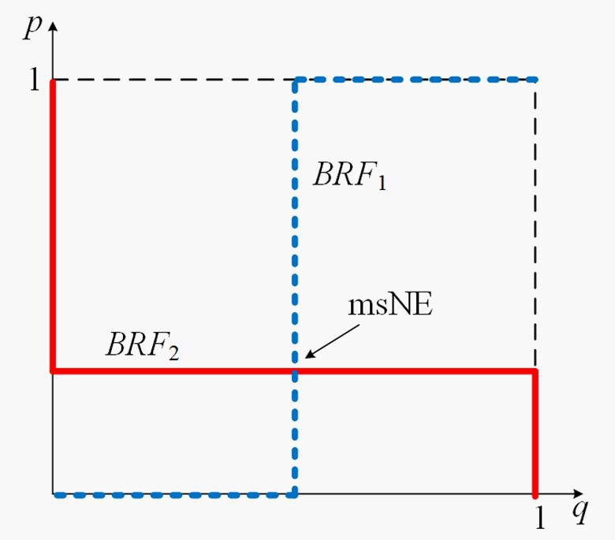

– For player 1, note that when q = 1 (player 2 chooses x), his best response is to choose b, implying that he assigns full probability to b, that is, p = 1

at the top right-hand corner of the figure. When q = 0 (player 2 selects y), player 1’s best response is to choose c, implying that he assigns no probability to b, that is, p = 0, at the bottom left-hand corner of the figure.

– For player 2, note that when p = 1 (player 1 chooses b), his best response is to choose y, implying that he assigns no probability to x, that is, q = 0 at the top left-hand corner of the figure. When p = 0 (player 1 selects c), player 2’s best response is to choose x, implying that he assigns full probability to x, that is, q = 1, at the bottom right-hand corner of the figure.

- [Entry deterrence game with simultaneous decisions after entry]. Consider the following extensive form game. It represents an entry-deterrence game where a potential entrant decides whether to enter the market in which an incumbent currently operates, or to remain outside the market. If the entrant decides to enter, then a simultaneous-move game is played, where both the entrant and the incumbent must decide whether they will take either a small or large niche of the market (denoted as S or L for the incumbent, and s or l for the entrant).
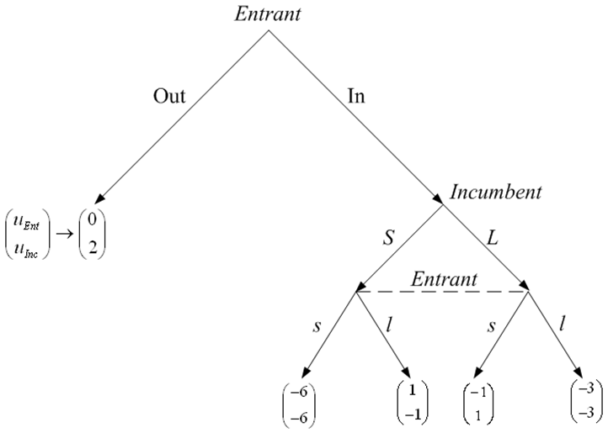

- Operating by backwards induction, firstly find all the Nash equilibria for the subgame initiated after the entrant firm decides to enter (simultaneous move game).

[Note: Consider both the pure strategy Nash equilibria and the mixed strategy Nash equilibrium.]

  - [20 points] Once you have identified all the equilibria for the proper subgame initiated upon entry, find the subgame perfect Nash equilibria (SPNE) of the entire game.

Hint: Note that you just need to take into account the utility resulting from each of the possible Nash equilibria of the subgame you found in part (a), and then check what is optimal for the entrant to do (either In or Out). There are three different SPNEs.

- Cournot vs. Stackelberg Consider two neighboring wineries in fierce competition over the production of their specialty wine (where their grapes come from the same vineyard, so the wines are exactly the same), One owned by Jill (J), the other by Ray (R). Each winery produces their wine the same way and have the symmetric total cost function ${TC}_{i}\left(q_{i}\right)=3+0.5q_{J}$ where i = J; R. Inverse market demand for wine is p = 50 2($q_{J}+q_{R}$).

  - Cournot competition. Write down the profit-maximization problem for each firm if they compete in quantities (à la Cournot).

Jill’s profit-maximization problem is

$$\max_{q_{J}}{{ π}_{J}}=\left[ 50-2\left(q_{J}+q_{R}\right)\right]q_{J}-(3+0.5q_{J})$$

Ray’s maximization-problem is

$$\max_{q_{R}}{{ π}_{R}}=\left[ 50-2\left(q_{J}+q_{R}\right)\right]q_{R}-(3+0.5q_{R})$$

- Using the profit-maximization problems you wrote in part (a), find each firm’s best response function. Interpret.

Jill’s best response function. If we differentiate Jill’s profit with respect to its output q_{j} , we obtain

$$\frac{∂π_{J}}{∂q_{J}}=50-4q_{J}-2q_{R}-0.5=0$$

rearranging, we have 4$q_{J}$ = 49.5 2$q_{R}$. Solving for $q_{J}$, we obtain Jill’s best response function

$q_{J}$ ($q_{R}$) = 12.375 $-\frac{1}{2}q_{R}$

which originates at a vertical intercept of 12.375 and decreases at a rate of $\frac{1}{2}$ for every unit of Ray’s output.

Ray’s best response function. Differentiating Ray’s profit with respect to its output $q_{R}$, we obtain

$$\frac{∂π_{R}}{∂q_{R}}=50-4q_{R}-2q_{J}-0.5=0$$

rearranging, we have 4$q_{R}$ = 49.5$-$2$q_{J}$ . Solving for${ q}_{R}$, we obtain Ray’s best response function

$q_{R}$($q_{J}$) = 12.375 $-\frac{1}{2}$ $q_{J}$

which is symmetric to Jill’s best response function. This comes at no surprise since both wineries face the same inverse demand function and total cost function.

- Using the best response functions you found in part (b), what is each winery’s equilibrium output and price?

In a symmetric equilibrium, both winneries produce the same output level, $q_{J}$= $q_{R}$ = q, which means that the above best response function becomes

q = 12.375 $-\frac{1}{2}q$

Rearranging, we find $\frac{3}{2}$q = 12:375, and solving for q yields equilibrium output

q* = 12.375 $\frac{2}{3}$ = 8.25 units.

Plugging these quantities into the inverse demand, we get the equilibrium price

p*= 50 $-$ 2(8.25 + 8.25) = $17
and equilibrium profits are

$π$* = p*q* $-$ (3 + 0.5q* ) = (17 $×$ 8.25) $-$ (3 + 0.5 $×$8.25)

    - 140.25 $-$ 7.125 = $133.125

- Stackelberg competition. If Jill was able to get her wine to market first (and become a Stackelberg leader), how will each winery’s output and price change?

Second stage (follower). If Jill is able to get to the market first, we start the problem by finding Ray’s best response function (since Ray is the follower), which we found in part (b) to be

$q_{R}$($q_{J}$) = 12.375 $-$0.5$q_{J}$

First stage (leader). Inserting this best response function into Jill’s profit maximization problem, we obtain

$$\max_{q_{J}}{{ π}_{J}}= \left[50-2(q_{J} +\underset{q_{R}}{\underbrace{12.375-0.5 q_{J}}})\right]q_{J}-(3+0.5q_{J})$$

Before differentiating, we can simplify the profit function

$$\max_{q_{J}}{{ π}_{J}}=\left(25.25- q_{J}\right)q_{J}-(3+0.5q_{J})$$

Differentiating with respect to $q_{J}$ , we obtain

$$\frac{∂{ π}_{J}}{∂q_{J}}=25.25-2q_{J}-0.5=0$$

Rearranging, 2$q_{J}$ = 24.75, and solving for $q_{J}$,

$q_{J}=\frac{24.75}{6}=12.375$ units.

Plugging this into Ray’s best response function, we get Ray’s equilibrium output
$q_{J}\left(12.375\right)=12.375-0.5\left(12.375\right)=6.19$ units.

Relative to the Cournot competition we examined in part (b), Jill increases her output when she is the industry leader while Ray decreases his.

Equilibrium price in the Stackelberg game is
$$p=50-2\left(12.375+6.19\right)=\$12.87$$

Jill’s equilibrium profits are
$${ π}_{J}=12.87\left(12.375\right)-\left(3+0.5×12.375\right)=\$150.08$$

and Ray’s equilibrium profits are

$${ π}_{R}=12.87\left(6.19\right)-\left(3+0.5×6.19\right)=\$73.57$$

Compared to the Cournot profits of $133.125 for each firm, Jill (the leader) increases her profit by being first to the market, and Ray (the follower) has a lower profit from being late to the market.

Answer key

Exercise #2 – Entry deterrence game with simultaneous decisions after entry

Consider the following extensive form game. It represents the entry-deterrence game that we discussed in class, but with a slight modification. The entrant firm decides whether to enter the market where an incumbent is currently operating, or to remain out of the market. If the entrant decides to enter, then a simultaneous move game is played, where both the entrant and the incumbent must decide whether they will take either a small or large niche of the market.
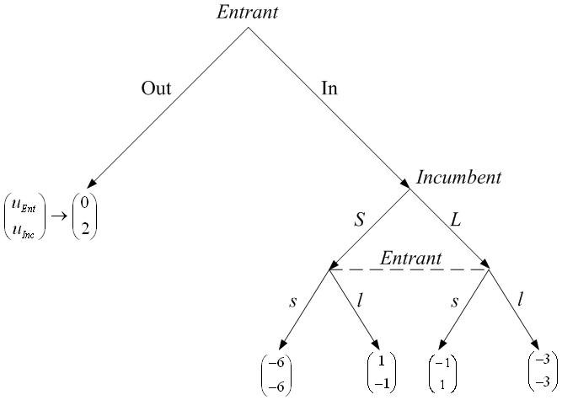

- Operating by backwards induction, firstly find all the Nash equilibria for the subgame initiated after the entrant firm decides to enter (simultaneous move game). Consider both the pure strategy Nash equilibria and the mixed strategy Nash equilibrium.

Notice that the subgame induced after the entrant decides to enter can be represented in its normal form representation (since it is a simultaneous move game) as follows:

 |  |  |  |  |  | Entrant
 | Incumbent |  | Small, s |  |  |  |  | Large, l
 |  | Small, S | -6,-6 |  |  |  |  | -1,1
 |  | Large, L | 1,-1 |  |  |  |  | -3,-3
This game has two equilibria in pure strategies: (Large, Small) and (Small, Large).
 |  |  | 1

In addition, there exists a mixed strategy Nash equilibrium, where the entrant randomizes with a probability q that makes the incumbent indifferent between choosing a Small or Large niche:
${EU}_{I}\left(small\right)={EU}_{I}(large)$ , that is
$-6q+\left(-1\right)\left(1-q\right)=1q+(-3)(1-q)$ , and rearranging we obtain$2=9q$

which implies that the entrant randomizes using a probability $q=2/9$

And similarly, the incumbent chooses a probability p such that the entrant is indifferent between selecting Small or Large. That is,

${EU}_{E}\left(small\right)={EU}_{E}(large)$, that is
$6p+\left(-1\right)\left(1-p\right)=1p+(-3)(1-p)$ , and rearranging we obtain$2=9q$

which implies that the incumbent randomizes with probability $p=2/9$

Then, the mixed strategy Nash equilibrium for this subgame is

{(2/9Small, 7/9Large),(2/9Small 7/9 Large)}

- Once you have identified all the equilibria for the proper subgame where firms compete in what niche they will capture, find the subgame perfect Nash equilibria of the entire game. Notice that you just need to take into account the utility resulting from playing each of the possible Nash equilibria of the subgame, and then check what is optimal for the entrant to do (either In or Out). Hint: there are three different SPNE.

Let’s analyze each of the different SPNE separately:

  - If the subgame is played using the pure strategy Nash equilibrium (Large, Small), then the corresponding payoff vector is (1,-1). That is, the Entrant is obtaining a payoff level from the psNE of this subgame of -1. Therefore, the Entrant prefers to remain out of the market (obtaining a payoff of 0) rather than entering and obtaining -1.

Entrant

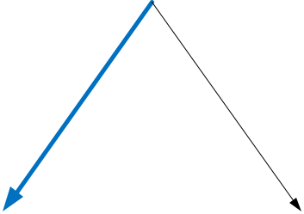
Out In

ddfvfdกไ

$\left({U_{Ent} \atop U_{Inc}}\right)→\left({0 \atop 2}\right)$ $\left({-1 \atop 1}\right)$

The first SPNE is then,

{Out, (Large, Small)}

- If the subgame is played using the pure strategy Nash equilibrium (Small, Large), then the corresponding payoff vector is (-1,1). That is, the Entrant is obtaining a payoff level from the psNE of this subgame of 1. Therefore, the Entrant prefers to enter into the market (obtaining 1) rather than remaining outside (and obtaining a payoff of 0).

2

Entrant
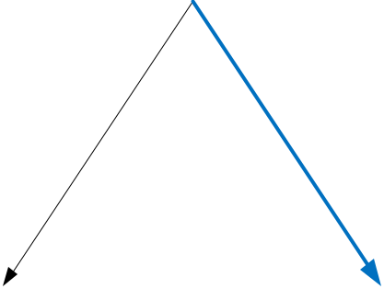

Out In

$\left({U_{Ent} \atop U_{Inc}}\right)→\left({0 \atop 2}\right)$ $\left({-1 \atop 1}\right)$

The second SPNE is then,

{In, (Small, Large)}

- If the subgame induced after the Entrant decided to enter is played using the mixed strategy {(2/9Small, 7/9Large),(2/9Small 7/9 Large)}, then the corresponding expected utility level for the Entrant from playing such a mixed strategy Nash equilibrium in this subgame is
$$\frac{2}{9}\left(\left(-6\right)\frac{2}{9}+1\frac{7}{9}\right)+\frac{7}{9}\left(\left(-1\right)\frac{2}{9}+(-3)\frac{7}{9}\right)=19$$

Therefore, the expected utility level from playing such mixed strategy Nash equilibrium for the entrant is so low, that it is better off by not entering into the market.

Entrant

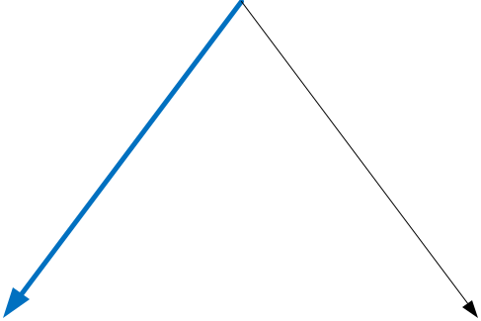

Out In

$\left({U_{Ent} \atop U_{Inc}}\right)→\left({0 \atop 2}\right)$ $\left({-19 \atop }\right)$

Then, the third SPNE is given by
{Out, {(2/9Small, 7/9Large),(2/9Small 7/9 Large)}}

