Abstract
This report clarifies and identifies what are the main factors that drive some countries to succeed in diminishing the number of infections in AIDS and HIV compared to some countries that did not. And what is the significant role of the government that they have managed for their own citizens.
The details regarding the origin of AIDS and HIV pandemic, the outbreaks in each regime leads to inequality and how inequality reinforces HIV/AIDS by gathering the secondary evidence from 1990s to 2020s and compares the distinction between policies in some countries and to make an assumption.
The result combined from our research, the main factor that makes some countries succeed in terms of reducing the number of HIV/AIDS infections is the government management together with norms and traditions that need to be progressed simultaneously.

Introduction
To mention the inequality, which is the significant issue in terms of the structure. Every factor in society is relevant to inequality for instance, political, norm, tradition, belief or even region signifying the contemporary or behavior of people. And the pandemic that our group has agreed which is most related to inequality is AIDS and HIV. The judgement or perspective according to the symptom or the transmission of the disease toward who infected the disease is the disparity that can clearly be seen. The underestimate, the violence on mental or physical or even the discrimination, these are the action were generated stigma and differentiate them from the society.
Our aim for this paper will inform the dearest reader to realize how the impact of inequality brings the disease (AIDS/HIV) occur. On the other side, why AIDS and HIV also reinforce inequality. Especially, some countries can successfully handle or reduce the amount of people who infected the virus and some countries cannot, thus we need to identify what is the reason or main factor establishing these things to happen.
As a result, this paper is occurred by our intention in order to offer our curiosity to be clarified for those interested in this issue.

Background
When did HIV and AIDS start and what is the difference between HIV and AIDS ?
According to UNAIDS, about 32.7 million people all over the world died from AIDS-related illness since the epidemic started, and approximately 75.7 million people became infected with HIV. Over decades, the world has been struggling with human immunodeficiency virus and acquired immune deficiency syndrome (HIV/AIDS).
In 1981, clinicians in New York and California observed among young, previously healthy, homosexual men an unusual clustering of cases of rare diseases, notably Kaposi sarcoma and opportunistic infections such as Pneumocystis carinii pneumonia, as well as cases of unexplained, persistent lymphadenopathy (Morb. Mortal. Wkly. Rep.,1981) that was when the first case of AIDS was documented. This disease was initially called Gay-Related Immune Deficincy (GRID), as the early suggestions that this disease was believed that it spread only from behavior specific to gay men.
After many disagreement among the medical and the scientists, during the middle of 1982, the scientists realized that this disease did not spread among gay community but also other group of people, haemophiliac, heroin users (Center for Disease Control, 1981 ), making this disease to be known that it can be transmitted by needleds from injection of drug, through the blood, during pragnancy from mother to child or sexual activity which is the most common way to get infected whether in homosexual or heterosexual.
In late 1982, Center for the disease began to use the name “The acquired immunodeficiency syndrome (AIDS)”, and later on the scientists discovered the virus that caused AIDS called “human immunodeficiency virus (HIV)”.
HIV is a virus that leads to AIDS condition known as the third stage of HIV. A person can be infected with HIV without AIDS, also that person who is diagnosed with AIDS must already contract with HIV. If an untreated HIV infection progresses, there is ongoing damage to immune defense cells (Boskey,2020).
Having an appropriate treatment is important to people infected with HIV in the long-term, and also can prevent them from developing AIDS.
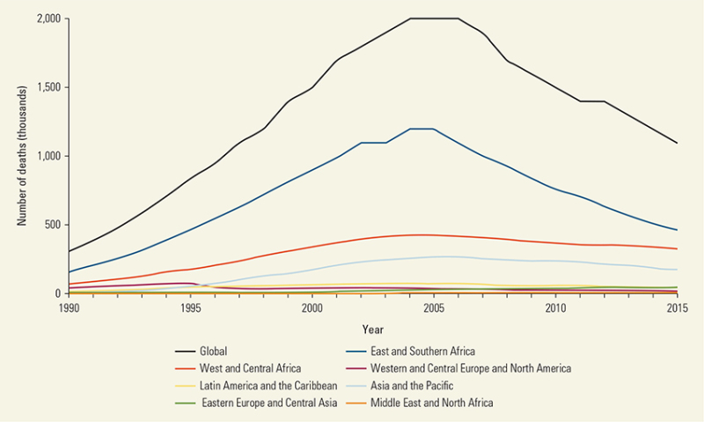
(Danforth, Granich, Wiedeman, Sanjiv Baxi, & Padian,2017)
The graph above shows the Global trends in AIDS-related mortality, Deaths peaked at just more than 2 million per year from 2004 to 2005 and have been steadily declining since, driven primarily by gains in Sub-Saharan Africa (Danforth et al., 2017).
AIDS is the sixth-leading cause of death globally and the leading cause in Sub-Saharan Africa, a fact that has not changed since 2000, despite the 41 percent decline in the region’s AIDS-related mortality rate. AIDS was responsible for one in nine deaths in the WHO’s African region in 2012 (“Global Health Estimates,” 2018)

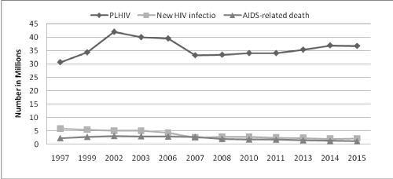
(Raya, 2018)
From the graph above, in 2002, the number of people living with HIV is the highest (42 million), and since 2002 the number of people living with HIV continuously decreased.
Since 1997, the number of new HIV infections gradually decreased until 2015 from 5.8 million to 2.1 million. In contrast, the number of AIDS-related deaths increased from 1997 to 2003 and then starts to decrease gradually.

Body I
Inequality stigma norm genders sexworker budge
Stigma to people living with AIDS or HIV is the consequence of the negative perspective or bad attitude toward the virus by justification or shame for people who infected AIDS or HIV relate to social issues, stereotype disease as a disgraceful illness according to the symptom and the transmission of the disease. Several evidence have signified that the bad attitude or negative perspective may be derived from lack of awareness or information about the disease. Of the 417 surveyed, the median age was 52 years and 96% were Hindus.
A majority (324, 77.7%) had no formal schooling, only 51 of the 417 (12%) reported hearing about HIV/AIDS (Madhivanan, Kumar, Adamson & Krupp, 2010). Therefore, several misunderstandings can occur, especially in countries that lack access to knowledge indicating education was the main important role to impel society.
Discriminstion is the action or behavior that causes huge effects on people living with HIV or AIDS. “My daughter refused to go to hospital to receive medicine. My daughter died because of the fear of stigmatization and discrimination” -Patience Eshun from Ghana, who lost her daughter to an AIDS-related illness(AVERT, 2019)
This statment can inidicate that the stigma and discrimination estsblished the greatest loss perhaps more than AIDS or HIV. The act of treating people unequally for instance, defamation their reputation, creates an dishonour, a marginalizing or treat to them differently than the others by college, friends, community especially in family are likely to begin the affliction in patients also lead to discourage the access of the treatment or testing the virus in order to prevent the revelation about diseases.

Body II
Break out of HIV/AIDS and cases in International
In 1930 Retrovirus passed from chimpanzees to humans subsequently spawning the global AIDS pandemic.(Warner C. Grenne Dr.,2007) Therefore,it started from animal to human like any other pandemic problem. In America in 1981, first case First cases of new immunodeficiency disease in gay men in US Fear of “gay plague” spreads rapidly.(Warner C. Grenne Dr.,2007)
AIDS case surveillance reported the highest number of new cases by date of diagnosis in 1993 (Dennis H. Osmond, PhD.,2003)
The first case in superpower country like USA came from homosexual and then the peak of HIV reached the top in 1993 by MSM(men who have sex with men) which other reason like IDU(injection drug users) and heterosexual contact as you can see from a graph below.
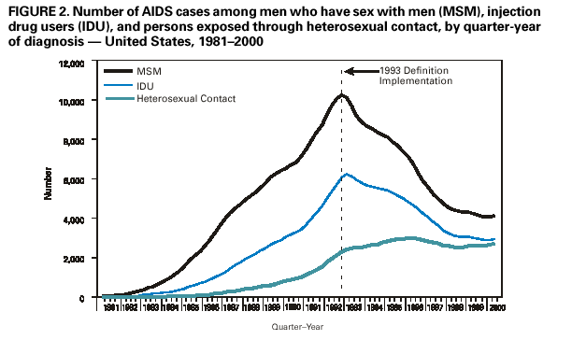

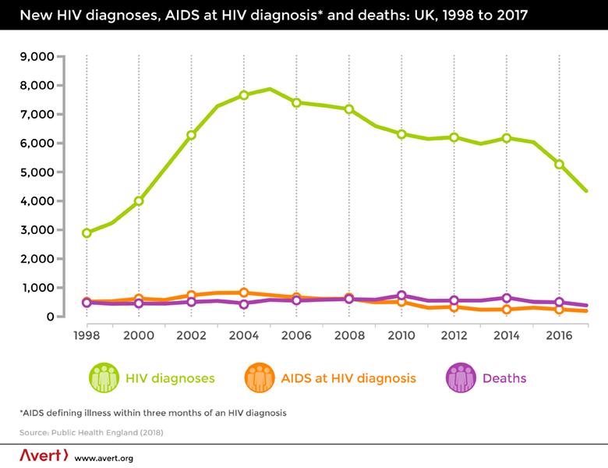
In Africa the 1960s- Early cases of AIDS Experts studying the spread of the epidemic suggest that about 2,000 people in Africa may have been infected with HIV by the 1960s. Stored blood samples from an American malaria research project carried out in the Congo in 1959 prove one such example of early HIV infection (Vanessa Vick.,2015).
The 1970s – The first AIDS epidemic
It was in Kinshasa in the 1970s that the first epidemic of HIV/AIDS is believed to have occurred (Vanessa Vick.,2015). which means the first case that was confirmed in African happened in Kinshasa in 1970 by the concern about HIV/Aids from before 1970.
The 1980s – The spread and reaction
Although HIV was probably carried into Eastern Africa (Uganda, Rwanda, Burundi, Tanzania and Kenya) in the 1970s from its western equatorial origin, it did not reach epidemic levels in the region until the early 1980s.(Vanessa Vick.,2015)
Once HIV was established rapidly, the transmission rates in the Eastern region made the pandemic far more devastating than in West Africa, particularly in areas bordering Lake Victoria. The accelerated spread in the region ,due to a combination of widespread labor migration, high ratio of men in the urban populations, low status of women, lack of circumcision, and prevalence of sexually transmitted diseases.
It is thought that sex workers played a large part in the accelerated transmission rate in East Africa; in Nairobi for example, 85 percent of sex workers were infected with HIV by 1986.(Vanessa Vick.,2015)
Uganda was hit very hard by the AIDS pandemic in the 1980s. At the beginning of the decade, doctors were confronted by a surge in cases of a severe wasting disease known locally as ‘slim disease’, alongside a large number of fatal opportunistic infections such as Kaposi’s sarcoma. By this time doctors were aware of AIDS cases with similar symptoms in the United States:(Vanessa Vick.,2015)

The 1990s – Southern Africa and the fight for treatment.
The beginning half of the 1990s was a bleak time in the history of AIDS in Africa. At a time when new HIV infection rates were rocketing in Southern Africa there were few new ideas of how to deal with generalised epidemics in poor countries.(Vanessa Vick.,2015)
From the information above you can be concerned that most countries of Africa which mostly are undeveloped countries were hit by HIV/Aids heavily and also this pandemic can spread quickly in Africa which the medical also cannot access to some areas, so that it is hard to be cured. People in Africa live with all big problem which lead africans to infect HIV/Aids
To illustrate the first graph, you can see the world graph the new infection and the death slightly decrease meanwhile people can live with HIV sharply increase. On the other hand,the second graph shows shares of deaths from HIV/Aids which you can see the sixth place were from Africa there are very high from the average of this world.Thus we have to be concerned about the countries that are undeveloped seriously about the opportunity to cure them.
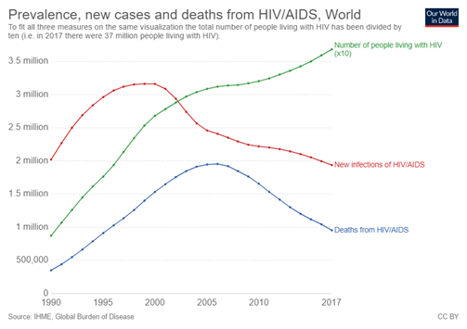
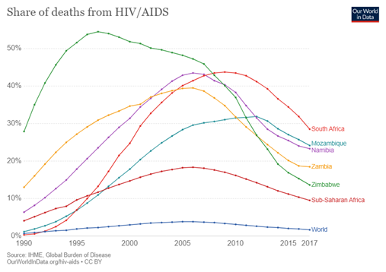

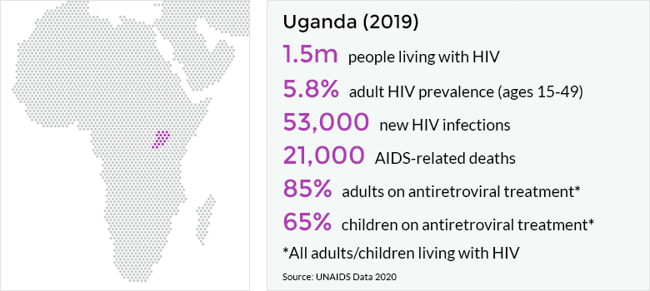
In 2018, an estimated 1.4 million people were living with HIV, and an estimated 23,000 Ugandans died of AIDS-related illnesses. The epidemic is firmly established in the general population. As of 2018, the estimated HIV prevalence among adults (aged 15 to 49) stood at 5.7%. Women are disproportionately affected, with 8.8% of adult women living with HIV compared to 4.3% of men.(HIV and AIDS in Uganda,2019)
HIV in Uganda mostly infecets to sex workers, young girls and adolescent women, homosexual mens, also people who inject drugs and people from Uganda’s transient fishing communities.
The increase in the number of people living with HIV accessing treatment. In 2013, Uganda reached a tipping point whereby the number of new infections per year was less than the number of people beginning to receive antiretroviral treatment.
On the other hand, as of 2018 around 27% of adults living with HIV and 33% of children living with HIV were still not on treatment. Persistent disparities remain around who is accessing treatment and many people living with HIV experience stigma and discrimination.

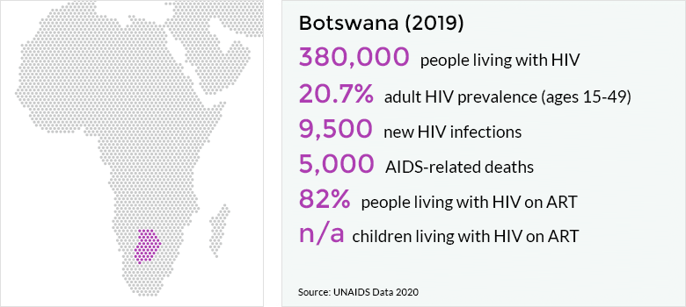
In 2012, for the first time, key populations including female sex workers and gay were included in HIV pandemic surveys. While this should allow for a better understanding of HIV among these populations, there is still very little data available.
Botswana's newest National Strategic Framework for HIV and AIDS includes mention of programmes for key populations, but most of these programmes are currently picked up by external donors In 2013, HIV prevention programmes were reaching only 44.9% of these key affected populations (HIV and AIDS in Botswana,2018)
Botswana is an upper middle-income country which faces a huge challenge in sustaining its impressive HIV response as donors increasingly focus on low-income countries. Many donors have reduced or withdrawn their funding in recent years. PEPFAR alone has more than halved its funding, from $84 million in 2011 to $28 million in 2016.

Body II
How inequality leads to AIDS and HIV?
In sub-saharan Africa, Botswana is a part of the most likely to be infected with AIDS and HIV especially in women. Approximately 200,000 women lived with AIDS or HIV which is more than a half (56%) of inflection are women driven from several reasons.
Firstly, Botswana's policy was determined using men as a key stakeholder factor role to launch the act without consideration for women for example, the state federal law or the penal code include the restriction for adoption in women, married person's property acts.
Low-paying employment in women compared to men, opportunity to access wealth, social security given from the government or more vulnerable from sexually transmitted infection, these are the consequences driven from unequalness from society.
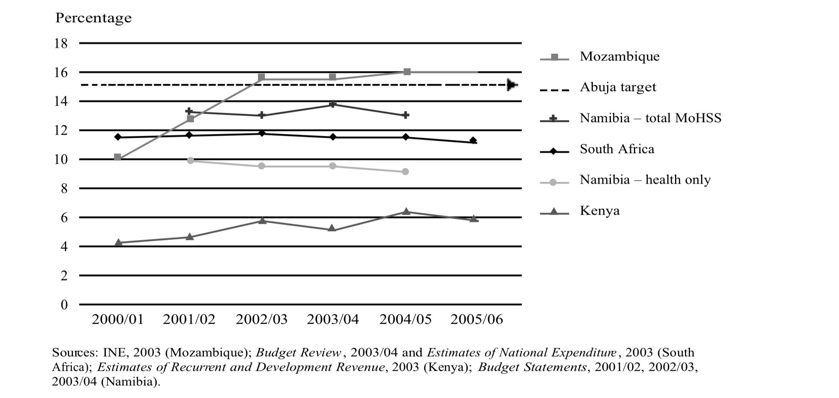
Secondly, it can deny that the cultural factors are also the main significant role to determine the act and understanding the contemporary position of women in the society. Unfortunately, norm and tradition in Botswana are pressuring women to be under the men's decision, thus women are the minor to determine or lack empowerment for their own gender sake.
The additional inequality is mostly the poor country having the inaccessible treatment or even the testing for those inflections.
In the Abuja Declaration of 2001 the Organisation of African Unity set a target of 15% of total state expenditure to be spent on health. And most of the sub-saharan region relied on the donor funds (Guthrie and Lara, 2004).
From this statement, it can indicate that these governments in Sub-Saharan Africa did not adequately allocate the budget to perform in the healthcare system part due to the lower state revenue that the government can generate ,plus these countries were hardly able to verify the management budget in social securities that were distributed into HIV or AIDS specifically.
This is the reason why the Sub-Saharan region lacks the resources, insufficient medical treatment to remedy or even infrastructure for the citizens leading to rising amounts of infection, inaccurate or underestimate of those infected.
To compare with the Latin American region, the number of infections required for the treatment are less than the sub-saharan african.
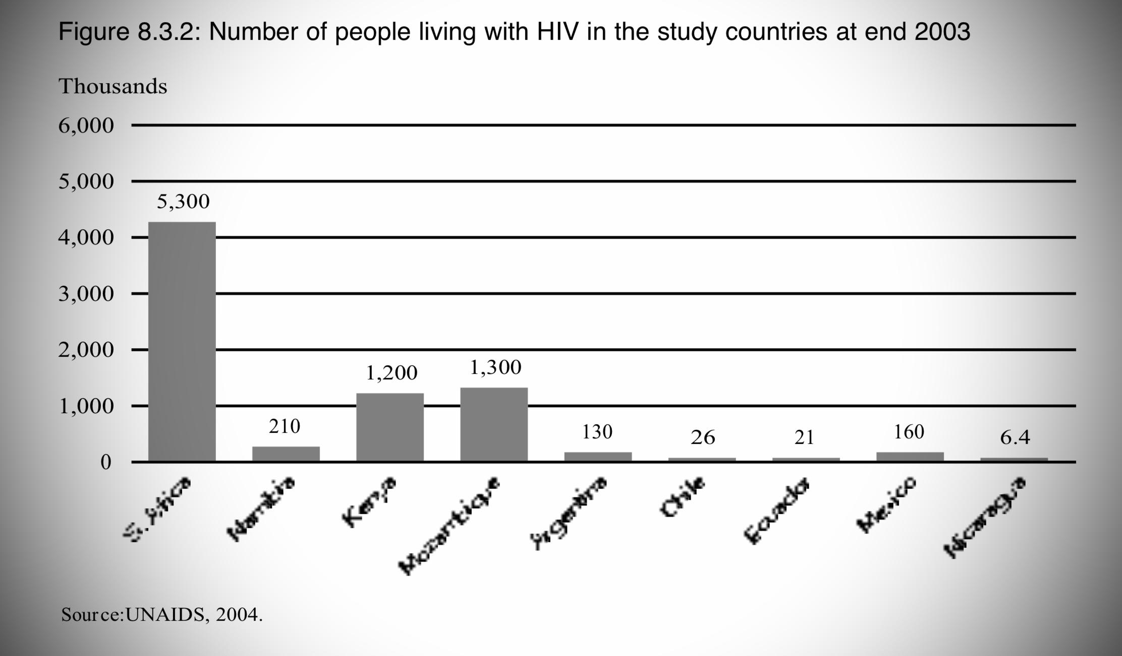
It is significant showing the accomplish in allocating budget from the government that spreaded the accessible treatment and security to everyone equally. From the graph illustrated the amount of people who lived with HIV, which is clearly seen that numerous numbers were in sub-saharan africa region contrasting, with the number in Latin America more than half given the equally distributed in budget allocation of government.
How AIDS and HIV reinforce inequality?
On economic terms, not only the enormous deaths in the short run of AIDS and HIV have occurred for the consequence, but also created an invaluable impact on the economy in each country in the long run regarding economic growth, the rate of GDP, the social capital, or even the imbalanced import and export.
AIDS and HIV are causing the wider age gap, the missing skill and experience, the fallen of the life expectancy which all these can obviously be seen in the climbing of number of mortality from AIDS and HIV reduced the life time in labour force plus, the paused in continual productivity of the labourers who took the recuperate would be a huge cost to the firm for losing their profit. Unfortunately, some skills were left over with the death which was not allowed to subsequently submit as experience for the next generation.
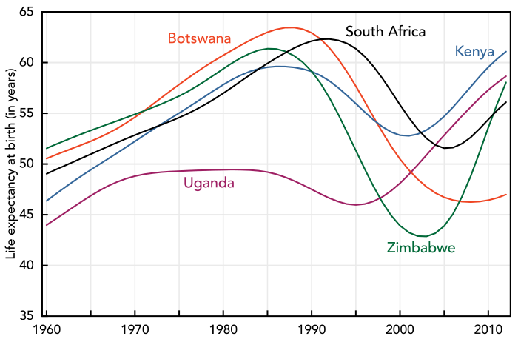
The graph shows the rapid reduction of life expectancy due to AIDS or HIV especially in 1995 because of the lack of condom usage and poor access to service health(Splettstoesser, 2015).
The cost of mortality due to AIDS and HIV was also affecting the problem that several countries have been facing which is poverty and strong linkage to the quality of citizen life. The lack of the income which was the significant factor have impacted for the limited demand consumption in order to save money the medical treatment instead of saving or investment for their future thus, it was much evidence to prove for instance, 13.32% of 1993 GDP at factor cost was lost due to HIV/AIDS in the years 1994 to 2003 in Botswana. (Botswana Journal of economics, 2008)
To mention the regulation, it is a tool for managing the system in order to control an activity or process according to the rule that in each country has legislated. The federal have acted an agreement in federal laws to protect the basic right for people who infected HIV or AIDS from the discrimination, marginalize, criminalized under section 504(HIV.gov, 2017). Also the privacy which is the right for guarding patient’s health information. Nevertheless, the crime, unequal mistreatment, imposition, and distinguishing can be found in the society indicating the regulations have not fully covered all the social issues which constantly created the affliction, traumatic emotion among the patients.
Sex worker, the carrer that have not been allowed to receive any respect, is the most likey to be infected by the viruse higher than regular people due to the raely protectection neither the low bargaining power to neogotiate consistent for condom used, the violance, the sexual harrasement from the sexual services nor the governement regulations that less marginalise in this carrer.
In Eastern and Southern Affrica, they have reported that “HIV prevalence among female in sex worker is increasing, 50% of sex worker lived with HIV”(AVERT, 2018). It has found an evidence which possess condom in public area even for protecing their health, Police in the United States of America, Kenya, Namibia, and Russia sexually abused and cited to detain and arrest people who possessed condom as justification related to sex worker (Open society foundations, 2012).
Obviously, the regulation in some regime did not fully protect the sex woker as legistismate carrer, thus it will definitely result in rising of HIV or AIDS due to the terror from the police to harrase and detain them for carrying condom.
The graph showed the number of sex worker among 19 countries during 2009-2013. It was cleary be seen that the amount of sex worker in each country has highly infected more than the general population (UNAIDS, 2014).
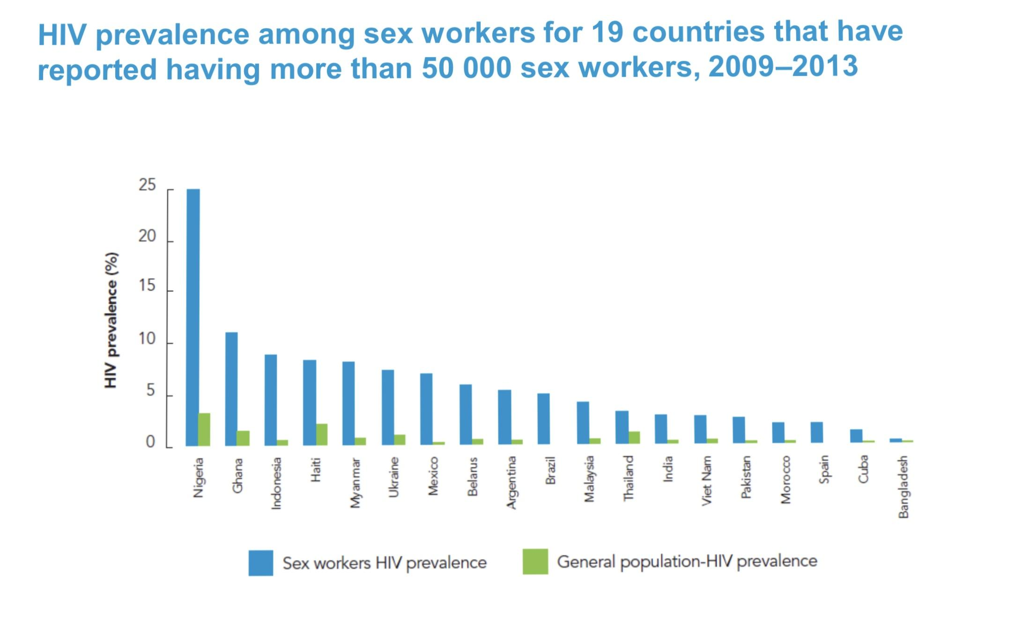
Same-sex sexual relationship is also the group of people which abundantly infected AIDS or HIV. Even the number of HIV infections have been declined from 3.4 million in 1996 to 1.8 million in 2017 despite gay men or men having sex with men most likely a risk for contracting HIV(Hugo Greenhalgh and Thomson Reuters Foundation, 2018).
In addition, these groups of people have been ignored, abused, and unacceptable identification by the majority particularly in Africa, Middle East, and Russia indicated the lack of political support and respect for human rights for these people.
Establishing the violence and harassment in the society. It has an evidence that if citizen particular in Iran, Sudan, or Saudi Arabia were found being same-sex sexual, he/she would be punished causing same-sex sexual fear to access HIV services due to terror of punishment or identity revealer. It can be signified that the government did not respect or accept citizens' right to disclose gender identity which does not harmonize to the region, modern norm or tradition.

Body III
How does the government handle the HIV/AIDS pandemic ?
Good Practice in the ministration of policy
As everyone knows, HIV/AIDS is hard to prevent and cure due to the infection rate from the past years. But there are some countries that can handle it and that country is the USA.
The USA, one of the most powerful countries in the world, has a lot of government policies that help people who have been infected in terms of prevention and treatment. The US has many kinds of policy such as providing human resources services, tracking budgets within its accounting system, transferring funds to other implementing agencies and Providing office space, communication, and information technology services. These are some of the policies that make the USA one of the most successful countries in the prevention and treatment of HIV/AIDS.
According to the policies that were in the previous paragraph, the USA provides human and resources to cure and prevent HIV/AIDS. To handle the infection, there must be a lot of human resources to treat the patients and service them. It has a lot of sections of the work that must have various people to maximize it. And it also is beneficial in the economy because this will increase the employment rate.
Tracking budgets within its accounting system is one of the most important policies that is very important because this is how the government knows where the money goes and the government can also show the information and data to citizens. This will make the prevention and curing more efficient because it is sure that money will be spent with no leaks and that also prevents the corruption that may occur in the operation too.

Transferring funds to other implementing agencies, this policy shows that governments not only handle it by themselves but they also cooperate with the other agencies, organizations that are related to HIV/AIDS and they are experts in the HIV/AIDS epidemic. Working along with the other agencies make the operation more successful.
From all of the policies above, these make the USA one of the best countries in terms of preventing and curing HIV/AIDS. And the below graph is the support data that shows us about the HIV/AIDS rates and the curing rate of it in the USA compared to the other countries. This is the case study of what the government in other countries should do. But this is just one of the examples of the ministry of policy in one country. There are many countries that also can prevent this pandemic similarly to European countries.
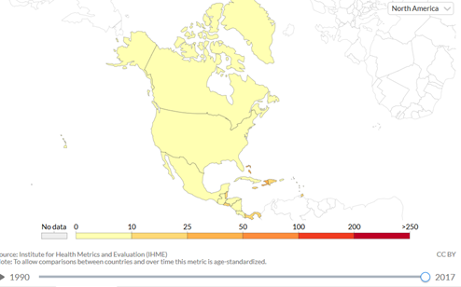

Bad Practice in the ministration of policy
On the other hand, there are many countries that could not handle this pandemic, HIV/AIDS well. And one of the examples is the Africa region which the country is Botswana.
The main point is why this country could not handle HIV/AIDS the policies that do not support the prevention and curing in HIV/AIDS.
Due to the limited public health and education systems, high levels of illiteracy and low life expectancy of these countries, these are the reasons why Botswana is the country that could not manage this pandemic.
The HIV/AIDS pandemic in Botswana is a critical problem. If we compare to Uganda, a sub-Saharan African which is a success story in terms of HIV/AIDS that culture and economic factors are the main factors for high infection rates in Botswana.
Cultural norms like tyranny gender norms, shortage of the knowledge about HIV/AIDS virus, and a lack of sex education such as the safe sex and the knowledge in sex makes Botswana be one of the most powerless countries that could not handle this virus.
Uganda has been way more successful in engaging women in politics and also the workforce than Botswana. The oppression of girls in Botswana has made the health epidemic worse. Sex education and data surrounding sex practices in Uganda are much better than in Botswana.
In Uganda, they have a sex education course which is necessary for the youth and they also enforce citizens to study about it. The prohibit nature of sex in Botswana creates a norm of secrecy that lead to the youth that is uninformed about sex activity practices and disease infection. the problem in the unequal gender norms becomes the big problem again and that lead to the economic inequality between genders within the state is the main reason for transactional sex, increasing the spread of HIV/AIDS. Because women are far less engaged within the professional sector than the men, that made men have power over women.
In Uganda, because women can engage with the professional and political realms, they are able to be more empowered and avoid reliance upon a person for financial stability.
Female politicians are providing services that are beneficial for the health of other women unlike in Botswana. Women will remain as a risks group for HIV/AIDS in Botswana until unequal gender norms in Botswana will be solved. For all of the reasons above, we can conclude that the main factors that make Botswana unable to handle this serious pandemic are the norms, culture and the management of the government within their country.
We are sure that the norms and culture can be changed. Although the norms and the culture are something that is hard to change suddenly. But one thing that Botswana should do now is the management in the political terms. In term of providing the services and the better sex education system that will make youth and also the adults can prevent the risky situations which can lead to the infection.

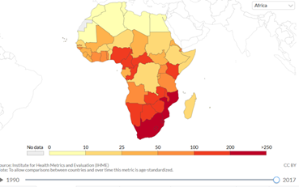
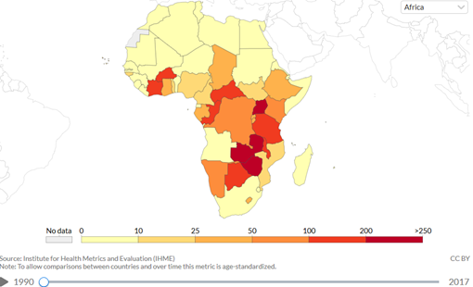

As we can see from the chart above, in 1990, Uganda had the HIV/AIDS rates higher than the other countries including Botswana (632.21 deaths per 100,000 people). But in 2007, the HIV/AIDS rates of Uganda reduced to 74.1 deaths per 100,000 people while the HIV/AIDS rates of Botswana increased from 168.89 deaths to 187.57 deaths per 100,000 people in 2007.
Moreover, from the policy about sex worker, why that the death rates from HIV/AIDS in developing countries still high although developing and developed countries have legal policy about sex worker.

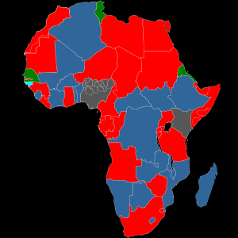
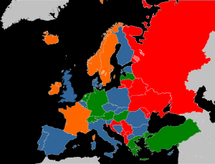

The light blue area represents the Decriminalization. The green area represents Legalization-Netherland. The dark blue area represents Abolitionism-Mozambique, Botswana, Finland.
The orange area represents Neo-abolitionism.
The red area represents Prohibitionism.
The grey area represents Legality varies with local laws.
From graph above, we will focus on countries that legalize the sex worker which is the green area and the light blue and dark blue.

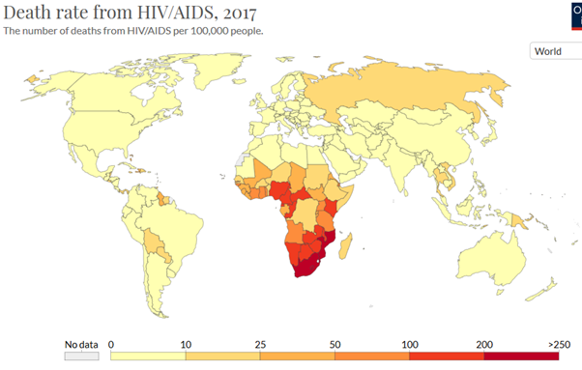
All of European countries have very low levels of death rates from HIV/AIDS unlike in many countries in Africa. One thing that we indicate from the map is that even the same policy may not give the same outcome among different countries.

Summary
To summarize, the inequality in AIDS/HIV is the issue that generated several consequences to those who are living with the diseases plus, AIDS and HIV also creates numerous effects related to inequality. The action, perspective or speech causes a stigma and discrimination to those infected.
We do believe that every country has been faced with these issues, but why in some countries can handle the problem.
From our research, our group has an opinion that the reason why some countries can manage and control the number of infection rate and inequality is firstly, the government which is the significant role to arrange and launch the act, in order to offer the quality of life for own citizen, for example in The United state of America, they have a practical government regime.
According to our research and the information. They have a big support funding system unlike many developing countries which could not handle the HIV/AIDS pandemic. Moreover, they have a tracking budget policy which can show the progress in the operation and also prevent the corruption.
These are why the difference inequality in the government regime can be the factor which can lead to the difference outcome in the pandemic.
Secondly, the tradition or norm in that particular country needs to adapt to the political simultaneously, because the perspectives and believes are consequences created from norms and traditions, for example, Botswana is the country that men play a key role to as the result to the norm that has been believed which men are more important than women pressured to have less of power or exploit in many ways, for instance receiving low-wage, access to jobs or even sexual violation.
As a result, these two things need to be changed in order to adjust the perspective of people in the society.
From our group point of view, to change the discrimination according to the disease and accept other’s rights are the most important variables as to give everyone a respect as human beings.

References
Boskey, PhD. E. (2020, January 17). Is There a Difference Between HIV and AIDS? Verywell Health. https://www.verywellhealth.com/what-is-the-difference-between-hiv-and-aids-3132969
Carter, P. L., & Reardon, S. F. (2014). Inequality Matters. https://ed.stanford.edu/sites/default/files/inequalitymatters.pdf
Children, HIV and AIDS. (2018, August 21). AVERT. https://www.avert.org/professionals/hiv-social-issues/key-affected-populations/children
Civil Rights. (2018, March 19). HIV.Gov. https://www.hiv.gov/hiv-basics/living-well-with-hiv/your-legal-rights/civil-rights
Criminalizing Condoms HOW POLICING PRACTICES PUT SEX WORKERS AND HIV SERVICES AT RISK IN KENYA, NAMIBIA, RUSSIA, SOUTH AFRICA, THE UNITED STATES, AND ZIMBABWE. (2012). https://www.opensocietyfoundations.org/uploads/77d576b0-41b0-45d8-ba72-afae15438e50/criminalizing-condoms-20120717.pdf
Danforth, K., Granich, R., Wiedeman, D., Sanjiv Baxi, & Padian, N. (2017). Global Mortality and Morbidity of HIV/AIDS. Nih.Gov, CHAPTER 2. https://doi.org/10.1596/978-1-4648-0524-0/ch2
Doku, P. (2009). Parental HIV/AIDS status and death, and children’s psychological wellbeing. International Journal of Mental Health Systems, 3(1), 26. https://doi.org/10.1186/1752-4458-3-26
Global Health Estimates. (2018). World Health Organization. https://doi.org//entity/healthinfo/global_burden_disease/en/index.html
Global HIV & AIDS statistics — 2020 fact sheet. (n.d.). Www.Unaids.org. https://www.unaids.org/en/resources/fact-sheet#:~:text=People%20living%20with%20HIV&text=36.2%20million%20%5B30.2%20million%E2%80%9342.5
HIV and AIDS in Uganda. (2019, January 2). AVERT. https://www.avert.org/professionals/hiv-around-world/sub-saharan-africa/uganda
HIV.gov. (2018, February 21). What Are HIV and AIDS? HIV.Gov. https://www.hiv.gov/hiv-basics/overview/about-hiv-and-aids/what-are-hiv-and-aids
Kaposi's sarcoma and pneumocystis pneumonia among homosexual men—New York City and California. Morb. Mortal. Wkly. Rep. 30, 305–308 (1981).
Madhivanan, P., Kumar, B. N., Adamson, P., & Krupp, K. (2010). Traditional birth attendants lack basic information on HIV and safe delivery practices in rural Mysore, India. BMC Public Health, 10(1). https://doi.org/10.1186/1471-2458-10-570
People left behind: Sex workers Link with the pdf, Sex workers. (n.d.). https://www.unaids.org/sites/default/files/media/images/gap_report_popn_06_sexworkers_2014july-sept.pdf
Raya, H. B. (2018, May 29). Global and National trends of HIV/AIDS. Www.Oatext.com. https://www.oatext.com/global-and-national-trends-of-hiv-aids.php#gsc.tab=0
Roser, M., & Ritchie, H. (2014). HIV / AIDS. Our World in Data. https://ourworldindata.org/hiv-aids
Sex workers, HIV and AIDS. (2018, August 9). AVERT. https://www.avert.org/professionals/hiv-social-issues/key-affected-populations/sex-workers
Stover, J., & Bollinger, L. (1999). The Economic Impact of AIDS The POLICY Project. http://www.policyproject.com/pubs/SEImpact/SEImpact_Africa.pdf
U.S. Government Global HIV/AIDS Activities. (2018, August 9). HIV.Gov. https://www.hiv.gov/federal-response/pepfar-global-aids/us-government-global-aids-activities
‌

‌
Krittaprak Kobrattatiwongsa 6204640186
Pathorn Jitjeankhan 6204641283
Jirisuda Jaroomanopass 6204640301
Suphitcha Udomsapthaworn 6204641432

