บช. 201 การบัญชีชั้นต้น
แบบฝึกหัด บทที่ 10
ผศ. ดร. อรพรรณ ยลระบิล

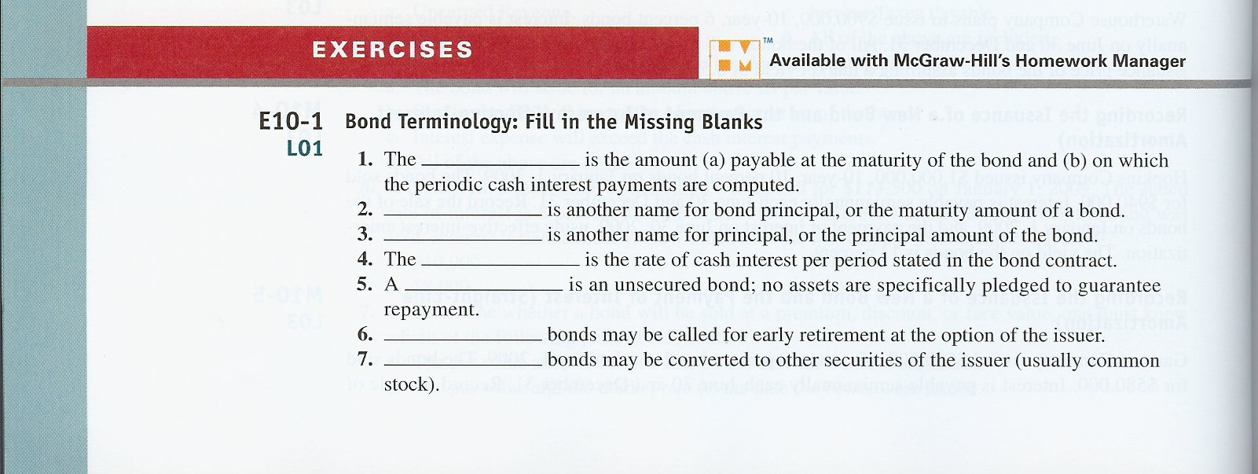

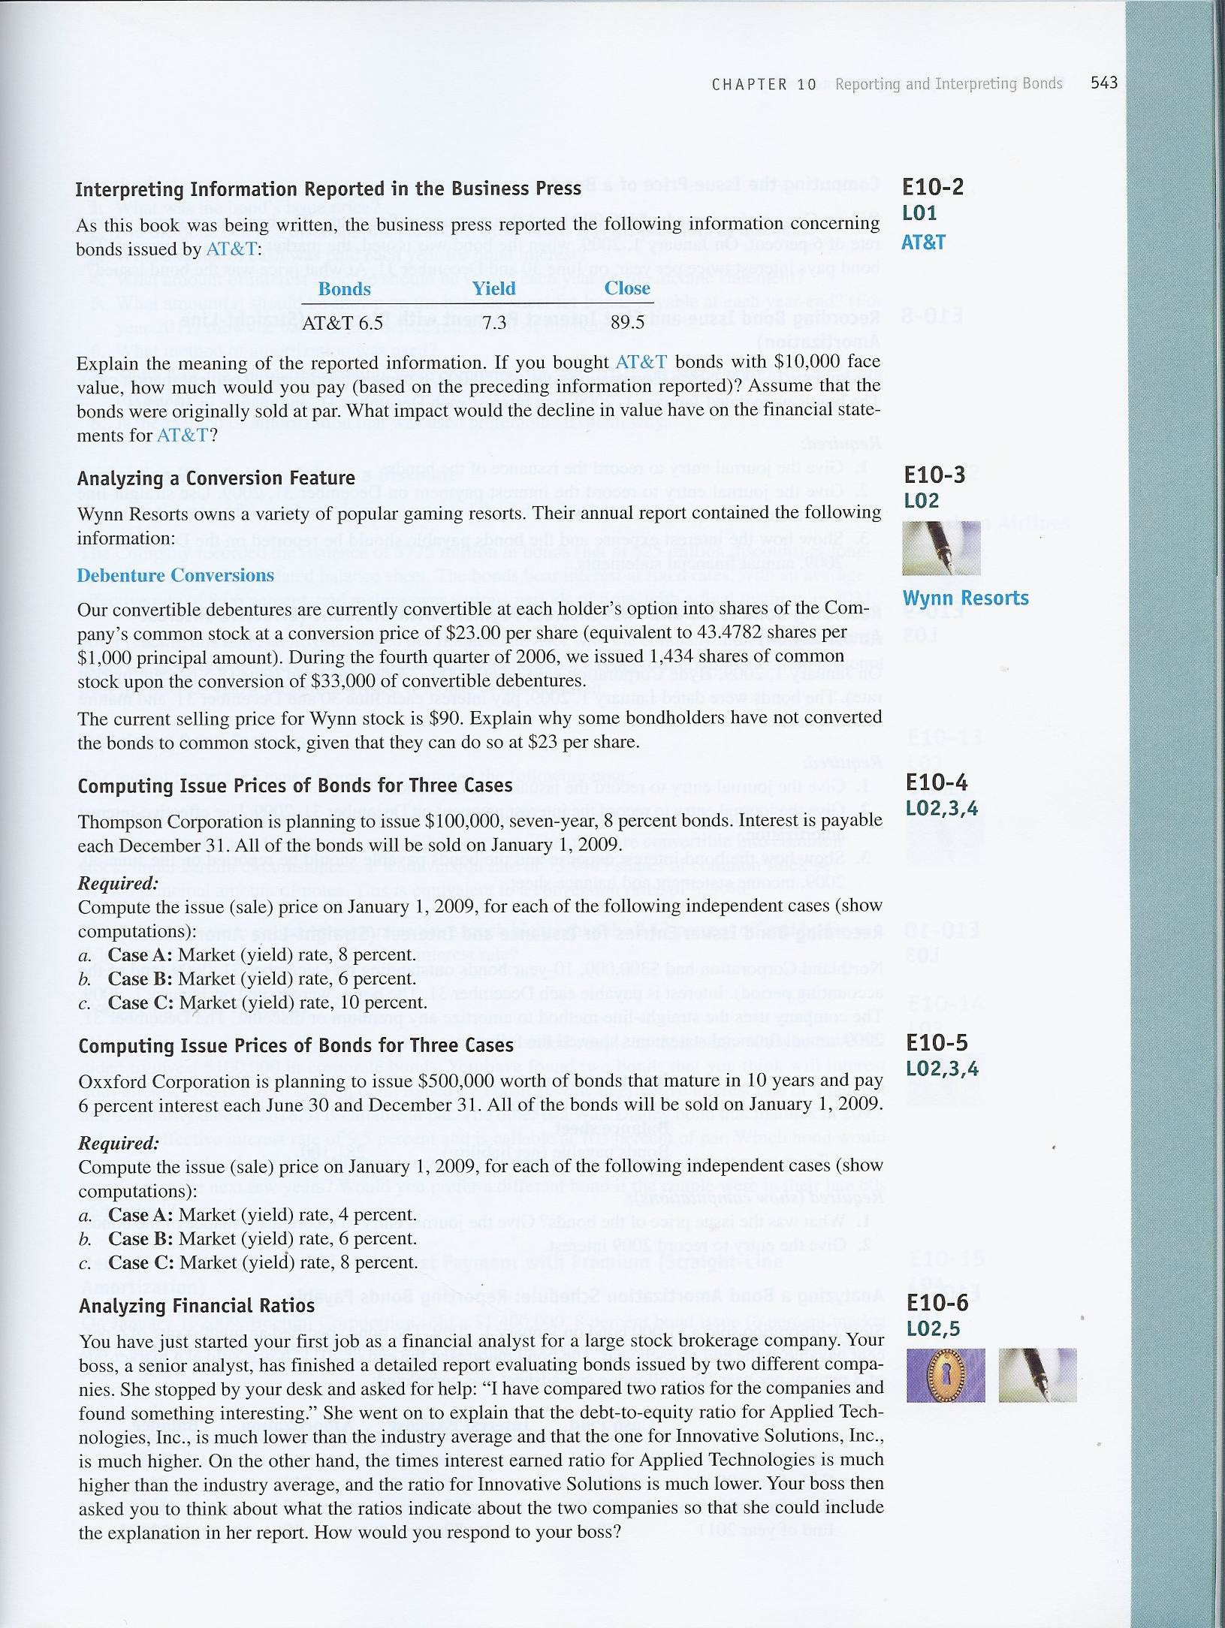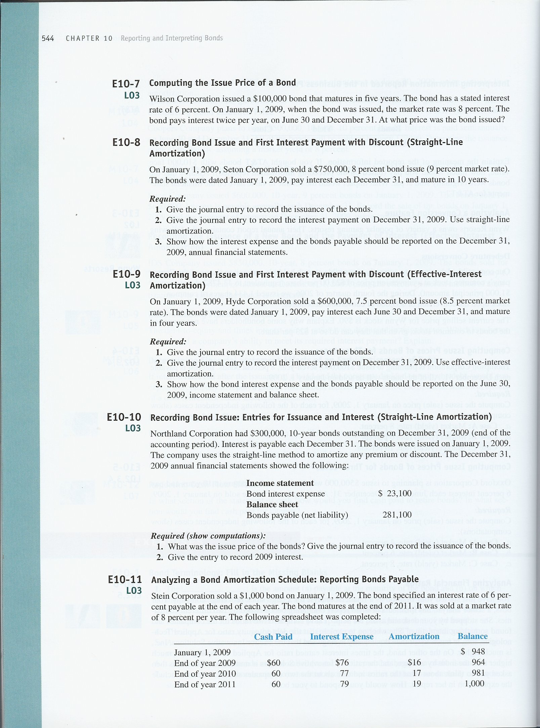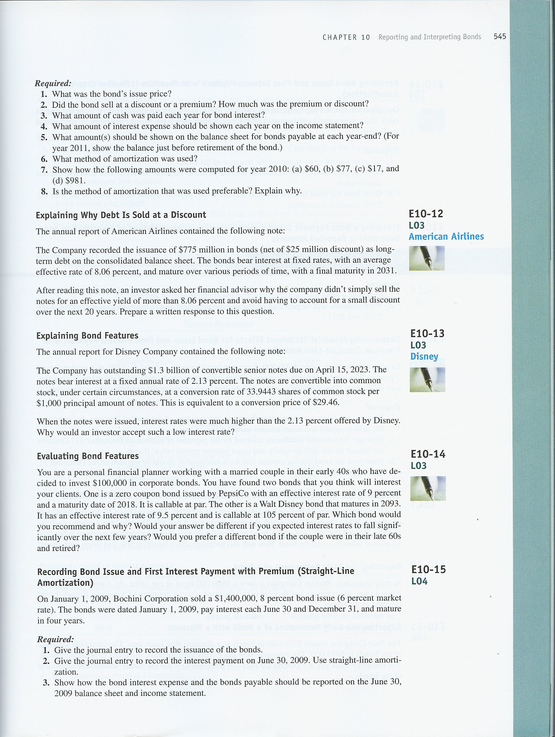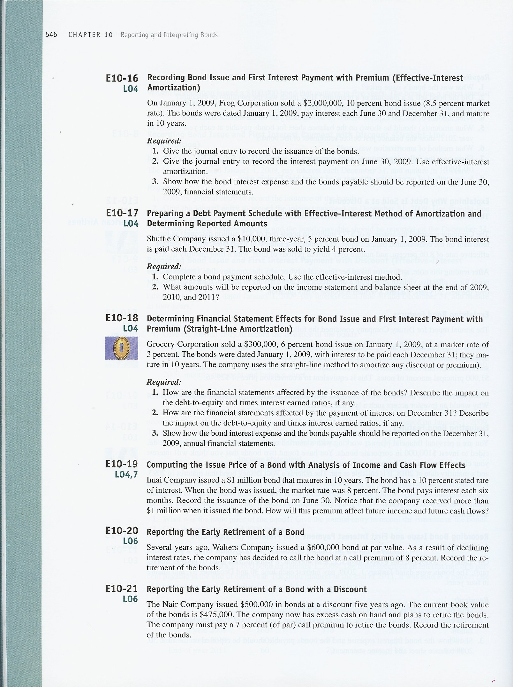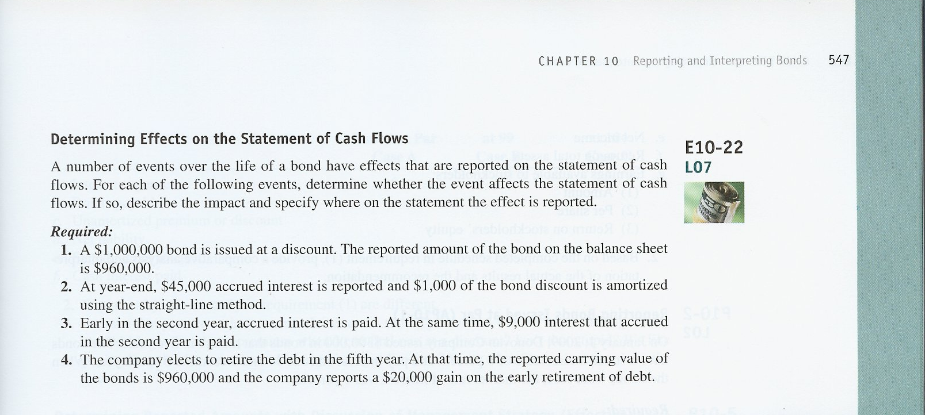

EXERCISES

E10–1.

1. Bond principal, par value, or face value
2. Par value or face value
3. Face value or par value
4. Stated rate, coupon rate, or contract rate
5. Debenture
6. Callable bonds
7. Convertible bonds

E10–2.
The AT&T bonds have a coupon interest rate of 6.5%. If bonds with a $10,000 face value were purchased, the issue price would be $8,950 and they would provide a cash yield of 7.3%. A decline in value after issuance would have no impact on AT&T’s financial statements.

E10–3.

When a bond offers a conversion feature, its value will be affected by the value of the common stock. As the price of the stock goes up, the bond becomes more valuable. In the case of the Wynn bond, each $1,000 face value bond can be converted into 43.4782 shares of stock. Given that the stock now sells for $90 per share, each bond is worth at least $3,913 based on this conversion feature. A bondholder who needs cash can simply sell the bond rather than converting it to stock and then selling the stock. In many cases, it is better to hold a company’s bond than its stock. Such is the case with Wynn. The company’s stock does not pay dividends but the bonds do pay periodic interest. Therefore, holders of bonds can participate in the appreciation of the stock while earning interest on their investment.

E10–4.
CASE A:
$100,000 x 0.5835 | $ 58,350
$8,000 x 5.2064 | 41,651
Issue price (market and stated rate same) | $100,001 |  | (at par; $1
 |  |  | rounding error)
CASE B:
$100,000 x 0.6651 | $ 66,510
$8,000 x 5.5824 | 44,659
Issue price (market rate less than stated rate) | $111,169 |  | (at a premium)
CASE C:
$100,000 x 0.5132 | $ 51,320
$8,000 x 4.8684 | 38,947
Issue price (market rate more than stated rate) | $ 90,267 |  | (at a discount)

E10–5.
CASE A:
$500,000 x 0.6730 | $ 336,500
$15,000 x 16.3514 | 245,271
Issue price (market rate less than stated rate) | $581,771 |  | (at a premium)
CASE B:
$500,000 x 0.5537 | $ 276,850
$15,000 x 14.8775 | 223,163
Issue price (market rate and stated rate same) | $500,013 |  | (at par, $13
CASE C: |  |  | rounding error)
$500,000 x 0.4564 | $ 228,200
$15,000 x 13.5903 | 203,855
Issue price (market rate more than stated rate) | $ 432,055 |  | (at a discount)

E10–6.
Applied Technologies’ ratios look better than Innovative Solutions’ ratios. Applied Technologies has a lower debt-to-equity ratio than Innovative Solutions. This means that they have less debt in their capital structure, and therefore, are a less leveraged company and have less risk than Innovative Solutions. Applied Technologies’ times-interest-earned ratio is higher than the ratio for Innovative Solutions. This also makes Applied Technologies a less risky company than Innovative Solutions because Applied Technologies generates a larger amount of income compared to its obligatory payments to creditors than Innovative Solutions.

E10–7.
Computations:
Interest:
$100,000 x 6% x 1/2 | = | $3,000
Present value:
$100,000 x 0.6756 | = | 67,560
$ 3,000 x 8.1109 | = | 24,333
Issue price | = | $91,893

E10–8.
Computations:
Interest:
$750,000 x 8% | = | $ 60,000
Present value:
$750,000 x 0.4224 | = | 316,800
$ 60,000 x 6.4177 | = | 385,062
Issue price | = | $701,862

Req. 1
January 1:
Cash (+A) | 701,862
Discount on Bonds Payable (+XL, -L) | 48,138
Bonds Payable (+L) |  |  | 750,000

Req. 2
December 31:
Bond Interest Expense (+E, -SE) | 64,814
Discount on Bonds Payable (-XL, +L) |  |  | 4,814
Cash (-A) |  |  | 60,000

Req. 3
December 31, 2009:
Income statement:
Bond interest expense | $ 64,814
Balance sheet:
Long-term Liabilities
Bonds payable | $750,000
Less: Unamortized discount ($48,138 - $4,814) | 43,324 |  | $706,676

E10–9.
Computations:
Interest:
$600,000 x 7.5% x 1/2 | = | $ 22,500
Present value:
$600,000 x 0.7168 | = | 430,080
$ 22,500 x 6.6638 | = | 149,936
Issue price | = | $580,016

Req. 1
January 1:
Cash (+A) | 580,016
Discount on Bonds Payable (+XL, -L) | 19,984
Bonds Payable (+L) |  |  | 600,000
Req. 2
June 30:
Bond Interest Expense (+E, -SE) ($580,016 x 8.5% x 1/2) | 24,651
Discount on Bonds Payable (-XL, +L) |  |  | 2,151
Cash (-A) |  |  | 22,500

Req. 3
June 30, 2009:
Income statement:
Bond interest expense | $ 24,651
Balance sheet:
Long-term Liabilities
Bonds payable | $600,000
Less: Unamortized discount ($19,984 – $2,151) | 17,833 |  | $582,167

E10–10.
Req. 1
Issue price:
1. Par, $300,000 – Carrying value at end of 1 year, $281,100 = $18,900 (unamortized discount for 9 remaining years).
2. $18,900 ÷ 9 years = $2,100 discount amortization per year (straight line).
3. $281,100 – $2,100 = $279,000 issue price (discount $21,000).
Issuance entry:
Cash (+A) | 279,000
Discount on bonds payable (+XL, -L) | 21,000
Bonds payable (+L) |  |  | 300,000
Req. 2
Coupon (stated interest) rate:
1. Reported interest expense, $23,100 – Discount amortized, $2,100 = $21,000 (cash interest).
2. $21,000 ÷ $300,000 = 7% coupon (stated interest) rate.
Interest expense:
Interest expense (+E, -SE) | 23,100
Discount on bonds payable ($21,000 ÷ 10 years) (-XL, +L) |  |  | 2,100
Cash ($300,000 x 7%) (-A) |  |  | 21,000

E10–11.
1. Issue price: $948. Stated rate, 6%; effective or yield rate, 8% (both were given).
2. Discount: $1,000 – $948 = $52.
3. $1,000 x 6% = $60.
4. 2009, $76; 2010, $77; 2011, $79.
5. Balance sheet:
2009 |  | $ 964
2010 |  | $ 981
2011 |  | $1,000 |  | (immediately before retirement)
6. Effective-interest amortization was used.
E10–11. (continued)
7. (a) $1,000 x 6% = $60.
(b) $964 x 8% = $77 (rounded).
(c) $77 – $60 = $17.
(d) $964 + $17 = $981.
8. Effective-interest amortization measures the amount of interest expense and net liability for each period on a present value basis. The interest expense and related amortization are based on the actual unpaid balance of the debt and the effective interest rate. Straight-line amortization is an approximation that does not take these factors into consideration. The effective-interest method is conceptually preferable but the straight-line method is used widely in practice because of computational simplicity and the materiality concept.

E10–12.
The effective interest rate for a bond is determined by market forces and not the company. American was able to specify the coupon rate for the bonds which determines the periodic interest payments. It appears that American intended to sell the bonds close to par value which would be achieved by having a coupon rate that was the same as the market rate. The market rate of interest continually changes as the result of such factors as inflation expectations and the level of business activity. It is virtually impossible to issue a bond at a point when the coupon rate and the market rate are exactly the same.

E10–13.
Students will typically offer one of two explanations:
- Normally, bonds that offer less than the market rate sell at a discount that results in a bond yield equal to the market rate of interest. While this is generally true, we do not think it explains the low interest rate for the Disney bond.
- The Disney bond includes a feature not seen in most bonds. It provides investors with the opportunity to participate in stock price appreciation while holding a more conservative investment. The conversion feature permits bond holders to convert their bonds into stock at a price of $29.46 per share. When this problem was written, Disney stock was selling for $33 per share. This conversion feature enhances the potential return for investors and permits the issuer to pay a lower rate of interest.

E10–14.
Assuming that both companies offer the same business risk, many people might prefer the bond that had the slightly higher yield which is Walt Disney at 9.5%. If interest rates were to fall significantly, companies might decide to call their bonds and issue new ones at a lower interest rate. In this case, a zero coupon bond offers an extra margin of protection. A zero is sold at a deep discount (say 60% of par). It would be very unusual to see a company call such a bond if it were callable at par. In this case, the PepsiCo bond would be preferred.
Many people who are retired desire to have a steady income without engaging in time-consuming transactions. These people would probably not want to buy a zero coupon bond which paid interest only at maturity.

E10–15.
Computations:
Interest:
$1,400,000 x 8% x 1/2 | = | $ 56,000
Present value:
$1,400,000 x 0.7894 | = | 1,105,160
$ 56,000 x 7.0197 | = | 393,103
Issue price | = | $1,498,263

Req. 1
January 1:
Cash (+A) | 1,498,263
Premium on Bonds Payable (+L) |  |  | 98,263
Bonds Payable (+L) |  |  | 1,400,000
Req. 2
June 30:
Bond Interest Expense (+E, -SE) | 43,717
Premium on Bonds Payable (-L) | 12,283
Cash (-A) |  |  | 56,000

Req. 3
June 30, 2009:
Income statement:
Bond interest expense | $ 43,717
Balance sheet:
Long-term Liabilities
Bonds payable | $1,400,000
Plus: Unamortized premium ($98,263 – $12,283) |  | 85,980 |  | $1,485,980

E10–16.
Computations:
Interest:
$2,000,000 x 5% | = | $ 100,000
Present value:
$2,000,000 x 0.4350 | = | 870,000
$ 100,000 x 13.2944 | = | 1,329,440
Issue price | = | $2,199,440
Req. 1
January 1:
Cash (+A) | 2,199,440
Premium on Bonds Payable (+L) |  |  | 199,440
Bonds Payable (+L) |  |  | 2,000,000
Req. 2
June 30:
Bond Interest Expense (+E, -SE) ($2,199,440 x 4.25%) | 93,476
Premium on Bonds Payable (-L) | 6,524
Cash (-A) |  |  | 100,000

Req. 3
June 30, 2009:
Income statement:
Bond interest expense | $ 93,476
Balance sheet:
Long-term Liabilities
Bonds payable | $2,000,000
Plus: Unamortized premium ($199,440 – $6,524) | 192,916 |  | $2,192,916

E10–17.

Req. 1
Date |  | Cash  Interest |  | Interest Expense |  | Premium  Amortization |  | Net Liability  Balance
1/1/2009 |  |  |  |  |  |  |  | $10,278
12/31/2009 |  | $500 |  | $10,278 x 4% = $411 |  | $89 |  | 10,189
12/31/2010 |  | 500 |  | $10,189 x 4% = $408 |  | 92 |  | 10,097
12/31/2011 |  | 500 |  | $10,097 x 4% = $404 |  | 96 |  | 10,001*
* $1 rounding error
Present value computation:
Principal: |  | $10,000 x .8890 |  | $ 8,890
Interest: |  | 500 x 2.7751 |  | 1,388
 |  | Issue price |  | $10,278
Req. 2
 | 2009 |  | 2010 |  | 2011
December 31:
Interest expense | $411 |  | $408 |  | $404
Bond liability…………………. | $10,189 |  | $10,097 |  | $10,000*
*Immediately before repayment of principal

E10–18.
Req. 1
Cash is increased on the balance sheet. The statement of cash flows shows an inflow from financing activities. Bonds payable and premium on bonds payable are increased on the balance sheet. The debt-to-equity ratio will be increased.
January 1:
Cash (+A) | 376,774
Premium on bonds payable (+L) |  |  | 76,774
Bonds payable (+L) |  |  | 300,000
Principal: $300,000 x .7441 |  |  | $223,230
Interest: $18,000 x 8.5302 |  |  | 153,544
Issue (sale) price |  |  | $376,774

Req. 2
The interest expense will be increased on the income statement and the cash will be decreased on the balance sheet. The premium on bonds payable will be decreased on the balance sheet. The debt-to-equity ratio will be decreased and the times-interest-earned ratio will be decreased.
December 31:
Interest expense (+E, -SE) | 10,323
Premium on bonds payable ($76,774 ÷10 periods) (-L) | 7,677
Cash ($300,000 x 6%) (-A) |  |  | 18,000

Req. 3
December 31, 2009:
Income Statement:
Bond Interest Expense | $10,323
Balance Sheet:
Long-term Liabilities
Bonds Payable | $300,000
Add: Unamortized premium ($76,774 - $7,677) | 69,097 | $369,097

E10–19.
Req. 1
Computations:
Interest:
$1,000,000 x 10% | = | $100,000 ÷ 2 = $50,000
Present value
$ 1,000,000 x .4564 | = | 456,400
$ 50,000 x 13.5903 | = | 679,515
 |  | $ 1,135,915
June 30:
Cash (+A) | 1,135,915
Bond payable (+L) |  |  | 1,000,000
Bond premium (+L) |  |  | 135,915
Req. 2

The amortization of bond premium results in cash payments for interest that are higher than reported interest expense for the period.

E10–20.

Bond payable (-L) | 600,000
Loss on bond call (+E, -SE) | 48,000
Cash (-A) |  |  | 648,000

E10–21.

Bond payable (-L) | 500,000
Loss on bond call (+E, -SE) | 35,000
Bond discount (-XL,+ L) |  |  | 25,000
Cash (-A) |  |  | 510,000

E10–22.
- Impacts Statement of Cash Flows (SCF) : report $960,000 inflow in financing section
- Does not impact SCF
- Impacts SCF : report $54,000 payment in operating activities section
- Impacts SCF : report $940,000 payment in financing section

