Thammasat University

Spanish flu and Public health

Treerapat srisatapornvong 6204640442
Watchara wiboonpattanapong 6204640590
Gulanut kiatsuranon 6204641416

Contemporary Economic Issues
EE406
Ajarn Thanasak Jenmana

Spanish flu and Public health

Spanish flu was marked as one of the most tragic incidents in the history of mankind as its deadly effects far reached almost all parts of the world. Due to the horrible consequences of the Spanish flu, this paper attempts to explore the main factors that contributed to the spreading of this virus, the complications of the determination of the mortality rates, as well as the aftermaths.
The 1918 influenza pandemic recognized as “Spanish flu” and sometimes known scientifically as the H1N1 and this virus that infected the respiratory system, the deadliest and most fast-spreading global outbreak, indiscriminately infected and killed patients from young, old to healthy citizens and led to fear of worldwide. The deaths began more than the Great War, known as World War I(WWI) thus it turned out that Spanish flu caused approximately 500 million contaminated and argued around 50 million people lives, The flu was most deadly in people who ages around 20-40, that happened in the overlapping time for around 8 months. Spanish flu was firstly detected in Europe, the United States, and regions in Asia before it spread throughout the world. At that time, the virus was incurable since there were no effective medications and vaccines to treat it causing the quick deaths around the world which resulted in Spanish flu to be the deadliest pandemic during the contemporary era.There was also a shortage of medical workers since they had to be responsible for the war casualties. The aspirin poisoning also occurred since doctors over-prescribe it to patients who suffer from the flu.This research will briefly illustrate the background of Spanish flu, as well as, explain its social issues, global effect, and economics.The term “Spanish flu”, it’s unlikely that this virus originated from Spain and until now the scientists are still uncertain of its source, So the first case that we known was announced in Kansas, United States of America, on March 11 in 1918. In the past, the individual was ordered to wear masks and quarantine at home.Furthermore, schools, theaters, and some businesses were shuttered, so this situation is similarly to the current time.

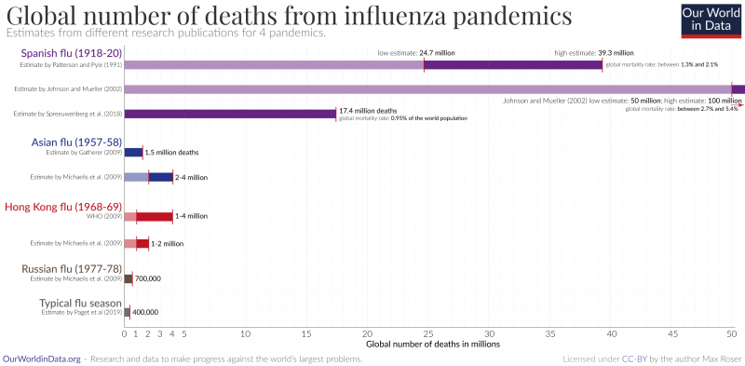

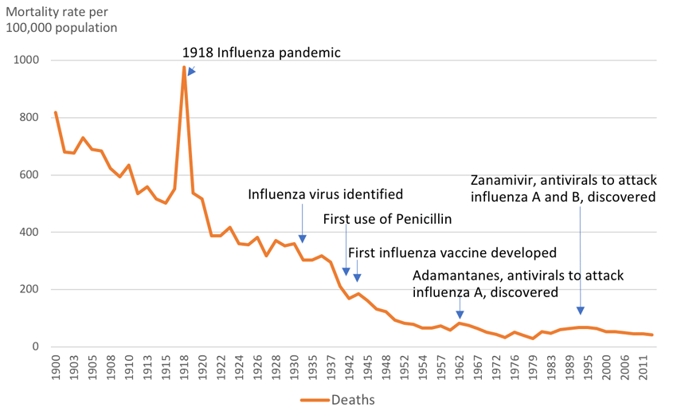

Causes
For the causes of the Spanish flu pandemic, generally, flu or influenza is a type of virus that attacks the respiratory system. It is an airborne disease that is highly spread around the world. Individuals who have issues with respiratory systems such as asthma, pneumonia, ear and sinus infections, etc. are vulnerable and at-risk to flu already. In western countries, typically, “flu season” occurs around fall until spring season which is the period that the flu spreads widely and infects a lot of people. In addition, Spanish flu is caused by influenza virus, H1N1, which is presumed to have the same characteristics as bird flu (CDC, 2019) . It can be transmitted from animals to people. Patients would begin to experience fever, cough, sneezing, nausea, aches, and diarrhea which are similar to the symptoms of common flu. However, this virus is terrifying that it can evolve and mutate into a new and more deadly virus, causing the patients to start to bleed in parts, suffocate, and die quickly whether it's a kid, an old man or even a young man. This is because this virus is spread and can be transmitted through air like the flu. This was during the World War I (1914-1918) in the late 191, when the World War was reaching its end. There has begun a virus outbreak in both military armies and millions of soldiers have died (Billings, 2005). Nonetheless, every country has tried to keep the news from outsiders and the military that there was an epidemic to prevent the fear of the soldiers from panicking, as well as not wanting to disclose to the opponent that their army was weak.
Spain, which did not participate in the war and was neutral, was the broadcaster of this terrible epidemic to all countries. Various countries thought that Spain is an epidemic area of ​​this disease and named it the "Spanish Flu." The Spanish flu pandemic spread around the world between 1918 and 1919, partly from soldiers infected with the virus and returned to their home countries (Billings, 2005). One of the notable events everyone was talking about was the Liberty Loan parade in Philadelphia. A parade to celebrate the end of the world war that built morale for people and welcome veterans. However, at that time, the Spanish flu epidemic continued to spread.On September 19, 1918, ten days before the event, 600 soldiers were reported to have contracted the Spanish flu, but the parade continued on September 28 (Wirth, n.d.). In 1918, as many as 200,000 Philadelphia residents attended the parade (Wirth, n.d.). October 1st, just 3 days after the event, 635 more cases were reported. Six weeks later, there were 12,000 more deaths and 47,000 additional infections, ultimately from the outbreak in six months. A total of 16,000 Philadelphia residents have died and 500,000 have been infected (Wirth, n.d.). Organizing a parade that day might not be the only cause of death but should have caused a lot of death compared to the city of St. Louis that canceled the parade where only 700 people died. There were about 50 million deaths worldwide and possibly as many as 100 million, as accurate statistics were not kept at the time, and 500 million people were infected, which was 27 percent of the global population (Roser, 2020). At that time there were 1.8 to 1.9 billion people, many times more than the deaths in World War I.

Spanish flu in Three Waves

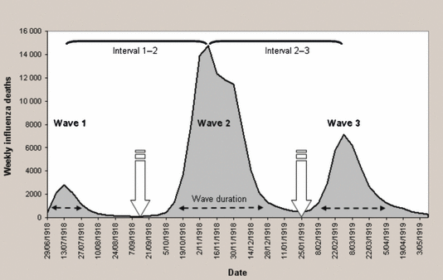

First wave: The first known case happened in the late final years of World War I or in Spring 1918. In March 1918, it was a period of 11 months in which the United States fought with Germany and the Central Powers (Centers for Diseases Control and Prevention, 2019). It was a time when American forces were still small until they began to mobilize large forces in order to ready to send more than two million soldiers to Europe by increasing the number of military bases and training centers in the country to prepare troops to fight on the battlefield. One of them was Fort Riley in Kansas, where a new training facility of more than 50,000 men was preparing to be trained before traveling to Europe. At this time, it was reported that soldiers with fever were admitted to medical facilities within the military bases before the number of people with the same symptoms had increased to hundreds more in a matter of hours. And, when entering April Scheduled forces to arrive in Europe, the beginning point of spreading the first wave of H1N1 or Spanish flu virus had officially begun.

Second Wave: Next, the second period of Spanish flu which began during the autumn of 1918 had killed many people within a short time. More than 195,000 Americans died in October (Roos, 2020). Compared to the number of deaths during World War I, the number of deaths was only around 116,000 (Rank, 2020). And, once again, the overcrowded barracks became the starting point for the second wave of the epidemic which was the Devens military camp in Massachusetts, where the epidemic began with more than 6,674 confirmed cases. In this second wave, there was almost nothing different. Soldiers who became ill with similar symptoms continued to receive treatment in the camp. However, the medical service itself began to go into a crisis. Funeral officials and undertakers had been unable to carry out normal funeral businesses, leading to the massing of the remains of the deceased into a large cemetery. This caused the spread of infection beyond tolerable.

Third Wave: After the second wave of Spanish Flu epidemic in 1918 which had affected humanity's life and way of being for decades without an expert to fully handle it, the flu has disappeared from human society for no reason. However, the nightmares revisited humanity in early 1919 when the Spanish flu pandemic had become and severely hit the world of humans in the way that no one could have predicted before. Because of this fact, it can be called the Third Wave of Spanish fever itself (Roser, 2020). In detail, there was a 1919 report that was written by Sir Arthur Neussholm from the Royal Medical Association of the United Kingdom (Roser, 2020). The key message of the report stated that the epidemic could be construed as a serious wildfire incident. The spread of the disease does not ignore the location, places and time. In spite of the crowded military transport system and hundreds of labor-intensive weapons factories, the epidemic could not be avoided. Nevertheless, the ugly truth was the fact that the advice articles for the public written by Neussholm in July 1918, which Neussholm advised people to stay at home if they were sick, was secretly kept by the government and banned from being publicly released. After that, by the summer of 1919, the outbreak had subsided. This has been thought by many to be the result of improved disease control by the government and the team. However, there was the evidence showing that this was not the case. The most likely case for this was the fact that the virus had mutated itself which calmed the violence of the world. Together with, there was the possibility that humans would infect each other around the world until they had completely spontaneous resistance.
In response to the novel of 1918 influenza pandemic that was hazardous and deadly for the population in a global sphere. Viruses such as spanish flu cause dispersion through entering the host, which is carried through the medium of transmissions such as air or physical contacts. It has been significantly observed that humans are mainly infected through personal contact, for instance, when a person coughs or sneezes, the dribbles carrying the virus can disperse into the air and can reach other persons’ mouth respiratory system. Hence, quarantine and social distancing is proven to be highly effective in preventing the virus, which, when contracted with more humans, can cause a widespread infection, giving rise to a higher risk of death. By that time, people of many countries quarantined and did the social distancing policy to prevent themselves from getting infected. In developed countries, this policy would be considered as the most effective one in keeping people from dying as a result of the virus. However, in impoverished countries, social distancing conveys drastic human disaster, in which the population faces hunger, ailment, and long-term unemployment. In any case, given that there are still no remedies that cure the disease discovered yet,quarantine and social distancing is considered to be the best way to reduce the number of cases of the influenza at that moment.

Globalization
Through the lens of globalization,to generalize, globalization is when the world becomes more interconnected in various aspects such as economy, culture, international diplomacy and so on.The incident of World War I was actually marked at the turning point of the connected and traveling across the continents.Before the beginning of WWI, people did not travel outside their regions much when compared to decades after. This limited the spread of infectious diseases such as Influenza from other countries.
On the other hand, during the war period, the movement and mobilization of armies and involved individuals occurred within the countries and across the country.The lives of non-combatants became even more connected and closed to each other. For instance, those who had to work inside the factories and produced supplies during wartime. They became close-connected right before the exposure to the flu. The regions that were prior isolated countries like Alaska and Samoa were affected hardly once the pandemic occurred. For instance, 22% of the population of the island of Samoa died from the virus.
During WWI, with the closed and unhygienic conditions, troops had to sleep in the trenches or camps causing the virus to mutate and kill the most vulnerable soldiers who mostly came from rural parts than those who came from the urban area (Mattews, 2014).The closeness and trench warfare mitigated the flu to spread and mutate in a way that it differed drastically from the century before that the plague occurred. After the U.S. filed the first report of the Spanish flu, the other parts of the world had begun to experience the spreading of the virus. It was documented that in August, 1918, there was a deadly strain of Spanish flu spreading in France and Sierra Leone, and the U.S. that killed people in 24 weeks more than the Black Death that killed people in a century (Sowards, 2020).
Furthermore, the new research suggested that the strain of influenza was essentially created in the trenches. Since the soldiers who suffered mild condition of the virus had to stay in the trench, and the ones who had severe illness had to be sent back home, during the trip back home, they could infect others due to the infectious nature of the virus (Sowards, 2020). It could be seen that the deadliness and fast-spreading of the Spanish flu directly resulted from the movement of the people around the globe, as well as, the close proximity of thousands of people that allowed viruses to mutate to become even more deadly than the Black Death phenomenon.

Public health
There are several reasons why developed countries or developing countries can not handle the Spanish flu infected rate. In 1918, public health was not good enough to control this pandemic owing to lack of knowledge and awareness, people are not reaching the fact that this influenza was infected easily and the announcement from the government is not getting citizens to take care of themselves in the correct way. Moreover, lacking a vaccine is the main cause that this pandemic kills such millions of people. However, the preparedness in each country is significant, many countries have started developing and implementing national influenza pandemic preparedness plans and these plans are the responses to prevent the pandemic which is the idea prevalent in society and the systematic in the society. For instance, it requires citizens to wear masks, be forced to close schools and restaurants, and ban all public gatherings: events , amusement, museums, and festivals.
The fighting in World War I is ending. But the Spanish flu is beginning to spread around the world. By the medical and scientific circles at that time, there were still many limitations in dealing with various ailments compared to today’s advancements. Treatment methods are limited. For instance, an antibiotic, newly discovered in 1928, when influenza vaccine was only available to the public in the 1940s. The victims of the Spanish flu are people between the ages of 20 and 40, and men are the more affected (Parmet & Rothstein, 2018). This situation occurred because an outbreak is believed to have started in the military camps at the "Western Front” during World War I, then the infection spread around the world when these soldiers returned home after the war was over. The epic origin of the plague of 1918 remains a mystery (Schwartz, 2018) . Due to medical limitations at the time, the word 'influenza' came from an Italian root meaning influence,or star influence, with regard to astrology, which the people of the era thought. The plague is caused by the influence of Jupiter and Saturn converging various disasters occurred (Schwartz, 2018) all around the world. Other theories related is that the plague came from the rotten carcass of dead animals in the open. Some theory mentioned, it was caused by an earthquake or volcanic eruption until it brought up the evil beneath the surface of the earth.
In the year 1890, two microbiologists from Berlin, a bacterium called 'Bacillus influenza' was discovered and believed to be the cause of influenza (Orentlicher, 2018). However, it was later found that it was an error in the basis because actually, although Bacillus influenza was found in people with influenza but did not cause the common cold (Orentlicher, 2018). It's just the number of two invaders taking the opportunity to enter the body while the immune system is weak. The culprit is actually the 'virus,' whereas the bacteria are just vultures eating the remains of predators. Viruses are much smaller than bacteria in which it can enter the body through many channels and no one has ever seen or known. They were dangerous predators and checkers. However, not until 1939, doctors and innovators invented a vital device for observing the virus with an electron microscope, giving us the first look at the virus (Roser, 2020). Later, we can successfully isolate the virus from the cold.
Scientists have also studied infants born during the Spanish flu pandemic. It was found that these children were more likely to be born with disorders such as heart disease than those born before and after the epidemic (Schwartz, 2018). Some theories hypothesize that the maternal stress that occurred during the epidemic can affect fetal development. However, the epidemic revealed the importance of international cooperation although World War I will cause the world to divide the political division (Schwartz, 2018). In 1923, the League of Nations, an international organization that was later replaced by the United Nations (United Nations), established the Health Organization, which became the World Health Organization (WHO) (CDC, 2019).
In the present, we now have vaccines for the flu. Nonetheless, it is far from 'perfect' because the vaccine itself is updated every year for the common cold virus mutation which if the year is lucky, only 50% of the vaccine is effective in treating the disease (Orentlicher, 2018). Moreover, the vaccine has different limitations in treating each patient ,and vaccines from 3 years ago may not be effective if taken this year. This is why it is imperative for the group of people at high risk, consisting of Children and the elderly.So, it is necessary to get the flu shot every continuous year. Therefore, the key task of further development is the more accurate vaccines for the universal treatment of the common cold virus.Hence, it is like a quest to find the solution of the medical community ever because it can reduce the enormous costs wasted in dealing with the flu and humans will not have to chase frequent updates and the treatment costs can be several times lower.

Inequality
In addition to the identified economic implications brought on by the outbreak of the Spanish flu, it is also arguable that the circumstances subsequently led to social inequalities amongst the general population throughout the world. While studies focusing specifically on the social inequalities of the Spanish flu are rare, there is still some evidence available which suggests that income inequality and income loss as a result of the economic crisis, contributed to a greater impact particularly towards the poorer sections of the general population around the world (Galleta and Gimmoni, 2020).
During the 1918 Spanish influenza pandemic, mortality rates differed considerably between high and low-income countries and between the rich and the poor in towns with a large degree of social inequality (Murray, C. Lopez, A. & Chin, B. 2006). During the onset of any pandemic throughout history, the most vulnerable demographics across societies usually tend to be the young, elderly, disabled and sick. However, individuals or communities with a lesser financial bracket or ability to readily obtain resources or benefits also suffer to a great extent. Evidently, much like today, developing countries with weaker infrastructures and healthcare facilities in 1918 suffered considerably more than their developed counterparts. For instance, the Spanish flu is estimated to have killed between 39-50 million of the global population at the time, yet poorer countries were hit hardest such as in India where it killed 5.2% of the population, and South Africa, where 3.4% died (Uren, D. 2020). Research by Galetta and Gimmoni suggests that pandemics in general do in fact increase income inequality percentages within societies. In 1918, this was particularly escalated as a result of the movement and ultimately the return of soldiers from the First World War conflict areas. Their research argues that in the short and medium term, this effect comes from a reduction in the amount of income gained by poorer communities, while the wealthier did not seem to be significantly impacted (Galetta and a Gimmoni, 2020).
To truly understand these inequalities between social classes during the Spanish Flu pandemic, it is important to understand the general environment and events during that time. Firstly, the Spanish flu coincided with the outbreak of the First World War, which arguably contributed significantly to escalating the regional and global spread of the virus across continents. Secondly, the general living conditions and standard of life was poor for a vast majority of the population throughout Europe, particularly through a lack of proper hygiene, a lack of sanitation facilities and difficulties for people in obtaining running water (Galleta and Gimmoni, 2020). Large portions of the world were living in abject poverty with a very low quality of living, coupled with a lack of access to healthcare facilities and infrastructure which inevitably impacted the poorer members of society more than others. Eugenics was then a mainstream view, and privileged elites looked down on workers and the poor as inferior categories of human beings, and public health generally referred to a suite of measures designed to protect those elites from the contaminating influence of the diseased underclasses (Spinney, L. 2020). The distribution of income and wealth, coupled with the lack of education and infrastructure in many developing nations meant a significantly uneven financial, and social balance in almost all societies around the world.
In the event of any pandemic at that particular time, public health generally tended to focus around a set of measures designed to protect the elites of society from the widespread devastation experienced by the poor. The concept of Eugenics seemed to be widely popular amongst the social elites during the turn of the 20th century, and played a pivotal part in the widespread social inequalities experienced throughout societies. Eugenics can essentially be described or defined as the belief of improving the humanity “by selectively breeding people with similar traits to ultimately stop disabilities and diseases in future populations. In Norwegian cities, the highest mortality rate was among the working classes with lesser means (Mamelund, S-E, 2006). This was a similar pattern across the globe, along with the illiterate, the unemployed and those with the most cramped living conditions who seemed to bear the brunt of the influenza's impact.
Again, this would be a reality of life experienced especially by those with lesser means and with a lower income bracket in society. The combination of fear of the virus and government interventions through state lockdowns and quarantine initiatives deeply hurt retail and other businesses that depended mainly on manual labour (Smith, N. 2020). Additionally, the significant number of males that were conscripted and deployed to fight in the conflicts of WW1, along with the significant loss of lives meant that the economy would naturally suffer, and was already at a fragile state in most countries even before the onset of the 1918 Pandemic. What the historical lessons from the 1918 pandemic is that the mechanisms leading to an increase of inequality and poverty in the aftermath of the crisis will be inevitable, and that the aftermath will be more of a factor leading towards social inequality rather than during the actual course of the outbreak.
In addition to the evident social inequalities and economic impact of the outbreak of the virus, the global healthcare systems were in short, ill prepared to deal with a virus of such proportions in 1918. With the onset of the Great War, much of the public healthcare facilities across Europe and later the United States, focused their efforts on the war front. Simply put, the entire global population and the health experts were not prepared for the spread of an influenza of such magnitude, and this subsequently led to mass hysteria, panic, and eventually, an unfathomable amount of fatalities. Many of the measures implemented were outdated and not suitable to withstand the considerable spread of the virus, which was doubled by the lack of effective preventative measures or available vaccines. Pandemics typically unfold across a wide spectrum of communities that are diverse in race, ethnicity, age, gender, and socioeconomic means (Stern, A. M., Cetron, M. S., & Markel, H. 2010). The United States especially had experienced a great shortage of professional nurses during the flu pandemic, as the majority of them were sent to military facilities to assist in the war effort.
As previously mentioned, doctors, healthcare practitioners and medical scientists were ill prepared in dealing with such a deadly strain of the flu, and no cures or vaccines were made available which lead to such immeasurable loss of life throughout the world. To overcome the shortages in healthcare workers, the US Public Health Service dispatched its Volunteer Medical Ser- vice Corps, Hospitals extended staff hours, assigned student nurses and doctors full duties, assigned Dentists as physicians, discharged the least ill, and accepted only urgent admissions (Schoch-Spana, M. 2001). At that time the idea of virus pandemics and vaccines were still in an infantile stage resulting in the clear lack of preparedness, and most doctors either worked for themselves or were funded by charities or religious institutions, and many people had no access to them at all (Spinney, L. 2020). Additionally, due to a lack of adequate infrastructure and facilities to shelter and care for the huge number of patients, healthcare organizations began creating makeshift medical tents, set up beds in hallways and office buildings, and even began turning down patients that were displaying only minor symptoms or other illnesses. In the US alone, many cities shutdown essential services, and health professionals including many volunteer nurses, deployed their limited medical armamentarium as they tirelessly tended to the ill and attempted to contain the spread of disease (Stern, A. M., Cetron, M. S., & Markel, H. 2010).
Without any available vaccine or antibiotics to treat the virus or the subsequent bacterial infections that tended to follow, efforts were structured around quarantine, isolation, hygiene, disinfectants, etc. There is substantial evidence pointing to the fact that the ill preparedness for the 1918 pandemic gave birth to the revamped and modernized healthcare systems that we have today, not to mention the substantial advancements that have since been made in the field of science and medicine. The international bureau of fighting epidemics was almost immediately established in 1919, followed by many countries creating or revamping health ministries in the 1920s, and introducing insurance measures (Spinney, L. 2020).

Economic impact

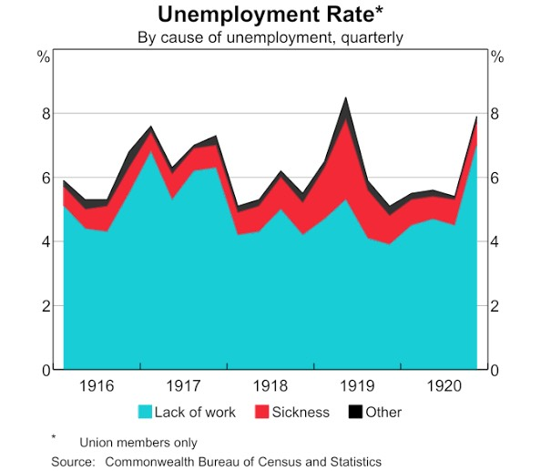

In the economic perspective, Spanish flu had obviously affected the economy on a significant scale since many lives had passed aways, and it happened at the overlapping period of WW I. The consequences of these incidents are commonly known that in several countries suffered economically. However, the research on the effects of the economy during Spanish flu is quite limited due to the lack of data and statistics during that period of time. Instead, the newspapers at that era were used to analyze the economic situations. For instance, the Arkansas Gazette in October 1918 reported that the percentages of grocery sales and department store sales fell down to 30 percent and 40-70 percent respectively. Furthermore, there also was a report on the labor shortages that affected the output or the production from the industrial fields(Garrett, 2008). In terms of the economic recovery, the recent studies suggested that Spanish flu decreased the GDP per capita approximately 6 percent among typical nations during the year between 1918-1921 (Barro et al, 2020). Additionally, the government measures also played an important role in controlling the effects of Spanish flu on the economy(Correia et al, 2020).

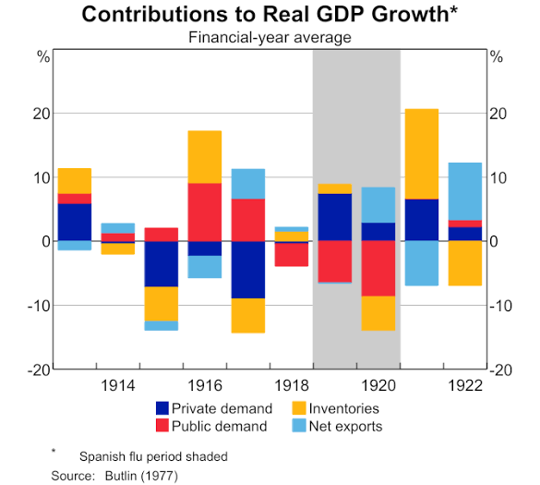

Furthermore, Real GDP can be measured by using a public demand and private demand,but it is almost impossible to isolate the effects of pandemic from other shock.Moreover, in some cases,using the public demand and private
demand is not enough to indicate the real GDP.A recent study by barro et al(2020) mentioned about “the third factor”,especially after shock of the pandemic. They are measuring the intensity of spanish flu to estimate the GDP across 42 countries. However, by applying this form to Australia.This model does not fit with the data and it is unclear whether mortality is a good agent for the agitation in Australia so this estimate is uncertain in order to capture all the effects. Thus, the effects of the Spanish flu on Australian’s GDP is very difficult to define due to the incapacity to control the other factors that influenced economics.

Conclusion
One of the critical ways to measure how large the pandemic is the death rate in which it is intended to focus on the idea of how it spreads and the consequences that occur permanently on humans. Even though it is called the spanish flu, the scientist is still unable to find the exact where the virus originated. The cause of the pandemic is divided into three parts. Firstly, the pandemic is an airborne disease due to the secretion that is distributed from human to human. Furthermore, the pandemic occurred in the world war one era thus the transportation of the soldier plays a crucial role in transmission the disease also the advancement of the disease which able to infect the animal to be the spreaders as well. The pandemic is at its highest spike; the second wave caused vastly increase which was measured by the numbers of the dead. Focus of this report is to determine the factors that have a large impact on during the pandemic; Public health. In the public health perspective, There are various shortages of knowledge in the field which most of focus during the era shifted toward the war veterian treatment. The mismanagement of the human waste led to the additional spread of the virus since the management in that area is not properly being managed by the state. When it comes to treatment in the past, one essential topic is the inequality that is related to wealth. The way people are treated in the past differentiate based on wealth, imposing the framework in india, the class still affects the way they get treated since the access of the healthcare system in india still a privilege therefore in the increasing value of inequality will lead to worsen the quality of the standard of living. We do believe this report will prevail with the additional information of the pandemic and we hope this will ignite the interest regarding this topic.

We raise the question : what is the main factors that influence the way we measure the deaths rate and what is its aftermath ?

Group members :

Treerapat srisatapornvong 6204640442
Watchara wiboonpattanapong 6204640590
Gulanut kiatsuranon 6204641416

Reference
- Garrett TA (2008), ‘Economic Effects of the 1918 Influenza Pandemic: Implications for a Modern-Day Pandemic’, Federal Reserve Bank of St. Louis Review, 90(2), pp 75–93.
- Correia S, S Luck and E Verner (2020), ‘Pandemics Depress the Economy, Public Health Interventions Do Not: Evidence from the 1918 Flu’, March, unpublished manuscript.
- Antoni Trilla, Guillem Trilla, Carolyn Daer, The 1918 “Spanish Flu” in Spain, Clinical Infectious Diseases, Volume 47, Issue 5, 1 September 2008, Pages 668–673,
- Parmet, W., &amp; Rothstein, M. (2018, November). The 1918 Influenza Pandemic: Lessons Learned and Not-Introduction to the Special Section. Retrieved November 06, 2020, from https://www.ncbi.nlm.nih.gov/pmc/articles/PMC6187781/
- History.com Editors. (2010, October 12). Spanish Flu. Retrieved November 06, 2020, from https://www.history.com/topics/world-war-i/1918-flu-pandemic
- 1918 Pandemic (H1N1 virus). (2019, March 20). Retrieved November 06, 2020, from https://www.cdc.gov/flu/pandemic-resources/1918-pandemic-h1n1.html
- Billings, M. (2005). The 1918 Influenza Pandemic. Stanford.Edu. https://virus.stanford.edu/uda/
- CDC. (2019, March 20). 1918 Pandemic (H1N1 virus). Cdc.Gov. https://www.cdc.gov/flu/pandemic-resources/1918-pandemic-h1n1.html
- https://www.passporthealthusa.com/2020/04/1918-spanish-flu-links-to-world-war-i/
- Murray CJ, Lopez AD, Chin B et al. Estimation of potential global pandemic influenza mortality on the basis of vital registry data from the 1918-20 pandemic: a quantitative analysis. Lancet 2006; 368: 2211 - 8
- Smith, N. 2020. Why Coronavirus Is Punishing the Economy More than Spanish Flu. Available at: https://www.bloomberg.com/opinion/articles/2020-05-06/why-coronavirus-is punishing-the-economy-more-than-spanish-flu
- Uren, D. 2020. The Strategist: Like Spanish flu, Covid-19 will hit the poor the hardest. Available at: https://www.aspistrategist.org.au/like-spanish-flu-covid-19-will-hit-the poor-the-hardest/
- Mamelund S-E. A socially neutral disease? Individual social class, household wealth and mortality from Spanish influenza in two socially contrasting parishes in Kristiania 1918-19. Soc Sci Med 2006; 62: 923 - 40
- Grantz KH, Rane MS, Salje H et al. Disparities in influenza mortality and transmission related to sociodemographic factors within Chicago in the pandemic of 1918. Proc Natl Acad Sci U S A 2016; 113: 13839 - 44.
- Schoch-Spana, M. (2001). " Hospital's full-up": the 1918 influenza pandemic. Public Health Reports, 116(Suppl 2), 32.
- Spinney, L. 2020. TIME: The World Changed Its Approach to Health After the 1918 Flu. Will It After The COVID-19 Outbreak? Available at: https://time.com/5797629/health 1918-flu-epidemic/
- Billings, M. (2005). The 1918 Influenza Pandemic. Stanford.Edu. https://virus.stanford.edu/uda/
- CDC. (2019, March 20). 1918 Pandemic (H1N1 virus). Cdc.Gov. https://www.cdc.gov/flu/pandemic-resources/1918-pandemic-h1n1.html
- Orentlicher, D. (2018). The Physician’s Duty to Treat During Pandemics. American Journal of Public Health, 108(11), 1459–1461. https://doi.org/10.2105/ajph.2018.304582
- Parmet, W. E., & Rothstein, M. A. (2018). The 1918 Influenza Pandemic: Lessons Learned and Not—Introduction to the Special Section. American Journal of Public Health, 108(11), 1435–1436. https://doi.org/10.2105/ajph.2018.304695
- Roser, M. (2020, March 4). The Spanish Flu (1918-20): The global impact of the largest influenza pandemic in history. Our World in Data. https://ourworldindata.org/spanish-flu-largest-influenza-pandemic-in-history
- Schwartz, J. L. (2018). The Spanish Flu, Epidemics, and the Turn to Biomedical Responses. American Journal of Public Health, 108(11), 1455–1458. https://doi.org/10.2105/ajph.2018.304581
- Spinney, L. (2018). The flu that transformed the 20th Century. Bbc.com; BBC Future. https://www.bbc.com/future/article/20181016-the-flu-that-transformed-the-20th-century
- Wirth, T. (n.d.). Encyclopedia of Greater Philadelphia | Influenza (“Spanish Flu” Pandemic, 1918-19). Philadelphiaencyclopedia.org. Retrieved November 5, 2020, from https://philadelphiaencyclopedia.org/archive/influenza-spanish-flu-pandemic-1918-19/
- Women: The Unsung Heroes of the 1918 Flu Pandemic. (n.d.). The Women in Medicine Legacy Foundation. Retrieved November 6, 2020, from https://www.wimlf.org/blog/women-the-unsung-heroes-of-the-1918-flu-pandemic

