AC 201 Fundamental Accounting
Chapter 6 Reporting and Interpreting Sales Revenue, Receivables, and Cash

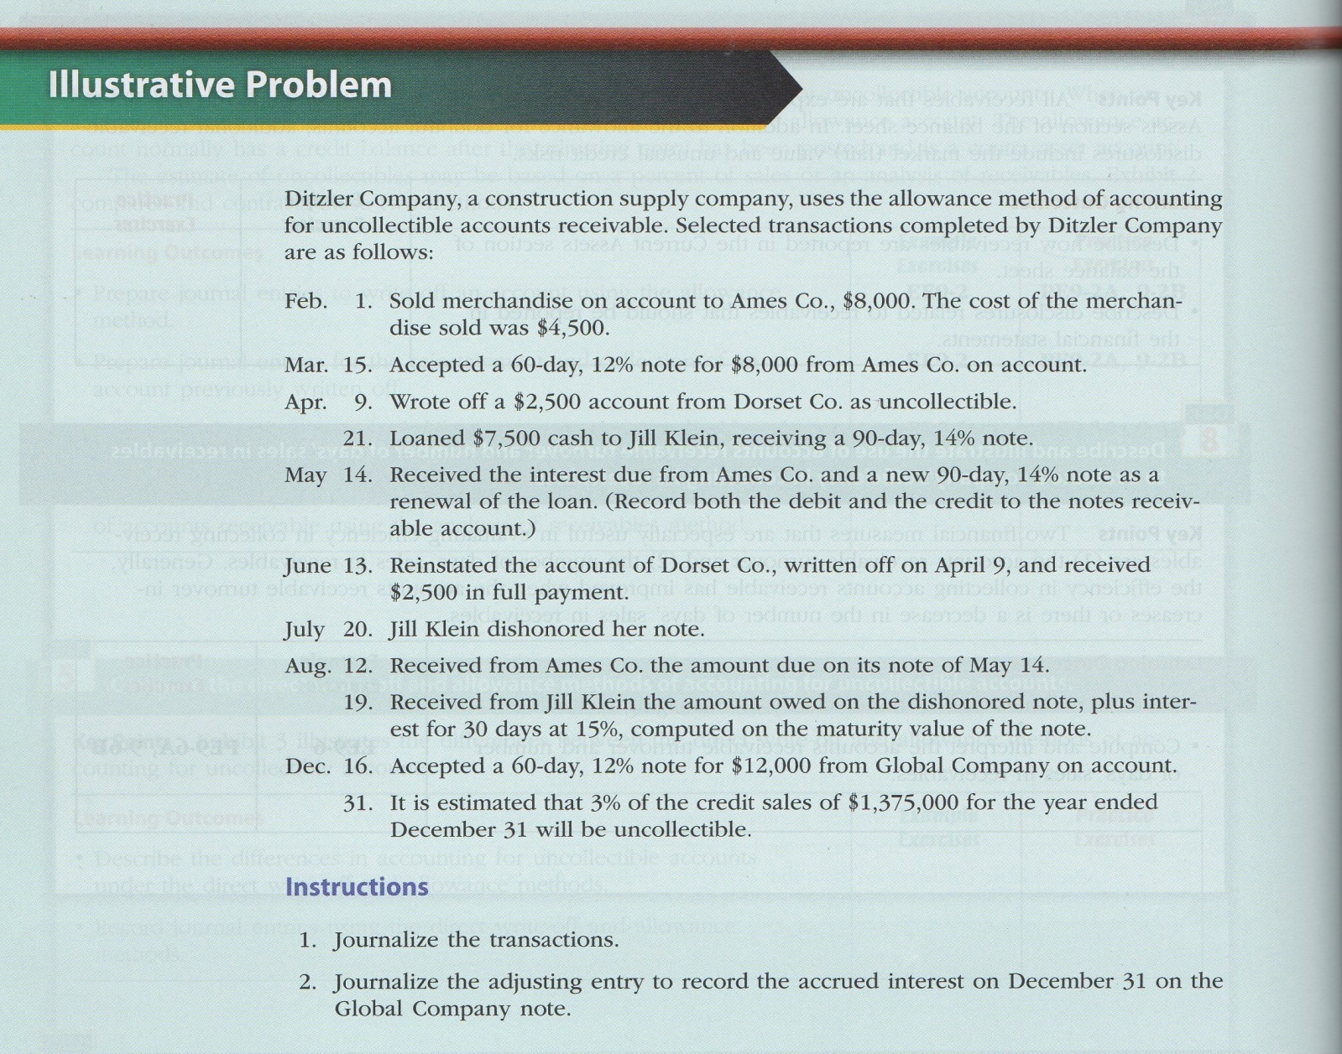

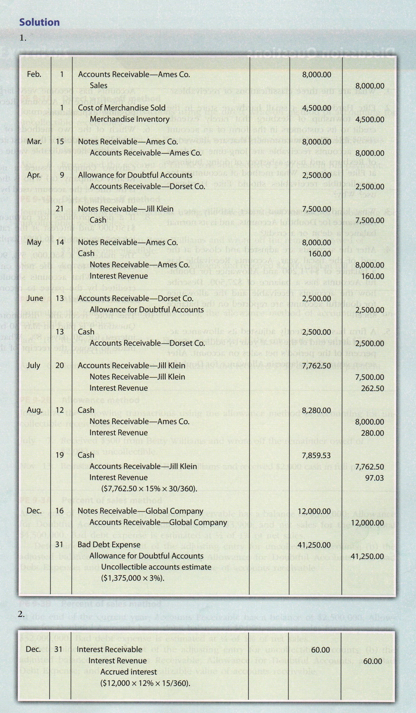
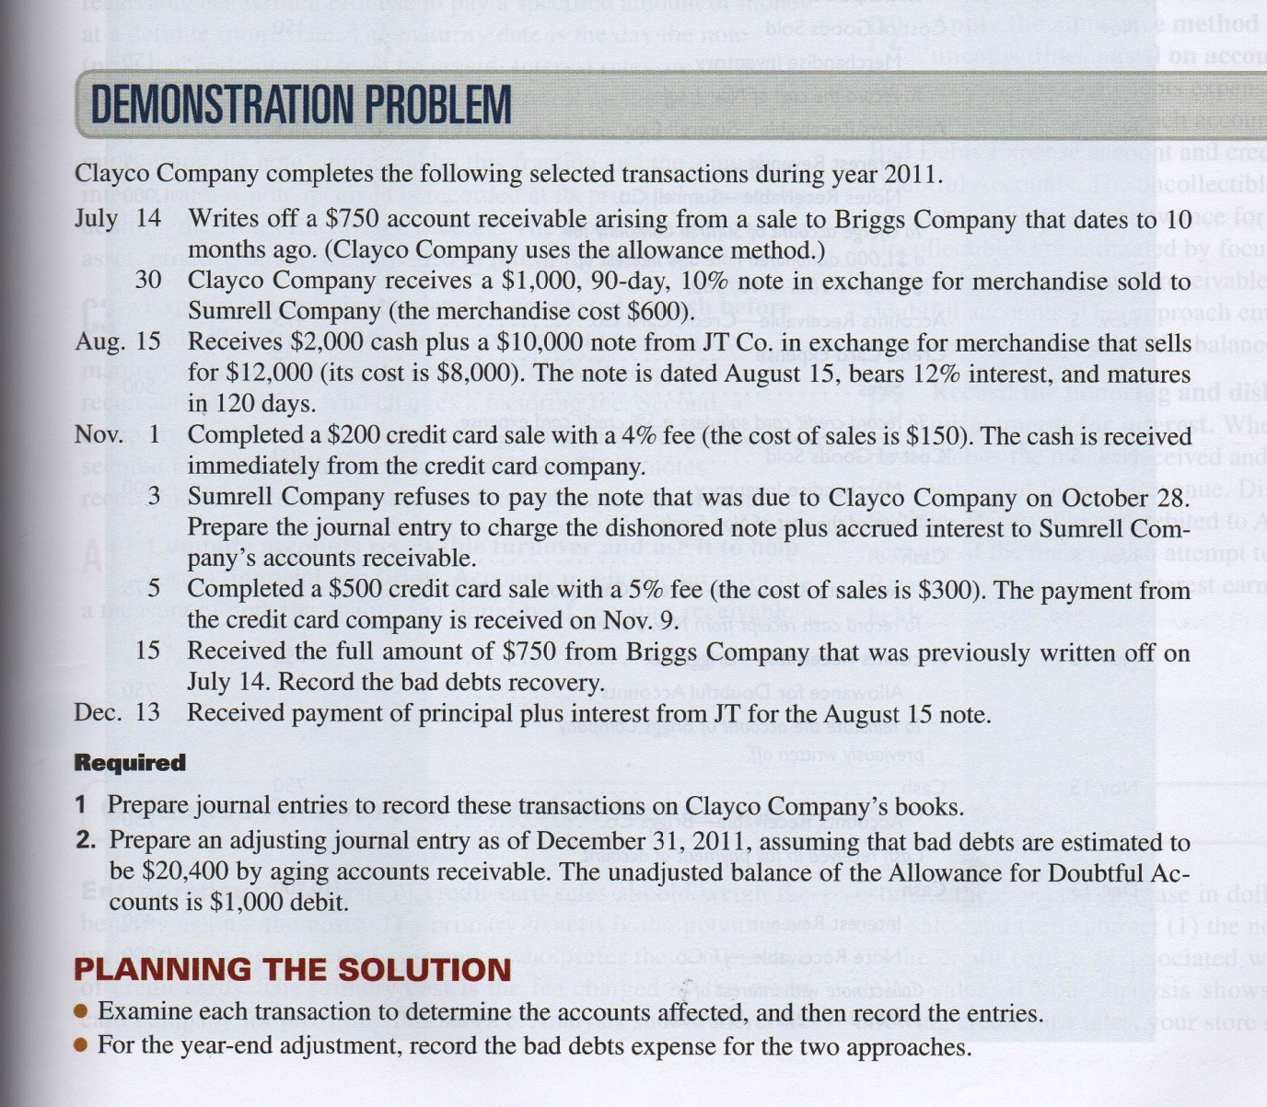

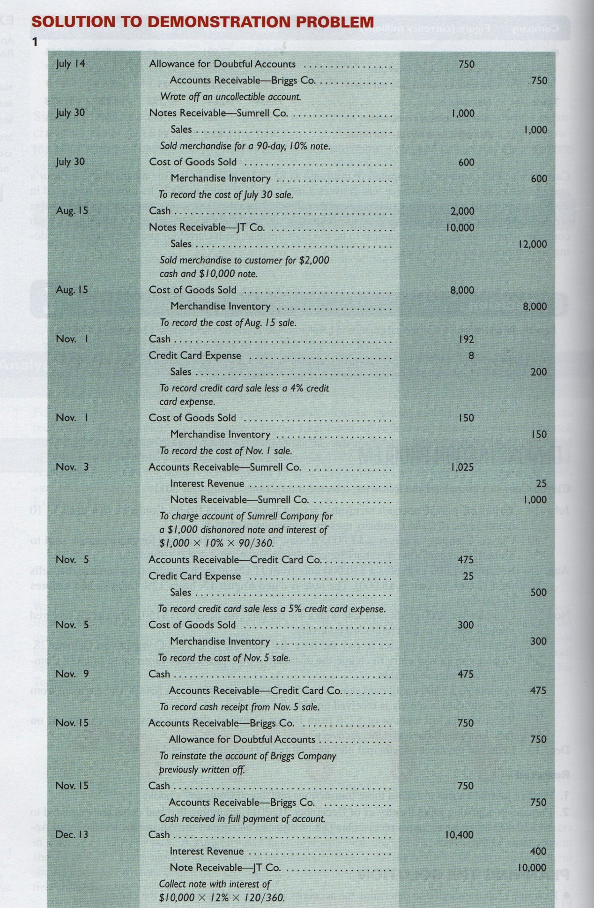

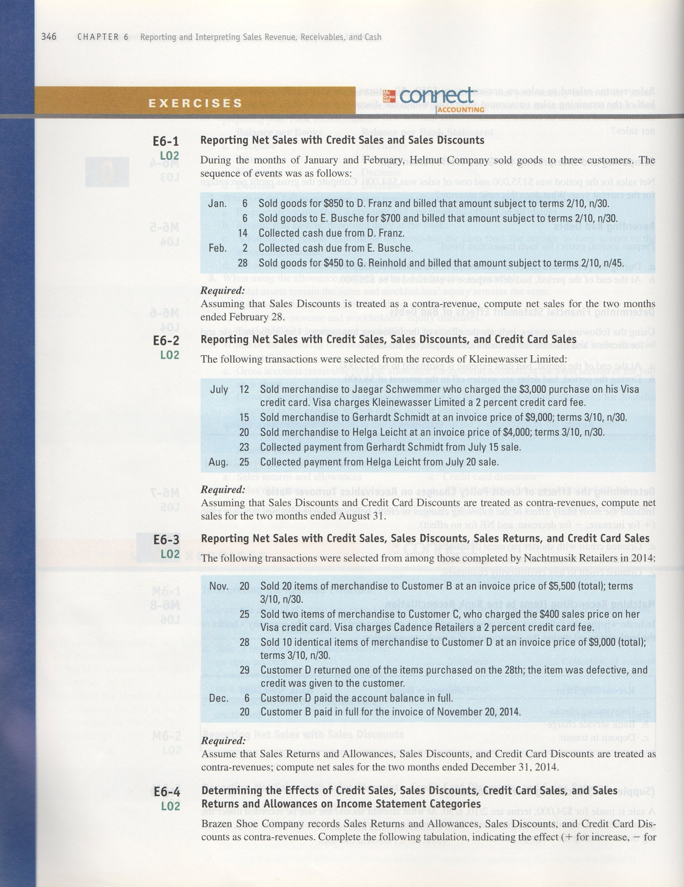
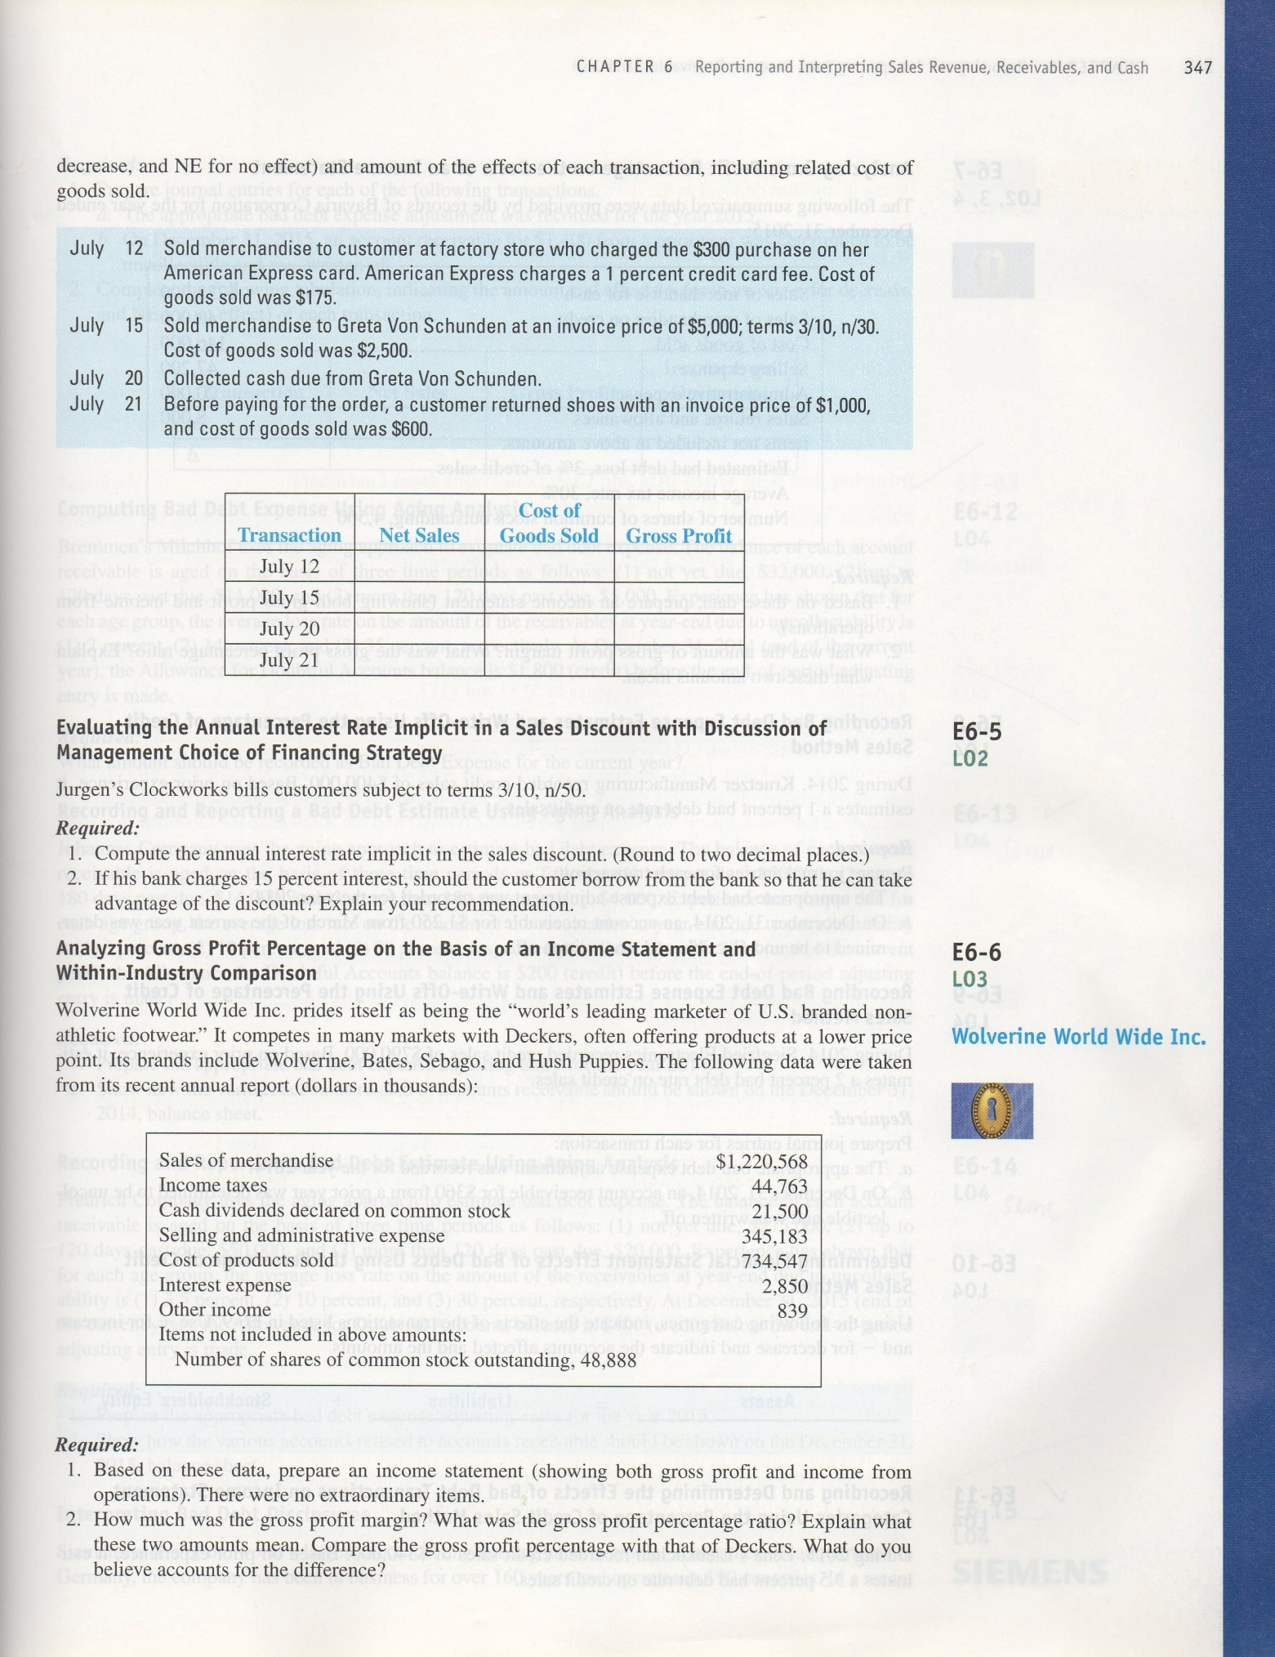
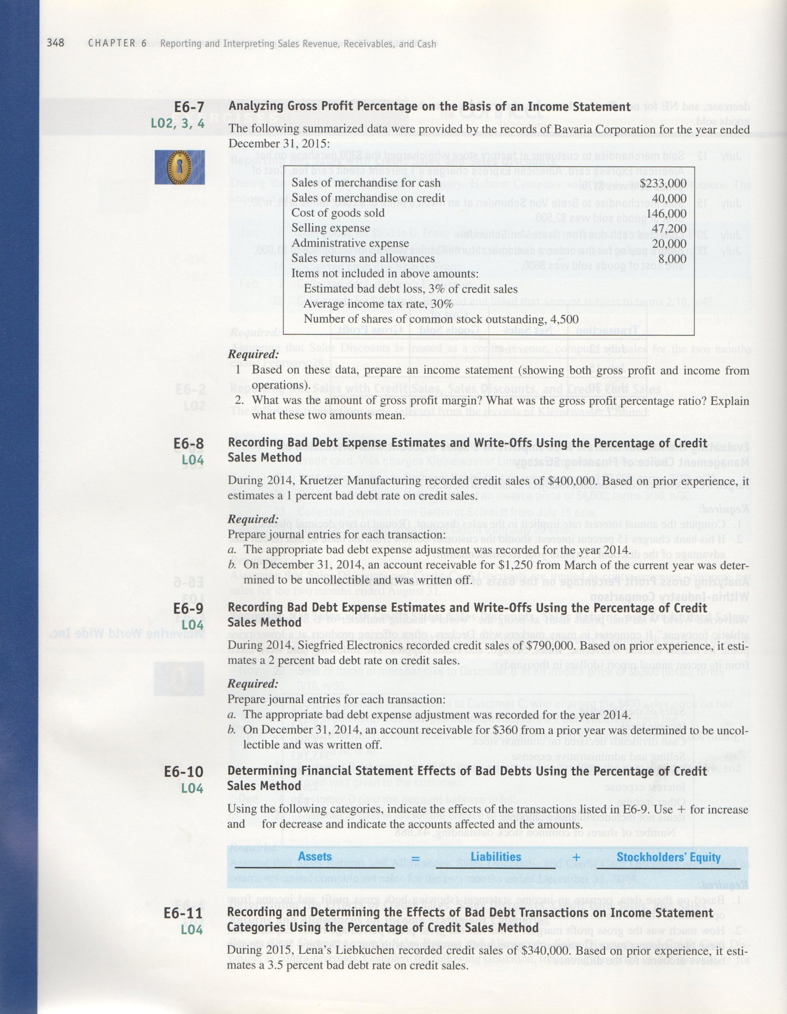
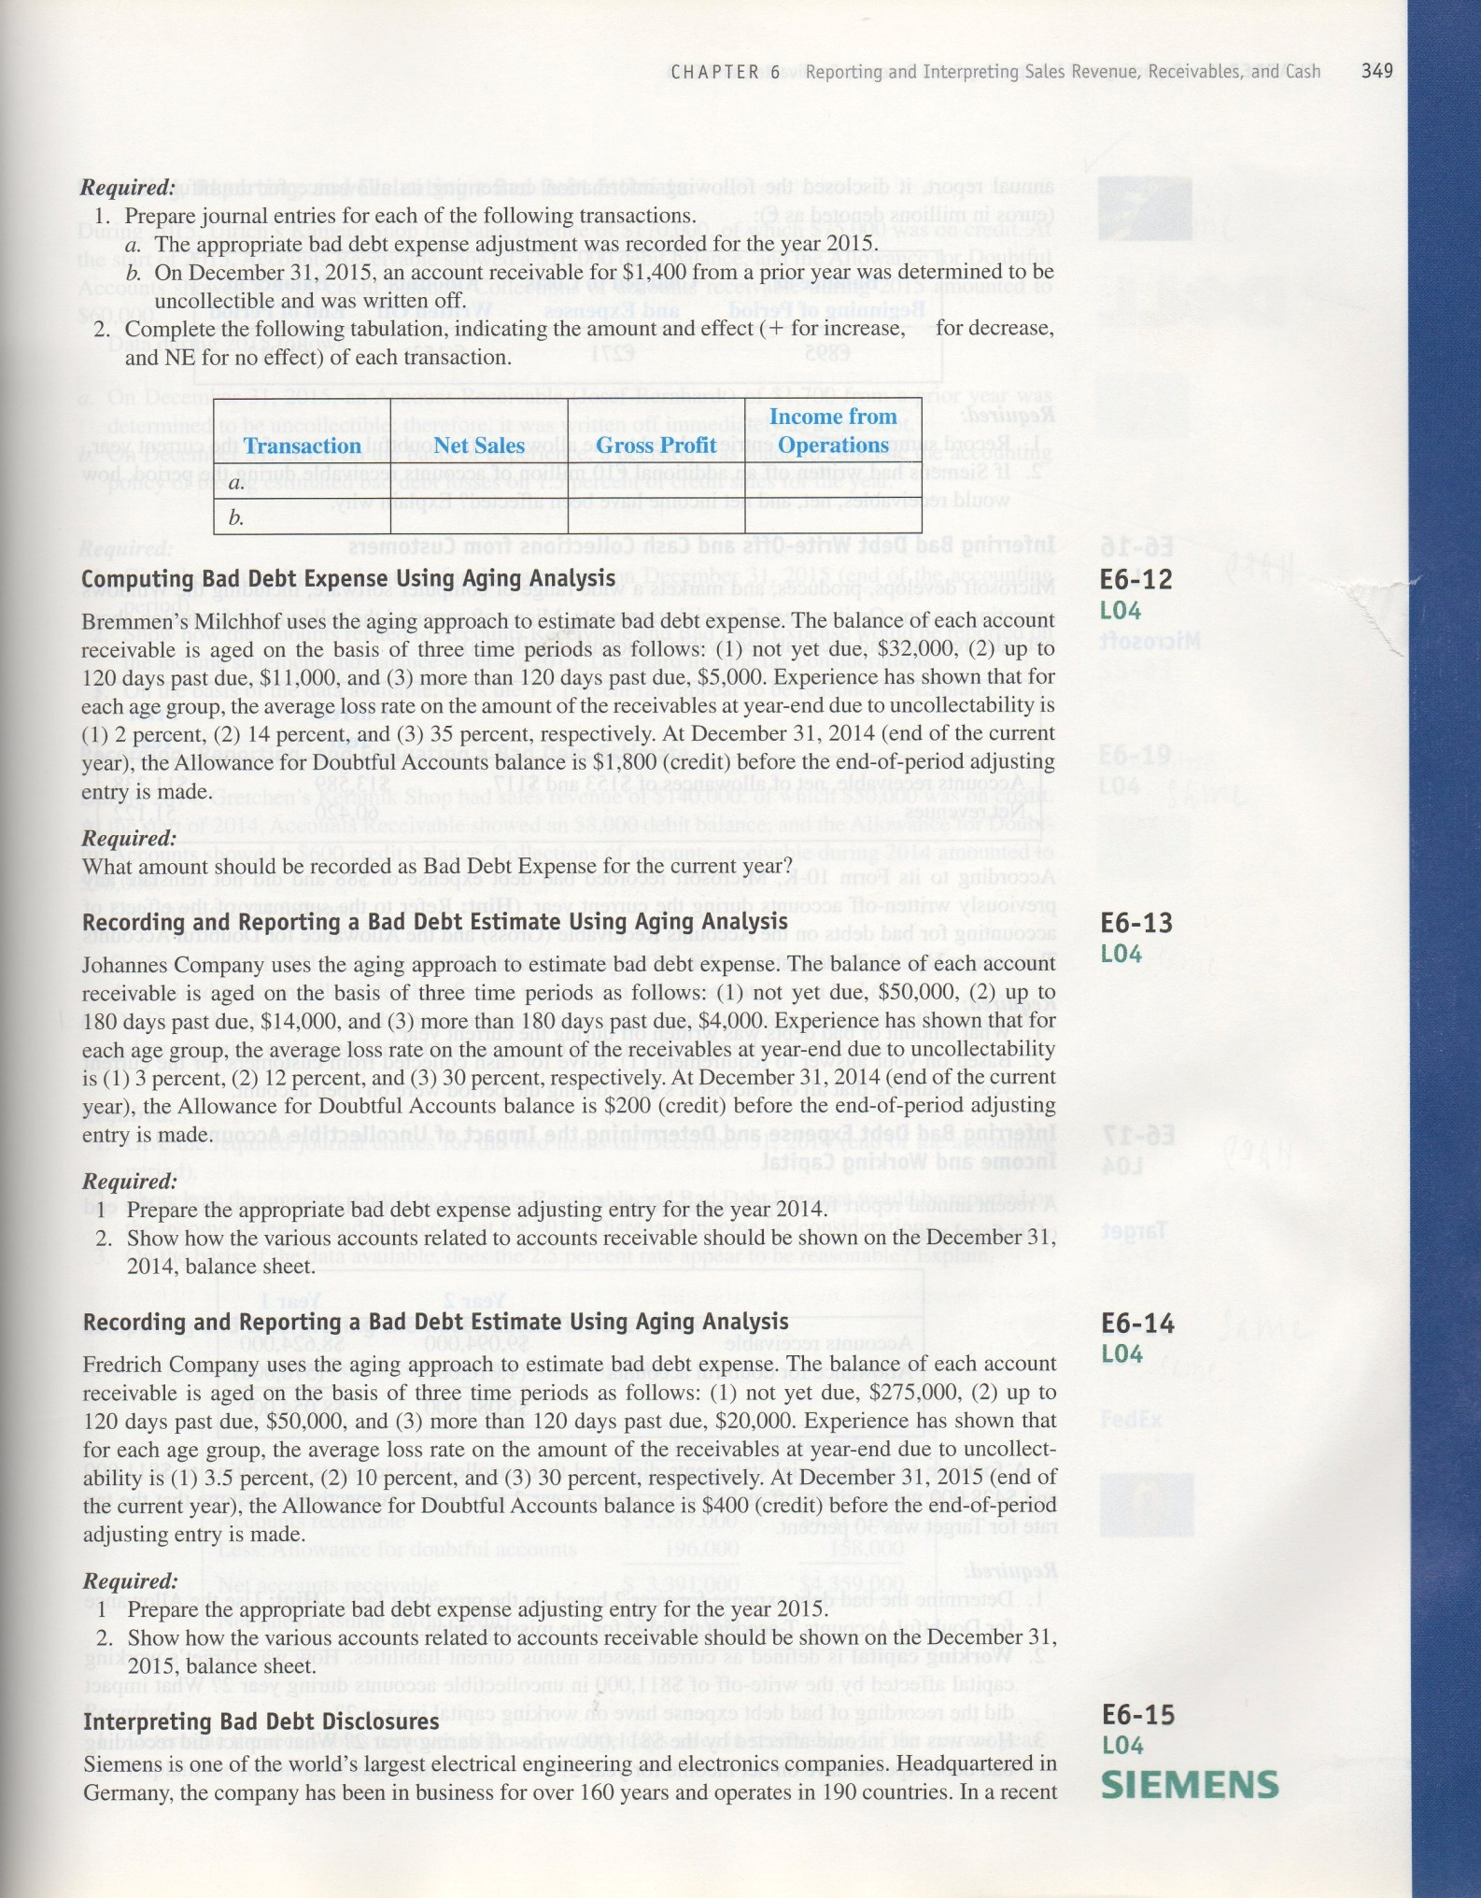
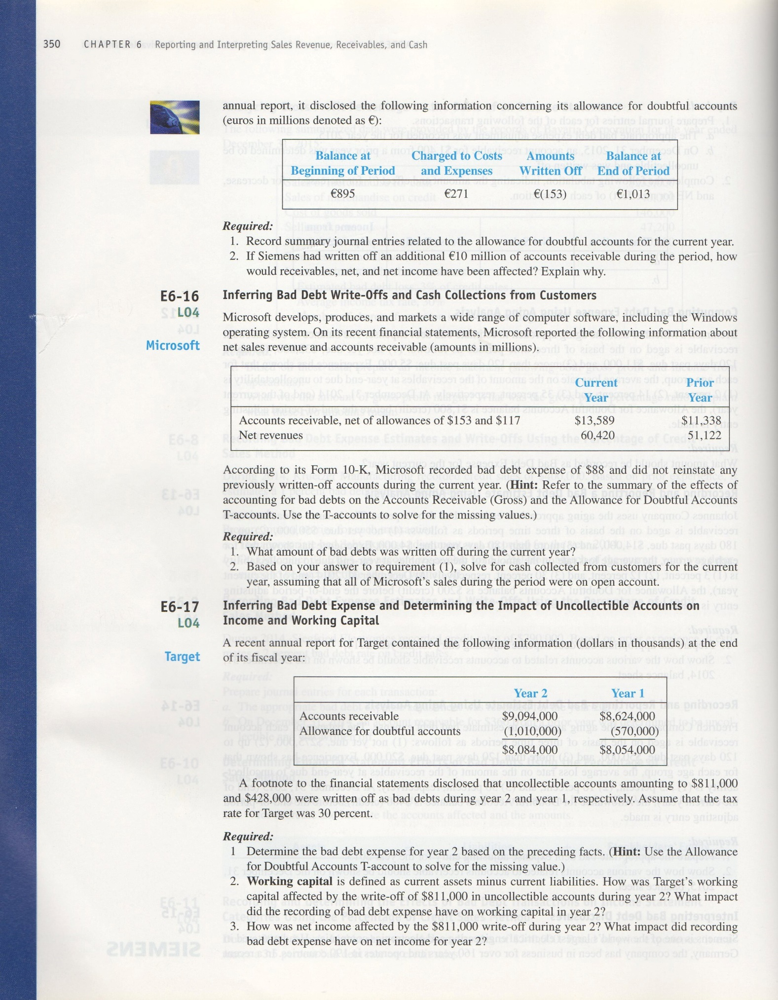
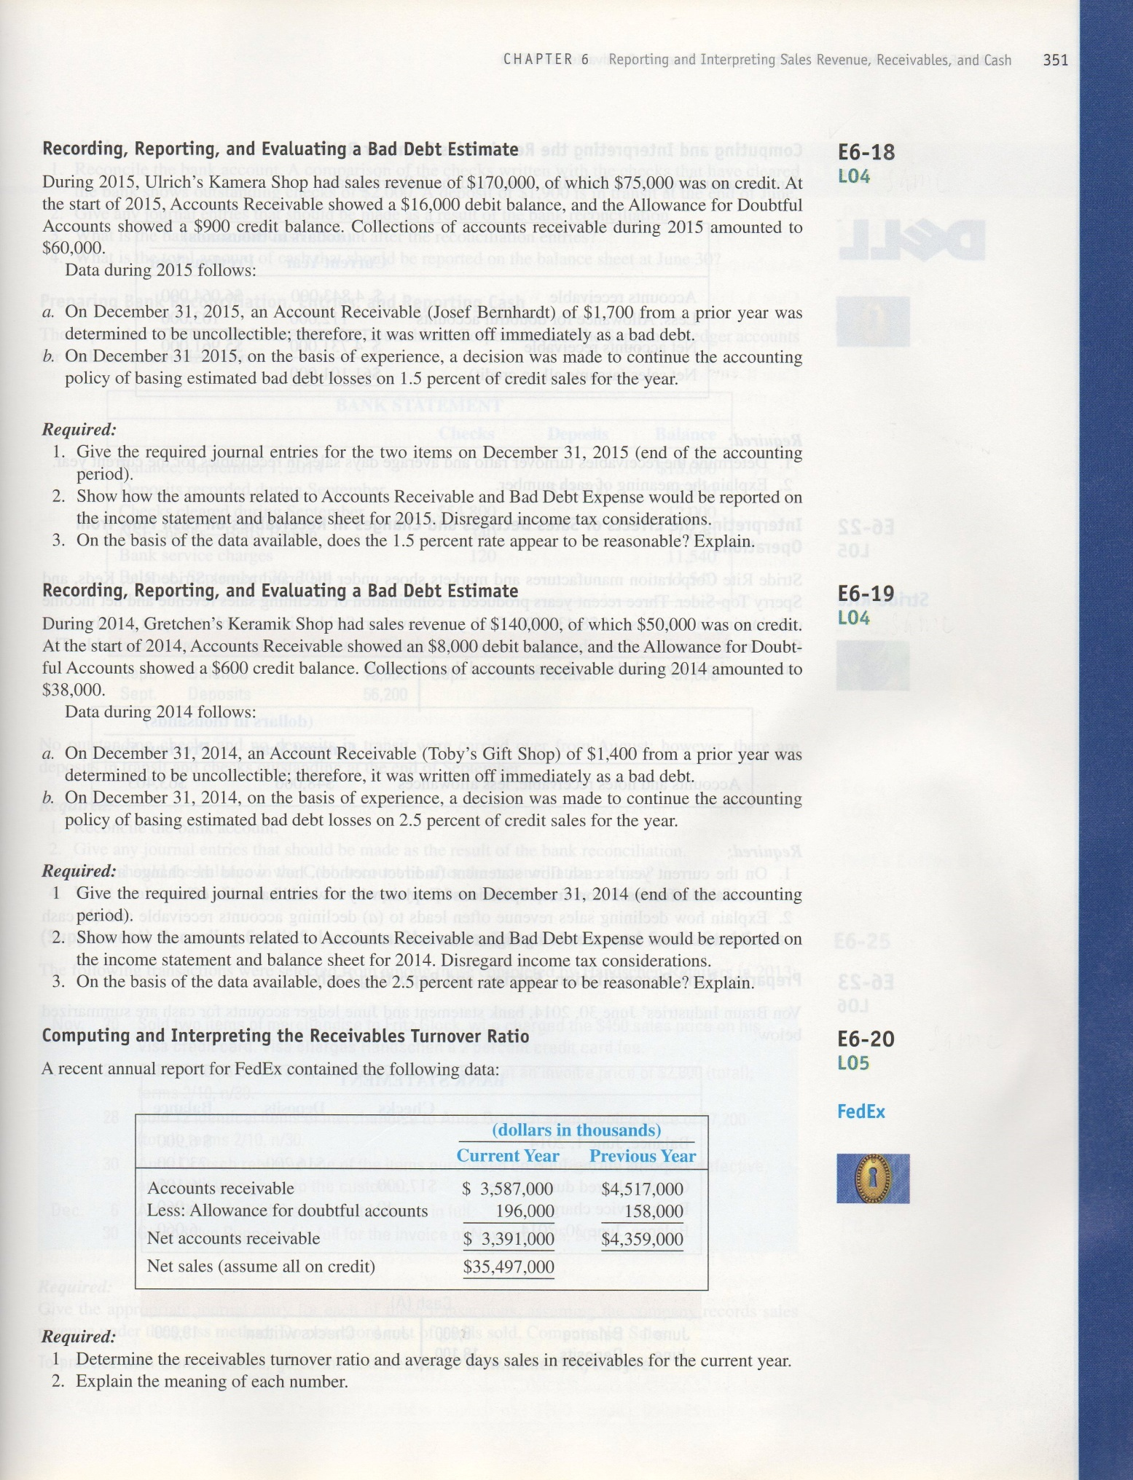
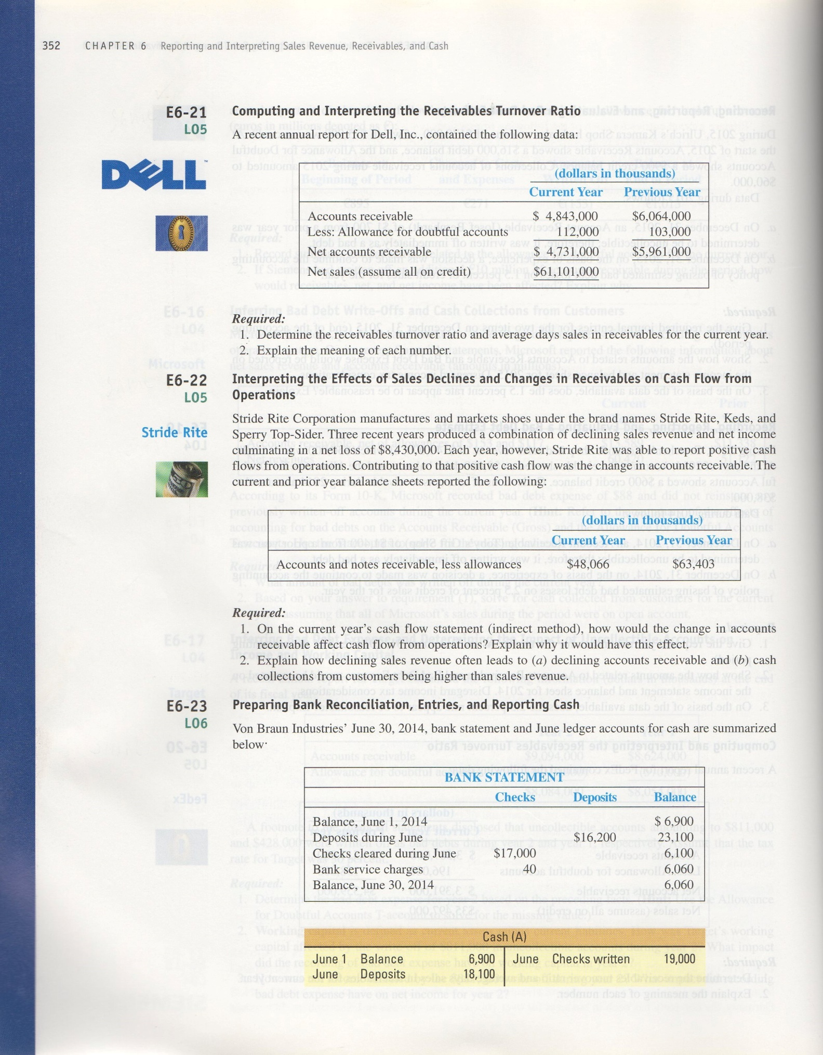
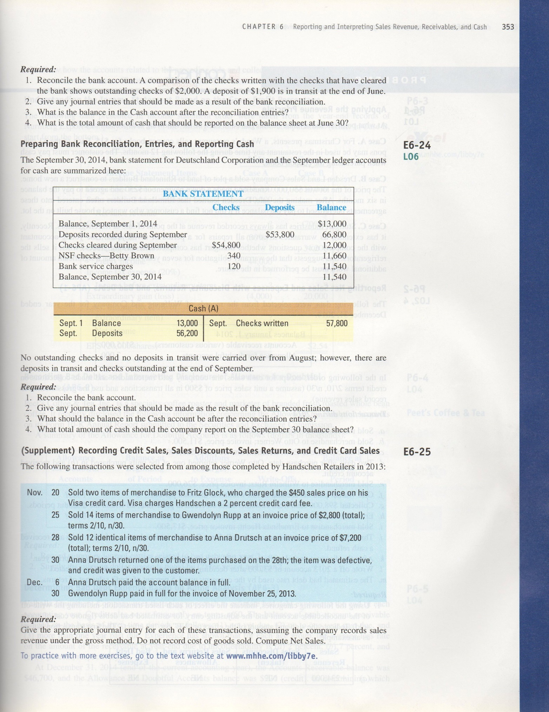
EXERCISES

E6–1.
Sales revenue ($850 + $700 + $450) $2,000
Less: Sales discount ($850 collected from D. Franz x 2%) 17
Net sales $1,983

E6–2.
Sales revenue ($3,000 + $9,000 +$4,000) $16,000
Less: Sales discounts ($9,000 collected from Schmidt x 3%) 270
Less: Credit card discounts ($3,000 from Schwemmer x 2%) 60
Net sales $15,670

E6–3.
Sales revenue ($5,500 + $400 + $9,000) $14,900
Less: Sales returns and allowances (¹/₁₀ x $9,000 from D) 900
Less: Sales discounts (⁹/₁₀ x $9,000 from D x 3%) 243
Less: Credit card discounts ($400 from C x 2%) 8
- Net sales $13,749

E6–4.

 |  | Cost of
Transaction | Net Sales | Goods Sold | Gross Profit
July 12 | + 297 | + 175 | + 122
July 15 | + 5,000 | + 2,500 | + 2,500
July 20 | – 150 | NE | – 150
July 21 | – 1,000 | – 600 | – 400

E6–5.

Req. 1 (Amount saved ÷ Amount paid) = Interest rate for 40 days.
(3% ÷ 97%) = 3.09% for 40 days.

Interest rate for 40 days x (365 days ÷ 40 days) = Annual interest rate
3.09% x (365 ÷ 40 days) = 28.22%

Req. 2 Yes, because the 15% rate charged by the bank is less than the 28.22% rate implicit in the discount. The company will earn 13.22% by doing so (28.22% – 15%).

E6–6.

Req. 1

WOLVERINE WORLD WIDE INC.
Income Statement
For the Year Ended
(dollars in thousands)

Sales of merchandise |  |  | $1,220,568
Cost of products sold |  |  | 734,547
Gross profit |  |  | 486,021
Selling and administrative expense |  |  | 345,183
Income from operations |  |  | 140,838
Other income (expense)
Interest expense |  |  | (2,850)
Other income |  |  | 839
Pretax income |  |  | 138,827
Income taxes |  |  | 44,763
Net Income |  |  | $ 94,064

Earnings per share ($94,064 ÷ 48,888 shares) $1.92

Req. 2

Gross profit margin: $1,220,568 – $734,547 = $486,021.

Gross profit percentage ratio: $486,021 ÷ $1,220,568 = .398 (or 39.8%).

Gross margin or gross profit in dollars is the difference between the sales prices and the costs of purchasing or manufacturing all goods that were sold during the period (sometimes called the markup); that is, net revenue minus only one of the expenses--cost of goods sold. The gross profit ratio is the amount of each net sales dollar that was gross profit during the period. For this company, the rate was 39.8%, which means that $.398 of each net sales dollar was gross profit (alternatively, 39.8% of each sales dollar was gross profit for the period).

Wolverine World Wide's gross profit percentage was below Deckers’s current (2008) percentage of 44.3%. Deckers’s shoes have a reputation as a rugged product as well as a premium "high fashion" product. This has allowed it to maintain higher prices and higher gross margins. In marketing this is called the value of brand equity.

E6–7.

Req. 1

BAVARIA CORPORATION
Income Statement
For the Year Ended December 31, 2015

Amount

Gross sales ($233,000 + $40,000) $273,000
Less sales returns and allowances 8,000
Net sales revenue 265,000
Cost of goods sold 146,000
Gross profit 119,000
Operating expenses:
Administrative expense $20,000
Selling expense 47,200
Bad debt expense ($40,000 x 3%) 1,200 68,400
Income from operations 50,600
Income tax expense ($50,600 x 30%) 15,180
Net income $ 35,420

Earnings per share ($35,420 ÷ 4,500 shares) $7.87

Req. 2

Gross profit margin: $265,000 – $146,000 = $119,000.

Gross profit percentage ratio: $119,000 ÷ $265,000 = .45 (or 45%).

Gross margin or gross profit in dollars is the difference between the sales prices and the costs of purchasing or manufacturing all goods that were sold during the period (sometimes called the markup); that is, net revenue minus only one of the expenses--cost of goods sold. The gross profit ratio is the amount of each net sales dollar that was gross profit during the period. For this company, the rate was 45%, which means that $.45 of each net sales dollar was gross profit (alternatively, 45% of each sales dollar was gross profit for the period).

E6–8.
(a) Bad debt expense (+E, –SE) ($400,000 x 0.01) 4,000
Allowance for doubtful accounts (+XA, –A) 4,000
To record estimated bad debt expense.

(b) Allowance for doubtful accounts (–XA, +A) 1,250
Accounts receivable (–A) 1,250
To write off a specific bad debt.

E6–9.
(a) Bad debt expense (+E, –SE) ($790,000 x 0.02) 15,800
Allowance for doubtful accounts (+XA, –A) 15,800
To record estimated bad debt expense.

(b) Allowance for doubtful accounts (–XA, +A) 360
Accounts receivable (–A) 360
To write off a specific bad debt.

E6–10.

 | Assets | Liabilities | Stockholders’ Equity
(a) | Allowance for doubtful accounts –15,800 |  | Bad debt expense –15,800
(b) | Allowance for doubtful accounts +360  Accounts receivable –360

E6–11.

Req. 1
(a) Bad debt expense (+E, –SE) ($340,000 x 0.035) 11,900
Allowance for doubtful accounts (+XA, –A) 11,900
To record estimated bad debt expense.

(b) Allowance for doubtful accounts (–XA, +A) 1,400
Accounts receivable (–A) 1,400
To write off a specific bad debt.

Req. 2
 |  |  | Income from
Transaction | Net Sales | Gross Profit | Operations
a. | NE | NE | – 23,800
b. | NE | NE | NE

E6–12.
Aged accounts receivable |  |  | Estimated percentage uncollectible |  | Estimated amount uncollectible
Not yet due | $32,000 | x | 2% | = | $ 640
Up to 120 days past due | 11,000 | x | 14% | = | 1,540
Over 120 days past due | 5,000 | x | 35% | = | 1,750
Estimated balance in Allowance for Doubtful Accounts |  |  |  |  | 3,930
Current balance in Allowance for Doubtful Accounts |  |  |  |  | 1,800
Bad Debt Expense for the year |  |  |  |  | $2,130

E6–13.

Req. 1

December 31, 2014-Adjusting entry:
Bad debt expense (+E, –SE) 4,180
Allowance for doubtful accounts (+XA, –A) 4,180
To adjust for estimated bad debt expense for 2014 computed as follows:

Aged accounts receivable |  |  | Estimated percentage uncollectible |  | Estimated amount uncollectible
Not yet due | $50,000 | x | 3% | = | $ 1,500
Up to 180 days past due | 14,000 | x | 12% | = | 1,680
Over 180 days past due | 4,000 | x | 30% | = | 1,200
Estimated balance in Allowance for Doubtful Accounts |  |  |  |  | 4,380
Current balance in Allowance for Doubtful Accounts |  |  |  |  | 200
Bad Debt Expense for the year |  |  |  |  | $4,180

Req. 2
Balance sheet:
Accounts receivable ($50,000 + $14,000 + $4,000) $68,000
Less allowance for doubtful accounts 4,380
Accounts receivable, net of allowance for
doubtful accounts $63,620

E6–14.

Req. 1

December 31, 2015-Adjusting entry:
Bad debt expense (+E, –SE) 20,225
Allowance for doubtful accounts (+XA, –A) 20,225
To adjust for estimated bad debt expense for 2015 computed as follows:

Aged accounts receivable |  |  | Estimated percentage uncollectible |  | Estimated amount uncollectible
Not yet due | $275,000 | x | 3.5% | = | $9,625
Up to 120 days past due | 50,000 | x | 10% | = | 5,000
Over 120 days past due | 20,000 | x | 30% | = | 6,000
Estimated balance in Allowance for Doubtful Accounts |  |  |  |  | 20,625
Current balance in Allowance for Doubtful Accounts |  |  |  |  | 400
Bad Debt Expense for the year |  |  |  |  | $20,225

Req. 2
Balance sheet:
Accounts receivable ($275,000 + $50,000 + $20,000) $345,000
Less allowance for doubtful accounts 20,625
Accounts receivable, net of allowance for
doubtful accounts $324,375

E6–15.

1. Bad debt expense (+E, –SE) 271
Allowance for doubtful accounts (+XA, –A) 271
To record estimated bad debt expense.

Allowance for doubtful accounts (–XA, +A) 153
Accounts receivable (–A) 153
To write off specific bad debts.

2. It would have no effect because the asset “Accounts receivable” and contra-asset “Allowance for doubtful accounts” would both decline by Euro 10 million. Neither “Receivables, net” nor “Net income” would be affected.

E6–16.

Req. 1 Allowance for Doubtful Accounts
 |  | 117 | Beg. balance
Write-offs | 52 | 88 | Bad debt exp.
 |  | 153 | End. balance

Beg. Balance + Bad debt exp. – Write-offs = End. Balance

Beg. Balance + Bad debt exp. – End. Balance = Write-offs
117 + 88 – 153 = 52

Bad debt expense increases (is credited to) the allowance. Since we are given the beginning and ending balances in the allowance, we can solve for write-offs, which decrease (are debited to) the allowance.

Req. 2 Accounts Receivable (Gross)
Beg. balance* | 11,455 | 52 | Write-offs
Net sales | 60,420 | 58,081 | Cash collections
End. balance ** | 13,742

* 11,338 + 117

** 13,589 + 153
Beg. balance + Net sales – Write-offs – Cash collections = End. Balance
Beg. balance + Net sales – Write-offs – End. Balance = Cash collections
11,455 + 60,420 – 52 – 13,742 = 58,081

Accounts receivable gross is increased by recording credit sales and decreased by recording cash collections and write-offs of bad debts. Thus, we can solve for cash collections as the missing value.

E6–17.

Req. 1

The allowance for doubtful accounts is increased (credited) when bad debt expense is recorded and decreased (debited) when uncollectible accounts are written off. This case gives the beginning and ending balances of the allowance account and the amount of uncollectible accounts that were written off. Therefore, the amount of bad debt expense (in thousands) can be computed as follows:

Allowance for Doubtful Accounts
 |  | 570,000 | Beg. balance
Write-offs | 811,000 | 1,251,000 | Bad debt exp.
 |  | 1,010,000 | End. balance

Beg. Balance + Bad debt exp. – Write-offs = End. Balance
End. Balance – Beg. Balance + Write-offs = Bad debt exp.
1,010,000 – 570,000 + 811,000 = 1,251,000

Req. 2

Working capital is unaffected by the write-off of an uncollectible account when the allowance method is used. The asset account (accounts receivable) and the contra- asset account (allowance for doubtful accounts) are both reduced by the same amount; therefore, the book value of net accounts receivable is unchanged.

Working capital is decreased when bad debt expense is recorded because the contra- asset account (allowance for doubtful accounts) is increased. From requirement (1), we know that net accounts receivable was reduced by $1,251,000 when bad debt expense was recorded in year 2, reducing working capital by $1,251,000.

Note that income before taxes was reduced by the amount of bad debt expense that was recorded, therefore tax expense and tax payable will decrease. The decrease in tax payable caused working capital to increase; therefore, the net decrease was $1,251,000 – ($1,251,000 x 30%) = $875,700.

Req. 3

The entry to record the write-off of an uncollectible account did not affect any income statement accounts; therefore, net income is unaffected by the $811,000 write-off in year 2.

The recording of bad debt expense reduced income before taxes in year 2 by $1,251,000 and reduced tax expense by $375,300 (i.e., $1,251,000 x 30%). Therefore, year 2 net income was reduced by $875,700 (as computed in Req. 2).

E6–18.

Req. 1

Dec. 31, 2015
Allowance for doubtful accounts (–XA, +A) 1,700
Accounts receivable (Josef Bernhardt) (–A) 1,700
To write off an account receivable determined to
be uncollectible.

Dec. 31, 2015
Bad debt expense (+E, –SE) 1,125
Allowance for doubtful accounts (+XA, –A) 1,125
Adjusting entry--estimated loss on uncollectible
accounts; based on credit sales ($75,000 x 1.5%
= $1,125).

Req. 2

Income statement:
Operating expenses:
Bad debt expense $1,125

Balance sheet:

Current assets
Accounts receivable ($16,000 + $75,000
- $60,000 - $1,700) $29,300

Less: Allowance for doubtful accounts
($900 - $1,700 + $1,125) 325 $28,975

Req. 3

The 1.5% rate on credit sales may be too low because it resulted in bad debt expense only two-thirds the amount of receivables written off ($1,700) during the year. However, if the uncollectible account receivable written off during 2015 is not indicative of average uncollectibles written off over a period of time, the 1.5% rate may be appropriate. There is not sufficient historical data to make a definitive decision.

E6–19.

Req. 1

Dec. 31, 2014
Allowance for doubtful accounts (–XA, +A) 1,400
Accounts receivable (Toby’s Gift Shop) (–A) 1,400
To write off an account receivable determined to
be uncollectible.

Dec. 31, 2014
Bad debt expense (+E, –SE) 1,250
Allowance for doubtful accounts (+XA, –A) 1,250
Adjusting entry--estimated loss on uncollectible
accounts; based on credit sales ($50,000 x 2.5%
= $1,250).

Req. 2

Income statement:
Operating expenses:
Bad debt expense $1,250

Balance sheet:

Current assets
Accounts receivable ($8,000 + $50,000
- $38,000 - $1,400) $18,600

Less: Allowance for doubtful accounts
($600 - $1,400 + $1,250) 450 $18,150

Req. 3

The 2.5% rate on credit sales appears reasonable because it approximates the amount of receivables written off ($1,400) during the year. However, if the uncollectible account receivable written off during 2014 is not indicative of average uncollectibles written off over a period of time, the 2.5% rate may not be appropriate. There is not sufficient historical data to make a definitive decision.

E6–20.

Req. 1

Receivables turnover | = | Net Sales | = | $35,497,000 | = | 9.16 times
 |  | Average Net Trade  Accounts Receivable |  | $3,875,000*

Average days sales | = | 365 | = | 365 | = | 39.8 days
in receivables |  | Receivables Turnover |  | 9.16

* ($4,359,000 + $3,391,000) ÷ 2

Req. 2

The receivables turnover ratio reflects how many times average trade receivables were recorded and collected during the period. The average days sales in receivables indicates the average time it takes a customer to pay its account.

E6–21.

Req. 1

Receivables turnover | = | Net Sales | = | $61,101,000 | = | 11.43 times
 |  | Average Net Trade  Accounts Receivable |  | $5,346,000*

Average days sales | = | 365 | = | 365 | = | 31.9 days
in receivables |  | Receivables Turnover |  | 11.43

* ($5,961,000 + $4,731,000) ÷ 2

Req. 2

The receivables turnover ratio reflects how many times average trade receivables were recorded and collected during the period. The average days sales in receivables indicates the average time it takes a customer to pay its account.

E6–22.

Req. 1

The change in the accounts receivable balance ($48,066 – 63,403 = –$15,337) would increase cash flow from operations by $15,337 thousand. This happens because the Company is collecting cash faster than it is recording credit sales revenue.

Req. 2

(a) Declining sales revenue leads to lower accounts receivable because fewer new credit sales are available to replace the receivables that are being collected.

(b) Cash collections from the prior period's higher credit sales are greater than the new credit sales revenue. Note that in the next period, cash collections will also decline.

E6–23.

Req. 1

VON BRAUN INDUSTRIES
Bank Reconciliation, June 30, 2014

Company's Books |  |  | Bank Statement
Ending balance per Cash  account……………………… | $6,000 |  | Ending balance per bank  statement……………… | $6,060
Additions: |  |  | Additions:
None |  |  | Deposit in transit………… | 1,900*
Deductions: |  |  | Deductions: | 7,960
Bank service charge…… | 40 |  | Outstanding checks… | 2,000
Correct cash balance……… | $5,960 |  | Correct cash balance…… | $5,960

*$18,100 – $16,200 = $1,900.

Req. 2
Bank service charge expense (+E, –SE) 40
Cash (–A) 40
To record deduction from bank account for service charges.

Req. 3

The correct cash balance per the bank reconciliation ($6,000 – $40), $5,960

Req. 4
Balance sheet (June 30, 2014):
Current assets:
Cash $5,960

E6–24.

Req. 1

DEUTSCHLAND CORPORATION
Bank Reconciliation, September 30, 2014

Company's Books |  |  |  | Bank Statement
Ending balance per Cash account |  | $11,400 |  | Ending balance per bank statement | $11,540
Additions: |  |  |  | Additions:
None |  |  |  | Deposit in transit* | 2,400*
 |  |  |  |  | 13,940
Deductions: |  |  |  | Deductions:
Bank service charges | $ 120
NSF check –  Betty Brown | 340 | 460 |  | Outstanding checks  ($57,800 – $54,800) | 3,000
Correct cash balance |  | $10,940 |  | Correct cash balance | $10,940

*$56,200 - $53,800 = $2,400.

Req. 2

(1) Bank service charge expense (+E, –SE) 120
Cash (–A) 120
To record bank service charges deducted from bank balance.

(2) Accounts receivable (Betty Brown) (+A) 340
Cash (–A) 340
To record customer check returned due to insufficient funds.

Req. 3

Same as the correct balance on the reconciliation, $10,940.

Req. 4

Balance Sheet (September 30, 2014):
Current Assets:
Cash $10,940

E6–25 (Based on Supplement A)

November 20, 2013
Cash (+A) 441
Credit card discount (+XR, –R, –SE) 9
Sales revenue (+R, +SE) 450
To record credit card sale.

November 25, 2013:
Accounts receivable (Gwendolyn Rupp) (+A) 2,800
Sales revenue (+R, +SE) 2,800
To record a credit sale.

November 28, 2013:
Accounts receivable (Anna Drutsch) (+A) 7,200
Sales revenue (+R, +SE) 7,200
To record a credit sale.

November 30, 2013:
Sales returns and allowances (+XR, –R, –SE) 600
Accounts receivable (Anna Drutsch) (–A) 600
To record return of defective goods, $7,200 x 1/12 = $600.

December 6, 2013:
Cash (+A) 6,468
Sales discounts (+XR, –R, –SE) 132
Accounts receivable (Anna Drutsch) (–A) 6,600
To record collection within the discount period,
98% × ($7,200 – $600) = $6,468

December 30, 2013:
Cash (+A) 2,800
Accounts receivable (Gwendolyn Rupp) (–A) 2,800
To record collection after the discount period.

Sales revenue ($450 + $2,800 + $7,200) $10,450
Less: Sales returns and allowances ($7,200 x 1/12) 600
Less: Sales discounts (2% × ($7,200 – $600)) 132
Less: Credit card discounts ($450 x 2%) 9
Net sales $9,709

