Student Information
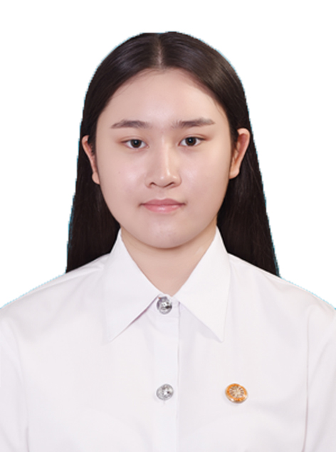ere.]
EE462 Development Macroeconomics
Semester 1/2020
- Name Tachana Upapong_____________
- Nickname ____________Snow___________________
- Email ___tachana.u@st.econ.tu.ac.th____ Phone Number _084-358-3332___
- Year of program: [] 2nd year [] 3rd year [] 4th year
- Major area (if any) ____Monetary Economics
- Minor area (if any) ______Finance___________
- Classes that you have already taken
EE212,EL221,ST216,TU100,TU101,TU122,EE211,EL321,MA216,TU102, TU103, TU106, JM372,AC201,BA291,EE311,EE320,EE404, PY200,EE312,EE325,EE431, FN201, FN211 ,EE466
- Classes that you are currently taking
EE432, EE462,EE476,EE482, FN311F, FN312
- Classes that you plan to take in the next semester(s) or next academic year(s)
_EE461,EE481,FN313,EE200,EE390.HR201_____
- What is/are your favorite subject(s)?
__EE466,JM376________________
- What do you expect to learn from this class?
_Concept and theories about development in macroeconomics level______________________
- What is your concern, if any, about being in this class?
______Cannot catch up with the class_____________________
- What would you suggest to enhance your learning experience while taking this class? Is there any teaching technique that other instructors use and you particularly like? If so, please suggest.
____Refer the learning context in class with real life economics situation may help enhance understanding____________
- Briefly describe your career aspiration(s). List the top two choices if there are many.
_________Financial planner, Investment analyst_____________
___________________________________________________________________
- Other comments and/or suggestions.
________-___________________________________________________________
___________________________________________________________________
___________________________________________________________________

(Note: All information is to be used for teaching purpose only, and will be kept confidential.)

