FN 312 Investment
Practice Midterm Exam (Sem 2/2016)

Question 1

For the following questions, refer to the T-bill that expires on February 9, 2006.

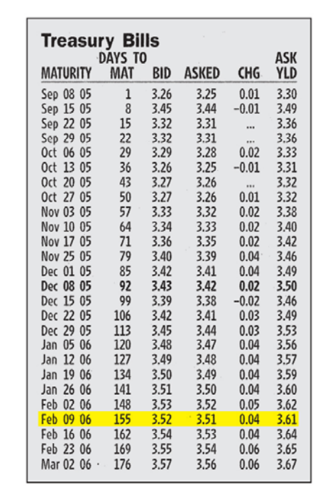

- Explain what the 6 columns represent.
- If the face value of the T-bill is $1,000,000, calculate the current T-bill price.
- What is the bank discount yield? What is the bond equivalent yield? Which is a more meaningful measure of the return on investment?
- What is the effective annual rate of this T-bill’s bond equivalent yield?
- Describe 3 factors that are known to move T-bill rates. Can these factors explain why T-bill rates across many countries are low now? Discuss.
- List 3 alternative investments to treasury bills and briefly describe their characteristics.

Question 2

Suppose you are constructing a portfolio of two companies. The first has $10000 shares outstanding at a current price of $100 per share, while the second has $60,000 shares outstanding at a current price of $50 per share. You have $10,000 to invest.
- How many shares of each company would you buy if you want to construct an equally weighted portfolio? How many shares of each company would you buy if you construct a value-weighted portfolio?
- A year later, company 1’s share price has risen to $150 while company 2’s share price is unchanged at $50. Neither company has paid a dividend. What are the returns on the equal-weighted portfolio and the value-weighted portfolio you constructed in part a)? Explain the difference.
- How must you trade a year later to keep the equal-weighted portfolio equal-weighted? How must you trade to keep the value-weighted portfolio value-weighted? Explain. (Note: It is sufficient to explain whether you need to buy or sell the shares of either company. You do not need to calculate the exact amounts.)
- Give an example of 2 stock indexes that are equally weighted and 2 that are value-weighted. Which method of constructing a stock index is preferred and why?

Question 3

List 2 other measures of risk that we can use in place of the standard deviation of returns. Outline the key differences among these risk measures.

Question 4

Plot the shape of the following utility functions in (W,U(W)) space. Determine whether the following utility functions exhibit risk averse, risk neutral, or risk loving behavior. Explain. Show whether or not someone with the given utility function and wealth W=$1000 would be willing to accept a gamble with 50% chance of gaining $100 and 50% chance of losing $100.

- U(W) = 2W+5
- U(W) = $W^{3}$
- U(W) = -(1/2)$e^{-2W}$
- Would all three utility functions work for Markowitz Portfolio optimization? Why or why not?

Question 5

You manage a risky portfolio with an expected rate of return of 17% and a standard deviation of 27%. The treasury-bill rate is 7%.

- One of your clients chooses to invest 70% of a portfolio in your fund and 30% in a T-bill money market fund. What is the expected value and standard deviation of the rate of return on your client’s portfolio?
- If the client wants an overall expected rate of return of 15%, how much should your client invest in the risky portfolio? If your risky portfolio includes the following investments in the given proportions: Stock A (27%), Stock B (33%) and Stock C (40%), what are your client’s investment proportions in your three stocks and the T-bill fund?
- Now suppose that your client prefers to invest in your fund a proportion y that maximizes expected return on the overall portfolio subject to the constraint that the overall portfolio’s standard deviation will not exceed 20%. What is the investment proportion y, and what is the expected return on the overall portfolio?
- Suppose that your client’s degree of risk aversion is A=3.5. What proportion y of the total investment, should you suggest he invest in your fund?
- You estimate that a passive portfolio (that is, one entirely invested in a risky portfolio that mimics the S&P 500 stock index) yields an expected rate of return of 13% with a standard deviation of 25%. What is the slope of the CML? What is the advantage of your fund over the passive fund?
- Your client is considering whether to switch to the passive portfolio the 70% of his wealth currently invested in your fund. To convince your client that he is better of staying with you, show your client the maximum fee you would charge that would still leave him at least as well off investing in your fund as in the passive one (hint: calculate this as a percentage of the investment in your fund deducted at the end of the year).

Question 6

An investor uses the mean-variance criterion for selecting a portfolio of two risky assets. Asset 1 has an expected return of 20% and a variance of 4. Asset 2 has an expected return of 60% and a variance of 36. There is no risk-free asset available.

- Explain how to construct the efficient portfolio frontier for the cases in which the correlation coefficient between returns is equal to +1 and also when it is equal to -1.
- Describe, in general terms, how to construct the portfolio frontier when -1 < ρ < +1

Question 7

- Consider a world with several risky assets and in which an investor can borrow at a given interest rate which is different (higher) than the rate at which the investor can lend.
- Construct the efficient portfolio frontier
- Depict an equilibrium for an investor who chooses to borrow.
- Suppose that the interest rate at which the investor can borrow increases. Examine the implications for the investor’s optimal investment decisions.

Question 8

The following information is provided for a stock market

 | Expected rate of return | Beta
Asset 1 | 6.6% | 0.4
Asset 2 | 9.8% | 1.2
Asset 3 | 12.2% | 1.8

- In the context of the Capital Asset Pricing model (CAPM), describe the ‘beta-coefficient’. Discuss how assets’ beta-coefficients should be interpreted and explain how their values can be obtained in practice.
- Assuming that a risk-free asset is available, explain and interpret the Security Market Line (SML) in the context of CAPM. Construct the SML from the given information and interpret the values of its coefficients.
- You are informed that fourth asset is available with beta = 0.8. Recent observations reveal that its average rate of return is 7%. What inferences, if any, would you draw from this information?

Question 9

What are the main predictions of the Capital Asset Pricing Model? Discuss the role and significance of the assumptions needed to obtain the predictions.

Additional Short Answer Questions
- Explain the difference between top down and bottom up approaches.
- Explain the difference between passive and active investing
- How are real assets and financial assets related? Does national wealth consist of financial securities?
- Explain the difference between primary and secondary markets
- What is the LIBOR rate and how is it determined? Are there any concerns with using it as a reference rate?
- What is a Treasury Inflation Protected Security? Are they a good representation of the real interest rate?
- What are mortgage backed securities? Why are they classified as a pass-through security?
- What are the draw backs of a price weighted average approach in computing the stock index versus the value weighted index?
- In what situation would VaR or expected short fall be a better measure of risk than standard deviation?
- Are the distributions of returns usually normal? Explain
- Is there a positive relationship between volatility and average returns for individual stock? What about for large portfolios?
- What is the difference between common and independent risk? How to gauge the level of systematic risk in a portfolio?

