6104640112_Exam
Harit Hatawong

Question 1:
Download the data for question 1
#question1
getSymbols("IPDCONGD",src = "FRED")
## 'getSymbols' currently uses auto.assign=TRUE by default, but will
## use auto.assign=FALSE in 0.5-0. You will still be able to use
## 'loadSymbols' to automatically load data. getOption("getSymbols.env")
## and getOption("getSymbols.auto.assign") will still be checked for
## alternate defaults.
##
## This message is shown once per session and may be disabled by setting
## options("getSymbols.warning4.0"=FALSE). See ?getSymbols for details.
## [1] "IPDCONGD"
getSymbols("IPNCONGD",src = "FRED")
## [1] "IPNCONGD"
getSymbols("IPBUSEQ",src = "FRED")
## [1] "IPBUSEQ"
getSymbols("IPMAT",src = "FRED")
## [1] "IPMAT"
IP = cbind(as.numeric(IPDCONGD),as.numeric(IPNCONGD),as.numeric(IPBUSEQ),as.numeric(IPMAT[-c(1:96)]))
colnames(IP) <- c("IPD","IPN","IPB","IPM")
IP=log(IP)

Question 1.1)
Take the first differences of the log data and obtain time plot
#1.1
IP=log(IP)
zt=diffM(IP)*100
par(mar=rep(2, 4))
MTSplot(zt)
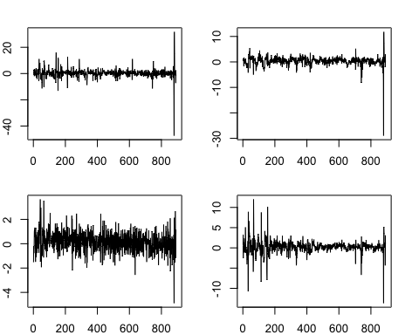

Comment: from the time plot of each series, they seem to be stationary since we have constant mean and volatility.

Question 1.2)
create VAR model, refinement and model checking process

Step1: Find the optimal order
#1.2
VARorder(zt)
## selected order: aic = 6
## selected order: bic = 2
## selected order: hq = 3
## Summary table:
## p AIC BIC HQ M(p) p-value
## [1,] 0 2.8153 2.8153 2.8153 0.0000 0.0000
## [2,] 1 2.6470 2.7330 2.6798 178.2331 0.0000
## [3,] 2 2.5125 2.6846 2.5783 147.9623 0.0000
## [4,] 3 2.4570 2.7151 2.5556 79.0713 0.0000
## [5,] 4 2.4563 2.8005 2.5879 31.4646 0.0117
## [6,] 5 2.4045 2.8348 2.5689 75.1412 0.0000
## [7,] 6 2.3832 2.8995 2.5805 48.7671 0.0000
## [8,] 7 2.3984 3.0008 2.6287 17.5535 0.3507
## [9,] 8 2.4168 3.1053 2.6799 14.8136 0.5383
## [10,] 9 2.4224 3.1970 2.7184 25.4492 0.0623
## [11,] 10 2.4268 3.2874 2.7557 26.3997 0.0487
## [12,] 11 2.4327 3.3793 2.7945 24.9845 0.0701
## [13,] 12 2.4258 3.4585 2.8205 35.4558 0.0034
## [14,] 13 2.4266 3.5454 2.8542 28.9289 0.0244

Comment:
choosing the order based on BIC then we have VAR order 2 as the most appropriate one.

Step2: check the stationary condition to make sure whether the data is valid to use or not
adfTest(zt,lags = 2)
## Warning in adfTest(zt, lags = 2): p-value smaller than printed p-value
##
## Title:
## Augmented Dickey-Fuller Test
##
## Test Results:
## PARAMETER:
## Lag Order: 2
## STATISTIC:
## Dickey-Fuller: -33.4206
## P VALUE:
## 0.01
##
## Description:
## Wed Jun 9 21:08:31 2021 by user:

Comment:
Since the p-value is less than 0.05 we reject the H0 which mean that there’s no unit root.

Step3: create the VAR model with lag = 2
m1.mts =VAR(zt,p=2)#create VAR model
## Constant term:
## Estimates: 0.1724828 0.1811122 0.1757223 0.1275675
## Std.Error: 0.1133758 0.02803105 0.05863395 0.05433982
## AR coefficient matrix
## AR( 1 )-matrix
## [,1] [,2] [,3] [,4]
## [1,] 0.11876 0.2193 -0.10721 0.3384
## [2,] 0.02955 -0.1678 0.00916 0.0162
## [3,] 0.00339 0.0539 0.12272 0.1800
## [4,] 0.01713 0.1435 0.02771 0.2112
## standard error
## [,1] [,2] [,3] [,4]
## [1,] 0.0473 0.1467 0.0928 0.0821
## [2,] 0.0117 0.0363 0.0230 0.0203
## [3,] 0.0245 0.0759 0.0480 0.0425
## [4,] 0.0227 0.0703 0.0445 0.0394
## AR( 2 )-matrix
## [,1] [,2] [,3] [,4]
## [1,] -0.157177 0.1887 -0.19773 0.10530
## [2,] 0.000419 -0.0449 -0.00132 0.00082
## [3,] -0.142158 0.0250 0.18277 0.10314
## [4,] 0.010632 0.1338 0.02122 -0.06006
## standard error
## [,1] [,2] [,3] [,4]
## [1,] 0.0471 0.1461 0.0924 0.0825
## [2,] 0.0116 0.0361 0.0229 0.0204
## [3,] 0.0243 0.0756 0.0478 0.0427
## [4,] 0.0226 0.0700 0.0443 0.0395
##
## Residuals cov-mtx:
## [,1] [,2] [,3] [,4]
## [1,] 10.0294942 0.8338041 3.6930427 2.3401480
## [2,] 0.8338041 0.6130805 0.4406453 0.3140822
## [3,] 3.6930427 0.4406453 2.6824829 1.2567987
## [4,] 2.3401480 0.3140822 1.2567987 2.3039604
##
## det(SSE) = 11.45125
## AIC = 2.509928
## BIC = 2.682044
## HQ = 2.575709

Step4: model checking by CCM and Box-test
MTSdiag(m1.mts)#model checking
## [1] "Covariance matrix:"
## IPD IPN IPB IPM
## IPD 10.041 0.835 3.697 2.343
## IPN 0.835 0.614 0.441 0.314
## IPB 3.697 0.441 2.686 1.258
## IPM 2.343 0.314 1.258 2.307
## CCM at lag: 0
## [,1] [,2] [,3] [,4]
## [1,] 1.000 0.336 0.712 0.487
## [2,] 0.336 1.000 0.344 0.264
## [3,] 0.712 0.344 1.000 0.506
## [4,] 0.487 0.264 0.506 1.000
## Simplified matrix:
## CCM at lag: 1
## . . . .
## . . . .
## . . . .
## . . . .
## CCM at lag: 2
## . . . .
## . . . .
## . . . .
## . . . .
## CCM at lag: 3
## - . . .
## . . . .
## . . . +
## . + . .
## CCM at lag: 4
## . . . .
## . . . .
## . . . +
## + . . .
## CCM at lag: 5
## . . - .
## . . . .
## . . . .
## . . . -
## CCM at lag: 6
## . . . .
## + . + .
## + . + .
## . . . .
## CCM at lag: 7
## . . . .
## . . . .
## . . . .
## . . . .
## CCM at lag: 8
## . . . .
## - . - .
## . . . .
## . . . .
## CCM at lag: 9
## . . . .
## . . . .
## . . . .
## . . . .
## CCM at lag: 10
## . . . .
## . . . .
## . + . .
## + + + .
## CCM at lag: 11
## . . . .
## . + . .
## . . . .
## . . . .
## CCM at lag: 12
## . . . -
## . . . .
## . . . .
## . . - -
## CCM at lag: 13
## . . . .
## . . . .
## . . . .
## . . . -
## CCM at lag: 14
## . - . .
## . . . .
## . . . .
## . . - -
## CCM at lag: 15
## . . . .
## . . . .
## . . . .
## . . . .
## CCM at lag: 16
## - . . .
## . . . .
## . . . .
## - . . .
## CCM at lag: 17
## . . . .
## . . . .
## . . . .
## . . . .
## CCM at lag: 18
## . . . .
## . . . .
## . . . .
## . . . +
## CCM at lag: 19
## . . . .
## . . . .
## . . . .
## . . . .
## CCM at lag: 20
## . . . .
## . . . .
## . . . .
## . . . .
## CCM at lag: 21
## . . . .
## . . . .
## . . . .
## . . . .
## CCM at lag: 22
## . . . .
## . + . .
## . . . .
## . . . .
## CCM at lag: 23
## . . . .
## . + . .
## . . . .
## . . . .
## CCM at lag: 24
## - - . .
## . - . .
## . - - .
## . . . .
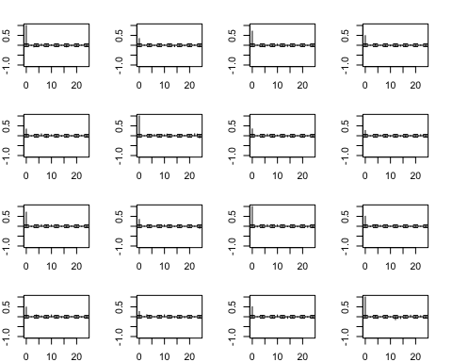
## Hit Enter for p-value plot of individual ccm:
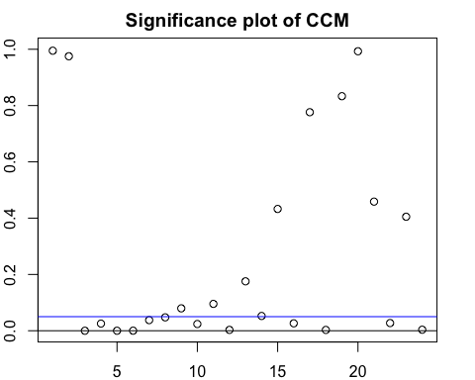
## Hit Enter to compute MQ-statistics:
##
## Ljung-Box Statistics:
## m Q(m) df p-value
## [1,] 1.00 5.18 16.00 0.99
## [2,] 2.00 12.10 32.00 1.00
## [3,] 3.00 70.97 48.00 0.02
## [4,] 4.00 99.82 64.00 0.00
## [5,] 5.00 151.76 80.00 0.00
## [6,] 6.00 196.00 96.00 0.00
## [7,] 7.00 223.41 112.00 0.00
## [8,] 8.00 249.96 128.00 0.00
## [9,] 9.00 274.49 144.00 0.00
## [10,] 10.00 303.57 160.00 0.00
## [11,] 11.00 327.36 176.00 0.00
## [12,] 12.00 363.26 192.00 0.00
## [13,] 13.00 384.39 208.00 0.00
## [14,] 14.00 410.56 224.00 0.00
## [15,] 15.00 426.89 240.00 0.00
## [16,] 16.00 455.62 256.00 0.00
## [17,] 17.00 467.16 272.00 0.00
## [18,] 18.00 503.24 288.00 0.00
## [19,] 19.00 513.87 304.00 0.00
## [20,] 20.00 519.35 320.00 0.00
## [21,] 21.00 535.30 336.00 0.00
## [22,] 22.00 563.89 352.00 0.00
## [23,] 23.00 580.63 368.00 0.00
## [24,] 24.00 615.98 384.00 0.00
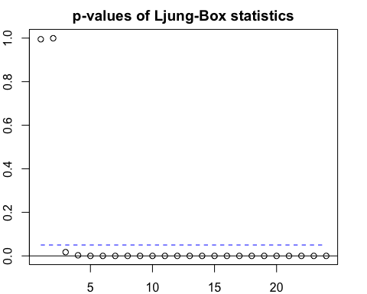
## Hit Enter to obtain residual plots:
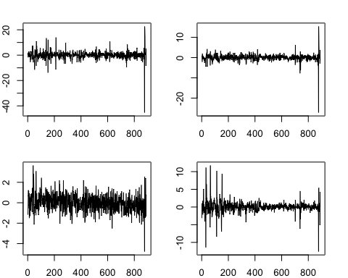

Comment:
From the L-Jung box statistics we have p-value > 0.05 so, it’s failed to reject the H0 which mean that our model is adequate. As well as the CCM there’s no correlation left in lag 1, 2 after using the VAR model

Model Refinement
m1.mts2=refVAR(m1.mts,thres = 1.645)
## Constant term:
## Estimates: 0.2152919 0.1773043 0.1842434 0.124001
## Std.Error: 0.109649 0.02686661 0.05687657 0.05346031
## AR coefficient matrix
## AR( 1 )-matrix
## [,1] [,2] [,3] [,4]
## [1,] 0.1023 0.000 0.000 0.347
## [2,] 0.0348 -0.155 0.000 0.000
## [3,] 0.0000 0.000 0.134 0.185
## [4,] 0.0000 0.178 0.000 0.232
## standard error
## [,1] [,2] [,3] [,4]
## [1,] 0.03733 0.0000 0.0000 0.0783
## [2,] 0.00844 0.0351 0.0000 0.0000
## [3,] 0.00000 0.0000 0.0378 0.0413
## [4,] 0.00000 0.0672 0.0000 0.0337
## AR( 2 )-matrix
## [,1] [,2] [,3] [,4]
## [1,] -0.129 0.000 -0.175 0.000
## [2,] 0.000 0.000 0.000 0.000
## [3,] -0.139 0.000 0.182 0.102
## [4,] 0.000 0.144 0.000 0.000
## standard error
## [,1] [,2] [,3] [,4]
## [1,] 0.0454 0.0000 0.0860 0.0000
## [2,] 0.0000 0.0000 0.0000 0.0000
## [3,] 0.0238 0.0000 0.0464 0.0425
## [4,] 0.0000 0.0654 0.0000 0.0000
##
## Residuals cov-mtx:
## [,1] [,2] [,3] [,4]
## [1,] 10.096231 0.827661 3.701401 2.322786
## [2,] 0.827661 0.614838 0.439733 0.313845
## [3,] 3.701401 0.439733 2.684327 1.256237
## [4,] 2.322786 0.313845 1.256237 2.315673
##
## det(SSE) = 11.75217
## AIC = 2.495463
## BIC = 2.570764
## HQ = 2.524243

model checking by CCM and Box-test (after refinement)
MTSdiag(m1.mts2)
## [1] "Covariance matrix:"
## IPD IPN IPB IPM
## IPD 10.108 0.829 3.71 2.325
## IPN 0.829 0.616 0.44 0.314
## IPB 3.706 0.440 2.69 1.258
## IPM 2.325 0.314 1.26 2.318
## CCM at lag: 0
## [,1] [,2] [,3] [,4]
## [1,] 1.000 0.332 0.711 0.480
## [2,] 0.332 1.000 0.342 0.263
## [3,] 0.711 0.342 1.000 0.504
## [4,] 0.480 0.263 0.504 1.000
## Simplified matrix:
## CCM at lag: 1
## . . . .
## . . . .
## . . . .
## . . . .
## CCM at lag: 2
## . . . .
## . . . .
## . . . .
## . . . .
## CCM at lag: 3
## - . . .
## . . . .
## . . . .
## . + . .
## CCM at lag: 4
## . . . .
## . + . .
## . . . +
## + . . +
## CCM at lag: 5
## . . - .
## . . . +
## . . . .
## . . . -
## CCM at lag: 6
## . . . .
## + . + .
## + . + .
## . . . .
## CCM at lag: 7
## . . . .
## . . . .
## . . . .
## . . . .
## CCM at lag: 8
## . . . .
## - . - .
## . . . .
## . . . .
## CCM at lag: 9
## . . . .
## . . . .
## . . . .
## . . . .
## CCM at lag: 10
## . . . .
## . . . .
## . . . .
## + + + .
## CCM at lag: 11
## . . . .
## . + . .
## . . . .
## . . . .
## CCM at lag: 12
## . . . -
## . . . .
## . . . .
## . . - -
## CCM at lag: 13
## . . . .
## . . . .
## . . . .
## . . . -
## CCM at lag: 14
## . - . .
## . . . .
## . . . .
## . . - -
## CCM at lag: 15
## . . . .
## . . . .
## . . . .
## . . . .
## CCM at lag: 16
## - . . .
## . . . .
## . . . .
## . . . .
## CCM at lag: 17
## . . . .
## . . . .
## . . . .
## . . . .
## CCM at lag: 18
## . . . .
## . . . .
## . . . .
## . . . +
## CCM at lag: 19
## . . . .
## . . . .
## . . . .
## . . . .
## CCM at lag: 20
## . . . .
## . . . .
## . . . .
## . . . .
## CCM at lag: 21
## . . . .
## . . . .
## . . . .
## . . . .
## CCM at lag: 22
## . . . .
## . + . .
## . . . .
## . . . .
## CCM at lag: 23
## . . . .
## . + . .
## . . . .
## . . . .
## CCM at lag: 24
## . - . .
## . - . .
## . - - .
## . . . -
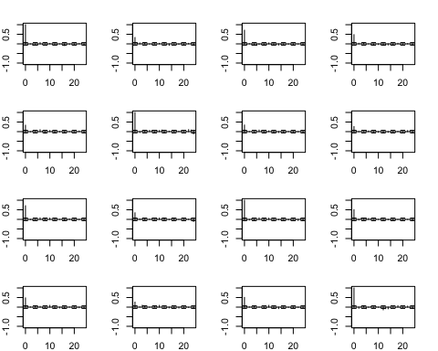
## Hit Enter for p-value plot of individual ccm:
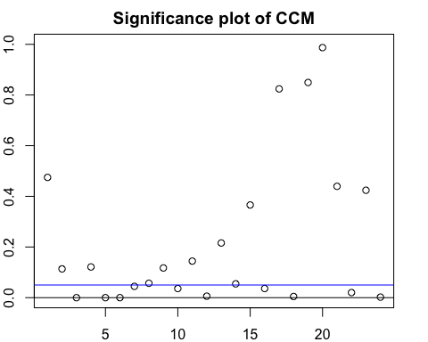
## Hit Enter to compute MQ-statistics:
##
## Ljung-Box Statistics:
## m Q(m) df p-value
## [1,] 1.0 15.7 16.0 0.47
## [2,] 2.0 38.8 32.0 0.19
## [3,] 3.0 92.1 48.0 0.00
## [4,] 4.0 114.8 64.0 0.00
## [5,] 5.0 166.4 80.0 0.00
## [6,] 6.0 212.5 96.0 0.00
## [7,] 7.0 239.3 112.0 0.00
## [8,] 8.0 265.2 128.0 0.00
## [9,] 9.0 288.1 144.0 0.00
## [10,] 10.0 315.7 160.0 0.00
## [11,] 11.0 337.7 176.0 0.00
## [12,] 12.0 371.5 192.0 0.00
## [13,] 13.0 391.6 208.0 0.00
## [14,] 14.0 417.7 224.0 0.00
## [15,] 15.0 435.0 240.0 0.00
## [16,] 16.0 462.6 256.0 0.00
## [17,] 17.0 473.4 272.0 0.00
## [18,] 18.0 507.9 288.0 0.00
## [19,] 19.0 518.3 304.0 0.00
## [20,] 20.0 524.4 320.0 0.00
## [21,] 21.0 540.6 336.0 0.00
## [22,] 22.0 570.3 352.0 0.00
## [23,] 23.0 586.8 368.0 0.00
## [24,] 24.0 623.8 384.0 0.00
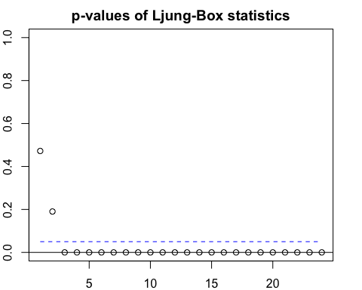
## Hit Enter to obtain residual plots:
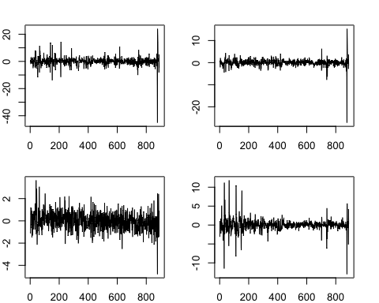
Comment:
From the L-Jung box statistics we have p-value > 0.05 so, it’s failed to reject the H0 which mean that our model is adequate. As well as the CCM there’s no correlation left in lag 1, 2 after using the VAR model
Final fitted model :
$\left[\begin{matrix}{\hat{IPD}}_{t} \\ {\hat{IPN}}_{t} \\ \hat{{IPB}_{t}} \\ \hat{{IPM}_{t}}\end{matrix}\right]= \left[\begin{matrix}\begin{matrix}0.215 \\ \left(0.110 \right)\end{matrix} \\ \begin{matrix}0.177 \\ \left(0.027\right)\end{matrix} \\ \begin{matrix}0.184 \\ \left(0.057\right)\end{matrix} \\ \begin{matrix}0.124 \\ \left(0.053\right)\end{matrix}\end{matrix}\right]+ \left[\begin{matrix}\begin{matrix}0.102 \\ \left(0.037\right)\end{matrix} & 0 & 0 & \begin{matrix}0.347 \\ \left(0.078\right)\end{matrix} \\ \begin{matrix}0.035 \\ \left(0.008\right)\end{matrix} & \begin{matrix}-0.155 \\ \left(0.035\right)\end{matrix} & 0 & 0 \\ 0 & \begin{matrix}0 \\ \left(0\right)\end{matrix} & \begin{matrix}0.134 \\ \left(0.038\right)\end{matrix} & \begin{matrix}0.185 \\ \left(0.041\right)\end{matrix} \\ 0 & \begin{matrix}0.178 \\ \left(0.067\right)\end{matrix} & 0 & \begin{matrix}0.232 \\ \left(0.034\right)\end{matrix}\end{matrix}\right] \left[\begin{matrix}{IPD}_{t-1} \\ {IPN}_{t-1} \\ {IPB}_{t-1} \\ {IPM}_{t-1}\end{matrix}\right]$
+ $\left[\begin{matrix}\begin{matrix}-0.129 \\ (0.045)\end{matrix} & 0 & \begin{matrix}-0.175 \\ (0)\end{matrix} & 0 \\ 0 & 0 & 0 & 0 \\ \begin{matrix}-0.139 \\ (0.024)\end{matrix} & \begin{matrix}0 \\ (0)\end{matrix} & \begin{matrix}0.182 \\ (0.046)\end{matrix} & \begin{matrix}0.102 \\ (0.043)\end{matrix} \\ 0 & \begin{matrix}0.144 \\ (0.065)\end{matrix} & 0 & 0\end{matrix}\right] \left[\begin{matrix}{IPD}_{t-2} \\ {IPN}_{t-2} \\ {IPB}_{t-2} \\ {IPM}_{t-2}\end{matrix}\right]$
Question 1.3)
Obtain impulse response function (IRF)
#creating the VAR model
m1.vars=VAR(zt,p=2)
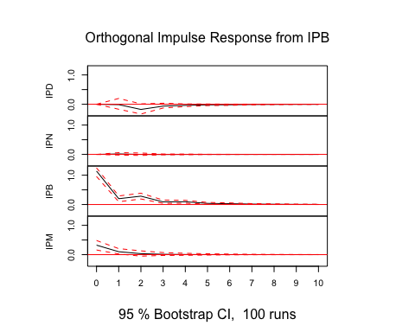
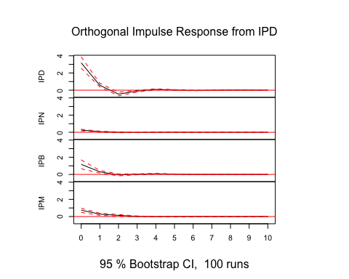
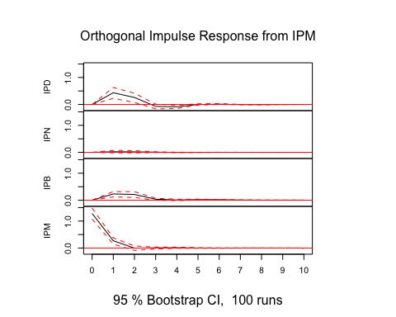
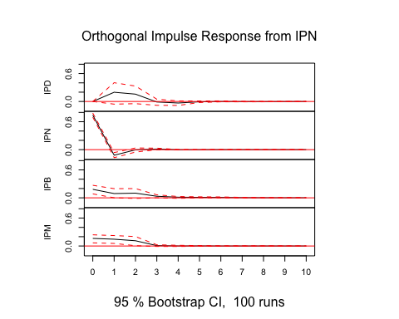
#IRF
imp1=irf(m1.vars)
plot(imp1)

Comment:
Impact on IPD: all of the variables have positive impact on IPD which the most impact on IPD come from the shocks of IPD itself, IPB, IPM and IPN, in order.
Impact on IPN: all of the variables have positive impact on IPN which the most impact on IPN come from the shocks of IPN itself, IPD, IPM and IPB, in order.
Impact on IPB: all of the variables have positive impact on IPB which the most impact on IPB come from the shocks of IPB itself, IPM, IPD and IPN, in order.
Impact on IPM: all of the variables have positive impact on IPM which the most impact on IPN come from the shocks of IPM itself, IPD, IPB and IPN, in order.

Question 1.4)
Obtain forecast error variance decomposition
#fevd
fevd(m1.vars)
## $IPD
## IPD IPN IPB IPM
## [1,] 1.0000000 0.000000000 0.000000e+00 0.00000000
## [2,] 0.9786677 0.003677477 1.547554e-05 0.01763932
## [3,] 0.9681556 0.005825149 2.865465e-03 0.02315381
## [4,] 0.9673749 0.005826039 3.233717e-03 0.02356535
## [5,] 0.9664951 0.005913986 3.365580e-03 0.02422538
## [6,] 0.9664566 0.005918078 3.400740e-03 0.02422457
## [7,] 0.9664239 0.005917334 3.427742e-03 0.02423098
## [8,] 0.9664153 0.005917546 3.434368e-03 0.02423283
## [9,] 0.9664095 0.005918007 3.436407e-03 0.02423607
## [10,] 0.9664087 0.005918072 3.437077e-03 0.02423614
##
## $IPN
## IPD IPN IPB IPM
## [1,] 0.1130659 0.8869341 0.0000000000 0.0000000000
## [2,] 0.1176617 0.8812807 0.0003848728 0.0006727082
## [3,] 0.1176060 0.8808902 0.0003857537 0.0011180226
## [4,] 0.1178793 0.8805521 0.0003980169 0.0011706388
## [5,] 0.1178761 0.8805347 0.0003990007 0.0011902249
## [6,] 0.1178942 0.8805099 0.0003989982 0.0011968518
## [7,] 0.1178942 0.8805093 0.0003991068 0.0011974314
## [8,] 0.1178956 0.8805076 0.0003991836 0.0011976850
## [9,] 0.1178956 0.8805075 0.0003991979 0.0011977477
## [10,] 0.1178956 0.8805074 0.0003991997 0.0011977775
##
## $IPB
## IPD IPN IPB IPM
## [1,] 0.5069355 0.01224107 0.4808235 0.00000000
## [2,] 0.5048449 0.01432290 0.4624710 0.01836117
## [3,] 0.4828424 0.01696945 0.4679075 0.03228060
## [4,] 0.4812822 0.01727732 0.4688451 0.03259533
## [5,] 0.4808006 0.01725670 0.4694796 0.03246315
## [6,] 0.4806182 0.01727671 0.4695372 0.03256786
## [7,] 0.4804322 0.01729458 0.4696161 0.03265708
## [8,] 0.4803961 0.01729859 0.4696392 0.03266607
## [9,] 0.4803859 0.01729914 0.4696485 0.03266650
## [10,] 0.4803820 0.01729948 0.4696507 0.03266778
##
## $IPM
## IPD IPN IPB IPM
## [1,] 0.2369914 0.01140501 0.04501385 0.7065897
## [2,] 0.2512518 0.01903374 0.04569678 0.6840177
## [3,] 0.2554440 0.02378324 0.04554842 0.6752243
## [4,] 0.2555947 0.02379966 0.04558903 0.6750166
## [5,] 0.2556231 0.02379681 0.04559513 0.6749849
## [6,] 0.2556249 0.02379765 0.04559845 0.6749790
## [7,] 0.2556289 0.02379741 0.04560048 0.6749732
## [8,] 0.2556296 0.02379737 0.04560115 0.6749719
## [9,] 0.2556295 0.02379740 0.04560134 0.6749718
## [10,] 0.2556295 0.02379741 0.04560140 0.6749717

Comment: FEVD have the same impact as the impulse response function except the IPB that having IPD impact the most and followed by IPB, IPN and IPM

Question 1.5)
1 to 6 steps ahead interval forecasting
#1.5
predict(m1.vars, n.ahead = 6, ci=0.95, h=879)
## $IPD
## fcst lower upper CI
## [1,] -0.06150473 -6.300249 6.177239 6.238744
## [2,] 0.77907327 -5.624736 7.182883 6.403809
## [3,] 0.18461230 -6.318302 6.687526 6.502914
## [4,] 0.05341044 -6.455561 6.562382 6.508971
## [5,] 0.18430627 -6.330032 6.698645 6.514339
## [6,] 0.24660374 -6.267897 6.761105 6.514501
##
## $IPN
## fcst lower upper CI
## [1,] -0.05426783 -1.596737 1.488201 1.542469
## [2,] 0.15209749 -1.415492 1.719687 1.567589
## [3,] 0.19159580 -1.376365 1.759557 1.567961
## [4,] 0.15594667 -1.412572 1.724465 1.568519
## [5,] 0.15469714 -1.413842 1.723237 1.568540
## [6,] 0.16062462 -1.407939 1.729188 1.568563
##
## $IPB
## fcst lower upper CI
## [1,] 0.9027450 -2.323714 4.129204 3.226459
## [2,] 0.7194082 -2.619747 4.058564 3.339155
## [3,] 0.5411836 -2.877592 3.959959 3.418775
## [4,] 0.3508809 -3.073996 3.775757 3.424877
## [5,] 0.3737427 -3.059243 3.806729 3.432986
## [6,] 0.3594820 -3.075094 3.794058 3.434576
##
## $IPM
## fcst lower upper CI
## [1,] 0.3852687 -2.604896 3.375434 2.990165
## [2,] 0.3011154 -2.805045 3.407276 3.106160
## [3,] 0.2343799 -2.891949 3.360708 3.126329
## [4,] 0.2485357 -2.878334 3.375405 3.126869
## [5,] 0.2380792 -2.888995 3.365153 3.127074
## [6,] 0.2275148 -2.899574 3.354604 3.127089

Question 2: indentify the optimal model for DOGEUSD log return.
Download and prepare the data for question 1
#question2
getSymbols("DOGE-USD", src = "yahoo", from="2015-01-01", to="2021-05-24")
## Warning: DOGE-USD contains missing values. Some functions will not work if
## objects contain missing values in the middle of the series. Consider using
## na.omit(), na.approx(), na.fill(), etc to remove or replace them.
## [1] "DOGE-USD"
adfTest(logDOGE)
## Warning in if (class(x) == "timeSeries") x = series(x): the condition has length
## > 1 and only the first element will be used
##
## Title:
## Augmented Dickey-Fuller Test
##
## Test Results:
## PARAMETER:
## Lag Order: 1
## STATISTIC:
## Dickey-Fuller: -1.7029
## P VALUE:
## 0.08744
##
## Description:
## Wed Jun 9 21:08:36 2021 by user:
#transform the data to be stationary
rDOGE <- diff(logDOGE)*100
rDOGE = na.omit(rDOGE)
ts.plot(rDOGE)
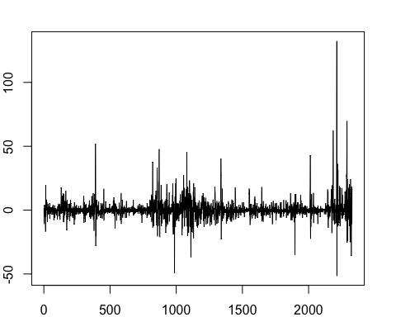
adfTest(rDOGE)
## Warning in if (class(x) == "timeSeries") x = series(x): the condition has length
## > 1 and only the first element will be used
## Warning in adfTest(rDOGE): p-value smaller than printed p-value
##
## Title:
## Augmented Dickey-Fuller Test
##
## Test Results:
## PARAMETER:
## Lag Order: 1
## STATISTIC:
## Dickey-Fuller: -32.2969
## P VALUE:
## 0.01
##
## Description:
## Wed Jun 9 21:08:36 2021 by user:
Comment: after transformed the data to be log return format, we have stationary condition according to the ADF test

Identify the optimal mean equation for DOGEUSD log return by using auto.arima
auto.arima(rDOGE)
## Series: rDOGE
## ARIMA(3,0,3) with non-zero mean
##
## Coefficients:
## ar1 ar2 ar3 ma1 ma2 ma3 mean
## -0.1365 -0.6177 0.2899 0.1575 0.6680 -0.2124 0.3246
## s.e. 0.2863 0.1375 0.2476 0.2920 0.1342 0.2587 0.1685
##
## sigma^2 estimated as 54.66: log likelihood=-7957.16
## AIC=15930.31 AICc=15930.37 BIC=15976.33
m.rDOGE = arima(rDOGE, order=c(3,0,3) )
summary(m.rDOGE)
##
## Call:
## arima(x = rDOGE, order = c(3, 0, 3))
##
## Coefficients:
## ar1 ar2 ar3 ma1 ma2 ma3 intercept
## -0.1365 -0.6177 0.2899 0.1575 0.6680 -0.2124 0.3246
## s.e. 0.2863 0.1375 0.2476 0.2920 0.1342 0.2587 0.1685
##
## sigma^2 estimated as 54.5: log likelihood = -7957.16, aic = 15930.31
##
## Training set error measures:
## ME RMSE MAE MPE MAPE MASE ACF1
## Training set 0.0007094938 7.382195 3.969358 NaN Inf 0.6871478 0.0006743052
Comment: as a result from using auto.arima function we have the ARMA(3,3) as the optimal mean equation for DOGEUSD log return series.

Check the ARCH effect to check whether we should use the volatility equation or not.
acf(m.rDOGE$residuals^2)
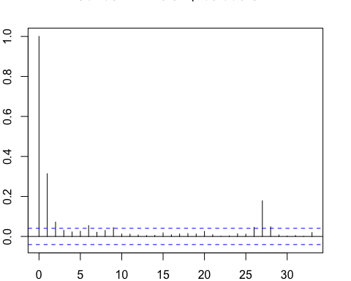
Box.test(m.rDOGE$residuals^2,lag=10,type = 'Ljung')
##
## Box-Ljung test
##
## data: m.rDOGE$residuals^2
## X-squared = 261.5, df = 10, p-value < 2.2e-16
Comment: According to the L-jung box test of residuals-squares we have p-value less than 0.05 so, we reject the H0 which mean that the ARCH effect exist and we should use the volatility equation.
Create the model with volatility equation

Model1: ARMA(3,3)+GARCH(1,1)
**using the GARCH(1,1) as volatility equation because it’s the most common model in time series analysis**
m.rDOGE2 <- garchFit(~arma(3,3)+garch(1,1), data =rDOGE,trace=F)
## Warning in arima(.series$x, order = c(u, 0, v), include.mean = include.mean):
## possible convergence problem: optim gave code = 1
summary(m.rDOGE2)
##
## Title:
## GARCH Modelling
##
## Call:
## garchFit(formula = ~arma(3, 3) + garch(1, 1), data = rDOGE, trace = F)
##
## Mean and Variance Equation:
## data ~ arma(3, 3) + garch(1, 1)
## <environment: 0x7fdbd0b189e0>
## [data = rDOGE]
##
## Conditional Distribution:
## norm
##
## Coefficient(s):
## mu ar1 ar2 ar3 ma1 ma2 ma3
## -0.099345 -0.052643 -0.505373 0.422826 0.012285 0.525635 -0.440708
## omega alpha1 beta1
## 1.289292 0.296546 0.739004
##
## Std. Errors:
## based on Hessian
##
## Error Analysis:
## Estimate Std. Error t value Pr(>|t|)
## mu -0.09935 0.10977 -0.905 0.36546
## ar1 -0.05264 0.31513 -0.167 0.86733
## ar2 -0.50537 0.17480 -2.891 0.00384 **
## ar3 0.42283 0.28508 1.483 0.13803
## ma1 0.01228 0.30899 0.040 0.96829
## ma2 0.52564 0.16398 3.205 0.00135 **
## ma3 -0.44071 0.28328 -1.556 0.11977
## omega 1.28929 0.17951 7.182 6.85e-13 ***
## alpha1 0.29655 0.02719 10.907 < 2e-16 ***
## beta1 0.73900 0.01904 38.813 < 2e-16 ***
## ---
## Signif. codes: 0 '***' 0.001 '**' 0.01 '*' 0.05 '.' 0.1 ' ' 1
##
## Log Likelihood:
## -7046.878 normalized: -3.02701
##
## Description:
## Wed Jun 9 21:08:38 2021 by user:
##
##
## Standardised Residuals Tests:
## Statistic p-Value
## Jarque-Bera Test R Chi^2 9736.555 0
## Shapiro-Wilk Test R W 0.8764045 0
## Ljung-Box Test R Q(10) 25.55067 0.004393901
## Ljung-Box Test R Q(15) 44.71623 8.487959e-05
## Ljung-Box Test R Q(20) 47.38123 0.0005191785
## Ljung-Box Test R^2 Q(10) 16.179 0.09462182
## Ljung-Box Test R^2 Q(15) 16.74742 0.3341864
## Ljung-Box Test R^2 Q(20) 19.19335 0.5092917
## LM Arch Test R TR^2 15.8257 0.1993504
##
## Information Criterion Statistics:
## AIC BIC SIC HQIC
## 6.062610 6.087321 6.062573 6.071614
plot(m.rDOGE2,which=13)
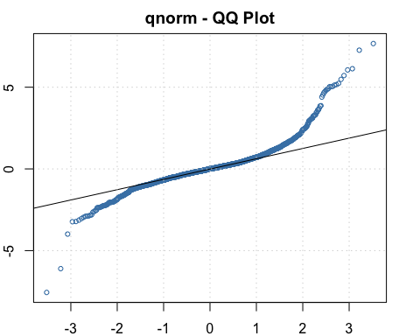
Comment: in this case we have adequate in volatility equation from L-jung box test but inadequate in mean equation.
Moreover, JB test is reject which mean that the distribution is not normal

Model2: ARMA(3,3)+GARCH(1,1) with student t-distribution
m.rDOGE3 <- garchFit(~arma(3,3)+garch(1,1), data =rDOGE,trace=F,cond.dist="std")
## Warning in arima(.series$x, order = c(u, 0, v), include.mean = include.mean):
## possible convergence problem: optim gave code = 1
summary(m.rDOGE3)
##
## Title:
## GARCH Modelling
##
## Call:
## garchFit(formula = ~arma(3, 3) + garch(1, 1), data = rDOGE, cond.dist = "std",
## trace = F)
##
## Mean and Variance Equation:
## data ~ arma(3, 3) + garch(1, 1)
## <environment: 0x7fdbce26d328>
## [data = rDOGE]
##
## Conditional Distribution:
## std
##
## Coefficient(s):
## mu ar1 ar2 ar3 ma1 ma2 ma3 omega
## -0.14284 0.38835 -0.50600 0.10203 -0.53313 0.57494 -0.18457 1.76623
## alpha1 beta1 shape
## 0.66919 0.71103 2.39291
##
## Std. Errors:
## based on Hessian
##
## Error Analysis:
## Estimate Std. Error t value Pr(>|t|)
## mu -0.14284 0.06017 -2.374 0.017597 *
## ar1 0.38835 0.29150 1.332 0.182789
## ar2 -0.50600 0.15016 -3.370 0.000752 ***
## ar3 0.10203 0.18078 0.564 0.572494
## ma1 -0.53313 0.28914 -1.844 0.065209 .
## ma2 0.57494 0.13900 4.136 3.53e-05 ***
## ma3 -0.18457 0.18285 -1.009 0.312779
## omega 1.76623 0.62418 2.830 0.004660 **
## alpha1 0.66919 0.20758 3.224 0.001265 **
## beta1 0.71103 0.02939 24.196 < 2e-16 ***
## shape 2.39291 0.15020 15.931 < 2e-16 ***
## ---
## Signif. codes: 0 '***' 0.001 '**' 0.01 '*' 0.05 '.' 0.1 ' ' 1
##
## Log Likelihood:
## -6616.755 normalized: -2.842249
##
## Description:
## Wed Jun 9 21:08:40 2021 by user:
##
##
## Standardised Residuals Tests:
## Statistic p-Value
## Jarque-Bera Test R Chi^2 11703.33 0
## Shapiro-Wilk Test R W 0.865867 0
## Ljung-Box Test R Q(10) 56.74191 1.490263e-08
## Ljung-Box Test R Q(15) 81.06267 4.462797e-11
## Ljung-Box Test R Q(20) 85.2772 4.903543e-10
## Ljung-Box Test R^2 Q(10) 11.10922 0.3490721
## Ljung-Box Test R^2 Q(15) 11.69596 0.7018812
## Ljung-Box Test R^2 Q(20) 14.32042 0.8138855
## LM Arch Test R TR^2 11.58141 0.4798545
##
## Information Criterion Statistics:
## AIC BIC SIC HQIC
## 5.693947 5.721130 5.693903 5.703852
plot(m.rDOGE3,which=13)
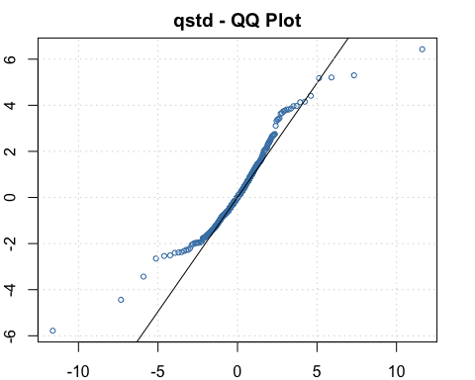

Comment:
we have adequate in volatility equation from L-jung box test but still inadequate in mean equation.
By the way QQ-plot is more fitted than previous one so, we choose std as our distribution
In this case it’s possible that our mean equation is not the optimal one which we have insignificant on ar3 ma3 ar1 in individual test

Model3: ARMA(2,2)+GARCH(1,1) with student t-distribution
(remove the insignificant variable from the previous model)
m.rDOGE4 <- garchFit(~arma(2,2)+garch(1,1), data =rDOGE,trace=F,cond.dist="std")
## Warning in arima(.series$x, order = c(u, 0, v), include.mean = include.mean):
## possible convergence problem: optim gave code = 1
summary(m.rDOGE4)
##
## Title:
## GARCH Modelling
##
## Call:
## garchFit(formula = ~arma(2, 2) + garch(1, 1), data = rDOGE, cond.dist = "std",
## trace = F)
##
## Mean and Variance Equation:
## data ~ arma(2, 2) + garch(1, 1)
## <environment: 0x7fdbd94053b0>
## [data = rDOGE]
##
## Conditional Distribution:
## std
##
## Coefficient(s):
## mu ar1 ar2 ma1 ma2 omega alpha1
## -0.111867 0.239253 -0.035540 -0.380129 0.073895 1.657158 0.633720
## beta1 shape
## 0.710900 2.426663
##
## Std. Errors:
## based on Hessian
##
## Error Analysis:
## Estimate Std. Error t value Pr(>|t|)
## mu -0.11187 0.04752 -2.354 0.018571 *
## ar1 0.23925 0.20184 1.185 0.235881
## ar2 -0.03554 0.13381 -0.266 0.790538
## ma1 -0.38013 0.20089 -1.892 0.058457 .
## ma2 0.07390 0.13545 0.546 0.585376
## omega 1.65716 0.55274 2.998 0.002717 **
## alpha1 0.63372 0.18187 3.484 0.000493 ***
## beta1 0.71090 0.02857 24.880 < 2e-16 ***
## shape 2.42666 0.14981 16.198 < 2e-16 ***
## ---
## Signif. codes: 0 '***' 0.001 '**' 0.01 '*' 0.05 '.' 0.1 ' ' 1
##
## Log Likelihood:
## -6620.225 normalized: -2.843739
##
## Description:
## Wed Jun 9 21:08:41 2021 by user:
##
##
## Standardised Residuals Tests:
## Statistic p-Value
## Jarque-Bera Test R Chi^2 11657.82 0
## Shapiro-Wilk Test R W 0.8665266 0
## Ljung-Box Test R Q(10) 53.53244 5.928819e-08
## Ljung-Box Test R Q(15) 77.34564 2.128102e-10
## Ljung-Box Test R Q(20) 81.48555 2.193558e-09
## Ljung-Box Test R^2 Q(10) 11.07519 0.3516903
## Ljung-Box Test R^2 Q(15) 11.65115 0.7052194
## Ljung-Box Test R^2 Q(20) 14.2906 0.8154614
## LM Arch Test R TR^2 11.45598 0.4902973
##
## Information Criterion Statistics:
## AIC BIC SIC HQIC
## 5.695210 5.717451 5.695181 5.703314
plot(m.rDOGE4,which=13)
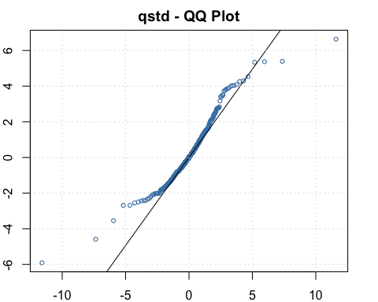
Comment: we have adequate in volatility equation from L-jung box test but still inadequate in mean equation. And have insignificant in individual test at ar1 ar2 ma2
Model4: GARCH(1,1) with student t-distribution
(Remove the insignificant variable from the previous model)
m.rDOGE5 <- garchFit(~garch(1,1), data =rDOGE,trace=F,cond.dist="std")
summary(m.rDOGE5)
##
## Title:
## GARCH Modelling
##
## Call:
## garchFit(formula = ~garch(1, 1), data = rDOGE, cond.dist = "std",
## trace = F)
##
## Mean and Variance Equation:
## data ~ garch(1, 1)
## <environment: 0x7fdbd193ae80>
## [data = rDOGE]
##
## Conditional Distribution:
## std
##
## Coefficient(s):
## mu omega alpha1 beta1 shape
## -0.13885 1.41763 0.55619 0.69703 2.59654
##
## Std. Errors:
## based on Hessian
##
## Error Analysis:
## Estimate Std. Error t value Pr(>|t|)
## mu -0.13885 0.05137 -2.703 0.006874 **
## omega 1.41763 0.39619 3.578 0.000346 ***
## alpha1 0.55619 0.12416 4.480 7.47e-06 ***
## beta1 0.69703 0.02888 24.132 < 2e-16 ***
## shape 2.59654 0.16237 15.992 < 2e-16 ***
## ---
## Signif. codes: 0 '***' 0.001 '**' 0.01 '*' 0.05 '.' 0.1 ' ' 1
##
## Log Likelihood:
## -6645.493 normalized: -2.854593
##
## Description:
## Wed Jun 9 21:08:42 2021 by user:
##
##
## Standardised Residuals Tests:
## Statistic p-Value
## Jarque-Bera Test R Chi^2 12163.9 0
## Shapiro-Wilk Test R W 0.8687031 0
## Ljung-Box Test R Q(10) 18.43129 0.04810984
## Ljung-Box Test R Q(15) 35.09531 0.002383332
## Ljung-Box Test R Q(20) 38.6249 0.007420702
## Ljung-Box Test R^2 Q(10) 9.153426 0.5176076
## Ljung-Box Test R^2 Q(15) 9.646243 0.8413826
## Ljung-Box Test R^2 Q(20) 12.12506 0.9117044
## LM Arch Test R TR^2 9.745108 0.6383111
##
## Information Criterion Statistics:
## AIC BIC SIC HQIC
## 5.713482 5.725837 5.713472 5.717983
plot(m.rDOGE5,which=13)
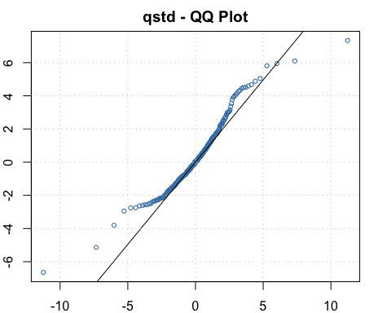

Comment: we have adequate in both mean and volatility equation from the L-Jung box test at 90% confidence interval
Moreover, all the variables are significant in individual test
As the conclusion: GARCH (1,1) is the optimal model for DOGEUSD log return series.
Question3: RGDP series of UK, CA and US

Import and prepare the data for creating the model
#question3
#get data
getSymbols("CLVMNACSCAB1GQUK",src = "FRED")
## [1] "CLVMNACSCAB1GQUK"
UKGDP = CLVMNACSCAB1GQUK[21:142,]
getSymbols("NAEXKP01CAQ189S",src = "FRED")
## [1] "NAEXKP01CAQ189S"
CAGDP =NAEXKP01CAQ189S[77:198,]
getSymbols("GDPC1",src = "FRED")
## [1] "GDPC1"
USGDP = GDPC1[133:254,]
zt = cbind(UKGDP,CAGDP,USGDP)
colnames(zt) <- c("UKGDP","CAGDP","USGDP")
zt = log(zt)

Question 3.1)
create VAR model, refinement and model checking process
check the stationary condition
#3.1 create the var model
detach("package:vars", unload = TRUE)
require(MTS)
## Loading required package: MTS
##
## Attaching package: 'MTS'
## The following object is masked from 'package:TTR':
##
## VMA
adfTest(zt)
## Warning in if (class(x) == "timeSeries") x = series(x): the condition has length
## > 1 and only the first element will be used
##
## Title:
## Augmented Dickey-Fuller Test
##
## Test Results:
## PARAMETER:
## Lag Order: 1
## STATISTIC:
## Dickey-Fuller: -0.6965
## P VALUE:
## 0.3943
##
## Description:
## Wed Jun 9 21:08:44 2021 by user:
#transform the data
diffzt = diff(zt)*100
diffzt =diffzt[2:122,]
adfTest(diffzt)
## Warning in if (class(x) == "timeSeries") x = series(x): the condition has length
## > 1 and only the first element will be used
## Warning in adfTest(diffzt): p-value smaller than printed p-value
##
## Title:
## Augmented Dickey-Fuller Test
##
## Test Results:
## PARAMETER:
## Lag Order: 1
## STATISTIC:
## Dickey-Fuller: -6.1599
## P VALUE:
## 0.01
##
## Description:
## Wed Jun 9 21:08:44 2021 by user:

Comment: changing the series into log growth rate series to make the stationary condition valid.

Find the optimal lag for the model
VARorder(diffzt)
## selected order: aic = 1
## selected order: bic = 1
## selected order: hq = 1
## Summary table:
## p AIC BIC HQ M(p) p-value
## [1,] 0 -3.0326 -3.0326 -3.0326 0.0000 0.0000
## [2,] 1 -3.9752 -3.7673 -3.8907 112.9553 0.0000
## [3,] 2 -3.9708 -3.5549 -3.8018 14.5040 0.1055
## [4,] 3 -3.8757 -3.2519 -3.6224 5.2399 0.8129
## [5,] 4 -3.8647 -3.0328 -3.5268 13.0101 0.1621
## [6,] 5 -3.7561 -2.7164 -3.3338 3.6819 0.9311
## [7,] 6 -3.7162 -2.4685 -3.2094 9.6294 0.3813
## [8,] 7 -3.5980 -2.1423 -3.0068 2.6121 0.9777
## [9,] 8 -3.5906 -1.9269 -2.9149 11.6608 0.2331
## [10,] 9 -3.5759 -1.7043 -2.8158 10.6590 0.2998
## [11,] 10 -3.4899 -1.4104 -2.6453 4.8021 0.8512
## [12,] 11 -3.5803 -1.2928 -2.6512 17.5762 0.0404
## [13,] 12 -3.6233 -1.1279 -2.6098 13.5241 0.1403
## [14,] 13 -3.5441 -0.8407 -2.4461 4.6913 0.8603

Comment: from the printout we have lag =1 as the optimal lag for the model

Create the VAR model with lag =1
m3.mts <- VAR(diffzt, p=1, output = T)
## Constant term:
## Estimates: 0.2343036 0.05746609 0.3151199
## Std.Error: 0.07520777 0.07585787 0.0790046
## AR coefficient matrix
## AR( 1 )-matrix
## [,1] [,2] [,3]
## [1,] 0.465 0.0656 0.0757
## [2,] 0.287 0.2199 0.3747
## [3,] 0.328 0.1749 0.1464
## standard error
## [,1] [,2] [,3]
## [1,] 0.0823 0.0853 0.0936
## [2,] 0.0830 0.0860 0.0945
## [3,] 0.0865 0.0896 0.0984
##
## Residuals cov-mtx:
## UKGDP CAGDP USGDP
## UKGDP 0.33297649 0.01355824 0.05185234
## CAGDP 0.01355824 0.33875787 0.15283321
## USGDP 0.05185234 0.15283321 0.36744546
##
## det(SSE) = 0.03290614
## AIC = -3.265336
## BIC = -3.057384
## HQ = -3.180879

Model refinement
m3.mts2 =refVAR(m3.mts,thres = 1.645)
## Constant term:
## Estimates: 0.2895998 0 0.3476848
## Std.Error: 0.06736582 0 0.07630967
## AR coefficient matrix
## AR( 1 )-matrix
## [,1] [,2] [,3]
## [1,] 0.528 0.000 0.000
## [2,] 0.303 0.229 0.394
## [3,] 0.369 0.248 0.000
## standard error
## [,1] [,2] [,3]
## [1,] 0.0726 0.0000 0.0000
## [2,] 0.0800 0.0850 0.0906
## [3,] 0.0823 0.0756 0.0000
##
## Residuals cov-mtx:
## [,1] [,2] [,3]
## [1,] 0.34081440 0.0119456 0.05547915
## [2,] 0.01194560 0.3404338 0.15188350
## [3,] 0.05547915 0.1518835 0.37446602
##
## det(SSE) = 0.03468526
## AIC = -3.262267
## BIC = -3.123633
## HQ = -3.205962

Model Checking with L-Jung box test
MTSdiag(m3.mts2)
## [1] "Covariance matrix:"
## UKGDP CAGDP USGDP
## UKGDP 0.3437 0.012 0.0559
## CAGDP 0.0120 0.342 0.1532
## USGDP 0.0559 0.153 0.3776
## CCM at lag: 0
## [,1] [,2] [,3]
## [1,] 1.0000 0.0351 0.155
## [2,] 0.0351 1.0000 0.426
## [3,] 0.1553 0.4259 1.000
## Simplified matrix:
## CCM at lag: 1
## . . .
## . . .
## . . +
## CCM at lag: 2
## . . .
## . . .
## . . .
## CCM at lag: 3
## . . +
## . . .
## . . .
## CCM at lag: 4
## . . .
## . . .
## . . .
## CCM at lag: 5
## . . .
## . . .
## . . .
## CCM at lag: 6
## . . .
## . . .
## . - .
## CCM at lag: 7
## . . .
## . . .
## . . .
## CCM at lag: 8
## . . .
## . . .
## . - .
## CCM at lag: 9
## . . .
## . . .
## . . .
## CCM at lag: 10
## . . .
## . . .
## . . .
## CCM at lag: 11
## . . .
## . . .
## . . .
## CCM at lag: 12
## . . .
## . . .
## . . .
## CCM at lag: 13
## . . .
## . . .
## . . .
## CCM at lag: 14
## . . .
## . . .
## . . .
## CCM at lag: 15
## . . .
## . . .
## . . .
## CCM at lag: 16
## . . .
## . . .
## . . .
## CCM at lag: 17
## . . .
## . . .
## . . .
## CCM at lag: 18
## . . .
## . . .
## . . .
## CCM at lag: 19
## . . .
## . . .
## . . .
## CCM at lag: 20
## . . .
## . . .
## . . .
## CCM at lag: 21
## . . .
## . . .
## . . .
## CCM at lag: 22
## . . .
## . . .
## . . .
## CCM at lag: 23
## . . .
## . . .
## . . .
## CCM at lag: 24
## . . .
## + . .
## . . .
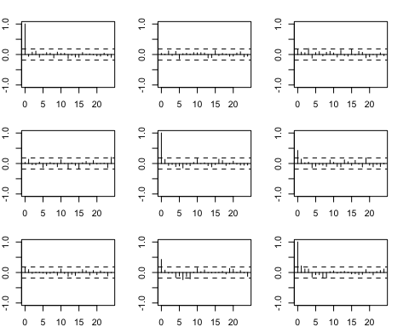
## Hit Enter for p-value plot of individual ccm:
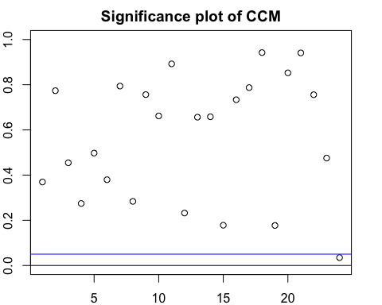
## Hit Enter to compute MQ-statistics:
##
## Ljung-Box Statistics:
## m Q(m) df p-value
## [1,] 1.00 9.93 9.00 0.36
## [2,] 2.00 15.70 18.00 0.61
## [3,] 3.00 24.68 27.00 0.59
## [4,] 4.00 35.93 36.00 0.47
## [5,] 5.00 44.49 45.00 0.49
## [6,] 6.00 54.33 54.00 0.46
## [7,] 7.00 59.88 63.00 0.59
## [8,] 8.00 70.93 72.00 0.51
## [9,] 9.00 76.87 81.00 0.61
## [10,] 10.00 83.74 90.00 0.67
## [11,] 11.00 88.06 99.00 0.78
## [12,] 12.00 99.86 108.00 0.70
## [13,] 13.00 106.82 117.00 0.74
## [14,] 14.00 113.70 126.00 0.78
## [15,] 15.00 126.57 135.00 0.69
## [16,] 16.00 132.75 144.00 0.74
## [17,] 17.00 138.27 153.00 0.80
## [18,] 18.00 141.70 162.00 0.87
## [19,] 19.00 154.73 171.00 0.81
## [20,] 20.00 159.41 180.00 0.86
## [21,] 21.00 162.89 189.00 0.92
## [22,] 22.00 168.82 198.00 0.93
## [23,] 23.00 177.61 207.00 0.93
## [24,] 24.00 196.19 216.00 0.83
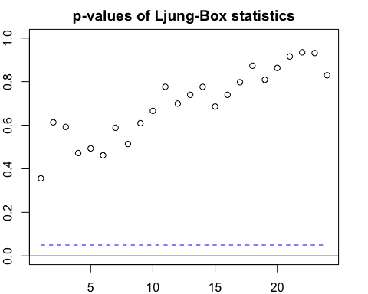
## Hit Enter to obtain residual plots:
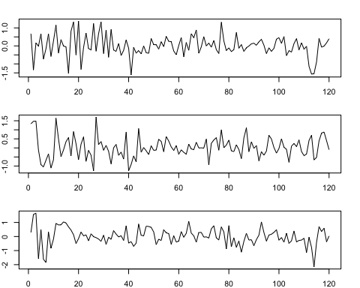

Comment:
From the L-Jung box statistics we have p-value > 0.05 so, it’s failed to reject the H0 which mean that our model is adequate.
Fitted model:
$$\left[\begin{matrix}{\hat{UKGDP}}_{t} \\ {\hat{CAGDP}}_{t} \\ \hat{{USGDP}_{t}}\end{matrix}\right]= \left[\begin{matrix}\begin{matrix}0.289 \\ \left(0.067 \right)\end{matrix} \\ \begin{matrix}0\end{matrix} \\ \begin{matrix}0.348 \\ \left(0.076\right)\end{matrix}\end{matrix}\right]+ \left[\begin{matrix}\begin{matrix}0.528 \\ \left(0.073\right)\end{matrix} & 0 & 0 \\ \begin{matrix}0.303 \\ \left(0.080\right)\end{matrix} & \begin{matrix}0.229 \\ \left(0.085\right)\end{matrix} & \begin{matrix}0.394 \\ (0.091)\end{matrix} \\ \begin{matrix}0.369 \\ (0.082)\end{matrix} & \begin{matrix}0.248 \\ \left(0.076\right)\end{matrix} & \begin{matrix}0\end{matrix}\end{matrix}\right] \left[\begin{matrix}{\hat{UKGDP}}_{t-1} \\ {\hat{CAGDP}}_{t-1} \\ \hat{{USGDP}_{t-1}}\end{matrix}\right]$$

Question 3.2)
Obtain the impulse response plot
#3.2
detach("package:MTS", unload = TRUE)
library(vars)
require(vars)
#creating the VAR model
m3.vars=VAR(diffzt,p=1)
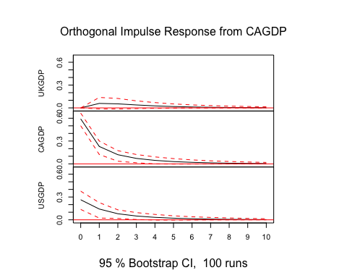
#IRF
imp3=irf(m3.vars)
plot(imp3)
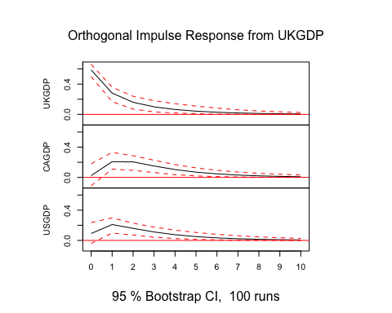

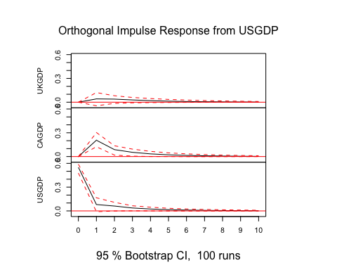

Comment:
Impact on UKGDP: all of the variables have positive impact on UKGDP which the most impact on UKGDP come from the shocks of UKGDP itself and partly from US and CA
Impact on CAGDP: all of the variables have positive impact on CAGDP which the most impact on CAGDP come from the shocks of CAGDP itself, USGDP and UKGDP, in order.
Impact on USGDP: all of the variables have positive impact on USGDP which the most impact on USGDP come from the shocks of USGDP itself, CAGDP, and UKGDP in order.
Question 3.3)
Obtain the forecast error variance decomposition
#3.3
#fevd
fevd(m3.vars)
## $UKGDP
## UKGDP CAGDP USGDP
## [1,] 1.0000000 0.000000000 0.000000000
## [2,] 0.9879122 0.008051641 0.004036157
## [3,] 0.9792614 0.013662123 0.007076510
## [4,] 0.9749169 0.016470288 0.008612792
## [5,] 0.9729263 0.017755226 0.009318504
## [6,] 0.9720396 0.018327282 0.009633084
## [7,] 0.9716481 0.018579840 0.009772034
## [8,] 0.9714757 0.018691078 0.009833243
## [9,] 0.9713998 0.018740044 0.009860189
## [10,] 0.9713664 0.018761596 0.009872049
##
## $CAGDP
## UKGDP CAGDP USGDP
## [1,] 0.001629684 0.9983703 0.00000000
## [2,] 0.089654470 0.8234779 0.08686759
## [3,] 0.155326814 0.7540718 0.09060141
## [4,] 0.186086767 0.7231901 0.09072312
## [5,] 0.199719337 0.7097669 0.09051377
## [6,] 0.205694399 0.7039187 0.09038688
## [7,] 0.208313712 0.7013606 0.09032570
## [8,] 0.209463688 0.7002383 0.09029797
## [9,] 0.209969172 0.6997452 0.09028564
## [10,] 0.210191520 0.6995283 0.09028020
##
## $USGDP
## UKGDP CAGDP USGDP
## [1,] 0.02197507 0.1828010 0.7952239
## [2,] 0.11633379 0.1988706 0.6847956
## [3,] 0.15998639 0.1975184 0.6424952
## [4,] 0.17958788 0.1960983 0.6243138
## [5,] 0.18816860 0.1953554 0.6164760
## [6,] 0.19192571 0.1950121 0.6130622
## [7,] 0.19357372 0.1948587 0.6115676
## [8,] 0.19429774 0.1947908 0.6109114
## [9,] 0.19461612 0.1947609 0.6106230
## [10,] 0.19475621 0.1947477 0.6104961

Comment: FEVD have the same impact as the impulse response function except the CAGDP that is impacted the most by CAGDP which followed by UK and US in order.

Question 3.4) Cointegration
Propose the co-integrating vector
#3.4
#co-integration vector
fit <- lm(UKGDP ~ USGDP + CAGDP)
summary(fit)
##
## Call:
## lm(formula = UKGDP ~ USGDP + CAGDP)
##
## Residuals:
## Min 1Q Median 3Q Max
## -8865.5 -2461.5 63.8 2838.1 7858.8
##
## Coefficients:
## Estimate Std. Error t value Pr(>|t|)
## (Intercept) 2.747e+04 2.607e+03 10.536 < 2e-16 ***
## USGDP 1.556e+01 1.453e+00 10.714 < 2e-16 ***
## CAGDP 3.199e-07 5.812e-08 5.504 2.17e-07 ***
## ---
## Signif. codes: 0 '***' 0.001 '**' 0.01 '*' 0.05 '.' 0.1 ' ' 1
##
## Residual standard error: 3931 on 119 degrees of freedom
## Multiple R-squared: 0.9969, Adjusted R-squared: 0.9968
## F-statistic: 1.885e+04 on 2 and 119 DF, p-value: < 2.2e-16

Engle-granger test
#engle-granger cointegration test
adfTest(UKGDP)
## Warning in if (class(x) == "timeSeries") x = series(x): the condition has length
## > 1 and only the first element will be used
## Warning in adfTest(UKGDP): p-value greater than printed p-value
##
## Title:
## Augmented Dickey-Fuller Test
##
## Test Results:
## PARAMETER:
## Lag Order: 1
## STATISTIC:
## Dickey-Fuller: 3.1741
## P VALUE:
## 0.99
##
## Description:
## Wed Jun 9 21:08:45 2021 by user:
adfTest(diff(UKGDP))
## Warning in if (class(x) == "timeSeries") x = series(x): the condition has length
## > 1 and only the first element will be used
## Warning in adfTest(diff(UKGDP)): p-value smaller than printed p-value
##
## Title:
## Augmented Dickey-Fuller Test
##
## Test Results:
## PARAMETER:
## Lag Order: 1
## STATISTIC:
## Dickey-Fuller: -3.1739
## P VALUE:
## 0.01
##
## Description:
## Wed Jun 9 21:08:45 2021 by user:
adfTest(CAGDP)
## Warning in if (class(x) == "timeSeries") x = series(x): the condition has length
## > 1 and only the first element will be used
## Warning in adfTest(CAGDP): p-value greater than printed p-value
##
## Title:
## Augmented Dickey-Fuller Test
##
## Test Results:
## PARAMETER:
## Lag Order: 1
## STATISTIC:
## Dickey-Fuller: 3.3892
## P VALUE:
## 0.99
##
## Description:
## Wed Jun 9 21:08:45 2021 by user:
adfTest(diff(CAGDP))
## Warning in if (class(x) == "timeSeries") x = series(x): the condition has length
## > 1 and only the first element will be used
## Warning in adfTest(diff(CAGDP)): p-value smaller than printed p-value
##
## Title:
## Augmented Dickey-Fuller Test
##
## Test Results:
## PARAMETER:
## Lag Order: 1
## STATISTIC:
## Dickey-Fuller: -4.1246
## P VALUE:
## 0.01
##
## Description:
## Wed Jun 9 21:08:45 2021 by user:
adfTest(USGDP)
## Warning in if (class(x) == "timeSeries") x = series(x): the condition has length
## > 1 and only the first element will be used
## Warning in adfTest(USGDP): p-value greater than printed p-value
##
## Title:
## Augmented Dickey-Fuller Test
##
## Test Results:
## PARAMETER:
## Lag Order: 1
## STATISTIC:
## Dickey-Fuller: 4.4998
## P VALUE:
## 0.99
##
## Description:
## Wed Jun 9 21:08:45 2021 by user:
adfTest(diff(USGDP))
## Warning in if (class(x) == "timeSeries") x = series(x): the condition has length
## > 1 and only the first element will be used
## Warning in adfTest(diff(USGDP)): p-value smaller than printed p-value
##
## Title:
## Augmented Dickey-Fuller Test
##
## Test Results:
## PARAMETER:
## Lag Order: 1
## STATISTIC:
## Dickey-Fuller: -3.0507
## P VALUE:
## 0.01
##
## Description:
## Wed Jun 9 21:08:45 2021 by user:
error = residuals(fit)
adfTest(error)
## Warning in if (class(x) == "timeSeries") x = series(x): the condition has length
## > 1 and only the first element will be used
## Warning in adfTest(error): p-value smaller than printed p-value
##
## Title:
## Augmented Dickey-Fuller Test
##
## Test Results:
## PARAMETER:
## Lag Order: 1
## STATISTIC:
## Dickey-Fuller: -3.2039
## P VALUE:
## 0.01
##
## Description:
## Wed Jun 9 21:08:45 2021 by user:

Comment:
From the ADF test all of the series are integrated series order 1 ,~I(1)
And the error of the model is also ~I(0) which mean that these series are cointegrated
series.

Question 3.5)
Build VECM model
#3.5
#VECM
diffUKGDP = diff(UKGDP)
diffCAGDP = diff(CAGDP)
diffUSGDP = diff(USGDP)
diffUKGDP.L1 = Lag(diffUKGDP,k=1)
diffCAGDP.L1 = Lag(diffCAGDP,k=1)
diffUSGDP.L1 = Lag(diffUSGDP,k=1)
error.L1 = Lag(error,k=1)
fit1 <- lm(diffUKGDP~diffUKGDP.L1+diffCAGDP.L1+diffUSGDP.L1+error.L1)
summary(fit1)
##
## Call:
## lm(formula = diffUKGDP ~ diffUKGDP.L1 + diffCAGDP.L1 + diffUSGDP.L1 +
## error.L1)
##
## Residuals:
## Min 1Q Median 3Q Max
## -5273.9 -807.0 30.3 962.3 4026.9
##
## Coefficients:
## Estimate Std. Error t value Pr(>|t|)
## (Intercept) 4.805e+02 1.985e+02 2.420 0.017067 *
## diffUKGDP.L1 6.383e-01 8.323e-02 7.670 6.06e-12 ***
## diffCAGDP.L1 -1.118e-07 7.872e-08 -1.420 0.158345
## diffUSGDP.L1 5.372e+00 2.469e+00 2.175 0.031643 *
## error.L1 -1.403e-01 3.956e-02 -3.548 0.000564 ***
## ---
## Signif. codes: 0 '***' 0.001 '**' 0.01 '*' 0.05 '.' 0.1 ' ' 1
##
## Residual standard error: 1582 on 115 degrees of freedom
## (2 observations deleted due to missingness)
## Multiple R-squared: 0.4976, Adjusted R-squared: 0.4802
## F-statistic: 28.48 on 4 and 115 DF, p-value: < 2.2e-16
fit2 <- lm(diffCAGDP~diffCAGDP.L1+diffUKGDP.L1+diffUSGDP.L1+error.L1)
summary(fit2)
##
## Call:
## lm(formula = diffCAGDP ~ diffCAGDP.L1 + diffUKGDP.L1 + diffUSGDP.L1 +
## error.L1)
##
## Residuals:
## Min 1Q Median 3Q Max
## -3.405e+09 -9.962e+08 -1.570e+08 1.109e+09 4.069e+09
##
## Coefficients:
## Estimate Std. Error t value Pr(>|t|)
## (Intercept) 1.770e+08 2.144e+08 0.826 0.41077
## diffCAGDP.L1 1.789e-01 8.501e-02 2.105 0.03750 *
## diffUKGDP.L1 3.727e+05 8.987e+04 4.147 6.47e-05 ***
## diffUSGDP.L1 1.051e+07 2.667e+06 3.941 0.00014 ***
## error.L1 -1.960e+04 4.272e+04 -0.459 0.64723
## ---
## Signif. codes: 0 '***' 0.001 '**' 0.01 '*' 0.05 '.' 0.1 ' ' 1
##
## Residual standard error: 1.708e+09 on 115 degrees of freedom
## (2 observations deleted due to missingness)
## Multiple R-squared: 0.5359, Adjusted R-squared: 0.5198
## F-statistic: 33.2 on 4 and 115 DF, p-value: < 2.2e-16
fit3 <- lm(diffUSGDP~diffUSGDP.L1+diffUKGDP.L1+diffCAGDP.L1+error.L1)
summary(fit3)
##
## Call:
## lm(formula = diffUSGDP ~ diffUSGDP.L1 + diffUKGDP.L1 + diffCAGDP.L1 +
## error.L1)
##
## Residuals:
## Min 1Q Median 3Q Max
## -262.642 -36.422 1.494 44.057 140.923
##
## Coefficients:
## Estimate Std. Error t value Pr(>|t|)
## (Intercept) 3.351e+01 8.100e+00 4.137 6.73e-05 ***
## diffUSGDP.L1 1.270e-01 1.008e-01 1.261 0.210
## diffUKGDP.L1 1.617e-02 3.396e-03 4.762 5.63e-06 ***
## diffCAGDP.L1 2.740e-09 3.212e-09 0.853 0.395
## error.L1 1.305e-03 1.614e-03 0.808 0.421
## ---
## Signif. codes: 0 '***' 0.001 '**' 0.01 '*' 0.05 '.' 0.1 ' ' 1
##
## Residual standard error: 64.55 on 115 degrees of freedom
## (2 observations deleted due to missingness)
## Multiple R-squared: 0.3662, Adjusted R-squared: 0.3442
## F-statistic: 16.61 on 4 and 115 DF, p-value: 9.026e-11

Fitted model:
$$∆{UKGDP}_{t}=(4.805e+02) +(6.383e-01{)∆UKGDP}_{t-1 }-\left(1.118e-07\right)∆{CAGDP}_{t-1 }+(5.372e+00{)∆USGDP}_{t-1}-\left(1.403e-01\right)error$$
$$∆{CAGDP}_{t}=(1.770e+08) +(1.789e-01{)∆CAGDP}_{t-1 }-\left(3.727e+05\right)∆{UKGDP}_{t-1 }+(1.051e+07{)∆USGDP}_{t-1}-\left(1.960e+04 \right)error$$
$$∆{USGDP}_{t}=(3.351e+01) +(1.270e-01{)∆USGDP}_{t-1 }-\left(1.617e-02\right)∆{UKGDP}_{t-1 }+(2.740e-09{)∆CAGDP}_{t-1}+(1.305e-03)error$$
Interpretation:
From the ECM model they provide the short-run equation and the direction of self-adjustment in each variable
For the $∆{UKGDP}_{t}$ if the error is positive it will adjust in negative direction
For the $∆{CAGDP}_{t}$ if the error is positive it will adjust in negative direction
For the $∆{USGDP}_{t}$ if the error is positive it will adjust in positive direction

