Wachirawit Phothirat
6104641409
Assignment 1

Question A:
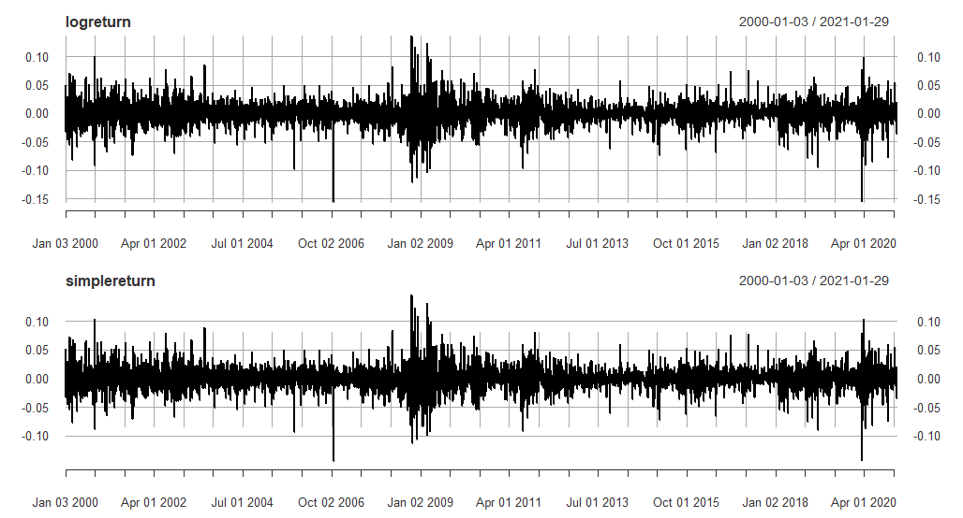
CAT Data: upper image is log return of CAT. The lower image is simple return of CAT.

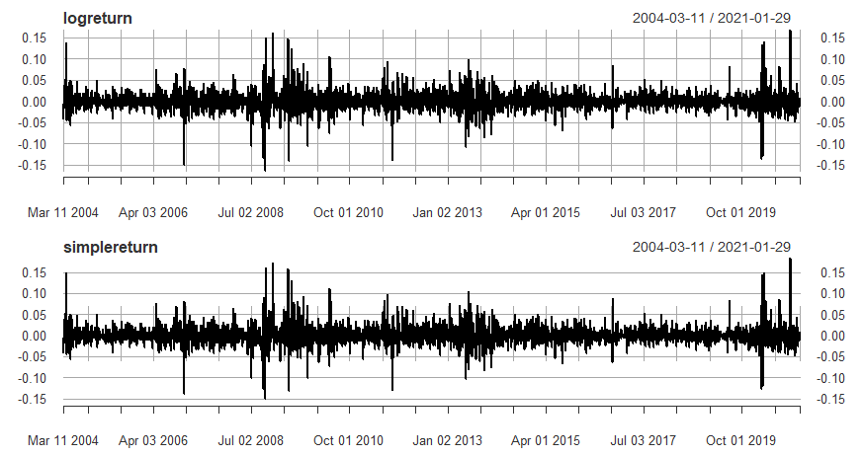
AOT Data: upper image is log return of AOT. The lower image is simple return of AOT.
Question B:

CAT. Adjusted Simple Return.
Minimum -0.1452
Arithmetic Mean 0.0007
Maximum 0.1472
Standard Deviation 0.0205
Skewness 0.0197
Kurtosis 4.5480

AOT.BK. Adjusted Simple Return.
Minimum -0.1505
Arithmetic Mean 0.0010
Maximum 0.1834
Standard Deviation 0.0213
Skewness 0.5443
Kurtosis 10.0827

Question C:
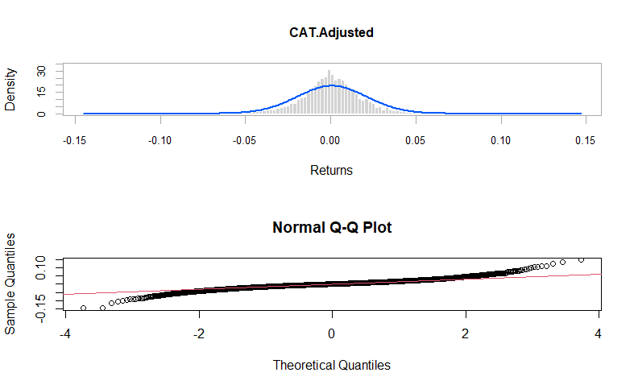

Jarque-Bera Test

Confident Interval = 95%
Critical point = 0.05
X-squared = 4569.9
df = 2
p-value < 2.2e-16

In conclusion, as we can see that p-value is less than critical point or 0.05 so we reject null hypothesis. The simple return of CAT does not distribute as normal with 95 percent confident.

Question D:

CAT. Adjusted Log Return
Minimum -0.1569
Arithmetic Mean 0.0005
Maximum 0.1373
Standard Deviation 0.0205
Skewness -0.1836
Kurtosis 4.6982

AOT.BK. Adjusted Log Return
Minimum -0.1632
Arithmetic Mean 0.0007
Maximum 0.1684
Standard Deviation 0.0212
Skewness 0.1746
Kurtosis 9.6096

Question E:

CAT
t = 1.7296, df = 5301, p-value = 0.08377

We can conclude that, we cannot reject null hypothesis. The mean of log return of CAT is equal to zero with 95 percent confident interval.

AOT
t = 2.2696, df = 4157, p-value = 0.02328

We can conclude that, we reject null hypothesis. The mean of log return of CAT is not equal to zero with 95 percent confident interval.

Question F:

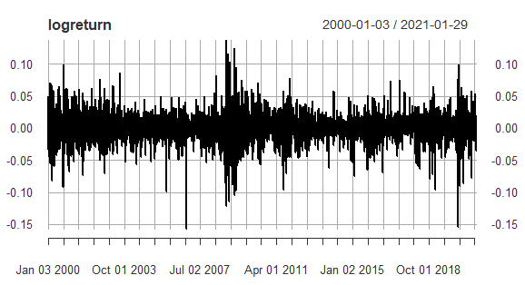
CAT daily log return illustration.

AOT daily log return illustration.
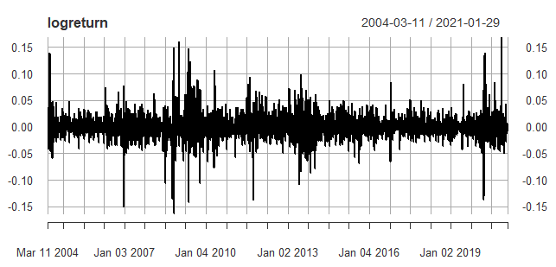
Question G:
t = 1.7296, df = 5301, p-value = 0.08377

With 95 percent confident interval. We can conclude that mean of log return of CAT is not equal to zero.

Question H:
CAT
TST = -5.458812
P-VALUE = 0.000000047933
We can conclude that, we reject null hypothesis which mean that the CAT skewness of return is not equal to zero with 95 percent confident interval.

AOT
TST = 4.596526
P-VALUE = 0.000004.29594
We can conclude that, we reject null hypothesis which mean that the AOT skewness of return is not equal to zero with 95 percent confident interval.

Question I:
CAT
TST = 69.83078
P-VALUE = 0
We can conclude that, we reject null hypothesis which mean that the CAT Kurtosis is not distribute as normal 95 percent confident interval.

AOT
TST = 126.4855
P-VALUE = 0
We can conclude that, we reject null hypothesis which mean that the AOT Kurtosis is not distribute as normal with 95 percent confident interval.
R for CAT data
Sorry Krub Ajarn I cannot compile file I try to fix it but I cannot find the root of cause. So I do know other way to sent the work as you require sorry krub.

setwd("C:/Work/University/EE435/R")
#install.packages("quantmod")
#install.packages("fBasics")
#install.packages("sn")
#install.packages("PerformanceAnalytics")
#install.packages("car")
#install.packages("tseries")
#install.packages("forecast")
library(quantmod)
library(fBasics)
library(sn)
library(PerformanceAnalytics)
library(car)
library(tseries)
library(forecast)
getSymbols("CAT",from="2000-01-03",to="2021-01-31")
dim(CAT)
head(CAT)
tail(CAT)
dataCAT=CAT
chartSeries(CAT,theme="balck")
price=dataCAT[,6]
plot(price,type='l')
logprice=log(price)
plot(logprice,type='l')
logreturn=diff(log(price))
simplereturn <-exp(logreturn)-1
plot(logreturn,type='l')

#1 Plot the series of log return and simple return

par(mfrow=c(2,1))
plot(logreturn,type='l')
plot(simplereturn)

newlogreturn <- logreturn[2:nrow(logreturn),]
newsimplereturn <- simplereturn[2:nrow(logreturn),]

#2 Histogram and sample statistics
par(mfrow=c(2,1))
hist(simplereturn, breaks=100, col="slateblue")
chart.Histogram(simplereturn,methods = c("add.normal"))
table.Stats(logreturn)

#3 QQ-plots and tests for normality
#
# use qqnorm function
par(mfrow=c(1,1))
qqnorm(newsimplereturn)
qqline(newsimplereturn, col = 2)
jarque.bera.test(newsimplereturn)

#4 Test mean = 0
t.test(logreturn)

#5 Test Skewness = 0
T=length(newlogreturn)
s3=skewness(newlogreturn)
tst = s3/sqrt(6/T)
tst
pv = 2*pnorm(tst)
pv

#6 Test excess kurtosis =3
k4 = kurtosis(newlogreturn)
tst = k4/sqrt(24/T)
tst
pv = 2*(1-pnorm(tst))
pv

R for AOT data

setwd("C:/Work/University/EE435/R")
#install.packages("quantmod")
#install.packages("fBasics")
#install.packages("sn")
#install.packages("PerformanceAnalytics")
#install.packages("car")
#install.packages("tseries")
#install.packages("forecast")
library(quantmod)
library(fBasics)
library(sn)
library(PerformanceAnalytics)
library(car)
library(tseries)
library(forecast)
getSymbols("AOT.BK",from="2000-01-03",to="2021-01-31")
dim(AOT.BK)
head(AOT.BK)
tail(AOT.BK)
dataAOT=AOT.BK
chartSeries(AOT,theme="balck")
price=dataAOT[,6]
plot(price,type='l')
logprice=log(price)
plot(logprice,type='l')
logreturn=diff(log(price))
simplereturn <-exp(logreturn)-1
plot(logreturn,type='l')

#1 Plot the series of log return and simple return

par(mfrow=c(2,1))
plot(logreturn,type='l')
plot(simplereturn)

newlogreturn <- logreturn[2:nrow(logreturn),]
newsimplereturn <- simplereturn[2:nrow(logreturn),]

#2 Histogram and sample statistics
par(mfrow=c(2,1))
hist(simplereturn, breaks=100, col="slateblue")
chart.Histogram(simplereturn,methods = c("add.normal"))
table.Stats(logreturn)

#3 QQ-plots and tests for normality
#
# use qqnorm function
par(mfrow=c(1,1))
qqnorm(newsimplereturn)
qqline(newsimplereturn, col = 2)
jarque.bera.test(newsimplereturn)

#4 Test mean = 0
t.test(logreturn)

#5 Test Skewness = 0
T=length(newlogreturn)
s3=skewness(newlogreturn)
tst = s3/sqrt(6/T)
tst
pv = 2*pnorm(tst)
pv

#6 Test excess kurtosis =3
k4 = kurtosis(newlogreturn)
tst = k4/sqrt(24/T)
tst
pv = 2*(1-pnorm(tst))
pv

