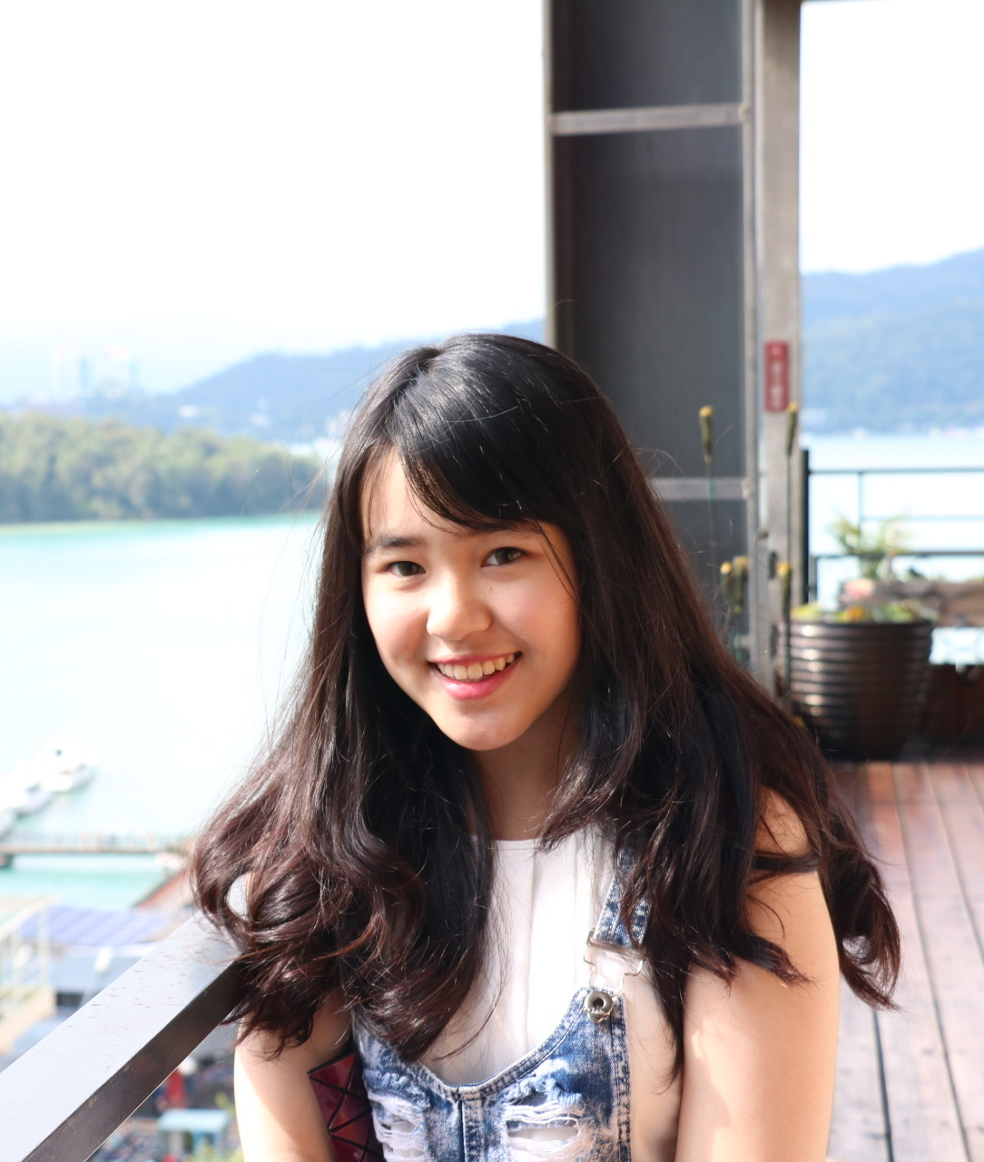
Student Information
[Insert your picture here.]
EE211 Microeconomics
Semester 1/2020
- Name Jipharada Sueprasertsithi_____________
- Nickname Japan_______________________________
- Email JJipharada@gmail.com____________ Phone Number 0661617878 __________
- Year of program: [] 1st year [ *]2nd year [] 3rd year [] 4th year
- Major area (if any)Econ________________________________________
- Minor area (if any) Marketing________________________________________
- Classes that you have already taken
EE212 EL221 MA216 TU100 TU101 AC201ST216 TU102 TU103 TU106 ___________________________________________________________________
___________________________________________________________________
___________________________________________________________________
- Classes that you are currently taking
EE221/MK201/FN201/OM201/HR201/TU122_________________________________
___________________________________________________________________
___________________________________________________________________
- Classes that you plan to take in the next semester(s) or next academic year(s)
EE311/EE320/EE406/FN211___________________________________________________________________
___________________________________________________________________
___________________________________________________________________
- What is/are your favorite subject(s)?
MK201___________________________________________________________________
- What do you expect to learn from this class?
Basic econ____________________________________________________________
- What is your concern, if any, about being in this class?
-___________________________________________________________________
- What would you suggest to enhance your learning experience while taking this class? Is there any teaching technique that other instructors use and you particularly like? If so, please suggest.
-___________________________________________________________________
___________________________________________________________________
- Briefly describe your career aspiration(s). List the top two choices if there are many.
Own business__________________________________________________________
___________________________________________________________________
- Other comments and/or suggestions.
-___________________________________________________________________
___________________________________________________________________
___________________________________________________________________

(Note: All information is to be used for teaching purpose only, and will be kept confidential.)

