5504640383
Jitlada Sethakomut
Neoclassical style by Jacques Louis David
1,014 words
What is art? This kind of field has taken an important role in human everyday life. We use skills and imaginations to create objects and express the feelings of what we think in order to share our ideas to the others. However, Art can be defined in many styles, depending on the period of time, characteristic of lines, colors, and so on. One of the well-known styles is Neoclassic which was influenced by famous French painter Jacques Louis David. His neoclassical paintings have an impact to cause French revolution.
Jacques Louis David was considered as the great painter who had lots of impact to Art, especially in neoclassical style. His works were in the period of changing from Rococo to the period of seeking for the purity of art. Most of the neoclassical paintings emphasize details of the picture such as linear designs, backgrounds, shade of colors, and the costumes of people in that picture. The combination of Greek and Roman element in the portraits, fabled beings, and mythological figures could be seen normally in this period in order to reflect the human belief about the courage, politics, and routine life.
In his lifetime, Jacques Louis David obviously had a negative attitude to the French monarchy and involved himself in French revolution by expressing his ideas through his paintings. For example, one of the most famous paintings, Oath of the Haratii, which shows about the patriotism of three brothers to their country, Rome, before battle, supported by their father. In the painting, the father is giving swords to his sons so that they will take them to kill the Curiatii brothers, the opponents. Crying behind the scene, one of the women is the sister of the Curiatii and the other one is going to marry one of the Curiatii. The implication from this painting is to let the country come first, family, lover, and friendship must come later. The death of Socrates, represents the scene of the death of Socrates, Greek philosopher drinking poison as a result of expressing ideas against Athenian government. He is offered two choices whether to be exiled and stop his philosophy or be sentenced to death and he choose to be death. This painting, Jacques Louis David wants to satirize people who are unsteady and flattering to choose the superior side during the French revolution by comparing to Socrates who are willing to be dead in order to preserve his ideal. The Death of Marat, shows the death scene of a very important figure of the revolution, Jean Paul Marat. He is a physician, political theorist, scientist, and journalist writing about attacking the enemies criticism which leads him become voice of the French revolution. Although he was murdered by a woman who claimed that she got the news about the enemies and used a knife stab down at his chest, Jacques Louis David tried to draw the figure not to look too severe as it really should and tried to show Jean Paul Marat’s face with peace as if death was not the thing to be afraid. The idea of this painting is to show Jacques Louis David’s admiration to this man. The Lictors Bring to Brutus the Bodies of His Sons, shows the Roman leader, Lucius Junius Brutus, crying in the shadow without looking back to see his headless dead sons that he kills them by himself. After knowing that his sons want to bring down the government and go back to the monarchy system, Lucius Junius Brutus decide to decapitate them in order to maintain the republic. He choose this way because he knows that it is the best for the country.This painting becomes the logo of French revolution that arouse people to put an end to the monarchy and do the best for the country as well.
Nowadays, France is no more monarchy and turns to republic with strong democracy. Did neoclassical paintings by Jacques Louis David have the impact to cause the French revolution? Yes, of course. From the paragraph above shows that his paintings not only focus on the symmetrical, beautiful, and realistic of the whole picture but also have hidden meaning which is all about the politics. He wants to encourage people to have the feeling of nationality, bravery, and sacrifice to the country. Without saying any words, art can convey the meaning itself. His paintings, of course, inspired many French people to rise in revolt against the king which not for long led to the greatly tragic revolution of France by beheading the king, Louis XVI. Jacques Louis David, himself, was known as the art dictator because he also involved in being one of the members Jacobin groupand was in National Conventionto vote for the execution.
As time goes by, the neoclassical paintings of Jacques Louis David still influence to the present. For example, the use to refer to the French revolution history and study technical Art. People still use his works to study and try to understand the truly emotional meaning of each painting which can imply the story occurring in that time. The painting technicality and the spirit of pictures remain until now.
In conclusion, neoclassical style by Jacques Louis David can stimulate people to make French revolution. But it is not the only factor that caused so. The details in each painting always indicate the story and the meaning of painter’s thought which is passed from generation to generation.

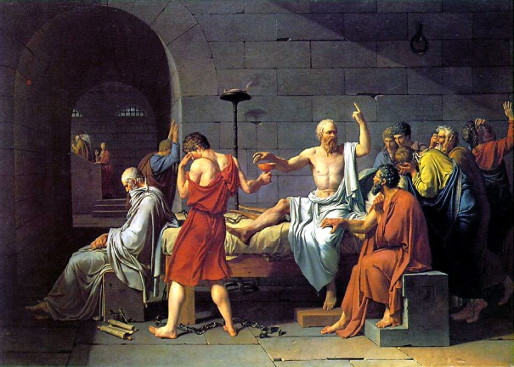
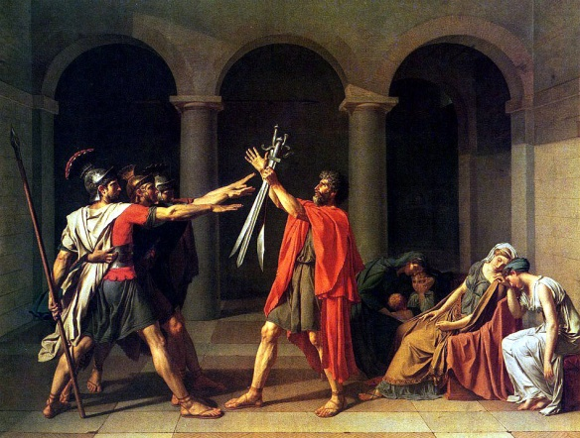
appendix

The Oath of the Horatii The Death of Socrates
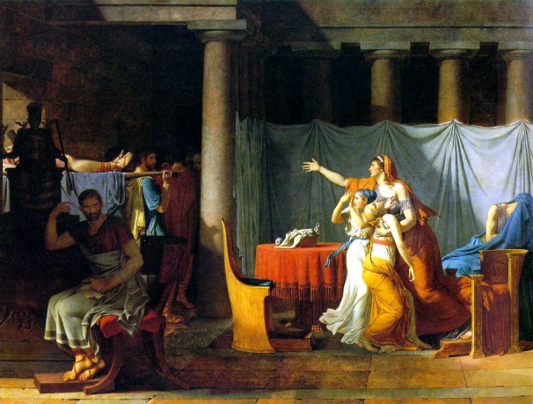
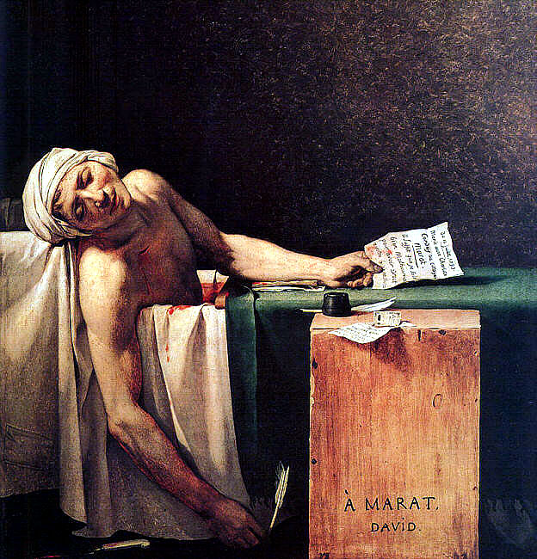
The Death of Marat The Lictors Bring to Brutus the Bodies of His Sons

Wikipedia contributors. “Neoclassic.” Wikipedia, The Free Encyclopedia. 9 Aug 2012. < http://en.wikipedia.org/wiki/Neoclassicism>
Wikipedia contributors. “Rococo.” Wikipedia, The Free Encyclopedia. 9 Aug 2012. < http://en.wikipedia.org/wiki/Rococo>
“Jacques-Louis David:The Oath of the Horatii.”Neo-classicm and French revolution. 9 Aug 2012. < http://www.bc.edu/bc_org/avp/cas/his/CoreArt/art/neocl_dav_oath.html>
“Jacques-Louis David:The Death Of Socrates.”Neo-classicm and French revolution. 9 Aug 2012. < http://www.bc.edu/bc_org/avp/cas/his/CoreArt/art/neocl_dav_soc.html>
“Jacques-Louis David:The Death Of Marat.” Neo-classicm and French revolution. 9 Aug 2012. < http://www.bc.edu/bc_org/avp/cas/his/CoreArt/art/neocl_dav_marat.html>
“Jacques-Louis David:The Lictors Bring to Brutus the Bodies of His Sons.” Neo-classicm and French revolution. 15 Aug 2012. < http://www.bc.edu/bc_org/avp/cas/his/CoreArt/art/neocl_dav_brutus.html>
Britannica contributor. “Jacobin club.” Encyclopedia Britannica facts matter. 15Aug 2012. < http://www.britannica.com/EBchecked/topic/299007/Jacobin-Club>
Britannica contributor. “National convention.” Encyclopedia Britannica facts matter. 15Aug 2012. < http://www.britannica.com/EBchecked/topic/404639/National-Convention>

