Exercise 1
Introduction to Macroeconomics
- What are the four macroeconomic agents? What are the three markets in which the agents interact?
- The four macroeconomics agents are households, firms, the government, and the rest of the world.
- What is sticky price? Explain why price may be sticky.
- Sticky price is the price that adjusts slowly to the equilibrium. The price may be sticky due to the minimum wage policy, labor union, employment contact.
- Explain the four main categories of unemployment.
- The first category is called frictional unemployment which is the normal turnover in the labor market. This type of unemployment is caused by skill matching problems. The second category is called structural unemployment that occurred due to changes in the structure of the economy that result in a significant loss of jobs in certain industries. The third category is cyclical unemployment which caused by fluctuations in business cycles. So, it is above both frictional and structural unemployment. The last category is called seasonal unemployment or the unemployment due to the change of seasons.

- Classify the following events into the categories of unemployment.
- Some friends just graduated from college and have been looking for jobs.
(Cyclical unemployment)
- Christine lost her job as a biologist at a biotech-company when the whole industry went into recession.
(Structural unemployment)
- Gerhard, who used to be a taxi driver, stopped looking for a job three months after he lost his job.
(Discouraged-Worker/ Hidden unemployment)

- Dirk used to work as a wooden-doll maker. Now all kids want plastic dolls, so he is out of work.
(Structural unemployment)
- The hotel part-timers were laid off during low season.
(Seasonal unemployment)
- Aditi, a high-tech engineer, just decided to quit her job; she is being interviewed for a better-paid job in a multinational company.
(Frictional Unemployment)
- A man lost his job as a public reader as literacy has increased in his village.
(Structural unemployment)
- Suppose there are 100 people in labor force and 60 people currently in employment. Find the unemployment rate. Can we find labor force participation rate? If not, what information do we need?
- The unemployment rate is 0.4. We cannot find labor force participation yet due to the fact that the information about the information about the people who are not in the labor force in the population is not given.

- What is the discouraged-worker effect? How can it affect the unemployment rate?
The discouraged-worker effect is when people who want to work but cannot find jobs become discouraged and stop looking for work. Since they are not classified as unemployed, they are not included in the circulation of unemployment rate which make it falls and sometimes become misleading.

- On average, nations in Europe pay higher unemployment benefits for longer periods of time than the US. How would this affect the unemployment rates in these nations? Explain which type of unemployment is most directly affected.
- The natural rate of unemployment in Europe is much more than in the United States. I will most probably affect the frictional and structural unemployment the most out of the four categories. The natural rate is often the sum of the two unemployment categories mentioned above, and since the supply and demand is different in Europe, the people may not seek to find better jobs or having extra qualifications.

- What is inflation? It is often said that inflation reduces one’s purchasing power, and hence inflation is bad. How can inflation reduce one’s purchasing power? Is there a case where inflation may not be bad?
Inflation is an increase in the overall price level. Inflation can reduce one’s purchasing power due to the increase in prices. In other words, inflation may not be bad as the income increases along with the price of goods.

- Who – lender or borrower – is better off, given unanticipated deflation? Explain with examples.
- Borrower is certainly better off given unanticipated deflation. For instance, if I borrow my brother’s money now and plan to return the same amount of money 5 years later, then it is most likely that the power of the money will be lessor. So, with that same amount of money, my brother may be able to buy stationaries but I may be able to buy a chair.

- When inflation is anticipated, what will the central bank do with the interest rate? (Hint: Fisher Equation)
- When inflation is anticipated, the central bank will charge higher interest rate. Fisher equation helps in deciding the interest rate they should charge. When inflation rate is high, banks will set higher nominal interest rate

- The CPI is 120 in year 1 and 150 in year 2. All inflation is anticipated. If the bank charges an interest rate of 30%, what is the bank’s real interest rate?
- The bank’s real interest rate is 5%.

- Explain why inflation is necessary to a growing economy with reference to the money supply.
- Inflation is necessary in a way when printing money since more and more people will need money for their transactions. With fixed money supply, there will not be enough cash for everyone

- What are the two administrative costs of inflation? Explain.

Menu cost of inflation ins when there may be costs associated even with anticipated inflation, such as costs from changing menus/price lists frequently.
Next, shoe leather cost or when interest rates tend to rise with anticipated inflation. When interest rates are high, the opportunity cost of holding cash outside banks is high.

- Draw a diagram of business cycles and the trend line. Label the four phases of business cycles. Answer the following questions.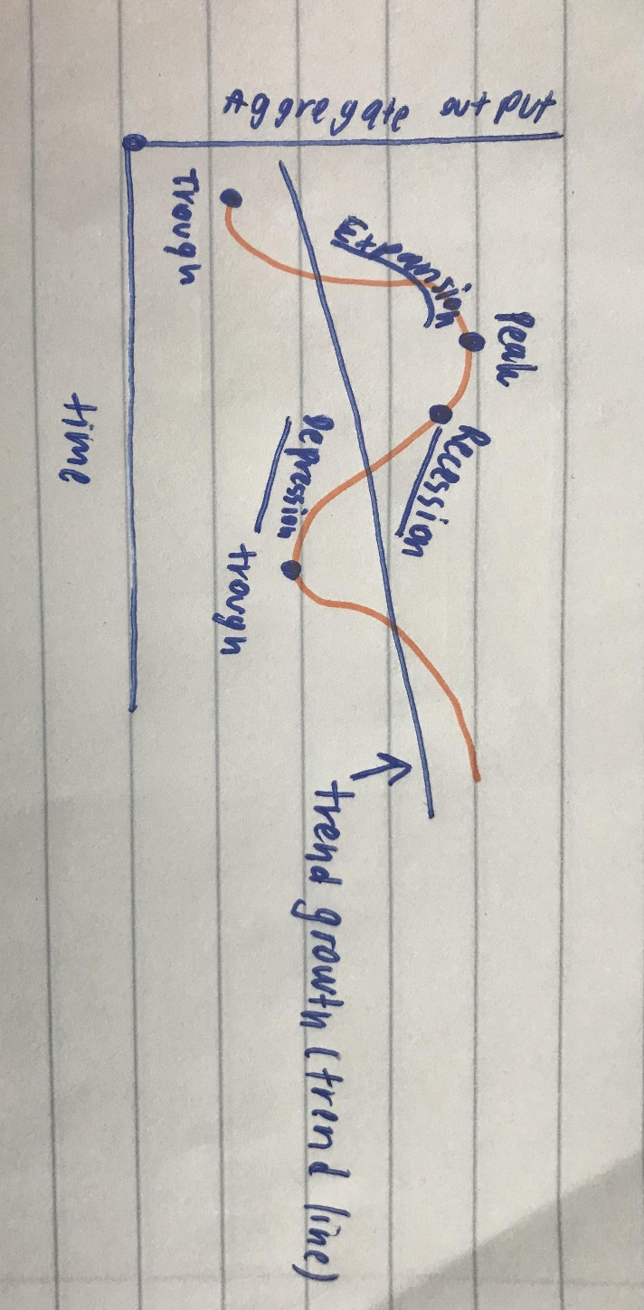
- Which phase do you expect to see inflation?
I expect to see inflation during expansion.

- Which phase do you expect to see high unemployment?
I expect to see high unemployment during recession.

- Which phase should the government use expansionary policy? Give example.
The government should use expansionary policy during the recession phase. For instance, the government can cut taxes, raise spending to boost the economy.

- Which phase should the government use contractionary policy? Give example.
The government should use expansionary policy during peak or at the most prosperity. In this case, the government can put some limits on the flow of money in the economy such as raising the taxes, and cut spending.

- What factors determine the trend line?
Factors that determine the trend line are quantity and quality of labor and capital.

- An article states that capital stock and labor force are both increasing at an annual rate of 7%. The same article also states that real output is growing by 11%. Explain why this is possible.
When an economy is producing beyond potential output, it might have experienced an increase in real GDP, but that is not economic growth.

By: Phenpojana H. 6404640770

