Please use the figures and table below to explain the relationship between education, health, and inequality. What do you observe from the data? (10 points)
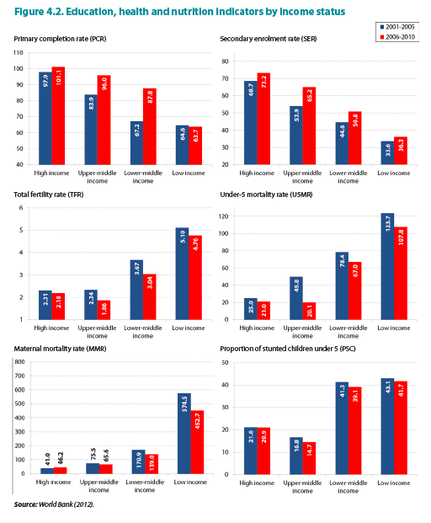
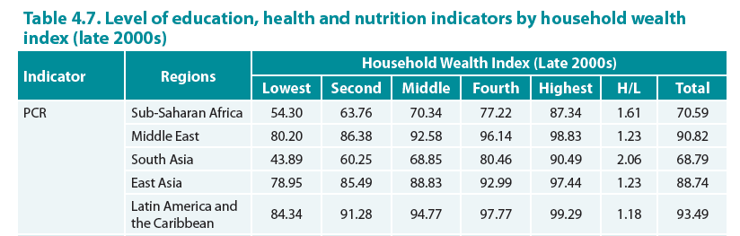
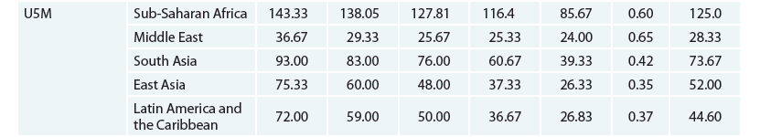
Note: PCR=Primary completion rate, USM= Under-5 mortality rate; Lowest = 1st quintile of household wealth index, H/L = indicator of highest wealth group/lowest wealth group

