Introduction

Name : Niskamon
Age : 30
Marital Status : Single forever
Gender : Female
Occupation : Auditor
Background on Niskamon’s life
Niskamon graduated from the Faculty of Commerce and Accounting with the first class honour so she got accept by one of the Big Four company as an auditor. She worked there for few years and with her diligence and wiseness, her career grew really fast. She gain a lot experience, became the Certified Public Accountant, and was offered a manager position by the company. Now, she is in her thirty with the position in the auditing department and salary of 80,000 THB. She really enjoys her life and faces many challenge in her career, so she does not plan on having family any time soon. Also with all her heartbrokens in the past, she realized she does not need a man in her life and she would rather happily live with her parents until their last days than staying with another cheaters. Now, she is looking very much further, she wants to plan out all her financial goals throughout the retirement, as a single lady with no burdens.

Career planning and development
Having been working as an auditor at Big4 company with her outstanding performance, she was offered a manager position by the company with salary 80,000 THB at the age of 30. After 5 years of work, her salary increases by around 50% to 150,000 THB . Then the rate continue to increases up 300,000 when she is the partner of the firm in her forties. When she becomes fifty, she receives 450,000 THB a month.
30
35
40
50
60
80,000
150,000
300,000
450,000
Age
Salary
+Bonus/year
+120,000
+300,000
+600,000
+1,350,000

Spending plan/cash flow analysis
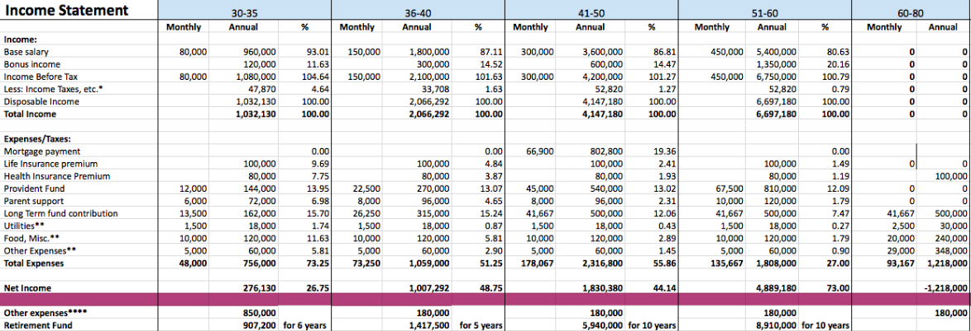

Tax planning
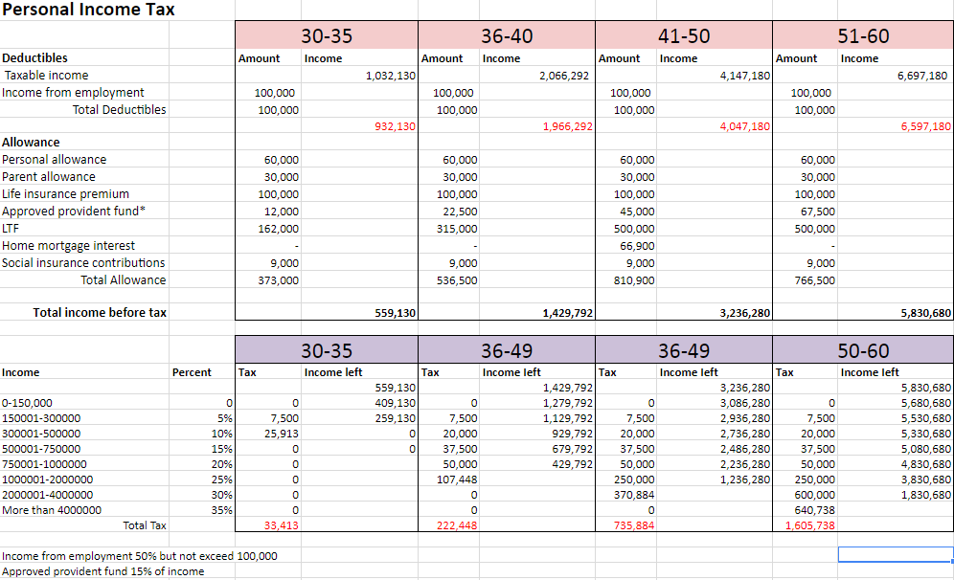

Use of credit
Niskamon plan to purchase her 18,000,000 THB vacation house at the age of 41. She has been looking through the home loans from many banks and find out that Bualuang Home Loan by Bangkok bank would be most suitable for her due to its reputation and the rate that she is willing to accept.

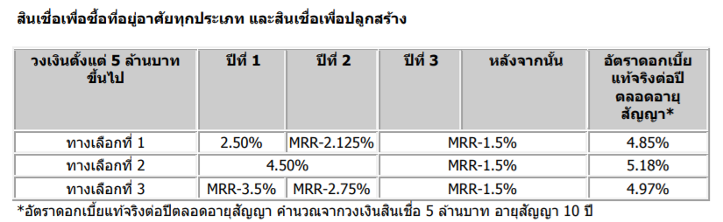

Net wealth at age of 41
Equity | 1,519,400
saving | 6,198,000
net income | 6,693,240
total wealth | 14,410,640

She decides to choose the first option with the approximate real interest rate 4.85% per year. Niskamon has savings total 14,161,640 THB. So, she decides to make a down payment, 10,000,000 baht and makes a loan contract to pay the remaining 8,000,000 baht by ten years. From the bank calculation, with the principle 8,000,000 THB, 10 years period and the rate 4.85%, Niskamon will have to make a payment 88,300 every month.
Short term financial goals (30-35)
- New notebook to replace the old one, lightweight, run smoothly, price around 50,000 THB, planning to buy it by the end of this year
- A sedan car costs around 700,000 baht for a safer driving experience (32)
- 10-day Europe trip for herself and her parents, buying the program from the premium touring company which costs around 450,000 baht (including the living expenses there.) She wishes to go there during this five years (34)
Long term financial goals
- 1,500,000 THB life insurance benefiting her love ones, the insurance premium is 100,000 per annum
- Health insurance for her parents and her own, as her company’s employee welfare is really good, she only needs to pay 80,000 THB a year as a health insurance premium for all her family.
- A 18 million baht vacation home in Khao Yhai where she can have anti-stress time with her family when she is getting older. (41)

SMART financial planning

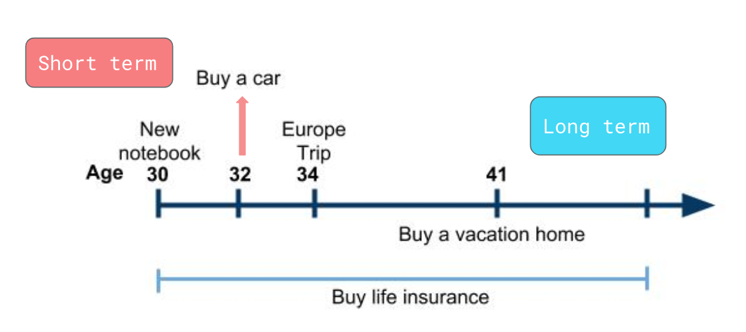
Savings and investment program
10% Equity fund
70% Saving
20% Mutual fund
700,000 THB
20% Equity fund
50% Saving
30% Mutual fund
1,000,000 THB
75% Saving
25% Mutual fund
2,000,000 THB
50% Saving
50% Mutual fund
1,000,000 THB
30
35
40
50
60
Age
- At age of 30-50 , 500,000 THB of fixed deposit saving at KIATNAKIN BANK PUBLIC COMPANY LIMITED with 3.3% rate of return per year
- At age of 51-60, 500,000 THB of fixed deposit saving at KIATNAKIN BANK PUBLIC COMPANY LIMITED with 3.3% rate of return per year and 1,000,000 THB of fixed deposit saving at CIMB Welcome with rate of return 3.4% per year
- She invest in mutual fund in LTF of K70LTFกองทุนเปิดเค 70:30 หุ้นระยะยาวปันผล with rate of return 6.95% per year
- For equity fund, she estimate that the average return is 7% per year

 | Age
 | 30-35 | 36-40 | 41-50 | 51-60 | Total
Saving | 3,099,000 | 2,582,500 | 5,165,000 | 15,505,000 | 26,351,500
Equity Fund | 449,400 | 1,070,000 |  |  | 1,519,400
Mutual Fund (until age 60) |  |  |  |  | 33,532,496
Total Return |  |  |  |  | 61,403,396

Changes in housing situation
Niskamon and her family choose to live in a house located in the heart of Bangkok, she can travel anywhere conveniently. Even though she owns a car, it is not used that often when she need to go somewhere in the city. So her current house is very convenient
and match with her lifestyle. Thus for her housing situation, she does not have any plan on moving to the other habitat.
Major consumer purchases
Now it is that time of the year when all the people in auditing field hates again, the start of the year, she is surrounded by the gigantic piles of work, all the books needed to be closed. So, she would like to have some time out, relieving all her stress from work, roaming through all the beautiful places. She wants to take a vacation time, and as a lovely daughter she is, she would like to take her parents to places with her. She decides to save some money for travelling around the world with her parents, using all her day offs. She have to save around 450,000 baht for a three-person-10-day premium Europe tour as she wishes for the best on her parents. Last year, her father also injured from the malfunction of the old car her family owned, she decides to purchase a new car for a safety of her own and her loved ones. She is considering a sedan car costs around 700,000 baht.
She also wants a new laptop which could work smoothly than the one she has since the first years of her work. She is looking for the model that is light and can work efficiently so she could carry it around to all her meetings or her outdoor trips everywhere. The notebook that she wants costs around 50,000 THB which she plans to buy it within this year.
Insurance needs
For her long term financial plan, after that car incident with her father, she realized the value of having a life insurance. Niskamon have made a life insurance with AIA and listed her parents as the beneficiary, in case something happens to her, her retired parents would not be in a financial distress and they would get a เงินปันผล 2%. She has to pay 100,000 THB every year as the insurance premium. She also apply for health insurance for her own and her parents which costs around 80,000 THB per year.

Retirement and estate planning
 | Provident Fund
Age | Monthly | Annual
30-35 | 12,000 | 144,000
36-40 | 22,500 | 270,000
41-50 | 45,000 | 540,000
51-60 | 67,500 | 810,000

Her company offer the provident fund, the fund that will take out 15% of her salary then these amounts will be given to hers after her retirement. When she is in her thirties, the company will keep 15% of her salary as the provident fund and give out the extra 5% from the amount kept to be accumulated in the fund. From her forty-first to her retire age, the extra amount will be increased from 5% to 10%.
 | Amount
LTF | 33,532,496
Retirement Fund | 17,174,700
Life Insurance | 3,060,000
Fixed Saving | 26,351,500
Net income | 73,888,840
Total Wealth | 154,007,536

At the age 60, Niskamon will have the total wealth amounted 153,947,536 THB from all her investments in long term fund, retirement fund, life insurance, fixed savings and her accumulated net income.
Since Niskamon and her family do not have any plan on moving to the other habitat. So for her real estate planning, Niskamon would not buy a new house in the city but more likely she would buy a house in the other surroundings. Her expenses on her current estate would be more on the renovating and maintenance of the house.
Since Niskamon lives in the crowded heart of the city, she seeks for the serenity to get away from all her challenging work. She wants to purchase a vacation home in Khao Yhai where she can surround herself with the calming nature and the love of her family. A fully decorated single detached house in Khao Yhai costs around 18 million THB. She is saving for her dream house and plan to purchase it at the age 41 with a down payment and bank loan.
Appendix
Balance Sheet | 30
Assets | Amount | %
Checking Account | 0 | 0.0
Savings | 1,500,000 | 5.5
3-year fixed saving account | 500,000 | 1.8
Provident Fund | 0 | 0.0
Individual Retirement Account | 0 | 0.0
Growth Mutual Fund | 0 | 0.0
Total Monetary Assets | 2,000,000 | 7.3
Car | 350,000 | 1.3
Personal Properties | 25,000,000 | 91.4
Total Fixed Assets | 25,350,000 | 92.7
Total Assets | 27,350,000 | 100.0
Liabilities & Equity
Liabilities:
Car Loan | 0 | 0.0
Mortgage Balance | 0 | 0.0
Total Liabilities | 0 | 0.0
Equity: | 27,350,000 | 100.0
Total Liabilities and Equity | 27,350,000 | 100.0

