- MK 312 Additionals:

Designing Consumer promotion (Pull) VS Trade promotion (Push)
- Theory – Integrated Marketing Communication consists of two main aspects which are Sales promotion (Pull) and Trade promotion (Push). These two methods are included in IMC that create a big picture like a jigsaw to become integrated to customer. Marketer should balance how to use these strategies effectively and study the trade-off analysis to combine and make optimum result of both strategies especially in terms of budget and the suitable exposure of each strategy. Often times, companies focus on pull strategy and create huge demand through media so they face out of stock problem when customer purchase. Sales Promotion can be categorized into two areas which is Above The Line and Below The Line. The criteria to group Sales Promotion to be ATL or BTL are different among marketing situation. Sometimes marketer counts all communications that are through media as ATL. In this case, I think about using objective of communication as main criteria i.e. ATL is the marketing communication that lead to long-term image and equity of company, brand and product. On the other hand, BTL is the marketing activities that generate sales shortly and do not focus on building brand as long-term target but drive sales.

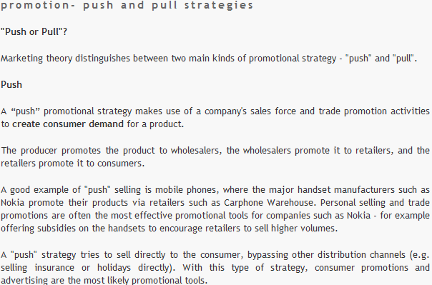
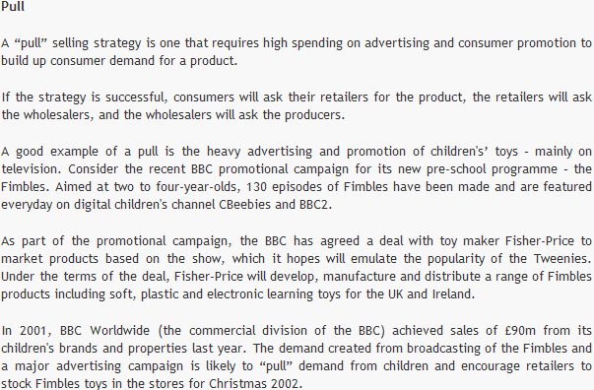

Major promotion tools are as following:
1. Sampling, consumer trial (pull) – Let customer try the product or service
2. Coupon (pull) – Good tool for price differentiation
3. Trade allowance (push) – Incentive to the middleman or sponsorship marketer gives to the trade
4. Money refund/rebate (Pull)
5. Price incentive (pull) – create short-term sales
6. Premium (pull) – Off and On-pack product, self-liquidation
7. Contest and sweepstake (pull) – high-value price
8. Loyalty program (Pull) – Mileage program, Cesar club
9. In-store display, promotion (Push)
10. Event (Push)



