TAIWAN
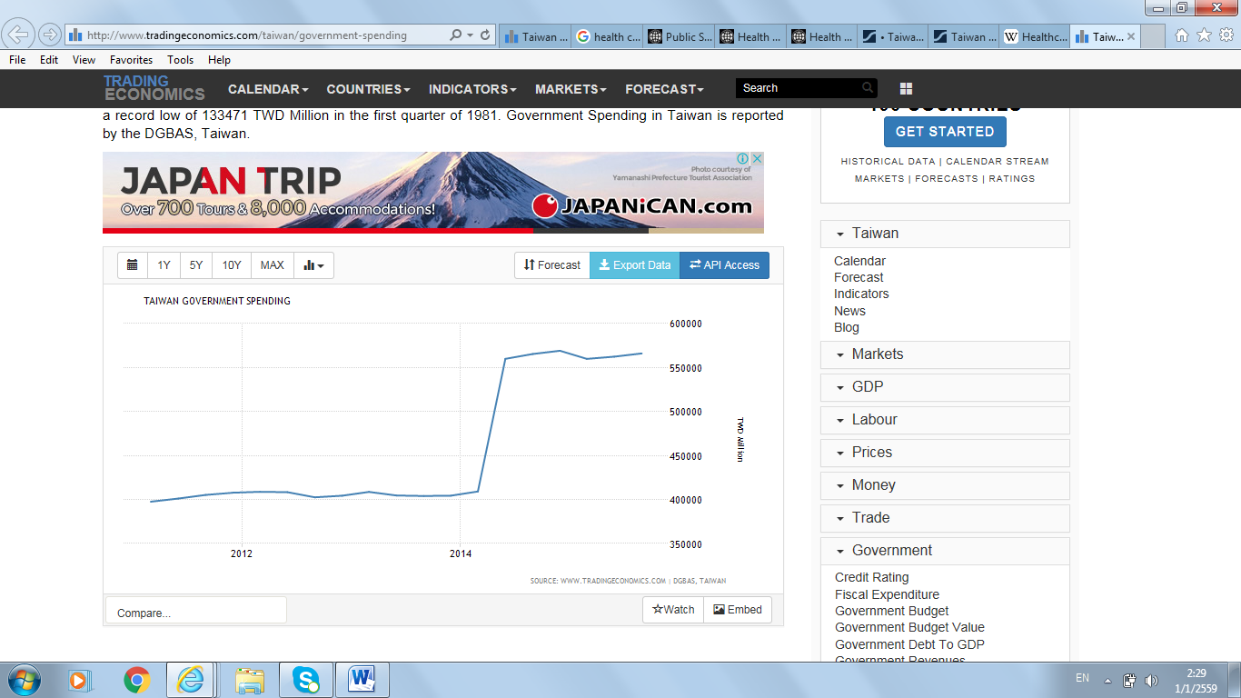
Figure 1
Taiwan is a sovereign state in East Asia. Due to the fact that some people considered Taiwan as a part of Republic of China, so, some information of Taiwan may not be available. Therefore, I try to find information as much as I can.
I take the 5 year to represent, since 2010 to 2015, the total change in the public spending by Taiwan Government. For government spending in Taiwan, increase continuously since 2010 and it rise rapidly in 2014 (From 400000 TWD million to 550000 TWD million as show on figure 1. My selected topic is Health care.
Health care or healthcare is the maintenance or improvement of health via the diagnosis, treatment, and prevention of disease, illness, injury, and other physical and mental impairments in human beings.
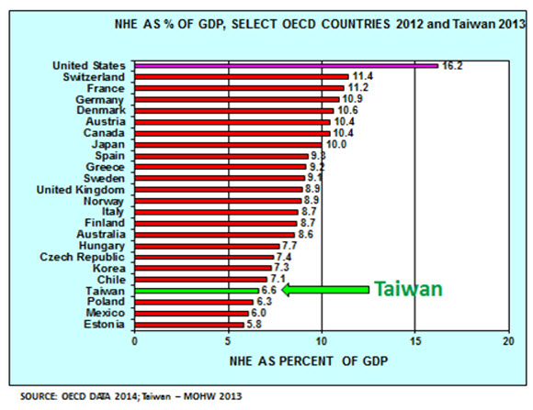
Figure 2
Total health spending in Taiwan in 2013 was 6.6% of Taiwan’s GDP. Majority of the spending around 52% is for NHI which I will talk in detail later. Out-of-pocket spending by the insured accounted for another 35.8 % which means that when a person got to hospital in order to pay full price that person pay only 36% of the full price. While government public health and general administration expenditures account for 6%.This is low compared to OECD countries (9.3%) represented by figure 2.
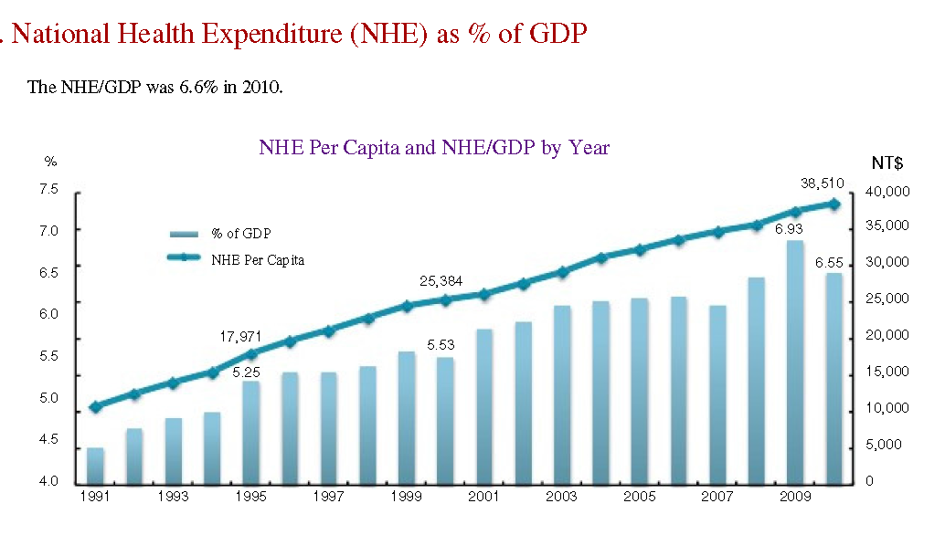
Figure 3
From the figure 3, no matter GDP of Taiwan is rise or fall the National health expenditure (NHE) per capita is always increase since 1991 – 2010 as represent on the graph. Allocation of NHE is General administration, Public health (such as Health station, Research and Promotion), Personal Health care (such as Hospital, Clinic, Medical supplies and equipment) and Capital formation. Most of allocation of NHE is go to Personal Health care about 85.6% from total 100% in 2006. It is increase to 87% in year 2010. Allocation for public health also increases from 3.6% in 2006 to 4.2% in 2010 because of increase in NHE.
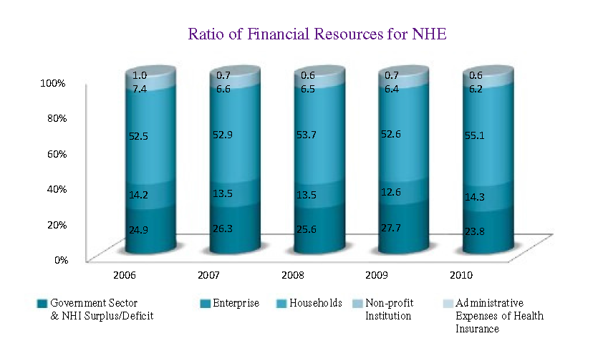
Figure 4
Figure 4 represent the ratio of financial resources of NHE. NHE fund mainly come from the Household and follow by Government sector. Household fund is increasing while government is fluctuated by a little and fall in year 2010.
National health Insurance (NHI)
Currently Health care system in Taiwan is National health Insurance (NHI) establishes since 1995. It is the system that provides equal access to health care for every people in Taiwan. This system is very successful because in 2004 this program can applies to 99% of Taiwan citizens. NHI is a single-payer compulsory social insurance plan which centralizes the disbursement of healthcare funds. NHI is mainly financed through premiums, which are based on the payroll tax, and is supplemented with out-of-pocket payments and direct government funding. The citizens have to pay for premium and some of the fund to NHI is come from government too. This program allows Taiwan citizens to choose hospital freely. Before NHI, Taiwan spent 4.7 - 4.8% on health care. A year after NHI, it increased spending to 5.39%.
This program is very successful because the single payer to set fees is done by the government. Therefore, government can capture the expenditure of this program. The Government agency that administers the NHI has monopsonistic power (single buyer of and payer for health care services in the market). This would influence the government agency to be able to control costs and provide the affordable health care services.
Government spending is increasing on health care as more applicants on NHI program. More burden that government has to bear which lead to spending. More spending, more improvement occur to health institutions in Taiwan.
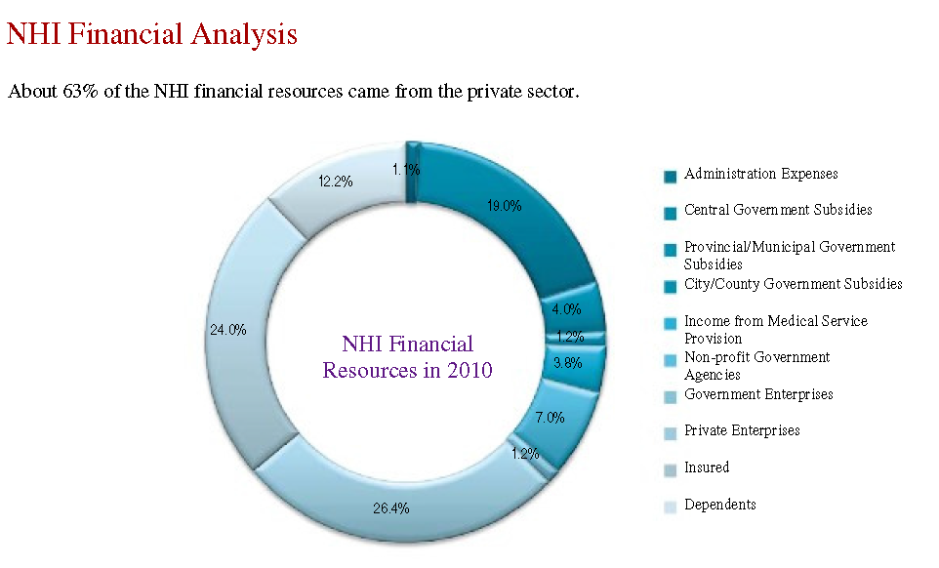
Figure 5
Taiwan Central government subsidies on NHI program about 19%, while most of the resources are by Private enterprise. Even though we combine with Provincial Government Subsidies, City Government Subsidies, Government enterprises and Non-profit Government Agencies together, more than half of the resources still come from Private sector by 63%.
The Second-generation of National Health Insurance was in year 2013. Second generation want to reform and solve the problem by imposing more responsibility on the government in finance, encourage to disclose the information and provide good medical care for citizens of Taiwan, expanding to everyone in the country which would make everyone can access for health care and etc.
In latest year (data available is in 2014), this project increases the number of medical clinic institution. It also improves the medical services and more available services in remote areas of the country. The second-generation reform, which aspires to “improve quality, care for the disadvantaged, ensure the health insurance system’s sustainability, and set an international benchmark,” will continue to provide Taiwan’s residents with comprehensive medical services and equal access to care. The approval rate for out-of-plan services was 32.2%. It is mean that person pay less than in the past which has to pay around 35%.
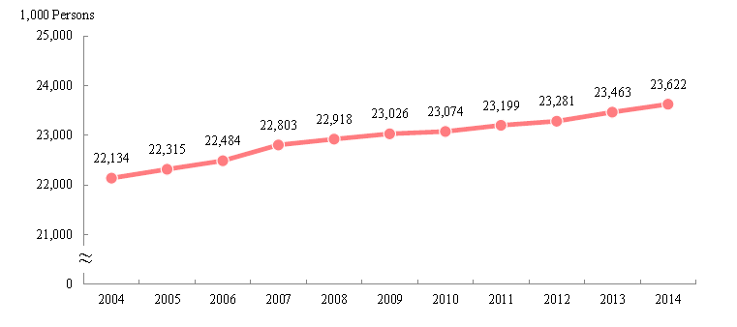
Figure 6: Number of beneficiaries
Number of beneficiaries increases continuously until recently year 2014. In addition, Number of beneficiaries for female is a little higher than male. However, most of the beneficiaries is mainly in Taipei city which is the big city and the least number is in Lienchiang which the number is low because this area is island and the population is low.
Second generation of NHI impose more responsibilities for government in Financial. It is not creating more burdens on insurance premium for citizens. Government will link the revenue and expenditure together. The link of revenue and expenditure would help the program become more sustain and strengthen. Government influences the problem of transparency of the information, government regulates to disclose the medical quality information for citizens and public which is advantage.
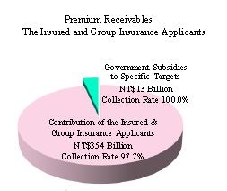
Figure 7: Premium
Moreover, in 2014, in this figure 7 show the premium that Government subsidies (specific target). While, mainly come from contribution of the insured and Group insurance applicants around NT$354 billion with collection rate 97.7%. Government subsidies to specific target, around NT$13 Billion or 3.54% of total premium collected with 100% of collection rate.
Because of improving in health care and most of the citizens be able to access the medical care from the National Health Insurance , life expectancy of Taiwanese is increasing. From the statistic in 2012, Men life expectancy is around 76 years and Female is 83 years. Aging population is increasing which leads to rise in number of patients suffer from non-communicable-disease (NCD). Cost of medical care for the elderly will be higher. In year 2011, health care costs for aging population accounted is around 34% from total NHI. In 2015 researcher give idea that health care quality in Taiwan can be able to improve more.
Compared to OECD countries, Taiwan has fewer doctors and nurses. Physician- and nurse-population ratios in Taiwan are 1.7 doctors and 5.7 nurses per 1,000 population, compared to the median of 3.3 doctors and 8.6 nurses in OECD countries. It creates scarcity of doctor and nurse in the future.
In addition, due to the higher health care spending, it allows new medical technology to be improved. New drugs and medicine, new vaccines, new equipment and etc. will be developed. Government spending has good impact on the country.
In conclusion, improving in health care would increase aging population which may cause future problem. It is also depend on the government to be concern of the situation in the future. However, this program is really effective and benefits from Taiwan citizens and country. The program helps to improve medical quality, technology and etc. Taiwan health care still leaves room for improvement. My suggestion is improve in the allocation cost efficiently and medical care. Shortage of doctors and nurses, government may provide scholarships and open more for foreign students to study in medical field in Taiwan. If Government spends wisely in future, it would make the development in health care policy in the next year more and more.
References
- Preface (n.d.). Retrieved December 31, 2015, from http://www.mohw.gov.tw/EN/Ministry/Statistic_P.aspx?f_list_no=474&fod_list_no=5628&doc_no=51965
- Taiwan. Retrieved December 31, 2015, from
https://en.wikipedia.org/wiki/Taiwan
- Healthcare in Taiwan. Retrieved December 31, 2015, from
https://en.wikipedia.org/wiki/Healthcare_in_Taiwan
- Taiwan profile-timeline. Retrieved December 31, 2015, from
http://www.bbc.com/news/world-asia-16178545
- Taiwan’s health care system: The next 20 years. Retrieved December 31, 2015, from
http://www.brookings.edu/research/opinions/2015/05/14-taiwan-national-healthcare-cheng
- National Health Expenditure. Retrieved December 31, 2015, from
http://www.mohw.gov.tw/MOHW_Upload/doc/Part%20IV.%20National%20Health%20Expenditure.pdf
- Taiwan government-spending. Retrieved December 31, 2015, from
http://www.tradingeconomics.com/taiwan/government-spending
- Taiwan’s healthcare report 2010. Retrieved December 31, 2015, from
http://www.ncbi.nlm.nih.gov/pmc/articles/PMC3405348/

- Taiwan Spends a High Percentage of its Healthcare Budget on Pharmaceuticals, but Second Generation Healthcare Reform is Transforming the Market Landscape. Retrieved December 31, 2015, from
http://www.prnewswire.com/news-releases/taiwan-spends-a-high-percentage-of-its-healthcare-budget-on-pharmaceuticals-but-second-generation-healthcare-reform-is-transforming-the-market-landscape-237012551.html

http://www.tradingeconomics.com/taiwan/government-spending
https://en.wikipedia.org/wiki/Health_care
http://www.brookings.edu/research/opinions/2015/05/14-taiwan-national-healthcare-cheng
http://www.mohw.gov.tw/EN/Ministry/Statistic_P.aspx?f_list_no=474&fod_list_no=5628&doc_no=51965
http://www.brookings.edu/research/opinions/2015/05/14-taiwan-national-healthcare-cheng

