Individual Assignment

1) Discuss one Insurance product and comment on its benefits

Insurance product that I choose is 20 Pay Life Par (Dividend participation) or we can call 20PLP from AIA life insurance company. This insurance emphasizes on people who care much about their family. To do the insurance, starting age is 1 month to 65 years old for both male and female. The minimum sum assure is 100,000 Baht.
I am interested in this product since the benefits of this are quite well. For the payment, it is only 20 years while it will cover for whole life (until 99 years old). The benefits are, first, 100% money back guaranteed at the end of policy amount equal to sum assure if you are not dead but in case of dead, you will receive 100% money back of sum insured. Second, dividend is paid every year after the second year payment until age 99 (paid until die or end at age 99). Moreover, we can get tax deductible benefit which only main premium is permitted to personal tax deductible.

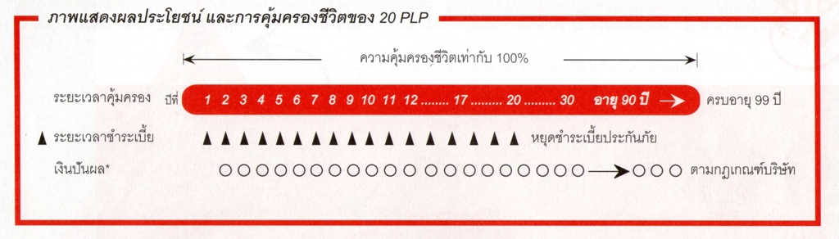

Reference: https://www.aia.co.th/th/our-products/life-protection/20-pay-life-par.html

2) Which mortgage would result in higher total payments?
Mortgage A: $970 a month for 30 years
Mortgage B: $760 a month for 5 years and $1005 for 25 years

For mortgage A, total payment is $ 970*30 years*12 months = $349,200
For mortgage B, total payment is ($760*5years*12 months) + ($1005*25 years*12 months) = 344,700
Therefore, mortgage A results in higher total payments.

3) What are the two main types of consumer credit?

The two main types of consumer credit are Closed-End Credit and Open-End credit.
For Closed-End credit, it is used for specific purpose and involves in a specific amount. It generally involves a written agreement for each credit purchase. A down payment or trade-in may be required to be repaid in equal monthly payments over a period of time. There are several types of closed-end credit. For instance, the first one is Installment sales credit which normally make a down payment and sign contract to repay principal and interest. Second, Installment cash credit which is a direct loan for personal purposes. Third, Single lump-sum credit which is a loan that must be paid in total on a specific day.
For Open-end credit, it used to make small purchases at different stores and you can make and purchase if it does not exceed your credit line. You may have to pay interest or other finance charges for using this credit. The examples of this type of credit are credit card, smart card, debit card and car for cash.

4) What are the general rules of measuring credit capacity?

There are two general rules of measuring credit capacity.
The first one is Debt payments to income ratio. It compares monthly debt payments to monthly income and can measure an individual’s ability to manage their income and repay debts. The formula of debt payments to income ratio is monthly debt payments over monthly income which results in percentage term. A low debt payment to income ratio implies a good balance between debt and income, in other words, he or she has small debt for the amount of income, vice versa. The recommendation is that the ratio should not be exceeded by 20%.
The second one is Debt to equity ratio. It measures the dollar amount of debt an individual or corporation has for each dollar of equity they have. The formula of this ratio is total liabilities divided by net worth. Note that net worth is the difference between total assets and liabilities. A high personal debt to equity ratio means an individual has high amount of debt relative to their equity. It implies that an individual’s ability to repay the loan is low.
The recommendation is that the ratio should not be exceeded by 0.5.

5) A few years ago, Michael Tucker purchased a home for $100,000. Today, the home is worth $150,000. His remaining mortgage balance is $50,000. Assuming that Michael can borrow up to 80 percent of the market value, what is the maximum amount he can borrow?

Now, market value of Michael’s home is equal to $150,000 and he can borrow up to 80 percent of the market value or she can borrow up to $120,000. Since he still has remaining mortgage or still owes $50,000, the maximum he can borrow is $120,000-$50,000 or $70,000.
Note; Book value = $100,000
Market value = $150,000
Remaining mortgage = $50,000
Equity = Market value ­ liability= $100,000
Borrow up to 80% of the market value; 80%*$150,000 = $120,000

