FN 281 personal finance (individual assignment)

1. Marine and transportation insurance
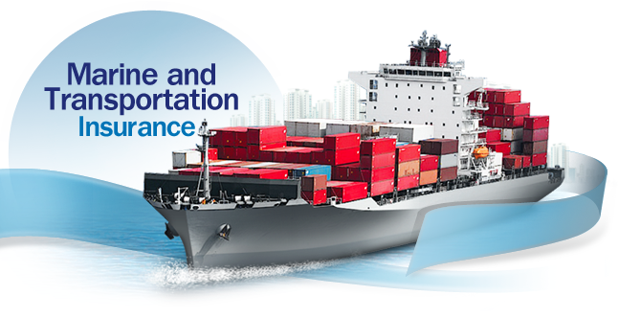
The insurance cover in the event that accident occur during the course of marine business whereby a vessel is used as a means of transportation (such as perils caused a storm, a vessel running aground, a collision, a vessel colliding with submerged rocks), the company with lessen your burden by insuring the loss or damage of the hull structure, including machinery and other equipment on board, to make you feel at ease and secure. (Information from the website www.viriya.co.th)
The benefit of this product is to cover damage caused to the vessel and the engines such as in the case of sinking or a fire. It suitable for ship owner to protect his ship in case of emergency, because value of the ship is very high, however, the owner want something to protect his own asset if something goes wrong such as shrink, firing and so on, which can make a huge loss because this industry is quite risky, because the ship is sailing on the sea and if something goes wrong, no one can help you except yourself. Therefore, this is another kind of insurance that can be the best choice for the ship transportation industry to lower their risk during run the business.

2.Which mortgage would result in higher total payments?

Q: Mortgage A: $970 a month for 30 years
A: Total payment = (amount of payment)*(number of months)*(number of years)
= ($970)* (12) *(30)
= $349,200

Q: Mortgage B: $760 a month for 5 years and $1005 for 25 years
A: Total payment = {(amount of payment1)*(number of months1)*(number of years1)} + {(amount of payment2) X (number of months2) X (number of years2)}
={($760) *(12)*(5)} + {($1005)*(12)*(25)}
= $347,100
Therefore, I compare these 2 mortgages; mortgage A give higher total payments than mortgage B, Which is $349,200 > $ 347,100.

3.What are the two main types of consumer credit?

Two main types of consumer credit are Closed-End Credit and Open-End Credit. The difference between open- and closed-end credit lies in the terms of debt repayment. Closed-end credit includes debt instruments that are acquired for a particular purpose and for a set amount of time. At the end of a set period, the entirety of the loan must be repaid, including any interest payments or maintenance fees.

Open-End Credit is not restricted to a specific use or duration. Credit card accounts, home equity lines of credit and debit cards are all common examples of open-end credit. The issuing bank allows the consumer to utilize borrowed funds in exchange for the promise to repay any debt in a timely manner. Unlike closed-end credit, there is no set date when the consumer must repay all of his debts. Instead, these debt instruments have a maximum amount that can be borrowed – though this is often revisable – and require monthly payments based on the amount of credit used.
Closed-End Credit is the most common types of closed-end credit instruments are mortgages and car loans. Both are loans taken out for a specific period when the consumer is required to make regular payments. The issuing bank retains some ownership rights over the asset in question as a means of guaranteeing repayment. If a customer fails to repay an auto loan, the bank may seize the vehicle as compensation for the default.

4.What are the general rules of measuring credit capacity?

The best way to determine how much credit you can assume is to first make an accurate and sensible personal or family budget. Budgets can be simple and carefully considered outlines of plans to distribute dollars of earnings. Two ways in measuring credit capacity are the debt to payments to income ratio and the debt to equity ratio. Cosigning a loan is a great thing to do for a relative or a friend. But in some cases it may feel like the worst thing a person can do ever. Remember by cosigning a loan, you as a person are ensuring the leader that if your friend or family member make any failure in repayments you will pay the amounts. Some factors that aid lenders to provide consumer with different types of credit or loan dependents on income. The higher the income, all other things being equal and the more credit the consumer can access. However, lenders make credit granting decisions based on both ability to repay a debt and willingness as indicated in the past payment history.

5. A few years ago, Michael Tucker purchased a home for $100,000. Today, the home is worth $150,000. His remaining mortgage balance is $50,000. Assuming that Michael can borrow up to 80 percent of the market value, what is the maximum amount he can borrow?

Market present value of Michael’s home is $150,000. So, he can borrow up to 80 percent of the market value, which is $120,000. He still has a $50,000 remaining mortgage on his home.
Therefore, he can borrow a maximum of ($120,000) – ($50,000) which equal to $70,000.

