Before Mid-term Review Question
1. Business Model and Business Plan.
- What is business model?
- What are the elements in business model?
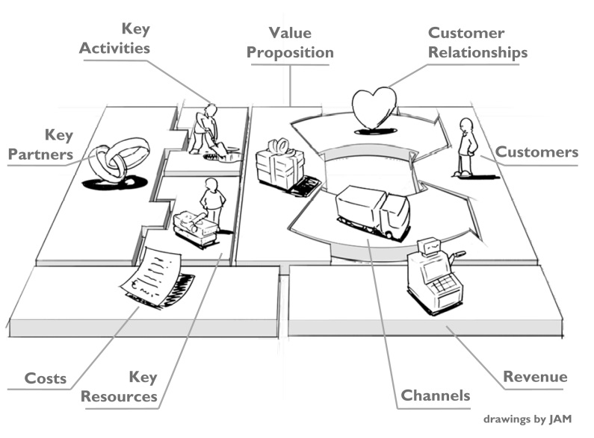
- What are the characteristics of these business models: Subscription, Razor and Blades, Low-cost, Brick and Click, Freemium, Auction? What are the benefits of using each model?
- What is business plan?
- Who use business plan, internally and externally?
- What will be described in business plan?
- The 5 C of the business plan – communicate, correct, clear, commercial, competitive
2. Business Environment
- What are the external factors that affect business?
- How each factor affects business? Please analyze.
- 5 Forces analysis – intensity of rivalry, bargaining power of supplier, bargaining power of customer, Threats of new entrants, Threat of Substitute
- What are the internal environments?
- How to manage the environment by using adaptation, influence, domain shift approach?
3. Business Ethics and Corporate Social Responsibility
- What is ethics, what is law?
- What is preconventional, conventional, postconventional (Level of moral development)?
- How to build ethical environment?
- What is CSR? Describe the concept of Tripple bottom line.
- What are CSR approaches?
- What is social enterprise?
4. Legal form
- What are the consideration points when choosing a legal form?
- What is sole proprietorship? What are the advantages and disadvantages?
- What is the partnership? What are the characteristics, liability, taxation, of each form – general partnership, registered partnership, limited partnership? What are the advantages and disadvantages? How would the partnership be dissolved?
- What are the private and public limited companies? How this company pays tax and how about the liability? What are the advantages and disadvantages? How would the partnership be dissolved?
- What are the benefits of SME?
- What are the characteristic of entrepreneur?

