1) Discuss one Insurance product and comment on its benefits


FWD for Life insurance iSave 60/5
This is a life insurance provided for AIA company called FWD for Life insurance iSave 60/5. The first important thing for a purchase decision is that it is better to decide to purchase when you have someone that depends on your income.
The detail of this insurance :
-5 years premium payment protect up to 60 years
-A refund of up to 60 years old
-Get a refund every year at 2 % of the sum insured until 60 years of age.
-At the maturity, receive 200% with dividend
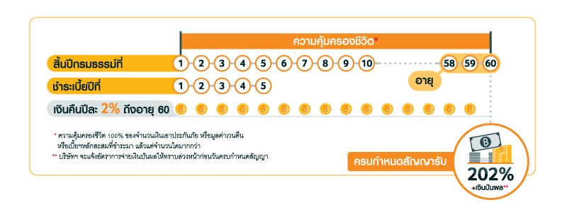
Assume Mr. Somsak who is a salary man earning 45,000 baht per month. In addition, Mr. Somsak is 30 years old who lives alone. Mr. Somsak is currently healthy and has no risk of genetic disease.
Benefit of this insurance:
-The computed tax benefits from this program is 10,000 Baht per year
-The computed IRR from this program is 3.3462265%

Generally, the higher a program's internal rate of return, the more desirable it is to purchase that life insurance. but we not always consider insurance from IRR.There are other factor that we consider such as Initial investment requirement , Tax benefit , Flexibility of the option , Living standards and Financial Aids as well as other facilities.

2) Which mortgage would result in higher total payments?

Mortgage A: $970 a month for 30 years
Mortgage B: $760 a month for 5 years and $1005 for 25 years

Mortgage A payment : $970*12*30 = $349,200
Mortgage B payment : $760*12*5 + $1005*12*25 = $347,100

Mortgage A total payment would higher than mortgage B total payment.

3) What are the two main types of consumer credit?

The two main type of consumer credit are closed-end credit and open-end credit.

- Close-End credit : This type of credit used for specific purpose, specific amount and period of time.We can divide this type of credit into installment sales credit, instalment cash credit and single lump-sum credit.Mortgage loan and automobile loan are the example of closed-end credit.

- Open-End credit : This type of credit made on a continuous basis as you purchase item. VISA and Master card are the example.The maximum amount of credit that you can used is called “line of credit”. We can divide this type of credit into revolving credit card and incidental credit.

4) What are the general rules of measuring credit capacity?

There are two general rules of measuring credit capacity with two measurement.

1.Debt Payments to income ratio :

Monthly debt payments/Monthly income

=> It shouldn’t exceed 10%

2.Debt to Equity ratio :

Liabilities/Net worth

=> It try not to go above 0.50

5) A few years ago, Michael Tucker purchased a home for $100,000. Today, the home is worth $150,000. His remaining mortgage balance is $50,000. Assuming that Michael can borrow up to 80 percent of the market value, what is the maximum amount he can borrow?

150,000*80% = 120,000

Because he already borrowed $ 50,000 , so that, the maximum amount he can borrow is $ 70,000.

