FN281 Infinidual Assignment
- Discuss one Insurance product and comment on its benefits

The insurance product that I choose is Muang Thai Happy Benefit 15/10 that offer the term of issurance for 15 years, have to pay premium 10 years which have mode annual, semiannual quarterly, and monthly to choose with minimum sum insured 120,000 baht.
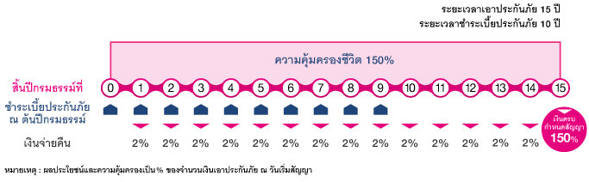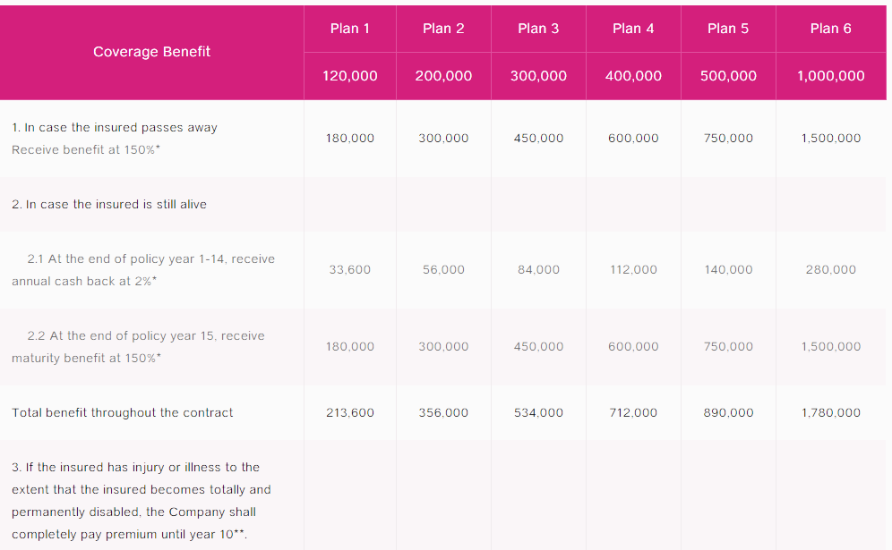
https://www.muangthai.co.th:1767/en/product/detail/happybenefit

We can see the detail from table above that they provide 6 plan with different payment. The more payment the more cover they will provide.
The benefits from these insurance is they will have annual cash back every year and have total benefit 178% of the initial sum insured if you hold throughout the contract. They also provide high life protection which provide life coverage throughout the contract of 150% of the initial sum insured. Moreover its life insurance premium of this plan is eligible for personal income tax deduction according to the Notification of the Director-General of the Revenue Department on Income Tax No. 172 announced on 30 December 2008.

- Which mortgage would result in higher total payments?
Mortgage A: $970 a month for 30 years
Mortgage B: $760 a month for 5 years and $1005 for 25 years
Total payment for mortgage A = 970*360 months = $349,200
Total payment for mortgage B = 760*60 months + 1005*300 months = $347,100

- What are the two main types of consumer credit?

- Closed-End Credit
One-time loans for a specific purpose that you pay back in a specified period of time, and in payments of equal amounts.
For example, Mortgage, automobile, and installment loans for furniture, appliances and electronics.
- Open-End Credit
Use as needed until reaching line of credit max and You pay interest and finance charges if you do not pay the bill in full when due.
For example, Credit cards, departments store cards, bank credit cards, incidental credit.

- What are the general rules of measuring credit capacity?
- Debt-to-income ratio
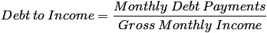
that measure an individual’s ability to manage monthly payment and repay debts which should not exceed 20 percent.
- Debt-to-equity ratio
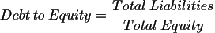
is a financial leverage ratio that are used to measure a company's ability to handle its long term and short term obligations.Its should not be higher than 0.5

- A few years ago, Michael Tucker purchased a home for $100,000. Today, the home is worth $150,000. His remaining mortgage balance is $50,000. Assuming that Michael can borrow up to 80 percent of the market value, what is the maximum amount he can borrow?
The market value of Michel’s home is 150,000. Michel can borrow up to 80 percent
= 0.8*$150,000 = $120,000. However, Michel still owe mortgage on his home $50,000. So, he can borrow at the maximum amount $120,000-$50,000 = $70,000.

