Creating a Crosstab Query
Microsoft Access provides tools for crosstab querying, which presents data in two dimensional table which has headers in both horizontal (row) and vertical (column) to make it easy to view and compare data. For example, displaying number of cars by model and color, if we use Crosstab Query to retrieve data by setting car model as column heading, color as row heading and number of car as a value to be displayed, the result will be as shown below.
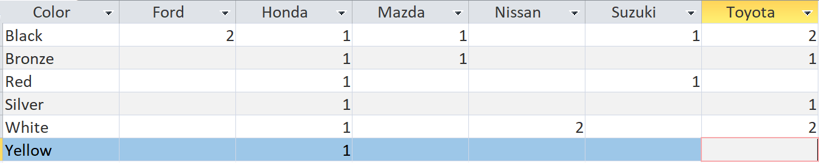
Retrieving such information can be done without the need to use a crosstab query. Only the display of information will be more difficult to read and understand as shown below.
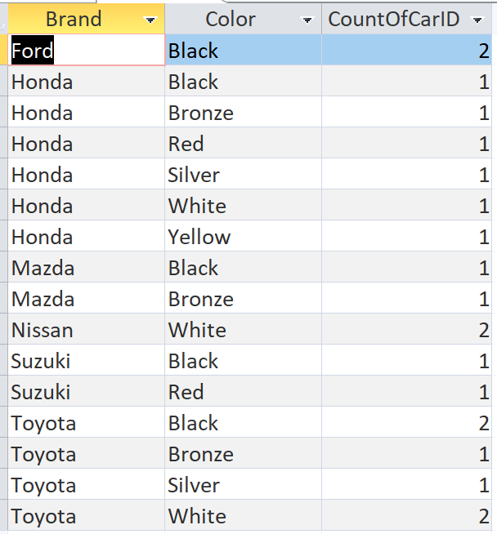
Crosstab Query Exercise
1. Display number of cars by brand and model of the cars.
2. Displays the number of cars by brand and year of the car.
3. Displays the number of employees by department and gender.
4. Display number of customers by country and city

Query data from more than 1 table using ‘Join’
All previous examples are data queries from only one table. However, in real life, most of data queries often use data combined from more than one table.
To query data from more than one table, you need to join the tables. Tables that can be joined must have fields that stores comparable data. For example, table ‘Cars’ has field CarID , and table ‘RentSchedule’ also has field CarID; these two tables can be joined via the CarID fields because they store data that can be compared.
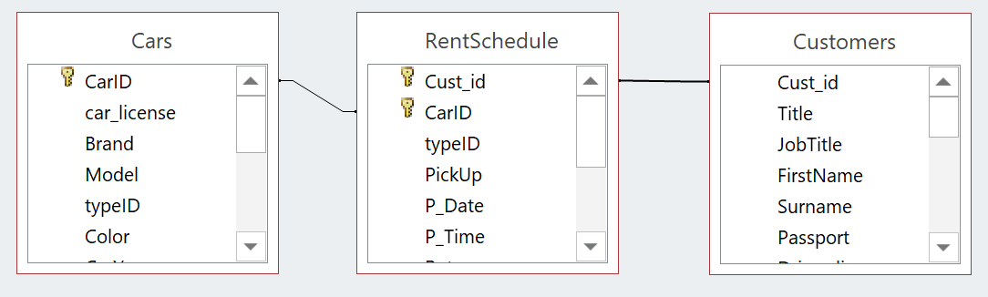
When a car rental shop manager wants to check the car rental date and return date of customer named Daniel. In this case, table Customers and table RentSchedule must be joined and query should be designed as follows.
***Remark*** notice that there must be a connected line between table Customers and table RentSchedule to tell Microsoft Access to join these two tables.
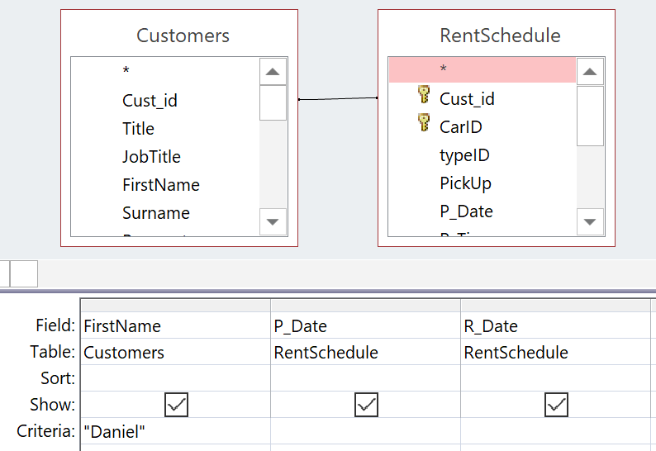
The Join from above example is called Inner join which is the default type of join in Microsoft Access. It joins only the records of both tables that have the same values in specified fields (Thus, also called Equi join). In the case of above example, if the values of field Cust_id of both tables are equal or same, so they can be joined. If the values are not equal, they cannot be joined. For instance, in Customers table, the records of customer number cust021 and cust022 will not be joined with any records in RentSchedule table because none of the records in RentSchedule table has customer number cust021 or cust022 in the field cust_id.
In addition to Inner Join, Microsoft Access also allows users to use Outer Join which allow joining two tables with unequal values in the field for joining. User who designs the query must select which tables to join all records from (Left table or Right table). As shown in picture below, left table is RentSchedule and right table is Customers, if we want to retrieve data by showing all records from Customers table, that is, despite there is customer information in table Customers but there are no car rental records exist in the table RentSchedule, also display those records. In this case, select option “Include all records from ‘Customers’” or right join.
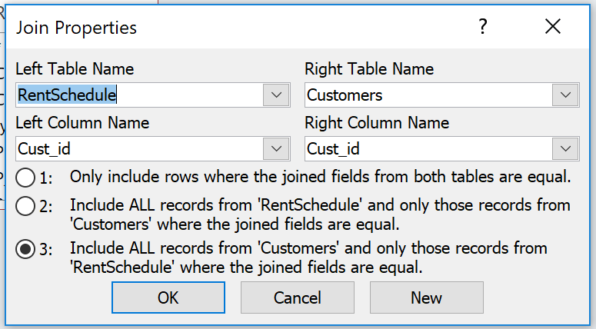
Exercise: Join Query
Use the database RentACar.accdb
- Display customer names and list of cars that the customer rented.
- Display customer names and car rental details, select only Honda car rentals.
- Display list of cars that have never been rented.
- Display number of rented days by brand and model.
- Display number of rented cars by brand.
- Display number of times each customer has rented cars.
Use the database Three-table.accdb
1. Display customer name, product name, price, quantity and total amount of all purchase items.
2. Display customer, product name, quantity and total values of each Bread purchase transaction
3. Display customer name, product name, price, quantity and total values. Select only purchase order with total values higher than 2000 and sort by total amount in ascending order.
4. Display total sales values of the company.
5. Display customer name with no purchasing record.
6. Display total sales by product.
7. Display product with no sales record
8. Display total sales by country
9. Display total sales by country and product.
10. Display total sales by customer.

Creating a parameter query
Parameter Query is a query that prompt for user to assign value to the conditional field. For example, In the case of library applications that require members to be able to search for books by specifying book name by themselves. In this case, parameter query must be used by setting the condition field, “book name” as a parameter to prompt for value to be compared from user.
When such query is run or executed, Microsoft Access will show a dialog box waiting for message assigned by user.
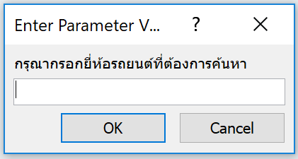
Creating a parameter query can be done in the same way as creating a general query which is clicking on Query Design button of CREATE tab. The difference is defining criteria to receive data from user. As in the case of the image above which allows the user to fill the car brand they want to search for, criteria must be defined as follows.
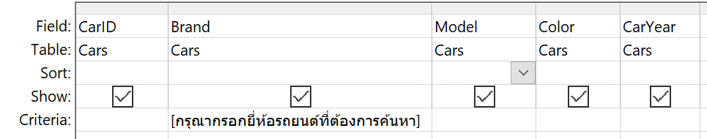
From the picture above, putting message inside square bracket lets Microsoft Access know that there will be a condition check in the field Brand and to use the value from input box entered by user to check conditions and show the message inside square bracket on the input box. When user input car brand such as Toyota, the value Toyota will be compared to the values in the field Brand of every record in Cars table, and only retrieve the records that the Brand field is equal to Toyota.
Exercise: Query with parameter
- Create a query to search all customers in any country. User can enter country they want.
- Create a query to search all cars in the color that user specify.
- Create a query to search list of customer names by letting user specify first letter of first name.

Creating a Make Table query
This type of query will take the results from the query to create a new table. Query designers have to define name of the new table and choose whether the new data table that comes from the query will be stored in the current database file or other database file.
To create Make Table query, query designers have to select the type query as Make Table in design tab (This tab will be appear when query is opened in design mode only)
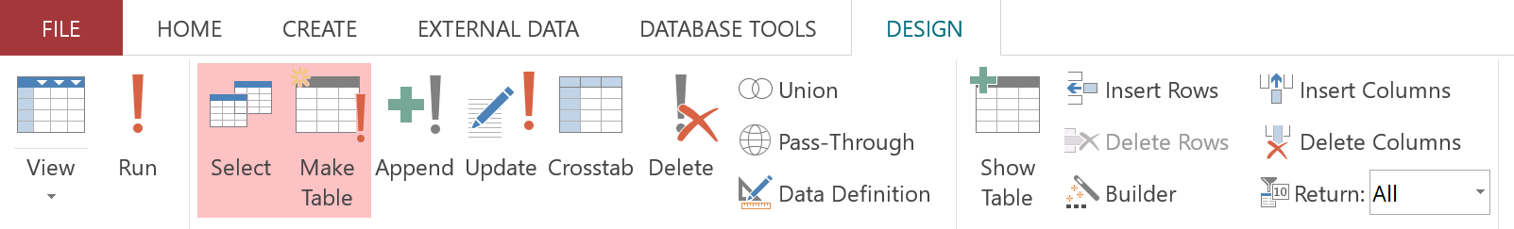
When pressing the make table button, the screen will appear as shown below for query designer to specify table name and to choose whether to save this new table in current database or another database.
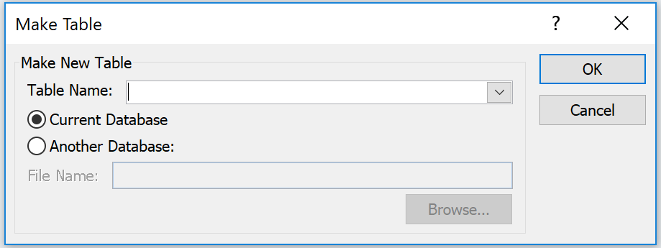

Exercise: Make Table query
Use the database three-table.accdb
1. Display product name and sales amount of product which has highest sales amount.
2. Display customer name, purchased amount of customer who has highest purchased amount.

