Thammasat University
Bachelor of Economics, International Program

Zika Virus
&
Public Health Concerns

Panchanok Siripanich 6204641135
Krit Pituckrachai 6204641598
Virakroth Ong 6204820028

Contemporary Economic Issues : EE406
Ajarn Thanasak Jenmana
21 December 2020
EE 406 Outline : Zika Virus

♦️ Abstract

Starting as a minor disease seven decades ago, the Zika virus has been rapidly causing great concerns in human society. During the past ten years, the disease shook world attention by causing a great epidemic in the early 2010’s and remarkably in 2016 as the infection reached its peak with six digits’ cases being reported worldwide. As a result, the virus possesses tremendous threat to the world. The purpose of the paper is to discuss the relationship between the Zika virus and the public health. Moreover, by reviewing academic literature and previous study as well as significant data from reliable organizational sources, the data obtained strongly support the research. Furthermore, public health plays a significant role in fighting the further spread of the virus. This shows that some countries with strong and effective public health seem to have great advantages over countries that lack public health management. Due to poor public health standards, some countries in the world face severe transmission. Microcephaly cases soon will occur. Thus, abortion problem occurred. However, the outbreak also led to changes in terms of response. All countries that are badly affected tried hard to strengthen their public health system in fighting the disease. Nevertheless, some countries are successful in fighting and implementing excellent strategies will be shown as examples. However, because of the spread we can see big five challenges in public health that all countries in the world should be taking action to solve and fix. Moreover, five possible solutions are suggested in helping the public health. we could conclude that the powerful public health system plays a vital role in solving the complexion of the epidemic. With weaker public health intervention, the country would fall into great chaos no matter how hard we try.

♦️ Contents

- Introduction
- Background
2.1 History
- Public Health
3.1 How Zika interacts with public health and the abortion problems in the infected countries?
- Transmission and health effect
3.2 The change in term of government response
3.3 Why are some countries more successful than others?
3.4 Health Care Provider And Challenges
3.5 Vaccine development
- Conclusion and Discussion
- References
- Appendices
6.1 Appendix 1

♦️1. Introduction

Zika is one of the viruses that epidemically affects the world. It was discovered in 1947 and throughout the times, there have been many cases of the zika virus. The latest being the 2015-present Brazil outbreak. Many people are concerned over the fact that there is no vaccine invented to stop this virus and that it can spread to newborn births. In newborn births, the virus can cause microcephaly, a potentially fatal congenital brain condition. The Zika virus also may cause other neurological disorders such as Guillain-Barre syndrome. Since it was announced as the outbreak, it causes a large effect on human beings and billions of people die and suffer illness from this virus with the problem of healthcare system management due to the large number of infected people and children made a large pressure on government healthcare. Therefore, in this research paper will show how the Zika virus interact with public health and abortion problems in the infected countries, what were the change in term of government response or related organization with the example case, and why some countries more succesfull than other in term of management and come up of effective strategies, in order to see how the good management for public healthcare system is important to save more life and reduce the number of new suspected cases of infected Zika virus.

♦️ 2. Background

2.1 History

Zika is a part of the virus family Flaviviridae. Flaviviridae is a virus that uses human and other breastfeeding animals as natural hosts. They are spread mainly from mosquitoes (for Zika, it's the daytime-active, Aedes mosquitoes) and ticks. Yellow fever, Dengue, and West Nile are also a part of this virus family. Zika is first founded in the Ziika Forest (Lake Victoria) of Uganda, hence the name, Zika virus. The virus was founded in April 1947, where the monkey, Rhesus Macaque is set in a cage to separate viruses from the blood. Zika was first founded in the Ziika forest. Hence, derivative naming of Zika virus, by George W. A. Dick, British virus hunter.
In 1968, the first recorded human carrier of Zika was reported in Nigeria. 1 decade later, the virus traveled Eastern to India, Malaysia, Thailand, Vietnam, and many other Southern Asian countries. April 2007 marks the date that the virus was founded outside of the typical range. It was founded in Yap Island and the infected human reported a symptom of rash, red eyes, and joint pain. Virologist warns the government about the concern that the virus is reaching America.
In 2013, Zika was found in Easter Island and French Polynesia, creating the largest outbreak of 383 people. Around the Summer of the same year, a team of French Polynesian athletes arrived in Rio de Janeiro, Brazil to compete in the canoe races. Scientists hypothesize over this as the transmission to America. The virus officially reached America with a confirmed case of infection in Brazil.
The number of Microcephaly cases in November 2015 surpasses the yearly cases for the previous year. December 2015, Brazil issued an alert after higher than usual monthly cases of Microcephaly in a new-born baby after evidence that correlates with the Zika virus. Health officials in many Southern American countries advised a delayed pregnancy to the population of their country. Canadian health officials also advised a delay for traveling to Zika infected countries and issued airlines a refund for travelers. This led the World Health Organization (WHO) to announce a public health emergency with the precautionary principle on 1 February 2016.
November 2016, the World Health Organization (WHO) tones down the global emergency yet noted that the virus still represents “ a highly significant and long-term problem” due to no certain developed vaccine. The number of cases peaked in 2016, with over 5,000 cases of Zika reported and dropped yearly to 3 digits and to 2 digits cases in 2017 and 2018, respectively.
Four years after the epidemic in America, we still have no vaccine that is proven to be immune to Zika but the spread of Zika has been so low that the World Health Organization (WHO) announced that travelers are not to worry about traveling to countries with previously reported Zika. Currently after 10 months through 2020, there are only 2 confirmed cases of Zika in the United States of America (USA).

♦️3. Public Health

3.1 How Zika interacts with public health and the abortion problems in the infected countries?

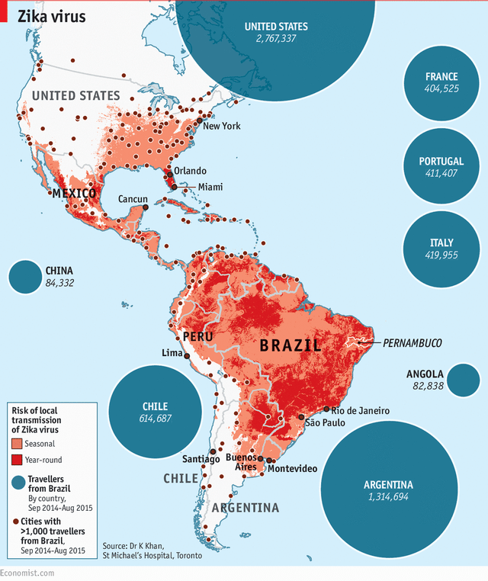
Zika interacts with the public health of many Latin American countries during 2016 in a very devastating way. At first, the government didn’t think that the spread of the Zika virus was a big issue until the medical officials found out about the complications of the Zika virus to pregnant women and how this creates small head and brain size syndrome is called Microcephaly disease in the newborn baby. Zika always gives the infected victims mild symptoms but never before a complication disease that actually creates a big problem for the population of that country.

The above map shows the spread of Zika virus throughout the continent of america, with reddish tones to emphasize on the highly infectious area and the countries with highest record of infection shown is blue circles around the text.
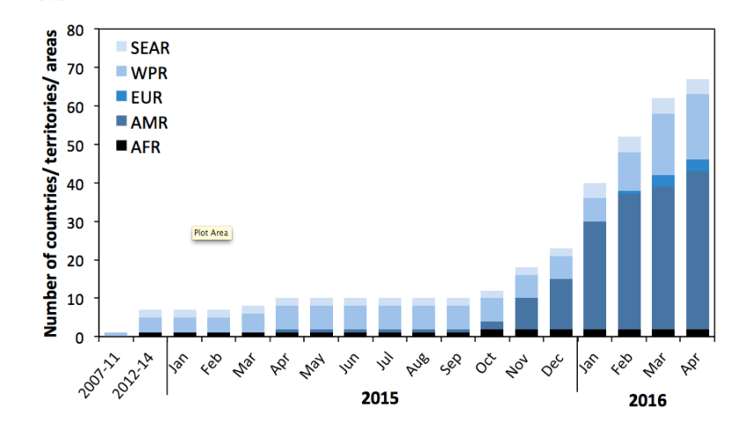
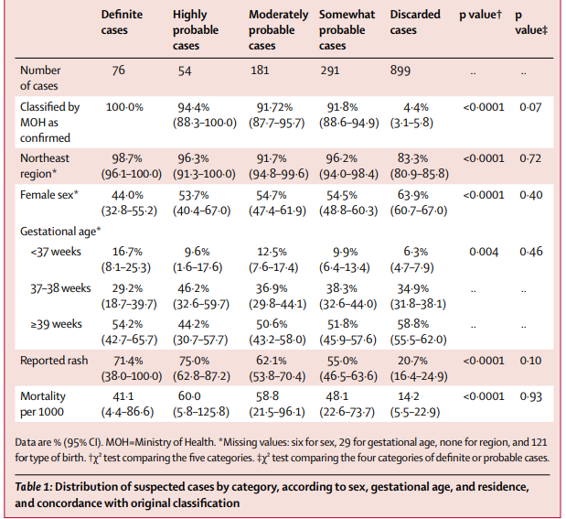
Zika virus started to spread in 1968 which people can get infected in several ways by Aedes Mosquito, sexual activity, blood transmission, and vertically transmitted infection, transmission that transfers from mother to child or fetus in their womb which affect badly and lead to microcephaly(small head) and in worse rarely cases of Zika syndrome(or Anencephaly) causes child with unique pattern of birth defect and disabilities. And also for people who get infected with the Zika virus, it can affect badly to their health leading to neurocognitive disorder which causes in decreases mental health and psychiatric illness but in the worse cases it also can cause Guillain-Barre syndrome that lead to muscle weakness and paralysis. From figure above it shows the cumulative number of countries, territories and areas by WHO region reporting Zika virus transmission in years, 2007-2014, amd monthly from 1 January 2015 to 27 April 2016 reports the evidence from 9 countries show the extreme growth during the end of year 2015 and continue increase number of infection on 2016.
All in all, the vertically transmitted infection has been one of many problems that most people concern about especially in Brazil where the number of infection from mother-to-child was very high since November 2015, there were 7830 suspected cases of Microcephaly reported to MoH(Ministry of Health) of Brazil. From Table 1, it illustrates the distribution of suspected cases by category by using the InterGrowth standards to calculate percentiles and Z scores of head circumference by the sex and gestation age in range between 24-42 weeks. The article shows that discarded cases had a lower mortality rate than definite or probable cases or 14 per 1000 cases. From figure2 below, shows the peak of microcephaly the epidemic occurred in the last week of November 2015.
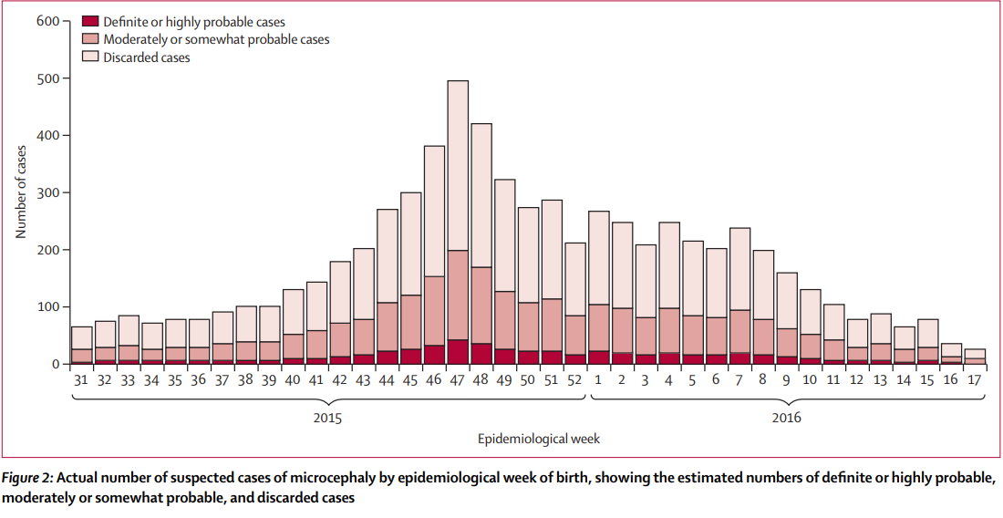

The UN Commissioner for Human Rights, Mr. Zeid Ra’ad Al Hussein asks many Latin American countries to lift the abortion ban. He even goes as far as promoting a pro-abortion in Brazil. Brazil has seen the highest infection rate of pregnant women as well as many other notable countries, like Colombia, El Salvador, Venezuela, and Peru. The recorded high of Microcephaly disease cases related to Zika is for Brazil, at 2,404(February 2017).
Looking in the country of Colombia, a total of 3,177 pregnant women are infected with the Zika virus, yet none of the babies is reported with any complications for the Microcephaly diseases.
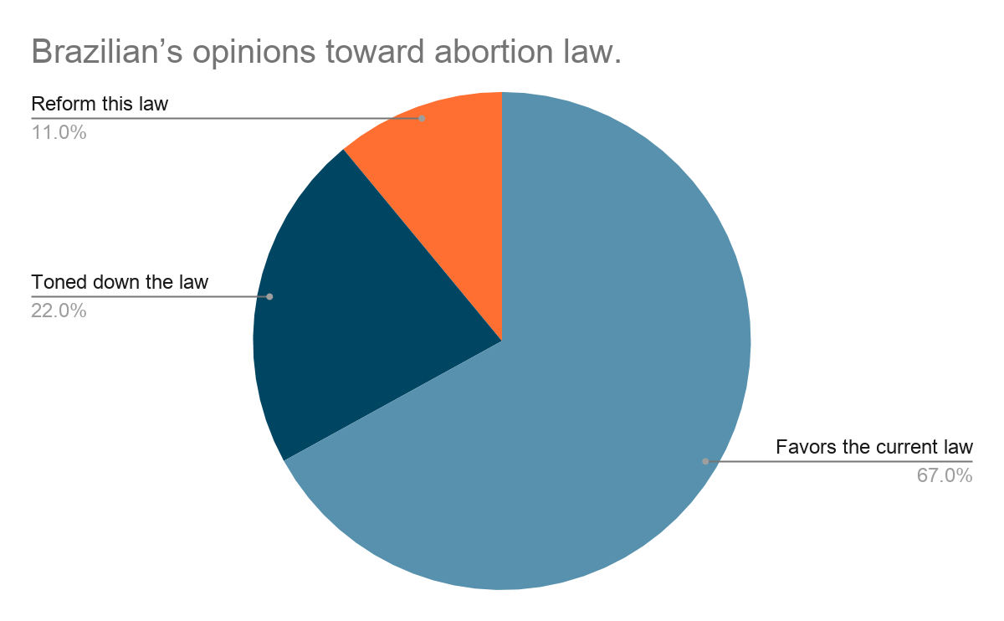
There is also another concern that it is hard to detect Microcephaly until the mother is in its 3rd trimester of pregnancy(both prenatal tests and ultrasound is used for the detection). As of 2017, a Brazilian pregnant woman infected with Zika is only permitted to do an abortion if there is proof that she is raped or that the baby is confirmed to have Anencephaly (a worse form of Microcephaly, and with some part of her brain and skull missing)
An estimation of Brazilian opinion on legalizing abortion, 67% of people favor the current law, 11% of the people think that the law should be toned down, and 22% of the people think that there should be reform to this law. This is also evidence that many people in this part of the continent are very much religious based on Christianity and many people think that aborting a child is considered a crime.
There are also movements from law professors at the University of Brazilia, a petition to the Brazilian supreme court that to lift the abortion law alleging that: 1. Giving access to legal abortion will result in lesser birth defects. 2. Brazilian government has the duty to provide free + safe abortion services to public hospitals and the most affected region, the poor. 3. To not legalize abortion will results in an unsafe method.
Yet, looking back at many health scientists opinion on abortion, many of them also give the opinion that abortion is not the ended solution for Zika virus, because it doesn’t solve the actual problem of the outbreak. “It doesn’t control the vector.”

3.2 The change in term of government response

Zika virus has been first discovered since 1947 and over seven decades, there has been found in more than 27 countries and territories with a very large number of people who get infected including infants born with microcephaly by the cause of Zika virus. Therefore, the government of each country and health international organization, for example: World Health Organization (WHO), Centers for Disease Control and Prevention (CDC), do not be negligent and give out response by raising awareness as much as possible to every area, especially in risky areas.
The change in term of overall response to Zika virus, mainly about raising awareness to people by several ways which can be classify into 4 main actions: first, create risk communication in order to manage risk and assist public health authorities in response to possible outbreaks which offers options and advice, to apply the principles of risk communication and to build a risk communication plan. Second, provide information to healthcare providers in the EU/EEA, in order to prevent ZIKA disease by population type and travelers to or returning from areas with ongoing transmission. The type of population can classify into 4 groups of people: pregnant women, partners of pregnant women, women of childbearing age, women considering pregnancy, and partners of women of childbearing age and women considering pregnancy. These 4 groups of people and travelers should apply measures to prevent mosquito-borne diseases when visiting the countries with past or current ZIKA circulation which aims to reduce risk of sexual transmission to their sexual partners in EU/EEA, especially for pregnancy women or considering pregnancy and their partners should take special precautions to prevent ZIKV infection. Third, vector management, the main method of tackling infectious disease which has been developed by WHO with the purpose of developing preparedness activities and updating national response plans to integrate vector management approach. Fourth, disclaimer, ECDC issues the risk assessment document based on an internal decision with the purpose to prevent different options on certain matters with their respective advantages and disadvantages in order to delimit the right and obligation and to prevent unreasonable risk of harm or injury.
For example, the change in response to Zika in Brazil, by the late of 2015, there was a sharp increase in the number of infants born with microcephaly and other neurological disorders in the northern area of the country. So, in response, the WHO declared that these were a Public Health Emergency of International Concern (PHEIC) which is a possible connection between Zika and Guillain-Barre syndrome. After the increased international pressures on Brazil for stronger policy response, the government has improved to help fund Sistema Unico de Saude (SUS) properly and ensure an effective response to Zika. In 2016, the Olympic and Paralympic Games that would happen in Rio de Janeiro has postponed as the response of Zika, it took place in August and September instead as it is the Brazilian winter which there are expected low mosquito density due to drier climate, but they still intensifying vector-control measures in and around the venues for the Games which should further reduce the risk of transmission. In terms of government response, the Ministry of Health (MoH) developed a policy strategy emphasizing three major pillars: vector control, assurance of access to healthcare, and technology and research development. Brazilian Zika’s vector, the MoH has the policy of providing mosquito repellent cream for pregnant women as their social welfare known as Bolsa Familia. Access to healthcare was unequal under the limit number of doctors and public clinics appointment less than the national average, this point out that the problem was many public policies of wide access to healthcare and social security do not reach the poor who are most at risk. Then, they think that the solution was to provide a clear budgetary estimate to deal with virus and resource allocation according to each area. For technology and research development, the central government must be fully committed to provide more funds and technical assistance to poor resource areas.
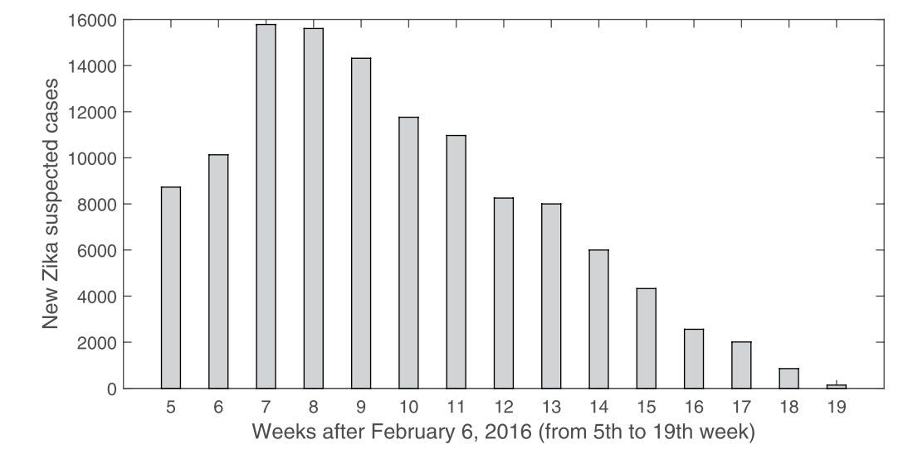
The graph below shows the reported suspected Zika cases in Brazil from February 6 to June, 2016 ,between week 5th to week 19th which clearly see that the situation in Brazil is getting better and the government was successful in controlling the spread of Zika virus as there is a decrease in the number of new Zika suspected cases from week 8 to week 19 where it was dramatic decreases comparing to during the peak range between week 7th and 8th where number of new suspected cases is almost reach 16000 new cases.

3.3 Why are some countries more successful than others?
Most countries around the world are taking responsibility in controlling the spread of the Zika virus all over the world. However, some are working well with the suppression of the spread during these many years of the recent outbreak. For approximately 10 years, data collecting plays a crucial part in estimating the effective outcome in the result of implementing various solutions and interventions. Additionally, if we look at the data from various countries in the world we can divide it into groups according to its location as known as continent and analyze the success and failure they have been struggling or achieving successfully. There has been a transmission circulating in 59 countries all around the world. Moreover, most countries are imposing policies in response to the spread of the virus regarding the guideline of the world health organization.

The American continents
Total reported cases in The America
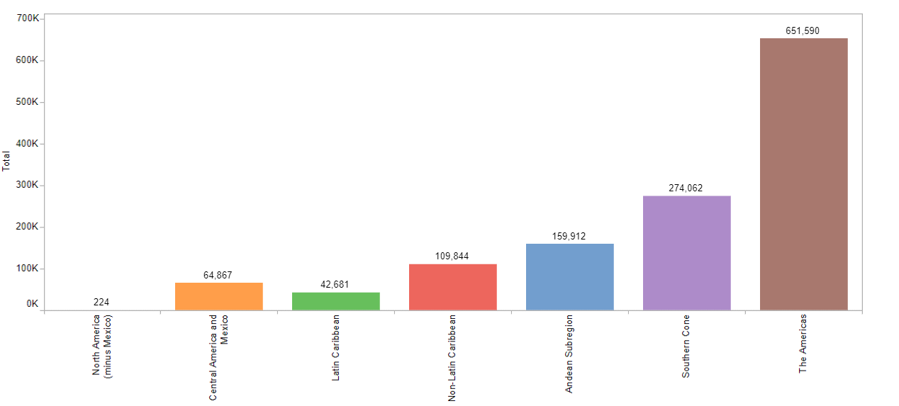

The graph above indicates the total cases that were reported during the great spread in 2016. However, we can see that for all countries in the american continent, the Southern cone region is the place where major spread occured. Brazil alone accounted for 273,904 cases in 2016,PAHO (2020).
According to the Pan American Health organization(PAHO), it shows that during the years of outbreak from 2016 until 2020 cases in brazil has been decreasing significantly from 56,159 in the year of 2015 and plunge tremendously to 273,904 that was considered as the country with highest in the world and decreased gradually to 15,898 cases in 2020. Ten thousand cases are thought to be high in Brazil since there are endogenous groups that could not reach the public health as well as not having sufficient knowledge of the disease. Furthermore, the dense population also plays a significant role in causing high spread, Rio de janiro as an example. However, this can be considered as a big success for Brazil as the implementation of the strategy provided by health care workers could reduce the total case in high amounts. Moreover, people then began to voluntarily go to have baby screening to trackdown the microcephaly that was caused by the Zika infection. Measurements from WHO are implemented as usual by health care workers. Mosquito fogging and information circulating are imposed regularly. In addition, many countries from the same continent also made such achievements in curing and preventing further spread such as Peru, and Colombia with 112 and 159 cases respectively. Moreover, most countries in the American continents are doing well in easing the spread and cure the disease as some are even dropped to zero as shown by the data from PAHO in collaboration with WHO.
​On the other hand, there was also a significant spread in the north America continent such as the United States and Canada. However, the cases were high during the 2016 outbreak but dropped to zero for both countries. In the USA, the public health sector seems to be well prepared in terms of fighting back the spread of the virus. In response, the public health providers have already been prepared to reserve enough blood supply with enough facility and effective diagnostic tests which will be enough to be available for the people to be tested. Nevertheless, the public health workers in both counties US and Canada are enough available to serve the people.

In Africa
The zika first originated from the ZIKA forest in Uganda, africa. However, the outbreak is not as big as what happened in the other countries, for example, Brazil. Still, african countries are still considered as high risk in case of involvement with ZIka as the zika forest is still as risky and thought of to be the main source of the spread. Additionally, what the public health worker can do now in african continent is to spread awareness and existence of the virus which could be called devastation to humankind. The only response to the spread from the countries is to stop the further existence of mosquito, Aedes aegypti type, as it is the main source of many deadly diseases caused by mosquitoes. however, since the health care system in the continent is still under international standard, plus lack of modern facilities. Moreover, catching up with other countries during the fight of the spread is still in slow pace. Furthermore, since most countries in african continent are poor, the health care system seems to lose effect. there are not enough doctors, nurses, medical workers as well as modern medical equipment to serve the people. For instance, only 2 doctors in Ethiopia and 1.2 doctors in Uganda are available for a ten thousand population, WHO (2020). Moreover, in the 2015 outbreak, african countries seem to get distracted by the virus as Cape Verde alone has a total infection of 4744 cases. The countries in Africa are following basic measures preventing people from mosquito bite since mosquito borne disease including zika are common in the continent. The measurement includes eliminating mosquito nests, covering water storage containers, wearing light color clothes as well as avoiding mosquito bite.

Southern Asia
As the ZIKA virus has been circulating freely around the world, the southern asian countries are vulnerable to the spread. Due to the unfortunate soil and weather, southern asian countries tend to get affected by mosquito borne disease which include zika as wet land and frequent rains are the source of mosquito existence. This will lead to a red sign in southeast asian countries as the spread does not fully vanish. However, the spread attack significantly in ASEAN countries as many cases were reported by the rapid cases of microcephaly that lead the countries to have thought of ZIKA outbreak to be occured again. However, even if there is a silence in a new outbreak, the virus is still hiding somewhere in the area. In response, most countries started playing crucial roles in controlling the spread. Likewise in Thailand, the public health workers in Thailand are taking action by having applied the mosquito-fogging operation which is part of the ministry's vector-control strategy. however, even since most countries in southern asia are struggling with areas of poverty such as india, and some areas of myanmar. In addition, countries like Thailand, Cambodia, Laos and Vietnam for examples, are at risk of the arboviruses including DENV, CHIKV and JEV, ect. This means that even with lower zika cases in the countries, therefore, we could not be sure that the nations are doing well or fight the spread of the virus effectively. Therefore, strategy response to the outbreak is not effective as expected. We could consider Singapore to be one of the countries with highest risk of the spread since the country is extremely at risk to arboviral diseases. This shows that even with lower levels of cases in the region, still the geographical condition of South Asian is not getting along with the strategies and measures implemented.

3.4 Public health provider and Challenges
Public health providers play important roles in promoting, protecting, and improving the health of the communities as well as the individual. After a major disaster, likewise the outbreak of the Zika virus, public health workers are often called upon to participate in a coordinated response to save lives and prevent unfavorable outcomes to vulnerable populations​. However, Health care system in the world has been changing little by little as many reforms have been implemented. However, some countries are doing great with the reforms while some are struggling with choosing the right strategy to perform. As we look at the American continent we can see a huge gap of performance between the north, central and the south.
​In the Latin America, since the late 20th century, the economic growth of the countries plays an important role in helping the countries develop their old fashioned health care service. However, we can see big challenges in imposing a successful public health system or strategies since there is failure in applying the strategies. The First challenge is the barrier to access the health care service. In the Latin America and Caribbean nation only half of the total population receive high quality or proper healthcare service as 30 percent of the population struggle with economic problems while 20 percent more could not get access to health care due to the cause of geography barrier. For instance, it will take many days for the health care worker to notice or receive information about the infection. This causes great risk in prolonging the further spread. Additionally, the second challenge is caused by the epidemiologic transition and chronic non-communicable disease. Since the late twentieth century, the countries in Latin American continent have experienced issues caused by high levels of infectious and acute disease that put an unpleasant pressure on the public health system in the countries. For instance, the Zika outbreak in Brazil in 2018 shows that acute and infectious disease would cause a huge drawback to the country's health care system. Third challenge is that there is very little training and distribution of human resources in the healthcare system. Only small number of countries in the world possess high number of medical doctor as well as health care personnel such as Australia, Austria, Japan, are considered to have high number of physician per 10,000 inhabitants while other country in the world are facing great fear with less medical worker to serve enough population at such African nations and Latin America. In addition, it is being reported that 44 percent of WHO member states have less than one physician per thousand population. For the fourth challenge, similar to the first matter, there are inequalities in health care access. For this reason, as in the Latin American nation and many poor countries in the world, health care service is rarely available or efficient in the rural part of the country. Moreover, equipment or facilities tend to be more available in the urban area. In addition, people who are living in the rural areas such as indigenous people are at risk of infection and face a high mortality rate. Furthermore, good and well facilitated medical centers tend to be located mostly in urban cities. There is a lack of proper health care centers in the rural areas for the poor to get access. Lastly, the fifth challenge of financing the health care system. With a great population and people starting aging and infectious disease starting to spread, health care services need big involvement of financing in the response of this challenge. Moreover, successful countries in implementing great healthcare systems like the USA show remarkable examples as the health care spending in the country increased significantly around 4.6 percent in 2019, which is equivalent to 17.7 percent of gross domestic product. Regarding Zika epidemic budget, as of 2016 just after the outbreak, there was a fund raising in response to the epidemic outbreak in cooperation of many countries around the world such as Japan, United kingdoms as well as Canada in the name of organization collaboration like wise USAID , DFAT,etc.

3.5 Vaccine Development ​
Since the first outbreak, there is no vaccine to be successfully announced yet. Moreover, the vaccine development program is still in an early stage. Remarkable scientific work has resulted in multiple candidate vaccines that are now undergoing further clinical development, with several vaccines now in phase 2 clinical trials. Additionally, the development process is running actively. Furthermore, there has been remarkable work from the United states by FDA ( Food and drug administration) in collaboration with national health institute (NIH) along with Biomedical Advanced Research and Development Authority (BARDA) and Center for disease control (CDC) as well as the private sectors in search of vaccine for the virus. in addition, there is no treatment for the disease, yet the solution is to ease the symptoms by applying medication and relieve joint pain and the fever of the patient.

♦️4. Conclusion and Discussion

Throughout the spread of Zika virus since 1968, there are a large number of people who got infected by Aedes mosquito, sexual transmission, blood transfusion, and vertically transmitted infection which affect badly to neurocognitive problems which also can lead to Guillain-Barre syndrome that cause muscle weakness and paralysis and also affect seriously to fetus in pregnant women womb as it was the cause of microcephaly in the common cases but in the worse cases it causes anencephaly. These lead to the problem of public health affected by the large number of children with microcephaly. Therefore, it was the part of government response to raise the awareness among citizens by these four actions: create risk communication to manage risk and help assist public health, provide information to healthcare providers, do vector control to tackle infectious disease, and having disclaimer to delimit the scope of right and obligation. We can see that each country has different controls on the spread of Zika virus as they have different management then some countries have better performance than others. In this case, the American continents have better control and are able to wipe the new suspected cases of Zika infected than in Africa and in Southern Asia during this past decade. As in American continents, they have enough support from public health services to serve their citizens while in Southern Asia and Africa do not have effective strategies to be able to control the spread of this virus.
The problems on the health care system from five challenges point out the issue came from barrier to access the healthcare service as the cause of economic problems and geography barrier and in some cases cause by poverty as in the poor countries people have less chance to available or efficient healthcare service in rural areas, unpleasant pressure due to high levels of infectious and acute disease which cause large obstacle for healthcare system of each country to handle, little training and lack of human resources to serve enough population especially in African nations and Latin America, and the need of large involvement of financing the healthcare system in response of these challenges.
Therefore, the possible solutions are first, having better access to healthcare with no barrier. Second, creating more public health in rural areas or creating risk communication to manage risk and assist public health to create plans to deal with future possible outbreaks. Third, to get more human capital is to hire more doctors and nurses as there was a lack of human resources in poor countries such as Nigeria or South Africa. Fourth, giving more budget to support local healthcare as they need large financing support to respond or support new strategies that are created to solve current situations. Fifth, to educate people in rural areas by the public health officer or provide information more to healthcare providers. Finally, public healthcare should provide sufficient information about how to prevent mosquito bite to every household, for example, giving out mosquito nets or cream to prevent mosquitoes, in order to control disease that could affect fetus in the womb of women.

5. Reference:
- Zika virus outbreak: reproductive health and the rights in Latin America(2016, February 12). Retrieved November 5, 2020, from: Zika virus outbreak: reproductive health and rights in Latin America (thelancet.com)
- CBCTheNational, T. (2016, February 01). The History of Zika. Retrieved December 20, 2020, from https://www.youtube.com/watch?v=FOcSe0LtoTg
- Laura Wright.(2016,Jan,29).Zika timeline: A look at how the mosquito-borne virus spread,CBC/Radio-Canada. retrieved on 05 Dec, 2020.https://www.cbc.ca/news/health/zika-timeline-a-look-at-how-the-mosquito-borne-virus-spread-1.3426172
- WHO.(2018,July,20).Zika Virus.https://www.who.int/news-room/fact-sheets/detail/zika-virus
- CDC(2019,Nov,7).Zika Virus: Statistics and Map. retrieved on 05 Decc,2020 https://www.cdc.gov/zika/reporting/index.html
- VOX channel(2016, February 02). The Zika virus, explained. Retrieved November 5, 2020, from; https://youtu.be/OILBAbva6QA

Zika virus, explained in 6 charts and maps (https://www.vox.com/2016/1/20/10795562/zika-virus-cdc-mosquitoes-birth-defects)
- World Health Organization.2016. ZIKA STRATEGIC RESPONSE FRAMEWORK & JOINT OPERATIONS PLAN. STRATEGIC RESPONSE PLAN. Retrieved on 27 Oct,2020.From https://apps.who.int/iris/bitstream/handle/10665/204420/ZikaResponseFramework_JanJun16_eng.pdf;jsessionid=3DCDE84BBDA59A638102A3E9C5F093D6?sequence=1

WHO.2020. Emergency 4Ws Portal for Zika virus response. Retrieved on 27 oct,2020.from: https://www.who.int/bulletin/africanhealth/en/

WHO.2020. The African Regional Health Report: The Health of the People. Retrieved on 27 oct,2020.from: https://www.who.int/bulletin/africanhealth/en/
- GOV.UK. 2019.Zika virus country specific risk. Retrieved on 27 Oct,2020. From: https://www.gov.uk/guidance/zika-virus-country-specific-risk
- Center for disease control and prevention. (2018).2018 case count in the US. Retrieved on 27 Oct, 2020. From: https://www.cdc.gov/zika/reporting/2018-case-counts.html
- Gregory A. Poland, Inna G. Ovsyannikova, Richard B. Kennedy,Zika Vaccine Development: Current Status,Mayo Clinic Proceedings,Volume 94, Issue 12,2019,Pages 2572-2586,ISSN 0025-6196,https://doi.org/10.1016/j.mayocp.2019.05.016.
- Centers for Disease Control and Prevention. Zika virus: 2018 case counts in the US Provisional data as of March 6, 2019. Available from: https://www.cdc.gov/zika/reporting/2018-case-counts.html
- Zika, public health, and the distraction of abortion(2016, Novembeer 29) Retrived on 5 November, 2020. From: Zika, public health, and the distraction of abortion | SpringerLink

Aiken, Abigail R.A., Scott, James G., Gomperts, Rebecca, Trussell, James, Worrell, Marc, Aiken, Catherine E. (2016). Requests for Abortion in Latin America Related to Concern about Zika Virus Exposure. New England Journal of Medicine. 375:396-398.DOI: 10.1056/NEJMc1605389

Vivian Maria Ribeiro Mota, Luciano Pamplona de Góes Cavalcanti, Alanna dos Santos Delfino, Thayse Elaine Costa Figueiredo Lopes, André Luiz Santos Pessoa, Erlane Marques Ribeiro, (2018). Abortion in Cases of Zika Virus Congenital Infection. Thieme Revinter. 40(07): 417-424.DOI: 10.1055/s-0038-1648219
- PAHO(2018.)Latin America and the Caribbean have the second highest adolescent pregnancy rates in the world.Retrieve on Dec. 5, 2020,URL: https://www.paho.org/hq/index.php?option=com_content&view=article&id=14163:latin-america-and-the-caribbean-have-the-second-highest-adolescent-pregnancy-rates-in-the-world&Itemid=1926&lang=en
- FEMS Microbiology Letters. (2016, August 21). Depression. https://academic.oup.com/femsle/article/363/18/fnw202/2197800
- The American Journal of Medicine Blog. (2016, August 12). Depression. https://amjmed.org/re-emergence-of-zika-virus-a-review-on-pathogenesis-clinical-manifestations-diagnosis-treatment-and-prevention/
- Centers for Disease Control and Prevention. (2018). Zika virus overview. Retrieved August 21,2020, from https://www.cdc.gov/zika/about/overview.html
- Rapid Risk Assessment. (2019). Zika virus transmission worldwide. Retrieved April 9, 2020, from https://www.ecdc.europa.eu/sites/default/files/documents/zika-risk-assessment-9-april-2019.pdf
- BMJ Global Health (2018). What explains the lacklustre response to Zika in Brazil? Exploring institutional, economic and health system context. Retrieved 27 August 2020, from https://gh.bmj.com/content/3/5/e000862.abstract
- Zika situation report. (2016, April 28). Retrieved December 19, 2020, from https://www.who.int/emergencies/zika-virus/situation-report/28-april-2016/en/
- Congenital Zika virus syndrome in Brazil: a case series of the first 1501 livebirths with complete investigation(2016, June 29). Retrieved December 19, 2020,from:https://reader.elsevier.com/reader/sd/pii/S0140673616309023?token=A33B9579C3AE96920F39041E45950F922E8A9270C5960E63478580E654A52A9BFFB315F5713BE8D743AFDD2185F6200F
- Modeling the transmission and control of Zika in Brazil(2017, August 10). Retrieved December 19, 2020, from: https://www.nature.com/articles/s41598-017-07264-y
- The history of Zika(2016, February 01). Retrieved December 20, 2020, from: https://www.economist.com/graphic-detail/2016/01/26/the-spread-of-zika-virus
- Veasna Duong, Philippe Dussart, Philippe Buchy,Zika virus in Asia,International Journal of Infectious Diseases,Volume 54,2017,Pages 121-128,ISSN 1201-9712,https://doi.org/10.1016/j.ijid.2016.11.420

Appendices
Appendix 1
Raw Data of zika cases in the american continent from 2015-216, extracted from health information platform for Americans (PLISA)

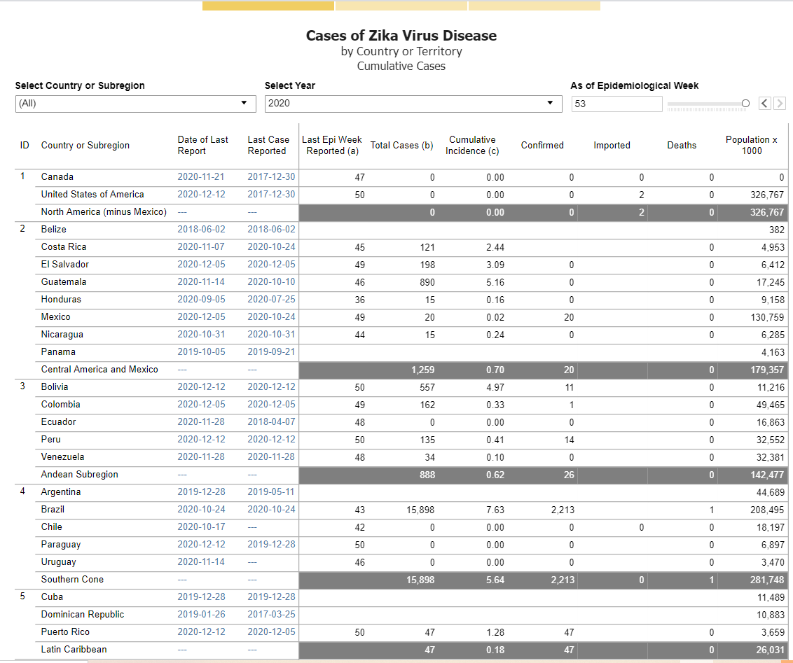

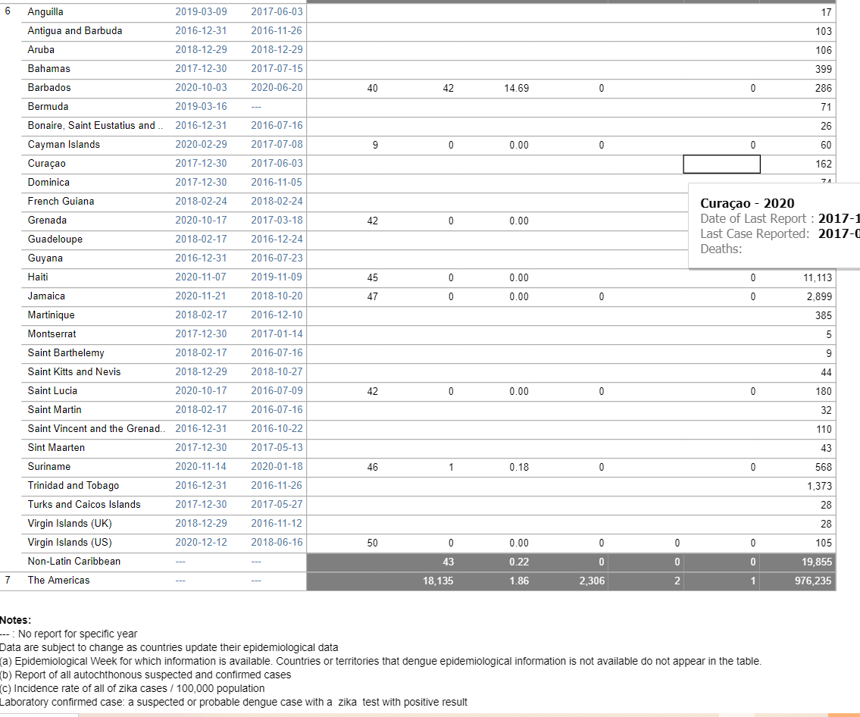
source: health information platform for Americas (PLISA)

