6104640153
Natchalin iwsakul
Assignment 5

1.1 Spot:
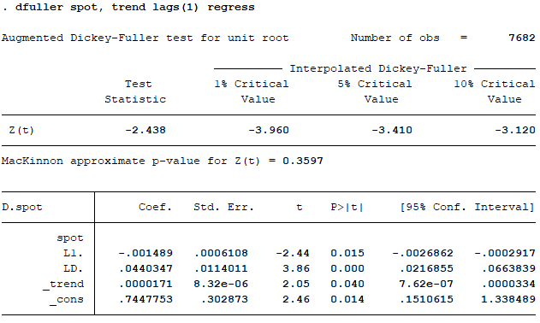

First, to check whether spot is stationary series or not, we check MacKinnon approximate p-value for Z(t) for H₀: ϒ = 0 at 0.05 significant level. The MacKinnon’s is 0.3597 which is more than 0.05. It means that we fail to reject H₀: ϒ = 0. Thus, go to the second step. We test whether α₁ or time trend is equal or 0 or not: H₀: α₁ = 0. At 0.05 significant level, time trend has P>ltl of 0.04 which is less than 0.05. Thus, we reject the null hypothesis, and that means there is a unit root. The spot series is non-stationary.
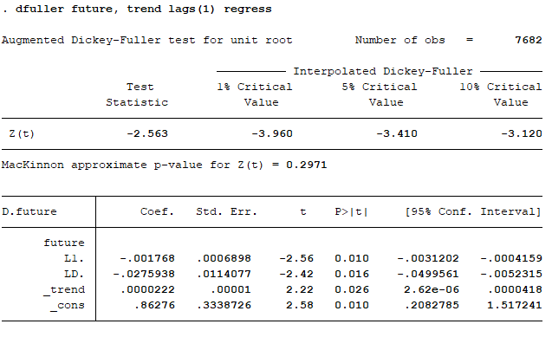
  - Future:

For the future series, the MacKinnon approximate p-value for Z(t) is 0.2971 which is more than 0.05 significant level. Thus, we fail to reject the H₀: ϒ=0. Then, we move to next step. The time trend’s p-value of t-stat is 0.026 which is less than 0.05 significant level. Thus, we reject the H₀: α₁=0 which means it is a unit root. The future series is non-stationary.

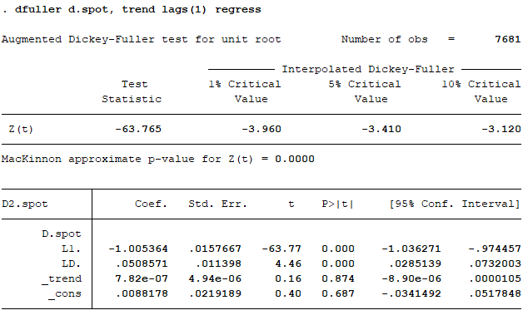
2.1 Spot
To determine order of integration of series spot, we test the level of series by using dfuller d.spot. According to the result, MacKinnon approximate p-value for Z(t) is equal to 0.000 which is less than 0.05 significant level. Thus, we rejected H₀ : γ = 0. There is no unit root or the model is stationary at integrated level 1 or I(1) means that Spot_{t} is nonstationary but ΔSpot_{t} is stationary.

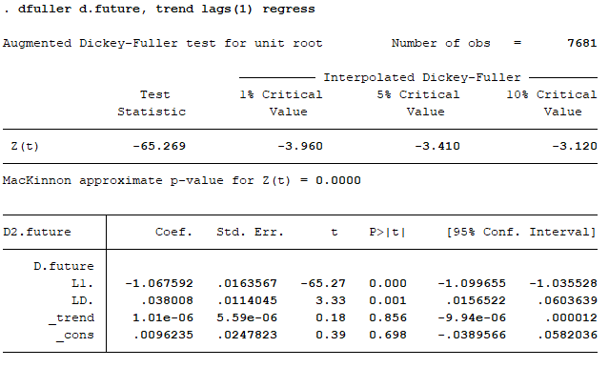
  - Future
To determine order of integration of series future, we test the level of series by using dfuller d.future. According to the result, MacKinnon approximate p-value for Z(t) is equal to 0.000 which is less than 0.05 significant level. Thus, we rejected H₀ : γ = 0. There is no unit root or the model is stationary at integrated level 1 or I(1) means that Future_{t} is nonstationary but ΔFuture_{t} is stationary.

3.1 rspot
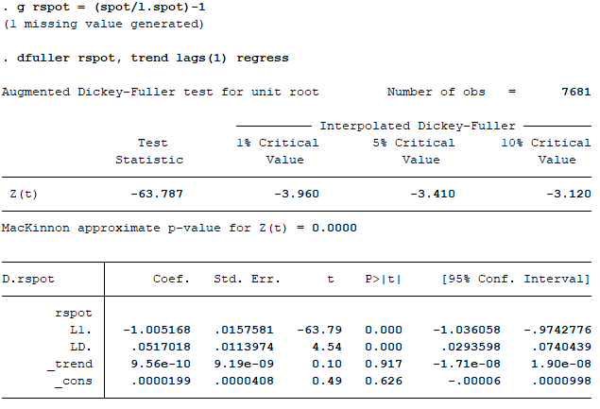

After generated rspot by (spot/l.spot)-1, to determine order of integration of series spot, we test for the level of series by using dfuller d.future. MacKinnon approximate p-value for Z(t) is equal 0.0000 (p-value = 0.0000 < 0.05). Thus, we reject H₀: γ = 0. There is no unit root or the model is stationary at integrated level 1 or I(1) means that Future_{t} is nonstationary but ΔFuture_{t} is stationary.
  - rfuture
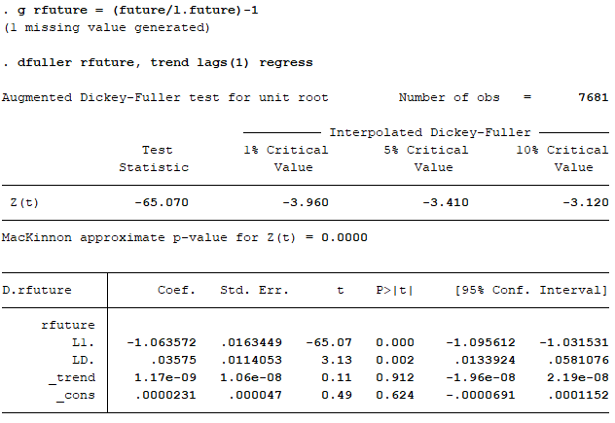

First, we need to generate rfuture by (future/l.future)-1. Then, to test whether rfuture is stationary or not, we use the ADF. According to the result, MacKinnon approximate p-value for Z(t) is 0.0000, p-value is less than 0.05, thus H0 : γ = 0 is rejected and series rfuture has no unit root or the model is stationary.

