Student number: 5504640748
Name: Nattachon Chujiravong
Subject: Ansel Adams
Words count: 1062
Natures or environments are the important things that create the world beautifully. In addition, if people could understand the beauty of the environmental combination, of mountains, rivers and trees, they will be able to know that, nature could be defined as one of the art. There were a lot of people that used photography to express the elegance of the nature, and one of the world’s most famous photographers was Ansel Adams, the landscape expert. He used his photos, not only to show the beauty, but also to express feelings that encourage viewers to be more concerned and to take good cares of the environment. Furthermore, he was not just a photographer, but he was also an environmentalist who was enamored by the unexplainable beauty of nature. He wanted this beauty to last forever. It could be said that Ansel Adams was one of the most distinguished photographers that was born to change the photography world due to his great vision, endless ambition and marvelous techniques.
The man named Ansel Adams, or Ansel Easton Adams, was born on the 20th of February 1902 in San Francisco, California, and died on the 22th of April 1984. When he was a child, he met a serious situation as he had to confront with the devastated earthquake which broke his nose. On the education, he did not receive a high education, just finished the eight graded, because of the problems in reading and spelling words and the personality that wanted to study only in the interested field. At first, about the age of 12, he liked to play piano in which he made a decision to be a pianist in the future. Somehow, he also interested in the photography. However, in 1916, his potential future was much clearer during a trip in Yosemite National Park, when he had a chance to take the first photograph of his life, and that was clearly made the direction for his future. He decided to be a great photographer.
The opportunity came to him in 1919, when he had a chance to be a part of the Sierra club, which gave him a chance to be in touch with the nature and the jungle. This was the place that his first work was published. Year 1927 was the most important year of his life because he met Albert M. Bender, who had influenced him to be a real photographer. He had produced a photograph named Monolith, which was a very famous imagined photograph. In 1930, he changed his style of photography to be much more professional due to the impact from the picture of one photographer; the style was called ‘straight photography’. In his career of being a photographer, he was very famous on environmental and wilderness photographs in black and white color. He said that black and white photography could express the feeling of timeless essence and it was stopped every particular moment of the picture. Moreover, he strongly believe that black and white photograph could express the feeling better than the colored one. In addition, because of this style and a technique that he used to make a photograph, it led him to be one of the photographers that changed the world of photography.
During his life time, Ansel Adams had taken a lot of environmental and a wilderness photographs, and many of them made a great impact on the world of photography, and also to the humanities. An example, firstly, was the Monolith or the face of half dome. This picture turned Ansel Adams’ life to become a professional photographer as a result of the techniques he used in the picture. The Monolith was one of the 18 photographs that were inserted in the first album of Ansel Adams life. It conveyed the touch of unlimited power and greatness of the nature very well. The second example was Pine Forest in Snow. This picture could express the feeling of coldness amazingly. People who take a look at this picture intentionally could touch the hidden sense of isolation. Moreover, this photograph was selected as one of the photographs in the album of Ansel Adams that was exhibited in New York. It perfectly showed the elegance of nature and inspired people to help taking care of the environmental beauties forever. Thirdly, the picture was called Mt. Mckinley Range and clouds. This picture was one of the pictures that showed the beauty of the landscape high vision. Furthermore, this photograph was the representative of the message from Ansel Adams. He told us that the universe was very beautiful and human was one of the parts. The last one was the Tetons or the Snake River. It demonstrated why we should save our world through the marvelous composition of mountains, trees, clouds and river.
Despite the touching messages hidden inside each photograph, the works of Adams were also rich in techniques. One of the superb techniques that had been used on the landscape works was called zone system. The zone system technique made his photographs became more realistic, for example, it could make the cloud looked softer. Ansel Adams also had his own photography technical book where he included the zone system and many others of his techniques, which were essential for the photographers of the next generations.
In conclusion, Ansel Adams was one of the most influenced people who had changed the world in the aspect of photography. He was recognized for his ingenious photography masterpieces, which have changed the nature and the wilderness to be an art. Some of his famous pieces like the Face of Half Dome, Pine Forest in Snow and the Snake River are held as the teachings to fellow photographers. Moreover, while many other modern photographers focus on the colored pictures and neglect the black and white technique, Adams showed them that this old style photography is still beautiful and attractive. Lastly, his zone system technique definitely changed the vision of the landscape photography forever.

Appendix
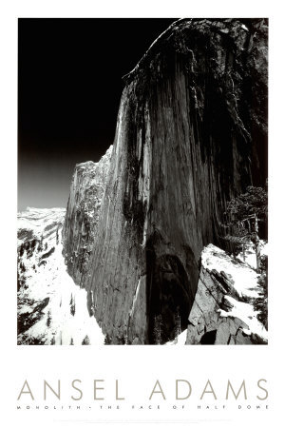
The Monolith or the face of half dome
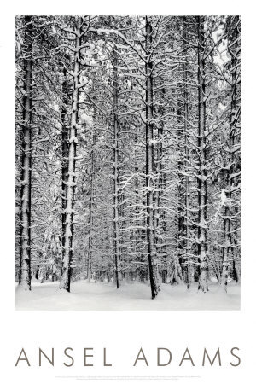
Pine Forest in Snow
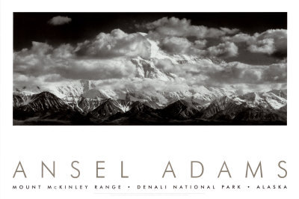
Mt. Mckinley Ranges and Clouds
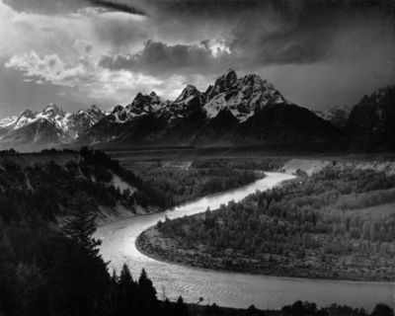
The Tetons or the Snake River

William A. Turnage. “Ansel Adams Biography.” THE ANSEL ADAMS GALLERY. 10 Sep 2012. <http://www.anseladams.com/ansel-adams-information/ansel-adams-biography/>
Diana Cooper. “Ansel Adams; Changing Photography forever.” Articlesbase. 10 Sep 2012. < http://www.articlesbase.com/photography-articles/ansel-adams-changing-photography-forever-276347.html>
Sally Stoneking. “Ansel Adams Pictures Changed Photography Forever.” Nature and Flower Pictures. 10 Sep 2012. <http://www.nature-and-flower-pictures.com/ansel-adams-pictures.html>
Ransom Riggs. “13 Photographs That Changed the World.” Neatorama. 10 Sep 2012. <http://www.neatorama.com/2007/01/02/13-photographs-that-changed-the-world/>
Mayflor Markusic. “Ansel Adams and Landscape Photography.” BRIGHT HUB. 10 Sep 2012. <http://www.brighthub.com/multimedia/photography/articles/33571.aspx>

