Assignment 3

- Explain what amortization is and how a down payment and loan duration impact it.

Answer
Amortization, by definition, is the process of decreasing an amount over a period.
View in the amortization on car or house loan, it is process by which your loan principal decreases over the life of the loan

So, Amortization is the way that payment of debt regularly installs to deduct of capital expense which owe to the bank and there is a charge of interest of remaining Principal.

To illustrate how down payment and loan duration impact
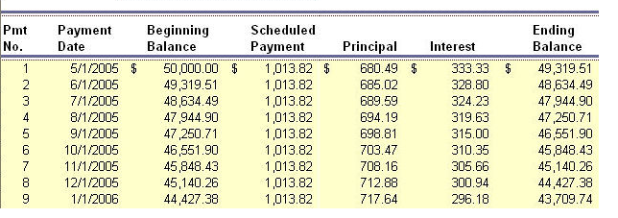
Source : http://www.wyzant.com/resources/lessons/accounting/liabilities
From the table

The impact from down payment
-Down payment is the amount of payment that you initially pay to the seller. The remaining is the amount that you owe to the bank which is “principal” that bank will calculate interest you have to pay each period. (From the table above, Beginning Balance in the first period is the remaining Principal you have to pay to the bank after deduct down payment which interest is charged on.)
Therefore, the more is your down payment, the less is your principal which leads to less interest payment.
The impact from duration
-Duration is the length of period you make payment. When the length of payment is longer, of course, each Period payment will be reduced. (From the table, column “Scheduled Payment”)but amount that will deduct of principal will decrease as well, thus interest on the next period will increase in consequence of higher remaining principal in next period.
Therefore, from the table, column “interest”, there will be more period that interest charge on higher remaining principal, thus total payment on interest increases.

- What is the importance of health insurance and disability insurance in personal financial planning?

Answer
important of health insurance
- simply, It help to reduce the risk of financial suffer from illness and injury, As you never know when an accident may occur. Therefore, it provides you the way out of high cost medical care when you need it.
Consequently, illness and injury is less likely to impact your financial planning since you know amount you pay on each period and there is no unexpected use of money from health medical care.
Important of disability insurance
- In the same way of reducing the risk of financial planning, disability insurance will play role and response of some payment such as food, mortgage payments, and other monthly bills.
In the other word, it is insurance for those who is incapacity of regular working happened by disability.
In conclusion, both health and disability help in personal financial planning in such a way that it reduces that amount of unexpected cost of both from health medical care and cost come from in ability to work.

- What is life insurance? What is its purpose and principle?
Answer
-Life insurance provides financial protection mainly when the policyholder has pass away.Benefit will goes to his family. However, there are some benefits during the policyholder life. Benefits of Life insurance are usually income tax free, help in retirement, estate planning, provide fund for children and family, children education and also in saving.
Purpose
- protect the policy's family financial – such as children education
- estate planning –transferring business to children
- Investment for retirement planning- The cash-value portion of permanent life insurance
- Forced saving – help in saving
Principals
1. Family should select policies that fit their financial need
2. Family should select plan fit their ability to pay for the insurance
3. Family should read policy carefully
4. Family should review and revise the program for any change and need.

- Bob and Mary Martin are both 35 years old. Although they graduated from college almost 15 years ago, they have never developed a diversified investment program. What extra money they had was invested in high-tech stocks that did quite well until the last five years. Then, with the economic downturn, they encountered major losses. How could asset allocation have reduced the dollar amounts of the Martin's losses?
Answer
-Firstly, situation analyst, Bob and Mary Martin has put all extra money they had invested in high – tech stocks. Then,the economic downturn.
In this case Martins has unmanaged risk of asset allocation which is the process of spreading their asset among several different types of investment in the purpose of lessen the risk. Martins could have taken a more diversified approach to allocate some to invest like mutual fund, corporate bond, government bonds or real estate.
in conclusion, because of putting money in on basket, when there is unexpected circumstance, there will be reduce in every money we put in that basket, in this case stock.

