Individual Assignment
1) Discuss one Insurance product and comment on its benefits
Thailife: Tanatawee 15/10
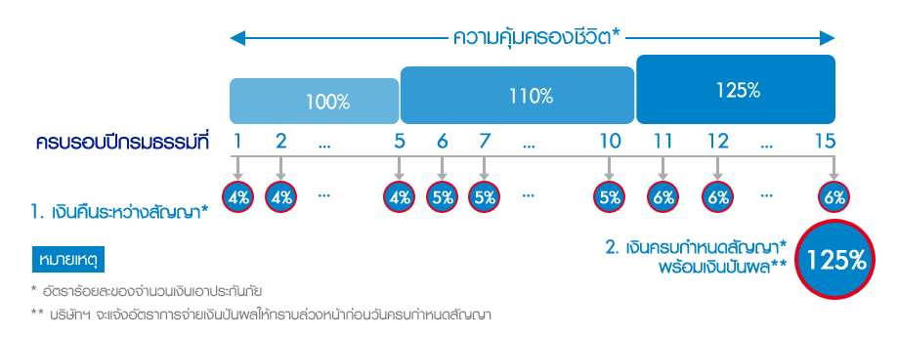
This insurance program provides a combination profits of life security and wealth saving. The clients are required to pay 10-year premium payment to get 15-year coverage. Clients will get both continuous periodically interest payment (4% for year 1-5, 5% for year 6-10, and 6% for year 11-15) and total principal (125% of the initial payment) at the end of contract. This insurance plan is suitable for the client who would like to make a collateral for themselves by receiving continuously return and security which can support their future plans and money saving for emergency case.
2) Which mortgage would result in higher total payments?
Mortgage A: $970 a month for 30 years, which results in total payments = 970*12*30 = $349,299.
Mortgage B: $760 a month for 5 years, and $1,005 for 25 years, so total payments = (760*12*5) + (1005*12*25) = $347,100
As a result, mortgage A would result in higher total payments.
3) What are the two main types of consumer credit?
Consumer credit can be classified into 2 main types: Closed-end credit and Open-end credit.
- Closed-end credit is the credit form that used for a specific purpose with a specific amount of borrowing and a specific period of time. Borrowers have pay back interest which the rate is determined in the contract and the full amount of principal at the end of period; for example, instalment sales credit, instalment cash credit, and single lump-sum credit.

- Open-end credit is the credit form which does not provide for specific amount of borrowing, but has the maximum line of credit for a loan. Loan can be revolved or continuously take loans. And, borrowers require to pay partial amount in the limited time otherwise they will be charged a higher rate of interest. For example, revolving credit and incidental credit.
4) What are the general rules of measuring credit capacity?
- Debt-to-Equity ratio = Total liabilities/Net worth
This ratio should be lower than 0.5. This formula excludes mortgage into account of liabilities.
- Debt payment-to-Income ratio = monthly debt payment/monthly income
This ratio should not exceed 0.2 in order to make sure that expense can be covered with some amount of money left for paying monthly payment of a loan.
5) A few years ago, Michael Tucker purchased a home for $100,000. Today, the home is worth $150,000. His remaining mortgage balance is $50,000. Assuming that Michael can borrow up to 80 percent of the market value, what is the maximum amount he can borrow?
According to assumption, the maximum amount of borrowing is 80% of current market price of the house which equals to 0.8*$150,000 = $120,000. As $50,000 remaining amount of mortgage, Michael can borrow $120,000-$50,000 = $70,000 as the total maximum borrowing amount.

