6104640153
Natchalin Iwsakul

Assignment 4

- Estimate model (1) using Panel Least Squares estimation method and PGLS assuming Heteroskedasticity, and test whether there exists Heteroskedasticity problem.
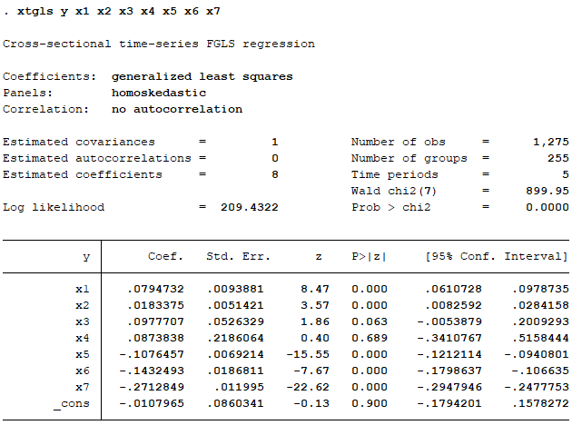

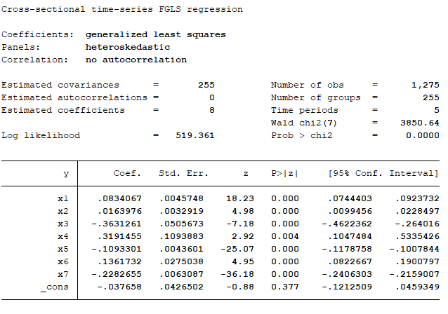

There is a heteroscedasticity as there are changes after run as heteroscedastic. Also, the amount of estimated Covariances increase by a lot.
- Estimate the above three models including Panel Least Squares model, Fixed effects model, and Random-effects model. Perform fixed effects tests and random effects test, also state null hypothesis of the tests. Then, determine the most appropriated model. Also, give explanation of the choosing criterion (perform the tests), and make interpretation of the estimated models.
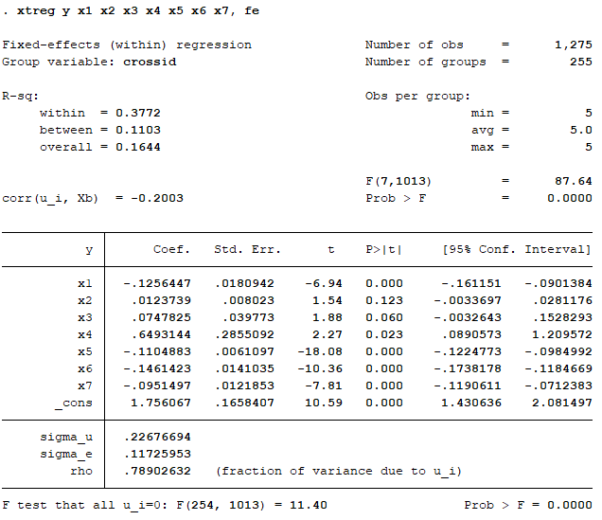
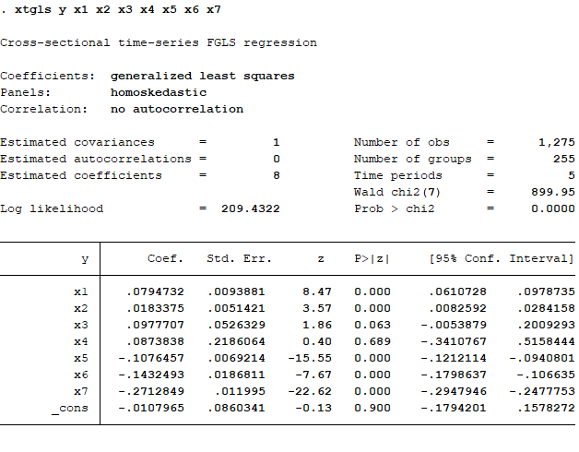

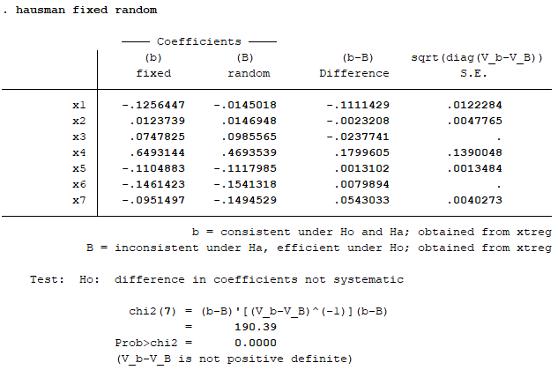
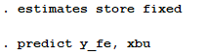
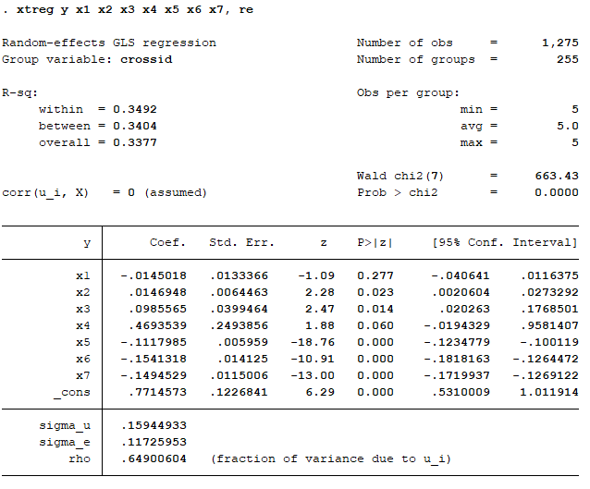

The Hausman test shows that it fails to reject the Null hypothesis which is β_{re}= β_{FE}. Thus, Fixed Effects Estimation is more appropriated for this model.

This is the Fixed Effects model where it uses average cross-sectional group mean overtime to get rid off α_{i}. It means that α_{i} is highly correlated with X’s in the model. Thus, getting rid of it is better than not.
From FE model, x2 and x3 are only two betas that shown as not significant (P-value of T-stat is less than 0.05). The overall test is shown to be significant at F-test = 87.61. And, the Fixed Effects test (F-test in the bottom) is shown significant at Prob>F = 0.000 which means it rejects the Null hypothesis (H₀: α₁ = α₂ =…= α_{n} = α). Thus, Fixed Effects can be used.

