Group Assignment 1
FN221/281 Personal Finance

Conducted by..
Kewalin Laorsukphaiboon 5504640441
Lalipat Tachapattarawat 5504640607
Pemika Thitipermpong 5504641084
Michelle Dings 5604640614
Palit Wonghirandecha 5604640960
Wirunya Rattanawongchai 5604642057

Like several other countries both developing and developed countries, one of the central objectives for monetary policies is to promote economic growth and to stabilize interest rate and inflation level. However, to achieve the goal, it might not be easy due to many economic variables. To be more specified, this economic issue is related to our daily life since we are one of the economic drivers. Every financial action, such as spending, borrowing, or saving money is deal with the economic condition at one particular time. Therefore, it is important keystone that everyone should acknowledge.
This paper is based on the current economic conditions in Thailand, focusing on the factors that drive the economic change and also analyzes how these factors could affect the behavior of people’s borrowing and saving money. There will be 2 main sections in this paper. The first part is to recommend the actions for people who are borrowing and saving money, based on the current situation, while the second part is to list the possible factors factors that people use in making spending decision, based on cost and benefit comparison.

Part I: The recommended actions for people who are saving and borrowing should follow, based on the current Thai economic condition.

In general, there are many factors that alter the saving and borrowing money behaviors of both firms and households; two main important factors are inflation and interest rate which they can affect the whole economy in several aspects. Since, the worldwide economy keeps changing all the time, so it’s necessary to keep track the trends of inflation and interest rate. To see how inflation and interest rate could affect people’s spending decision; the economic condition in the last quarter which is the fourth quarter of 2014 is used as the driver situation of the change in inflation and interest rate.
First of all, the recently interesting factor is the price of oil, since the worldwide current situation recently concentrated on the change in price of oil, which it kept decreasing relatively heavily in the last quarter of 2014 until January 2015
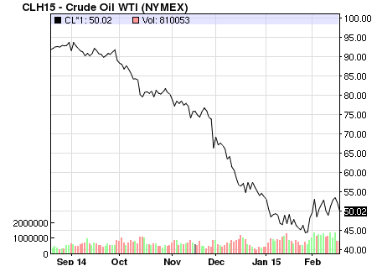
As the graph has shown above, the consequences in decreasing in oil price affected in both positive and negative ways. All energies prices fell down including the petroleum product and rubber product, which is the second most exported product from Thailand. Even though this remarkably falling in prices caused the inflation declined, the overall inflation level is not totally negative. Lower bound of this falling inflation is not considered as deflation since there is still the demand from domestic and also the expansion on tourism and on international trade. However, inflation is expected to rebound again in the second half of 2015, as the global oil price is starting to recover to reach the balanced level in the global oil market.
According to the world situation on oil price, the inflation rate in Thailand was captured at -0.41% decreased in January of 2015. Inflation Rate in Thailand averaged 4.52 percent from 1977 until 2015, reaching an all-time high of 24.56 percent in June of 1980 and a record low of -4.38 percent in July of 2009. However, The Bank of Thailand already announced the average inflation target for 2015 is approximately 2.51.5% which is in the good level. As Inflation and interest rates are related through the fisher’s equation, and frequently referenced in macroeconomics, the change in the inflation level will lead to the change in interest rate.
Regarding to the interest rate announcement from the central bank, Bank of Thailand still remains the interest rate policy to be the same at 2 percent on January 28th, as current policy stance is considered to be sufficiently supportive of the economic recovery, helping to contain risk associated with a prolonged period of interest rate and to stimulating the economy to reach the higher level of inflation. Five out of seven members of the committee voted this decision. The dissenting voices expected the interest rate to fall, due to low inflation.

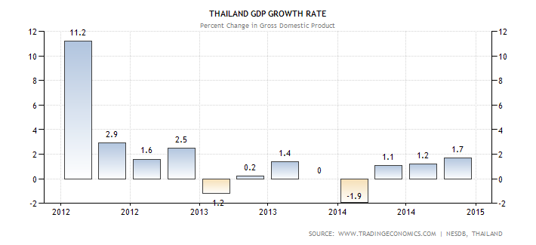
Another important influencing factor which directly affects Thai economy is the stability of Thai government. The economy was almost in the recession as a result of coup d’état in May 2014. Thailand GDP growth rate has dropped 1.9% in the first half of the year; this caused strikes fear to both domestic and foreign investors. People tend to spent less on their consumption and save more which this can contribute to depression. Even though the recovery of economy seems to be positive overtime and some improvements are expected to be obtained in 2015 but there are still some economic and political issues that have been concerned in foreigners’ aspect. Since the current military government has announced that the election will be delayed from late 2015 to 2016, the postponement may prompt the protest and cause the economic turmoil. This literally leads to political instability.
In conclusion, based on the current economic conditions in Thailand, government is trying to recover the economy by either encouraging household and firms spend more money to increase the level of inflation, or getting the confidence back from the foreign investors. As a result, we recommend people to spend more and invest more rather than save their money into their account because the current interest rate is too low and unattractive for saving and when people spend more money, it will help recovering the economy to be healthier again. By saying this, people can invest in many financial activities. For example, they might invest in real estate industry by buying the condominium from which you can speculate the future profit or another choice is that you can buy government bonds, if you want to invest in some safe industry. Anyways, whatever industry one will invest is depended on his/her risk-aversion level. You can study the information of each industry first, or maybe you can take a look in the second part of this paper that we provide the information of saving in many ways.

Part II. The list of possible factors that a person might consider when comparing the cost and the benefit of various saving plans
There are various types of saving plans offered by financial institutions. One type of saving plan that would be considered is saving in bank account because it’s the common thing that almost people will pop-up in their mind when they concern about their life in their future consumption. So, they usually save some current income in banks in order to gain some benefit in their future lives. However, there are many factors that influence people to saving in bank account. Not only the rate of return that people will get from banks in the future but also saving types, default rate of bank, liquidity and services that are the factors of making decision about their financial activities.
- Rate of return is a profit that people gain on an investment. In this case, we will talk about a profit gain on saving in bank account, which is called “interest rate “. As we can see from many banks, there are a lot of promotions about high interest rate that bank offer to people in order to encourage customers to saving with them.
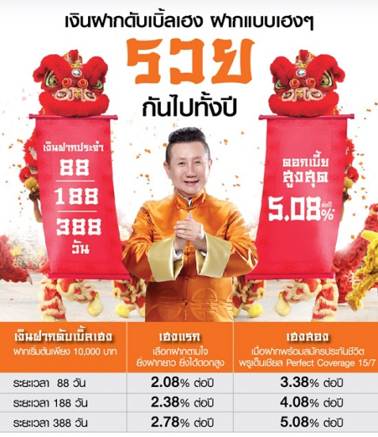

This is an example of Thanachart bank’s advertisement. In this picture, bank offers high interest rate that attracts people to saving in bank account with this bank.
- Saving Type is type of saving that people choose to invest depending on their own liquidity, which can be classified into many types.
- Saving account is an account that is the most convenient way to deposit and withdrawal money. This account always pays lower interest rate because its purpose is not for the long-term holding period. It gives you more financial flexibility in every day’s life. Therefore, this type of investment is for person who has lower liquidity because they don’t have much money to deposit in the long-term period without withdrawing. They sometimes need to use money in their saving account to consume during their lifetime.


Principal | Interest rate  ( per year )
More than 5,000 Baht | 2.00%
More than 500,000 Baht | 2.50%
More than 10,000,000 | 2.40%
More than 30,000,000 50,000,000 | 2.00%
Picture 2.1: From this picture, you can see that bank offers 5 times of initial interest rate when you deposit with this bank. Moreover, as you increase time to maturity, you will also get higher interest rate
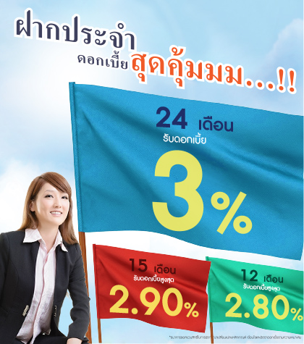
- Fixed account is an account that you have to deposit money until the given maturity date without any withdrawing. This account provides investors with higher interest rate than a regular saving account. Hence, fixed account is suitable for person who has high liquidity because they have enough money to deposit in this account until the given maturity date and they don’t withdraw any money during their saving period.
 | Principal | Interest rate  ( per year )
12 months | More than 1,000 | 2.70 %
12 months | More than 10,000,000 | 2.80 %
15 months | More than 1,000 | 2.80%
15 months | More than 10,000,000 | 2.90%
24 months | More than 1,000 | 3.00%
Picture 2.1 : From this picture, you can see that bank offers high interest rate when you deposit with this bank. Besides, you will get higher interest rate as you hold long time of maturity.

- Liquidity of Bank is the term used to describe how easy bank can convert asset into cash. Therefore, high liquidity of bank implies that people can easily withdraw from bank whenever they want without problems.

- Service of Bank
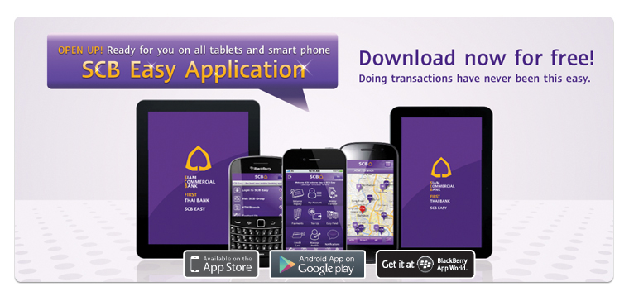
- Bank provides application for online banking services on smart phone and tablet holders. Most of the financial transactions will be done easily via this application. Moreover, all of the bank basic information will be provided in this application, so that you can search or update your information anytime.
This picture is the example of SCB online banking system,.
Alternatively, Investors can also contribute a part of their money in insurance such as annuity insurance for retirement saving plans. Since most of people are risk-averse, so that they want to invest in some certain and beneficial asset. Of course, retirement seems to be a long way, yet, the sooner people save, the financial independence they will get in the future. Therefore, it is important to start concerning how much income people really need to enjoy life after their long retirement period.
However, there are factors that needed to be considered in order to purchases these type of insurances which are the rate of return, the frequency of money received or liquidity, year coverage, conditions, and services.
- Rate of Return is the most considered factor because it tells the total money one will gain starting from the first money paid toward the end of the contract. In Thailand, most of the returns are around 10-15% of the sum insured meaning that the higher percentage of return, the more money you will receive.
- The Year Coverage is likely to be important as well because risk-averse person always wanted their life to be insured since they received zero income.
- A Service from the company is concerned from the fact that people would want to sign a contract with a company that actually take care of the clients and provided them useful information.
- The Cost of Insurance is that a person must sacrifice some amount of money from their income to this investment or as it is called an opportunity cost. However, the benefits are much greater than the cost as shown following
- There is no medical checkup required. Individual who are age between 20-55 years old (depending on the policy of each company) can be applied to this type of insurance without asking any questions about their health issues.
- Clients will receive living annuity every year but depends on how much is the sum insured.
- There is life coverage during premium payment period. Basically, not only will a person gain more money, but they will also have their health covered.
- Insured can have their tax deducted from personal income at maximum THB 200,000 according to the rules under the Notification of the Director-General of the Revenue Department No.194.
- In case of death, parents or siblings will receive all the benefits as said in the contract.

There are various companies in Thailand that have good backgrounds and reputations such as AIA Annuity 60/85, Thai life retired millionaire. However, each company has slightly differences in conditions and benefits so it won’t make many differences to invest in any of these companies. In conclusion, Insurance is trustful and certain investment that people like us should consider because we do not know what is going to happen to life whether physical problem or financial problem. So, having life protected and money saved at the same is reasonable enough to sacrifice some amount of money to invest in it.
Last but not least, financial Institutions have offered many kinds of investments to their customers such as Short-term papers, Long-term papers, or Funds. Each customer has different risk acceptance level so they may choose to invest in different assets. Factors that customers should think of before they invest are as following;
- Risk: Risk from each asset is varied and has its own characteristics. Short-term papers such as Treasury Bills have a very low risk since they are offered from the government. Long-term papers such as Bonds still have low price risk and low default risk if offered from government or credible companies. These two assets are suitable for risk-averse person. Funds can be separated into many types. A risk loving person may like to invest in Equity funds. Equity funds have the highest risk since they invest in stocks which are volatile. If investors can bear less risk, they may invest in fixed income funds which mostly invest in bonds. A saver who wants to save for the future should considered LTF and RMF, which are long term investments.

- Return: A classic quote “high risk, high return” can be used in this case. Securities with higher risk will give higher return. In the short run, despite invest in stocks themselves, Equity funds may provide the highest return for investors. On the other hand, if investors can accept low return from safer securities, they should invest in Short-term papers, Long-term papers or fixed income funds.

- Liquidity: Liquidity is the ability of each asset to be converted to cash. If investors have no need for urgent short-run money and want to save for a long period, they may invest in LTF or RMF, which has low liquidity because investors cannot remove the money out of them for a certain period. If investors prefer high liquidity assets, they should invest in stocks or equity funds since these securities can always be traded when the market is operated.

- Economic Condition: Each kind of investments fits different economic condition. If the country’s economy grows rapidly and the stock market is bullish, investors should invest in stocks or equity funds because companies will make a lot of profit and stock prices will increase in a very high rate, which contributed to a very high return for investors. However, if the economy is in a downtrend, there are economic crisis and political problems, the stock market can go down even faster than the uptrend. So in this kind of situation, investors may invest in less risky securities such as bonds, or treasury bills

Bank of Thailand. BOT Press Release on the Economic and Monetary Conditions for December and the Forth Quarter of 2014. No.5/2015, 30 Jan 2015. https://www.bot.or.th/English/MonetaryPolicy/EconomicConditions/PressRelease/DocPressRelease/PressEng_December2014.pdf
NASDAQ. Crude Oil Price. 19 Feb 2015. http://www.nasdaq.com/markets/crude-oil.aspx?timeframe=6m
Note that Fisher’s effect is describes the relationship between inflation and both real and nominal interest rates. The Fisher effect states that the real interest rate equals the nominal interest rate minus the expected inflation rate. Therefore, real interest rates fall as inflation increases, unless nominal rates increase at the same rate as inflation.
NESDB, Rida Husna l rida@tradingeconomics.com, Monday February 16 2015, http://www.tradingeconomics.com/thailand/blog
NESDB,Thailand. Jan 2015. http://www.tradingeconomics.com/thailand/gdp-growth
Thanachart Bank, Interest rate for Saving Account, http://www.thanachartbank.co.th/tbankcmsfrontend/PersonalTHDetail.aspx?PTypeID=9&ProID=228&PName=Personal&gclid=CM-M_5P768MCFQ4pjgod1X0ABg
LH BANK, http://www.lhbank.co.th/promotion/description/1596
Siam Commercial Bank, Our services,2010, https://www.scbeasy.com/v1.4/site/presignon/en/bnr/prebnr.asp
AIA Insurance, http://www.aia.co.th/en/individuals/products-and-services/annuity/
Thai Life Insurance, http://www.thailife.com
Siam Commercial Bank, Personal Banking, http://www.scb.co.th/en/personal-banking/investment
Krungsri Bank, Investment Products, http://www.krungsri.com/bank/en/PersonalBanking/InvestmentProducts.html

