Member
5604640945 Pachaya Chansukho
5604641505 Sarinya Na Choomporn
5704641199 Nattasorn Tanpichai
5704641280 Nontawat Srilert
5704640332 Ditiphatra Chanarithichai

As a group pick one mutual fund issued by a Thai Asset Management Company. Read its prospectus.
Write half a page explaining what the fund invests in and why you would like to invest in this fund. You may also compare this fund to another fund with similar investment objectives.
ANSWER
SSB mutual fund is chosen. SSB mutual fund is considered to be large-cap equity. Large-cap equity (mutual fund) is the investment that is concentrated in large market capitalization equities. A large market capitalization equity would have lower risk than middle and small market capitalization as they have more liquidity, lower volatility, and risk.
Even with 9.20% volatility, SSB mutual fund has 3-year annualized mean return of 8.04%, initial charge of 8%, and total expense ratio of 0.76%, which is considered as quite risky but with very nice return. Somehow, we can diversify our investment portfolio by investing in commodity mutual fund, such as the mutual fund that is invested in gold, as a hedge of the equity invested. Later on, when we are getting older and turning to be more risk-averse, we might lower our risky investment and switch to less-risky mutual fund instead.
One of benefits from buying this mutual fund is that it is no-dividend mutual fund as we can postpone the tax payment from dividend return to be realized when he desired. Moreover, later on, if we want to alleviate our annual tax payment, we can diversify to invest in LTF too.
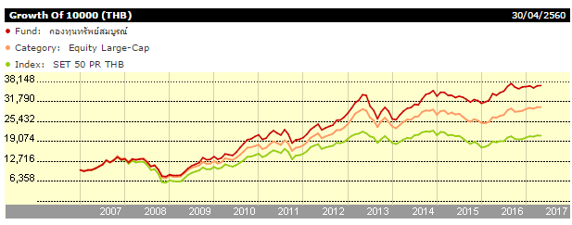
Source:http://tools.morningstarthailand.com/th/snapshot/snapshot.aspx?tab=2&Id=F000000RR2&ClientFund=0&BaseCurrencyId=THB&CurrencyId=THB&LanguageId=th-TH
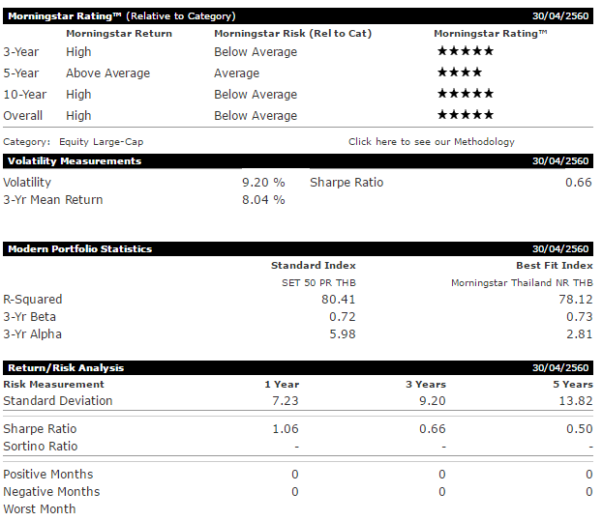
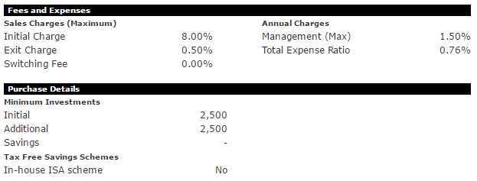

gr

