FN 312 Investment
Practice Midterm Exam Solutions (Sem 2/2016)

Question 1

- Column 1 represents the date the bill will be redeemed and the investor paid the face value amount.
Column 2 represents the days to maturity calculated from the settlement date.
Column 3 represents the interest rate that the buyer wants to receive. (The bid price is the price at which you can sell.)
Column 4 represents the interest rate that the seller is willing to pay. (The ask price is the price at which you can buy)
Column 5 represents the difference from the prior bid
Column 6 represents the annualized rate of return if the T-bill is held until maturity based on the ask price

- The T-bill bid price can be calculated from the bank discount yield formula:

r_BDY = (FV – P)/FV * 360/n

Rewriting to calculate the bid price gives:

P = FV * (1-n/360 * r_BDY) = 1000000 * (1-155/360*0.0352) = 984,844.44

Verify that you can calculate the ask price to be 984,877.50

- The bank discount yield is a measure of a bond’s percentage return. The bank discount yield based on the ask price is 3.51 whereas the bond equivalent yield based on the ask price is 3.61. The bank discount yield is not a meaningful measure of the return on investment because: (i) it is based on the face value of the T-bill, not on the purchase price, and so the return on investment is not measured based on the cost of investment; (ii) it is annualized using a 360 day year, not 365; (iii) it annualizes with simple interest and ignores the effect of compounding interest.

- Earlier, using the bid discount rate, we calculated a bid price for 155-day T-bill to be 984,844.44.

- At maturity, this T-bill will be worth $1,000,000
- You will earn $15,155.56 of interest on an investment of $984,844.44 over 155 days, a percentage return of 1.5389%.
- In a 365 day year, there are 365/155 = 2.3548 periods of 155 days in length.
- 1.5389 times 2.3548 is 3.6238% (this is the bond equivalent (bid) yield).
The effective annual rate is corresponding to the bid yield is:
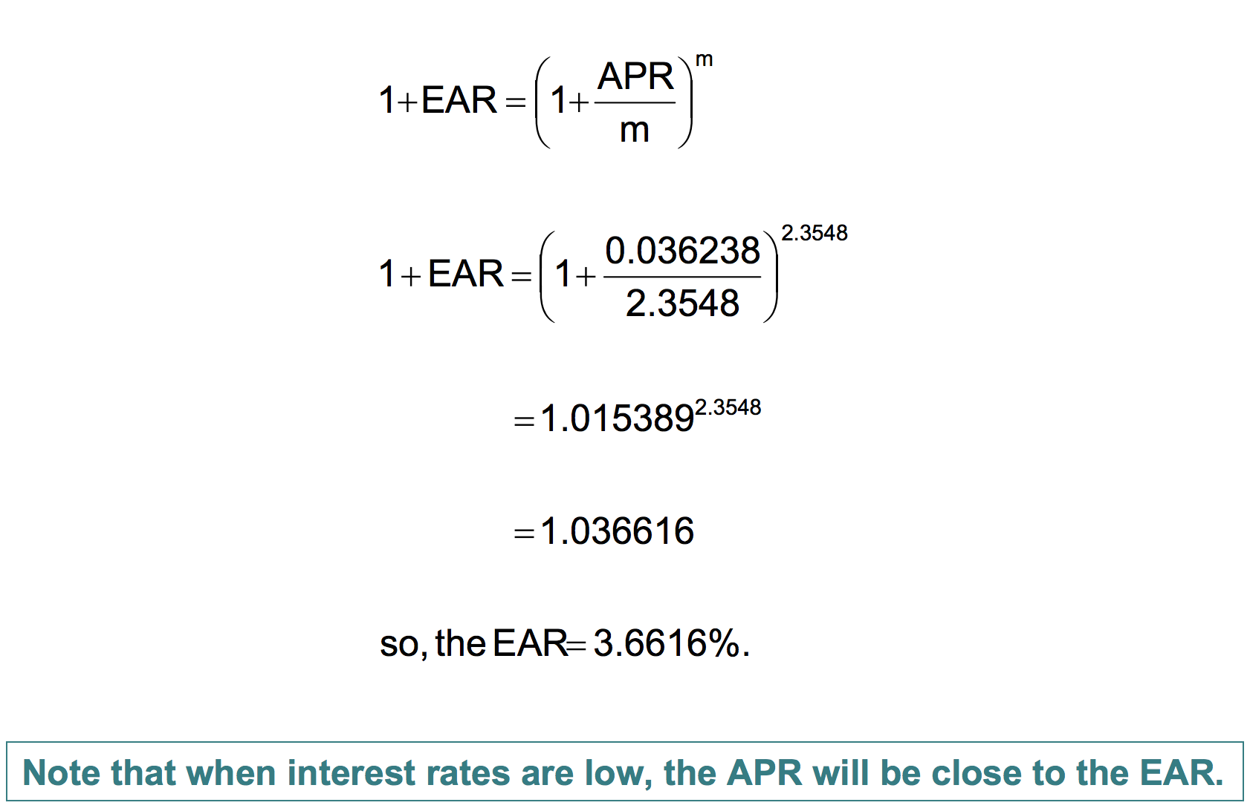

Make sure you know how to do this for the ask yield.

- Factors that are known to move T-bill rates are: 1) Demand for risk-free fixed income securities (higher demand increases the prices of bonds and lowers interest rates) 2) Supply of bonds by the US government (when the Fed purchases bonds, it reduces its supply and injects liquidity into the economy causing interest rates to be lower) 3) Economic conditions (rates tend to rise in expansions, fall in recessions) 4) Inflation (high inflation yields high interest rates and vice versa)

During the recent global financial crisis a number of investors were concerned about default and liquidity risks of other assets causing them to demand more risk-free securities. This phenomenon is known as a “flight to safety” which pushed down the short-term T-bill rates.

At the same time, due to the massive quantitative easing program and the Fed’s policy of low interest rates, the interest rates in the economy are lower due to the reduced supply of bonds.

Due to prevailing low inflation rates, investors also expect inflation rates to be low in the future, and may not expect high yields on bonds to cover for the lost of purchasing power.

Question 2

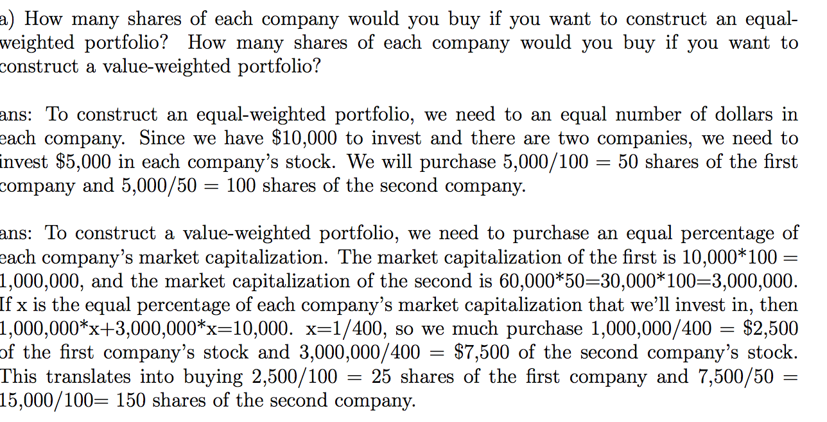
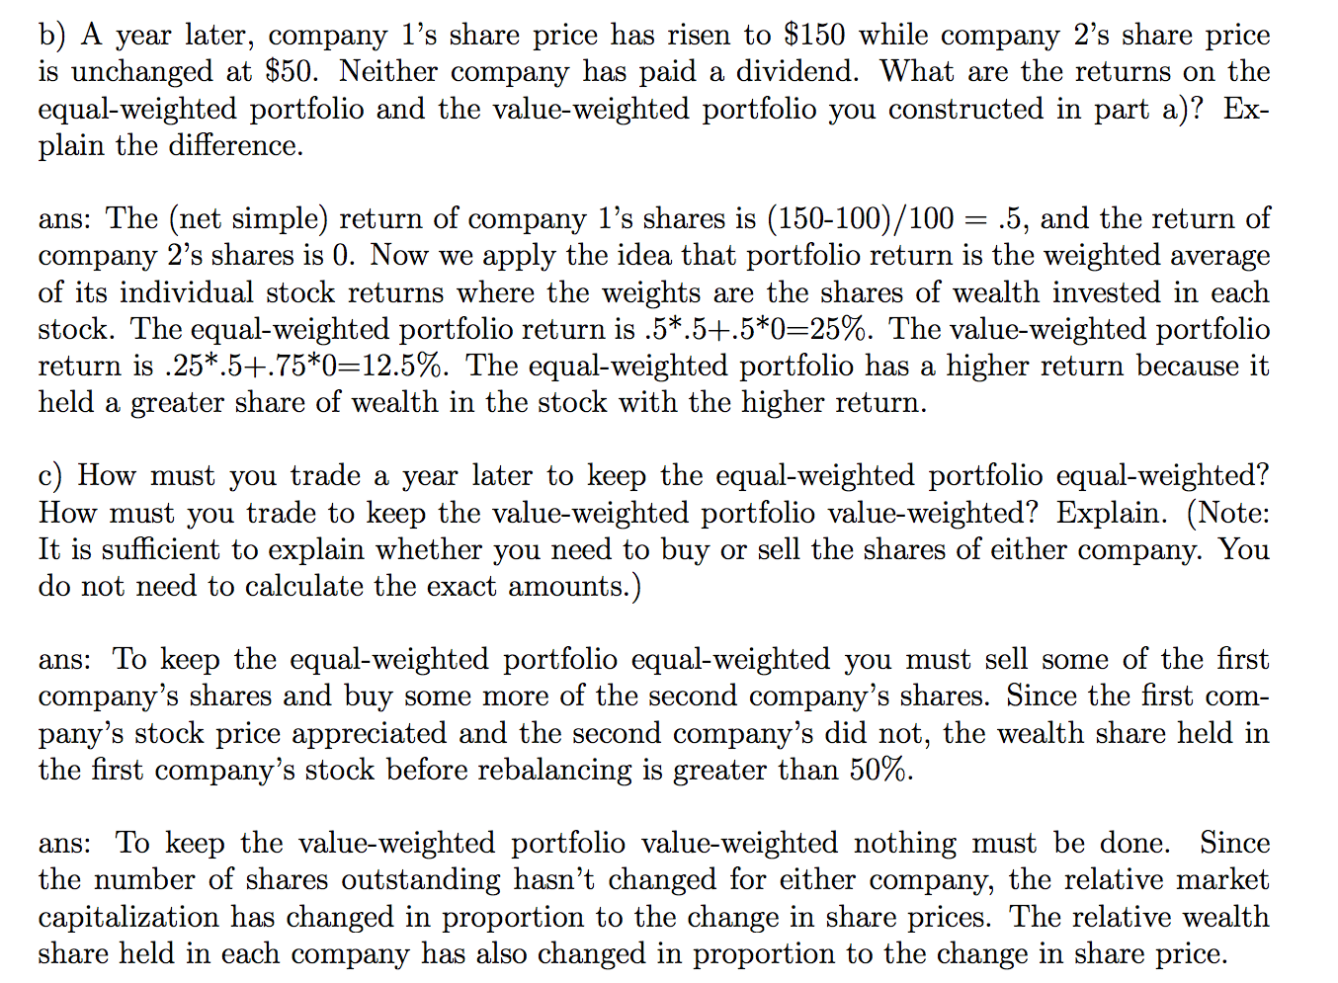

d) In this question, there is a typo. I meant to ask for examples of price-weighted stock indexes (eg. Dow Jones, Nikkei). Examples of value-weighted indexes are the S&P 500 and the NASDAQ. The value-weighted index is preferred because stocks with larger market-cap should get larger weight in the index. The value-weighted index also does not have to use an adjustment factor to account for stock splits and dividends.

Question 3

The problem with using the standard deviation as a risk measure is that it does not differentiate between good and bad surprises. Also, the standard deviation may not be a measure of risk that reflects what really troubles investors. Investors care about downside risk of a crash or a poor market, while returns above the average are viewed desirable.

The semi-variance measure is a risk measure that accounts for downside risk. It takes the average of the squared deviations below the mean. Another one is the Value at risk (VaR) measure which estimates how much an investor might lose given normal market conditions in a set time period such as in a day. For example, if a portfolio of stocks has a one-day 5% VaR of $1 million, that means that there is a 0.05 probability that the portfolio will fall in value by more than $1 million over a one-day period if there is no trading.

Question 4
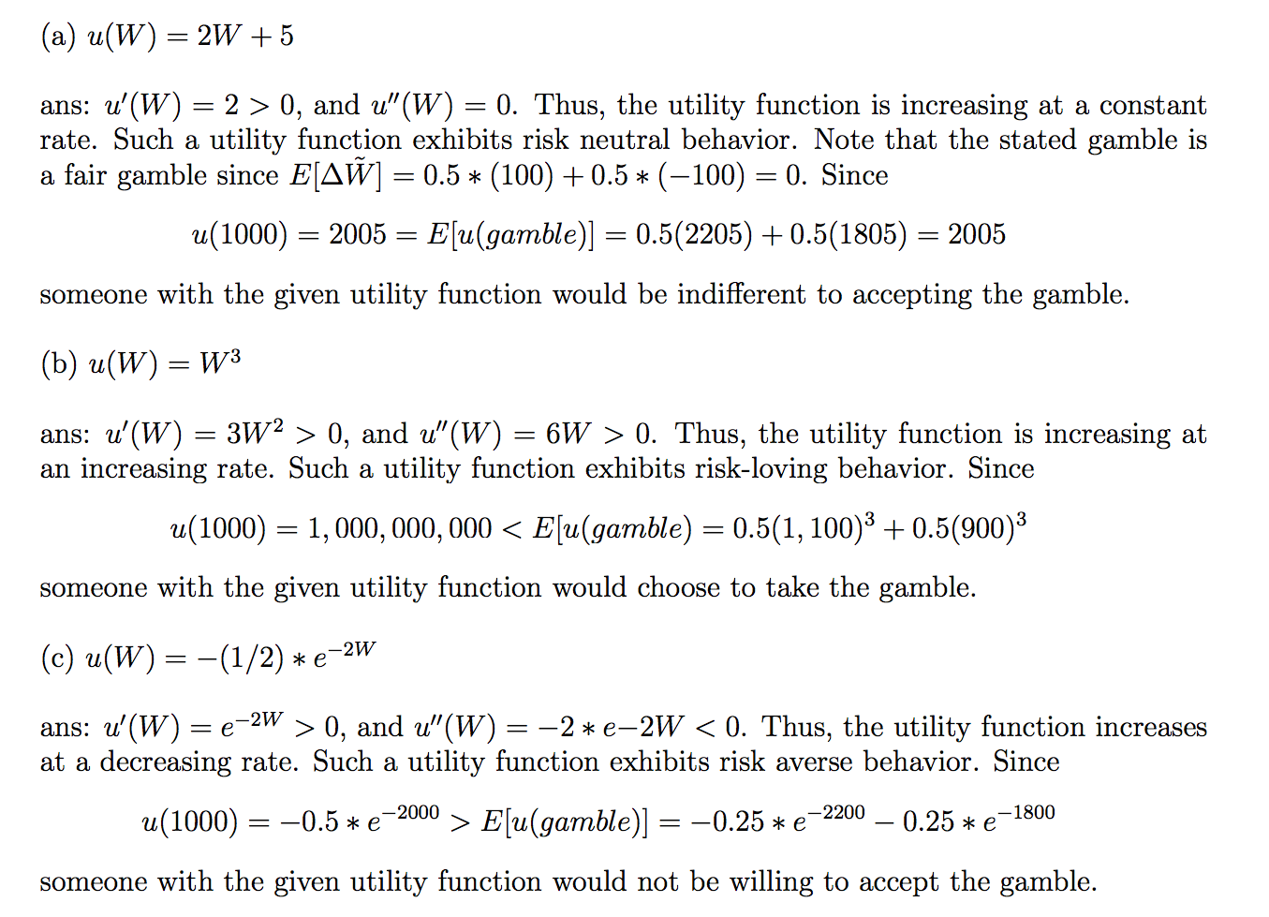
d) An underlying assumption for Markowitz portfolio optimization is that investors are risk-averse and therefore only the utility function in c) would work.

Question 5

a)
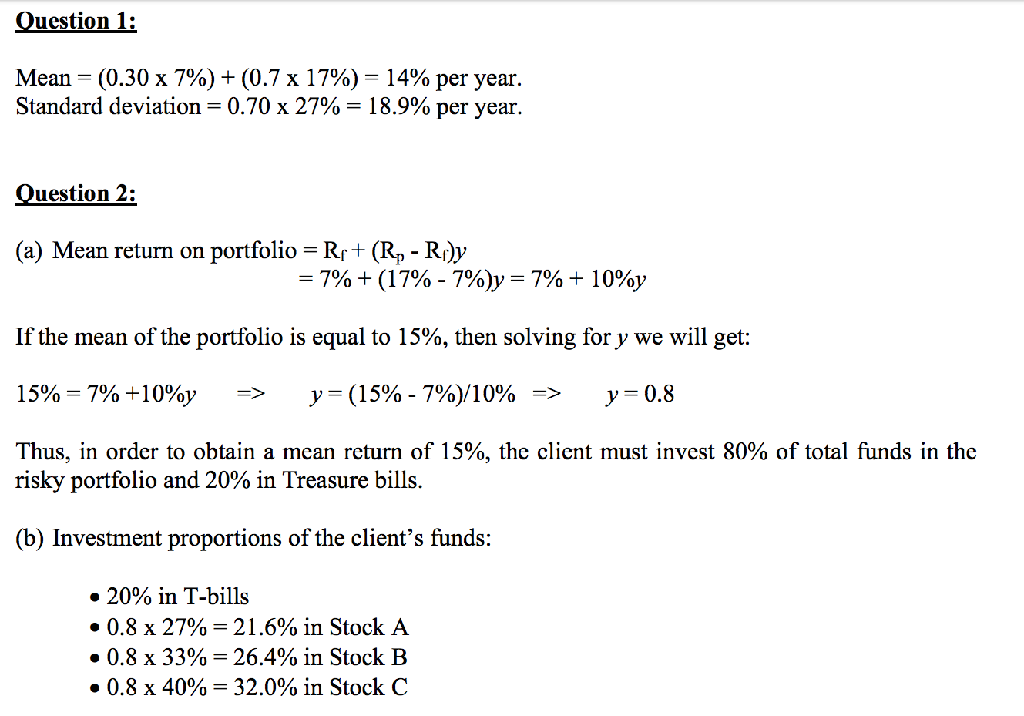
b)
c)
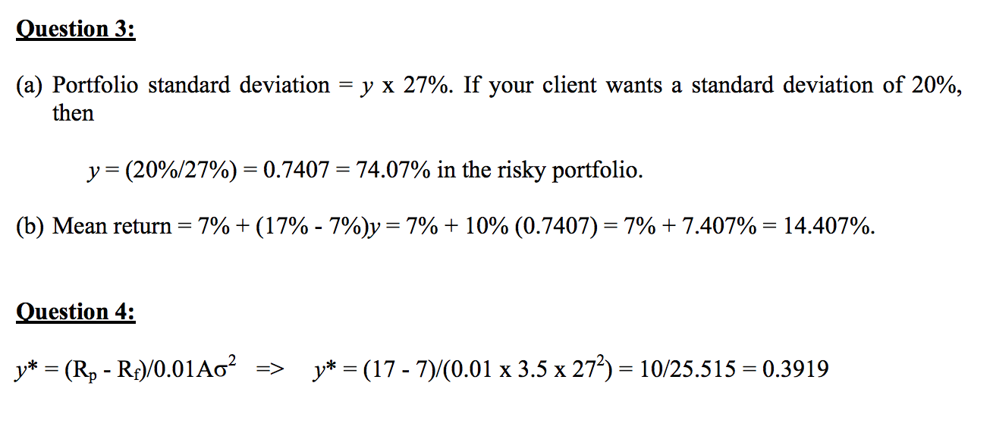
d)
e)
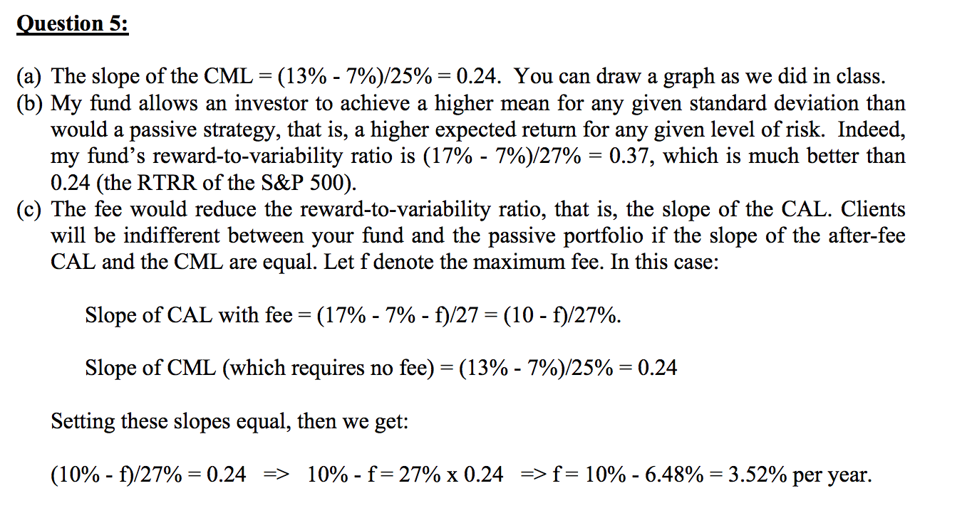
f)

Question 6

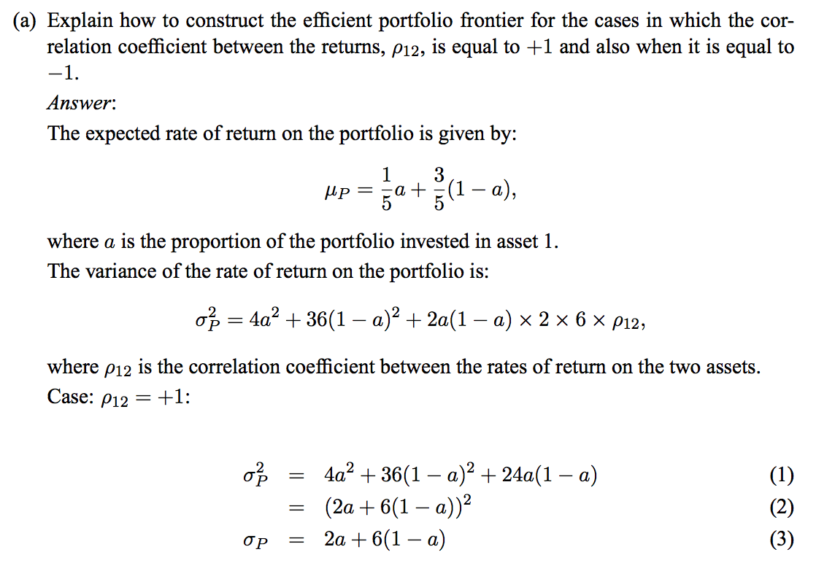
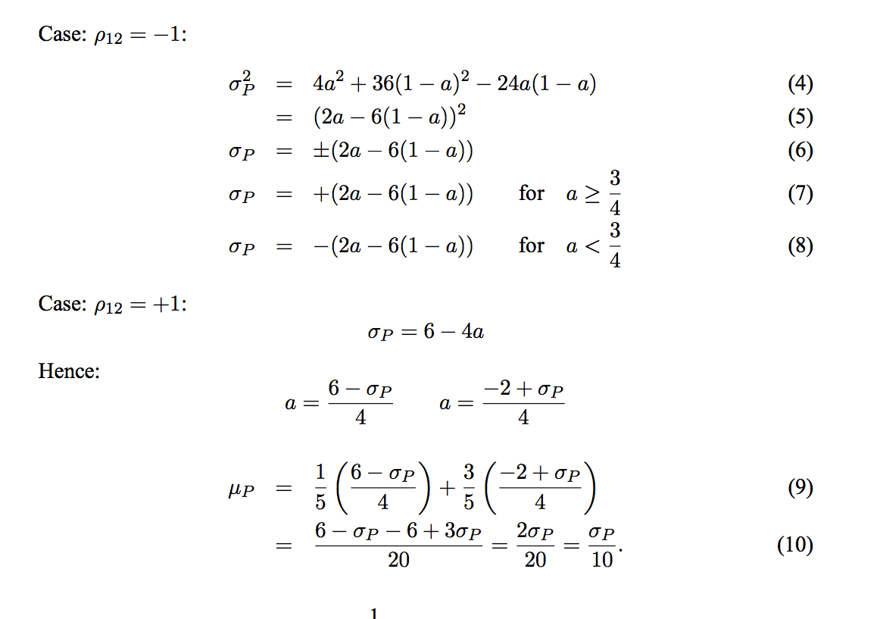
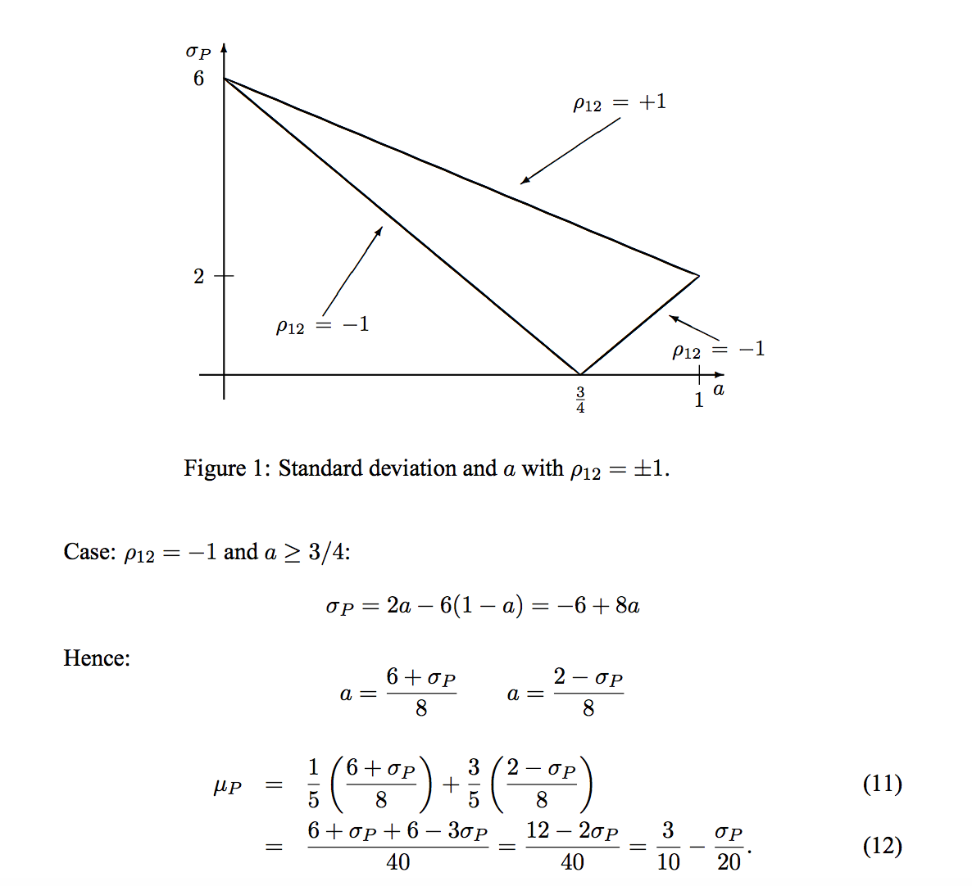
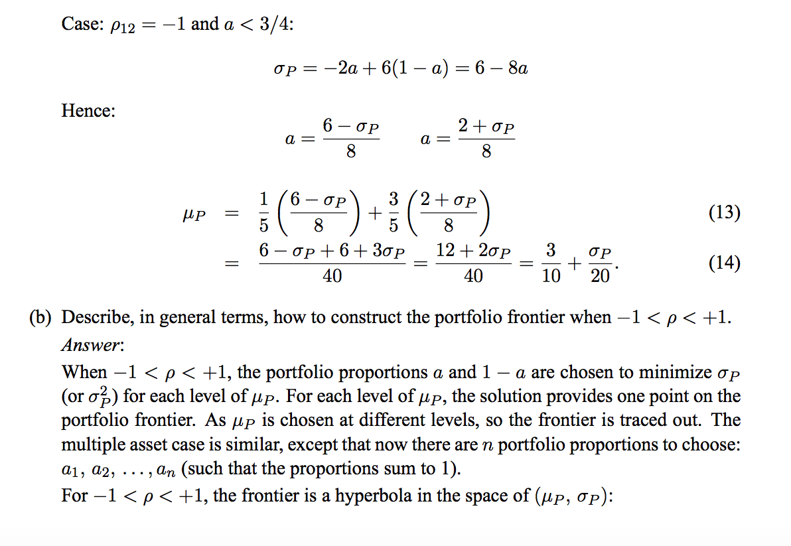
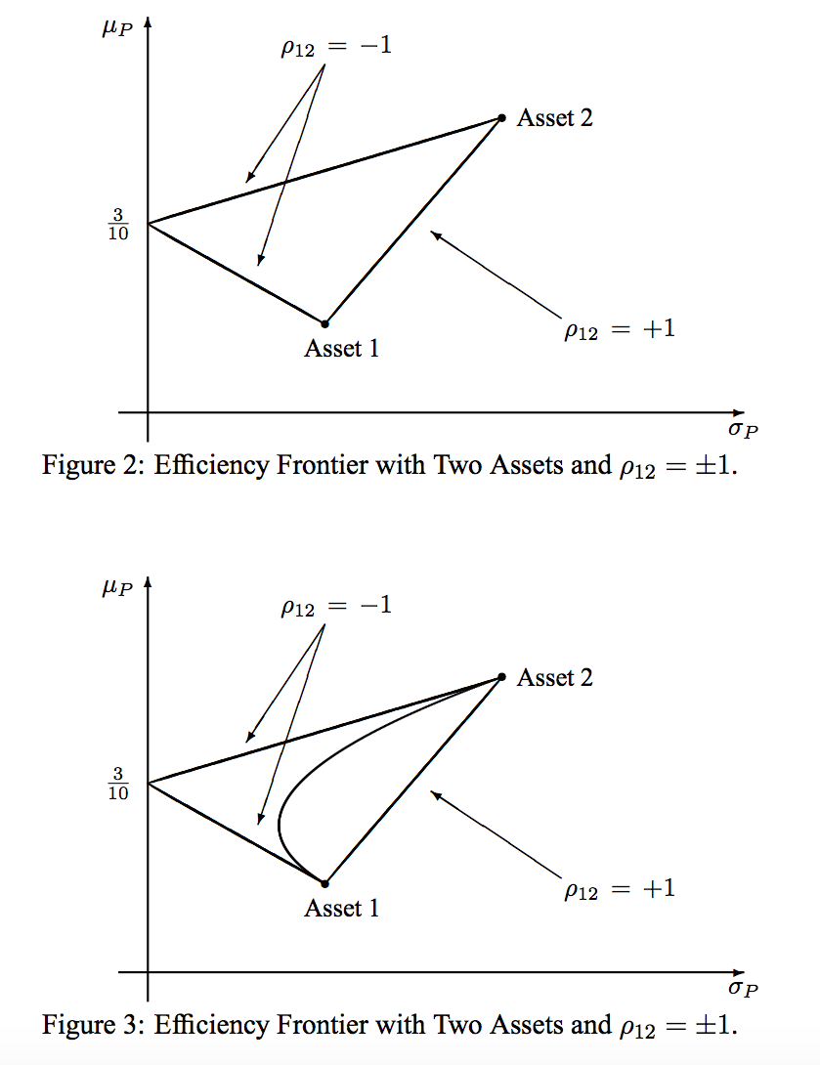
Question 7
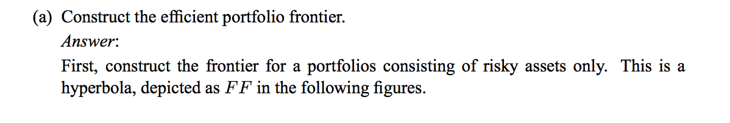
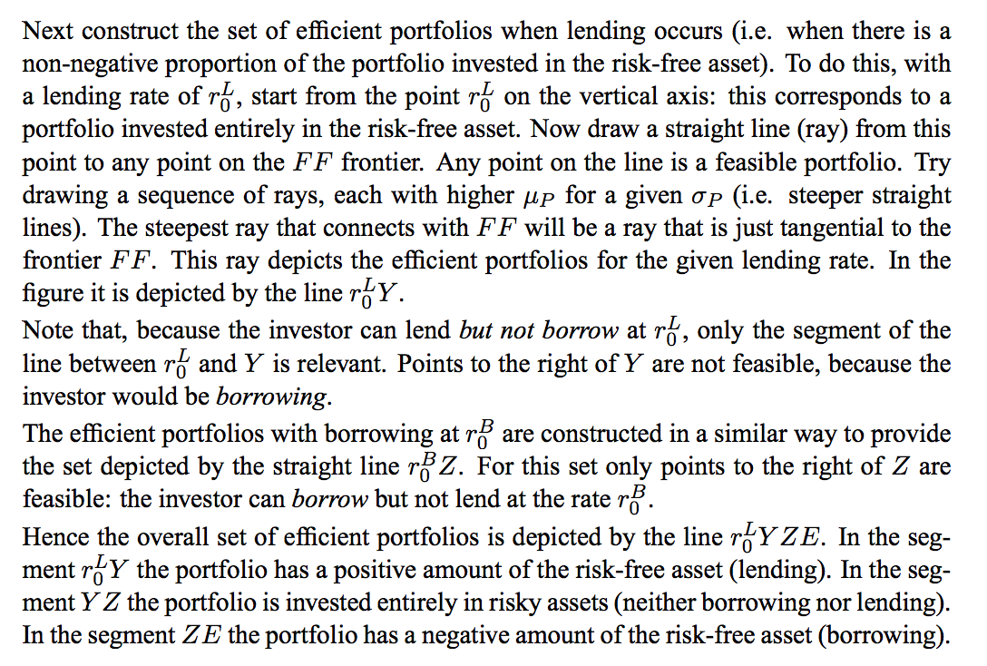
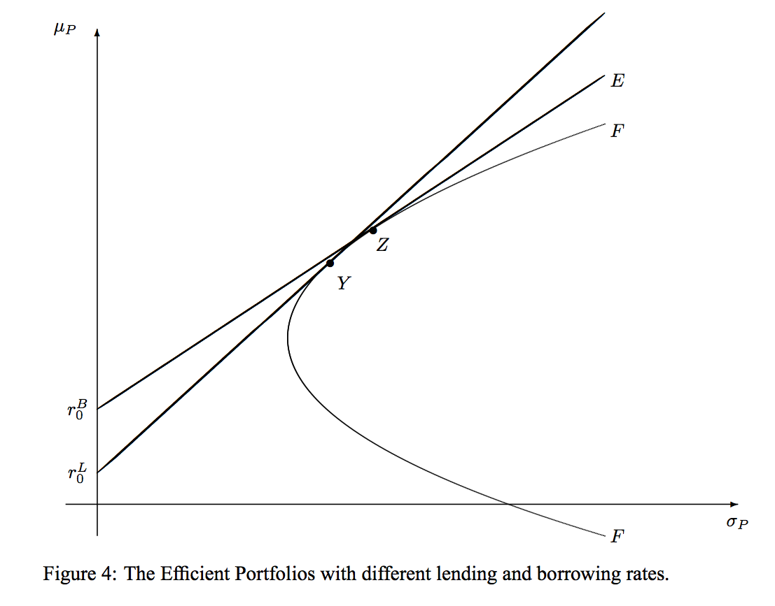
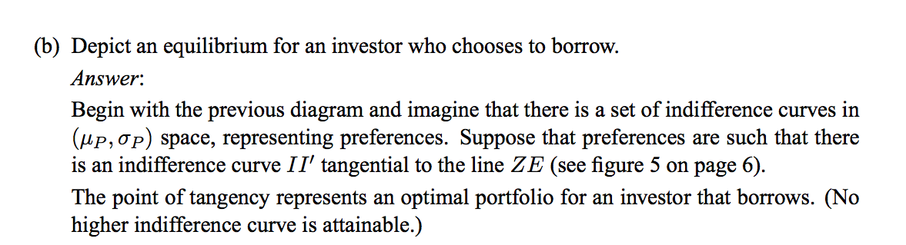
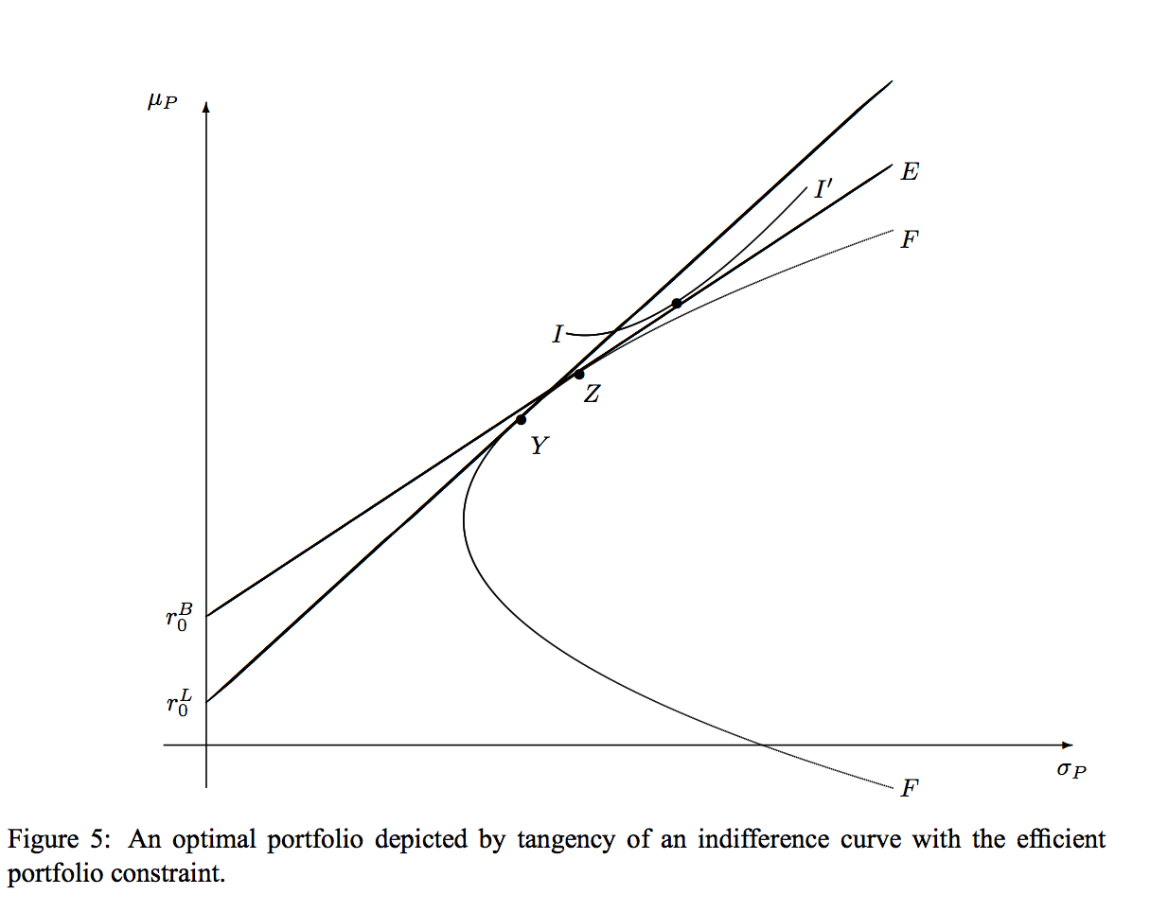
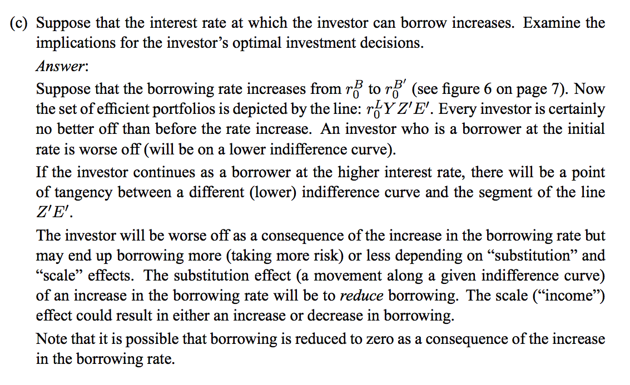
Question 8
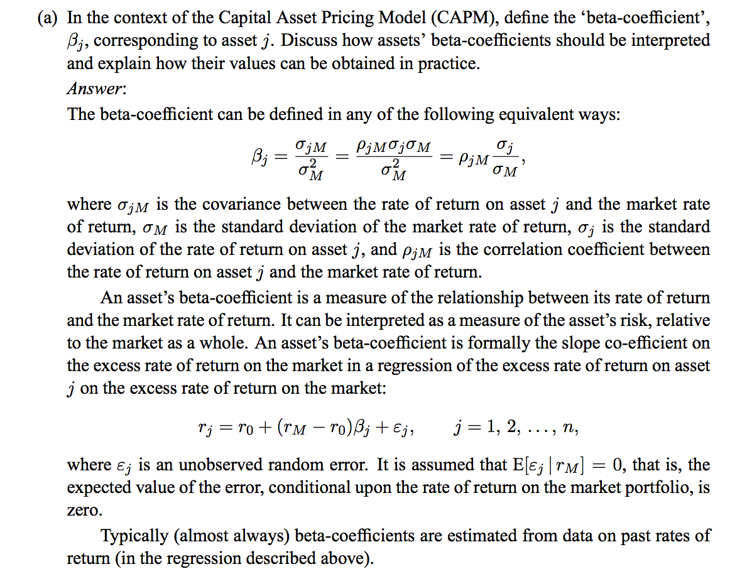
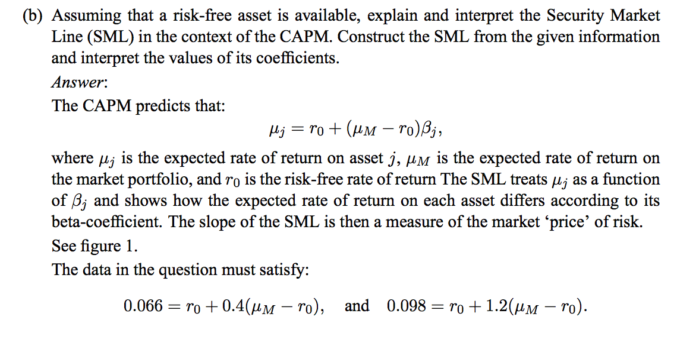
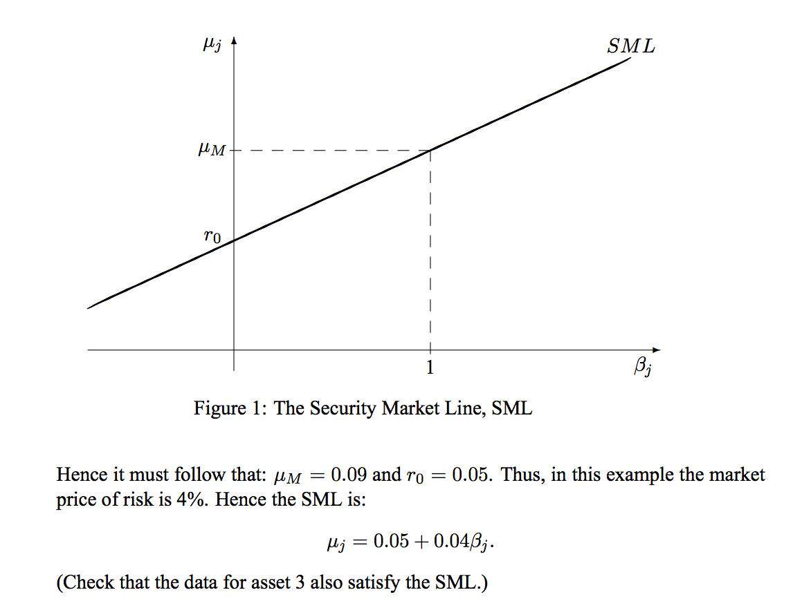

c)
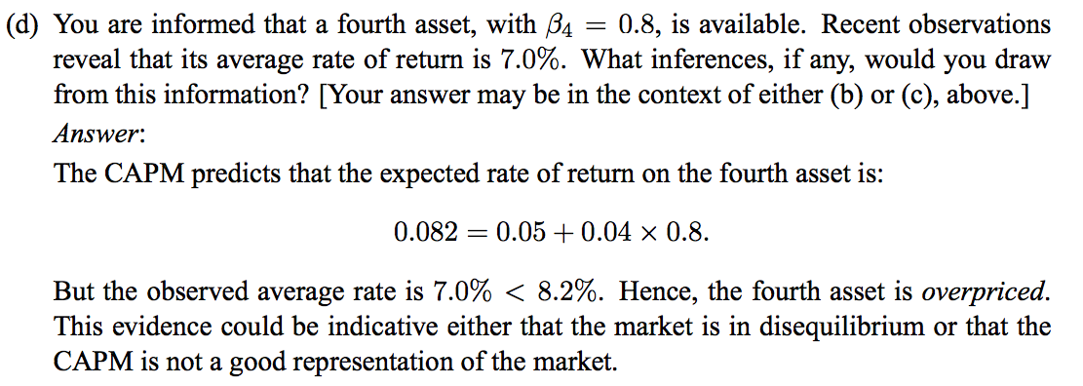

Question 9


