AC 201 Fundamental Accounting
Chapter 2 Investing and Financing Decisions & the Statement of Financial Position

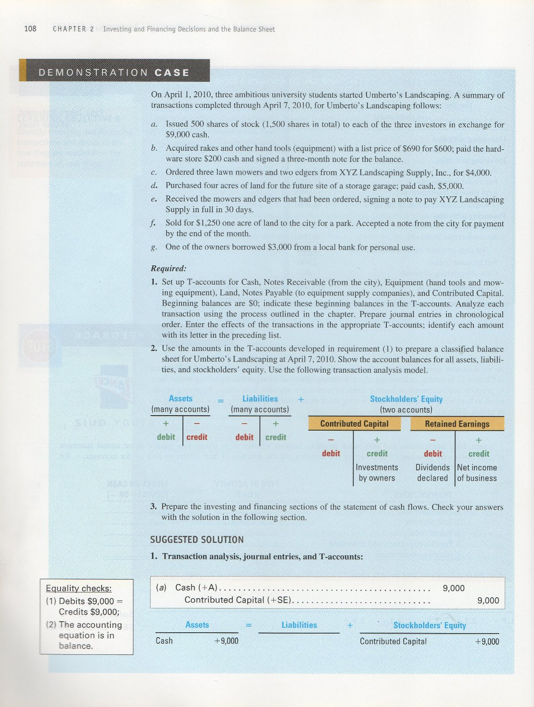
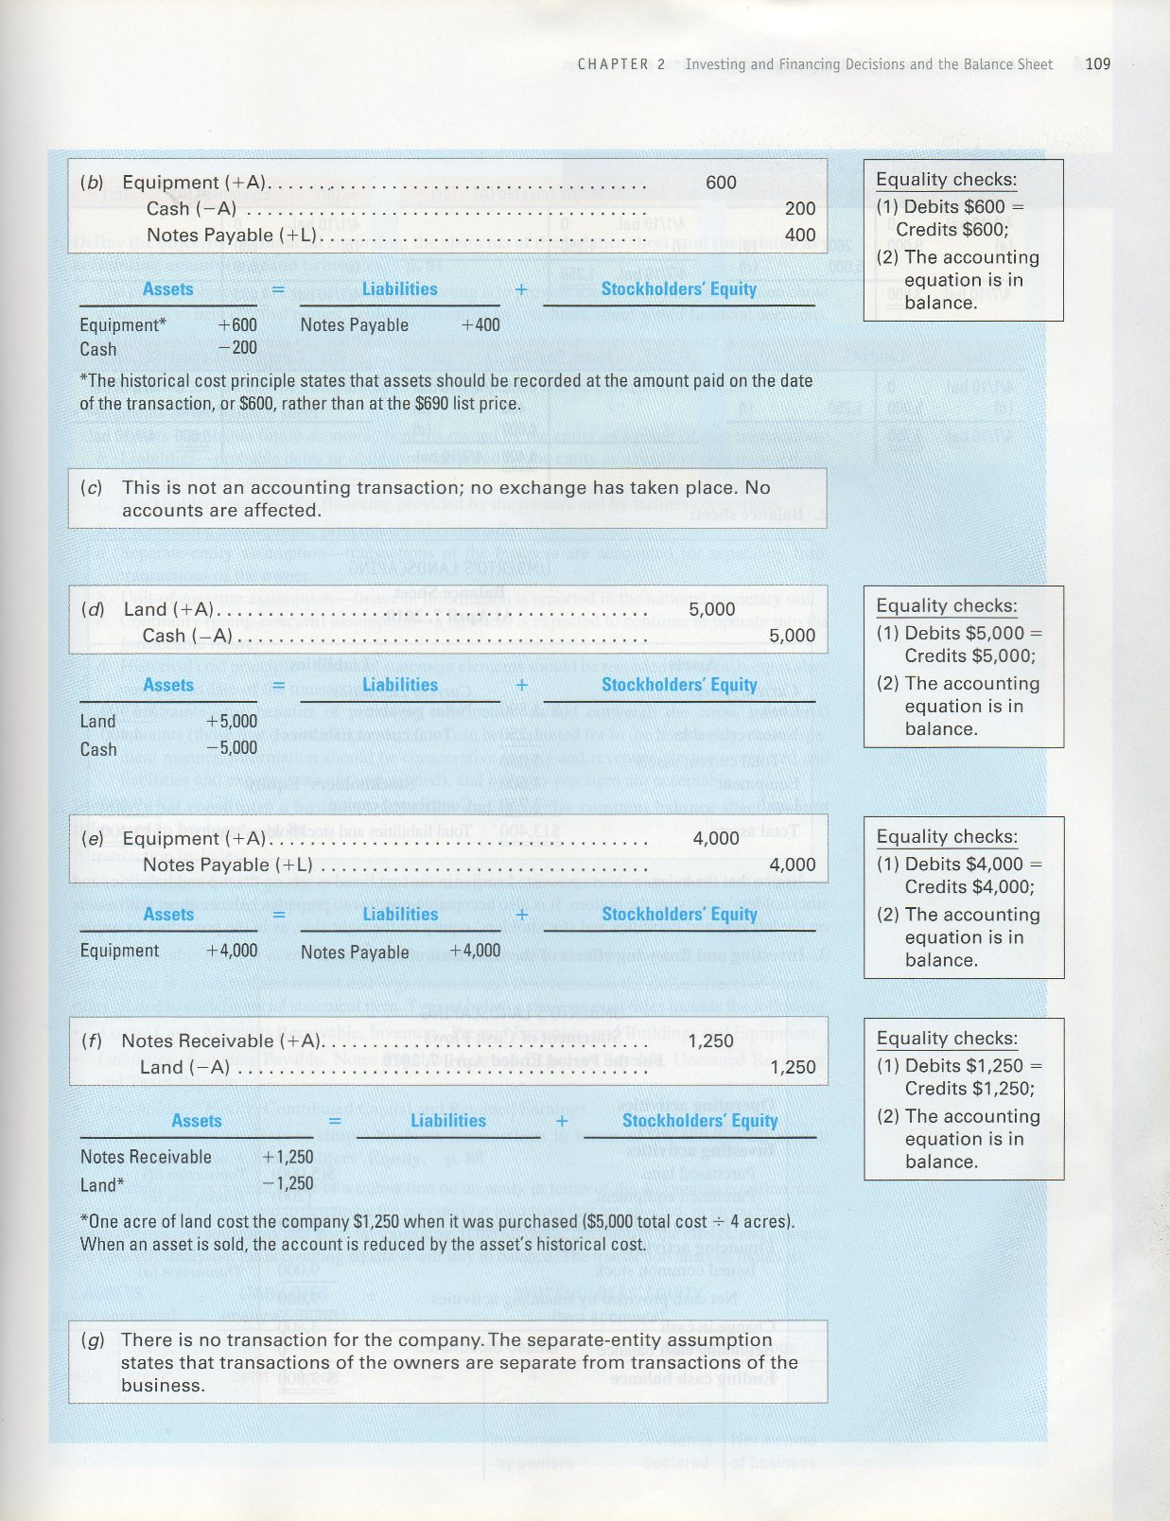

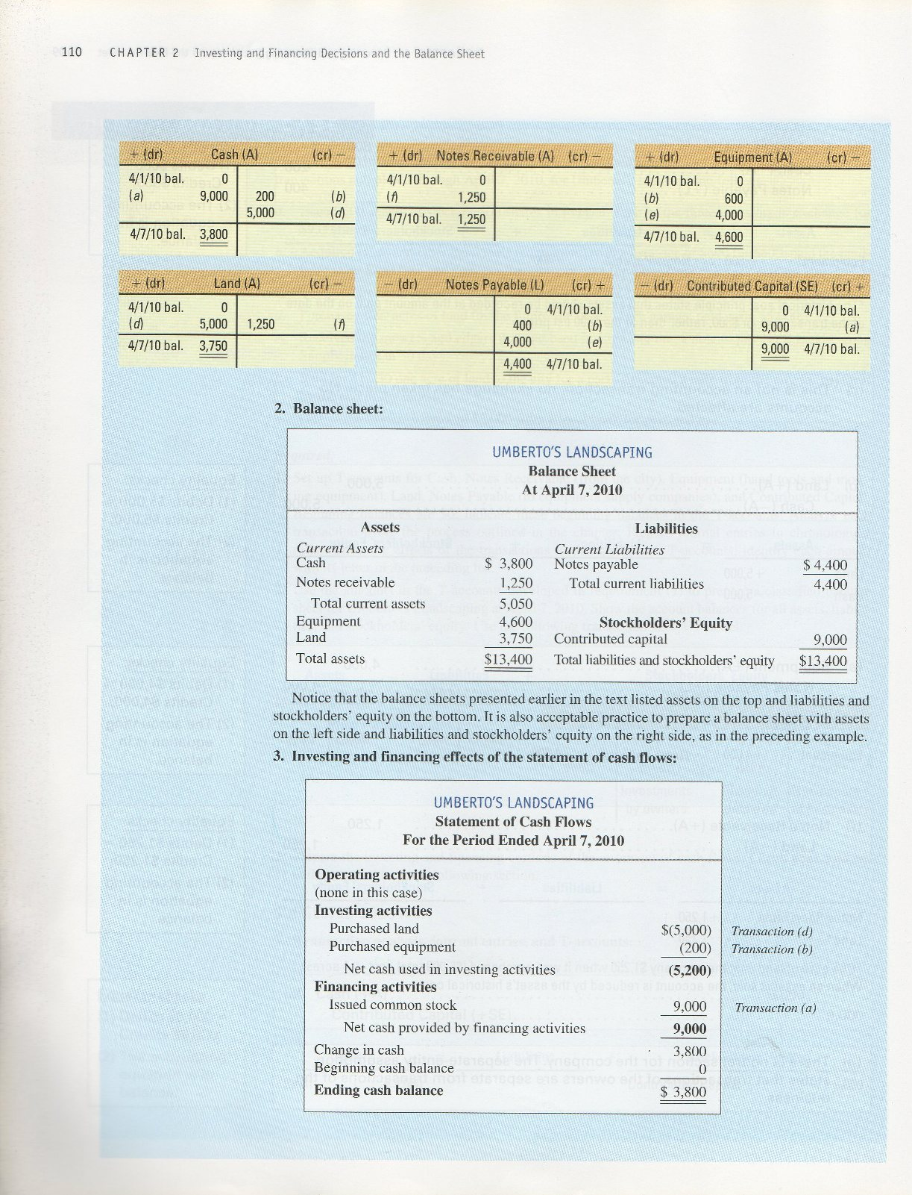

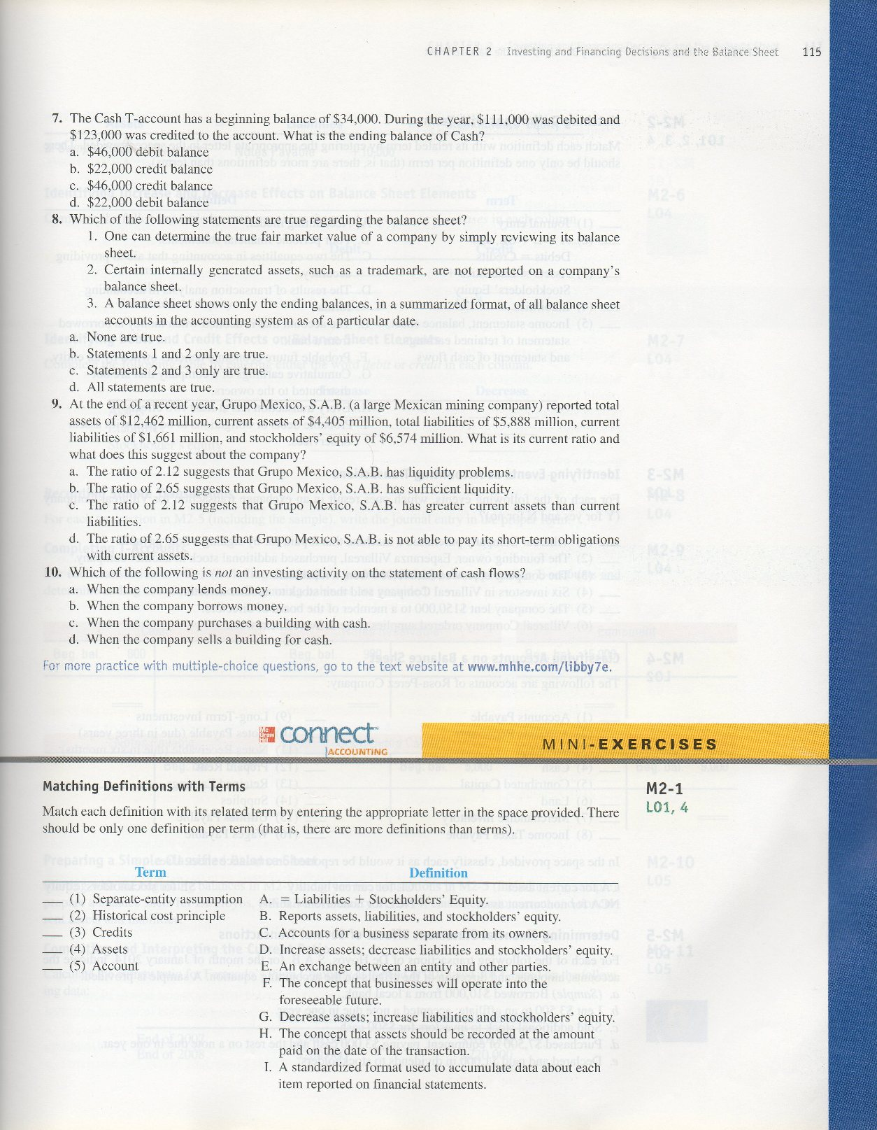

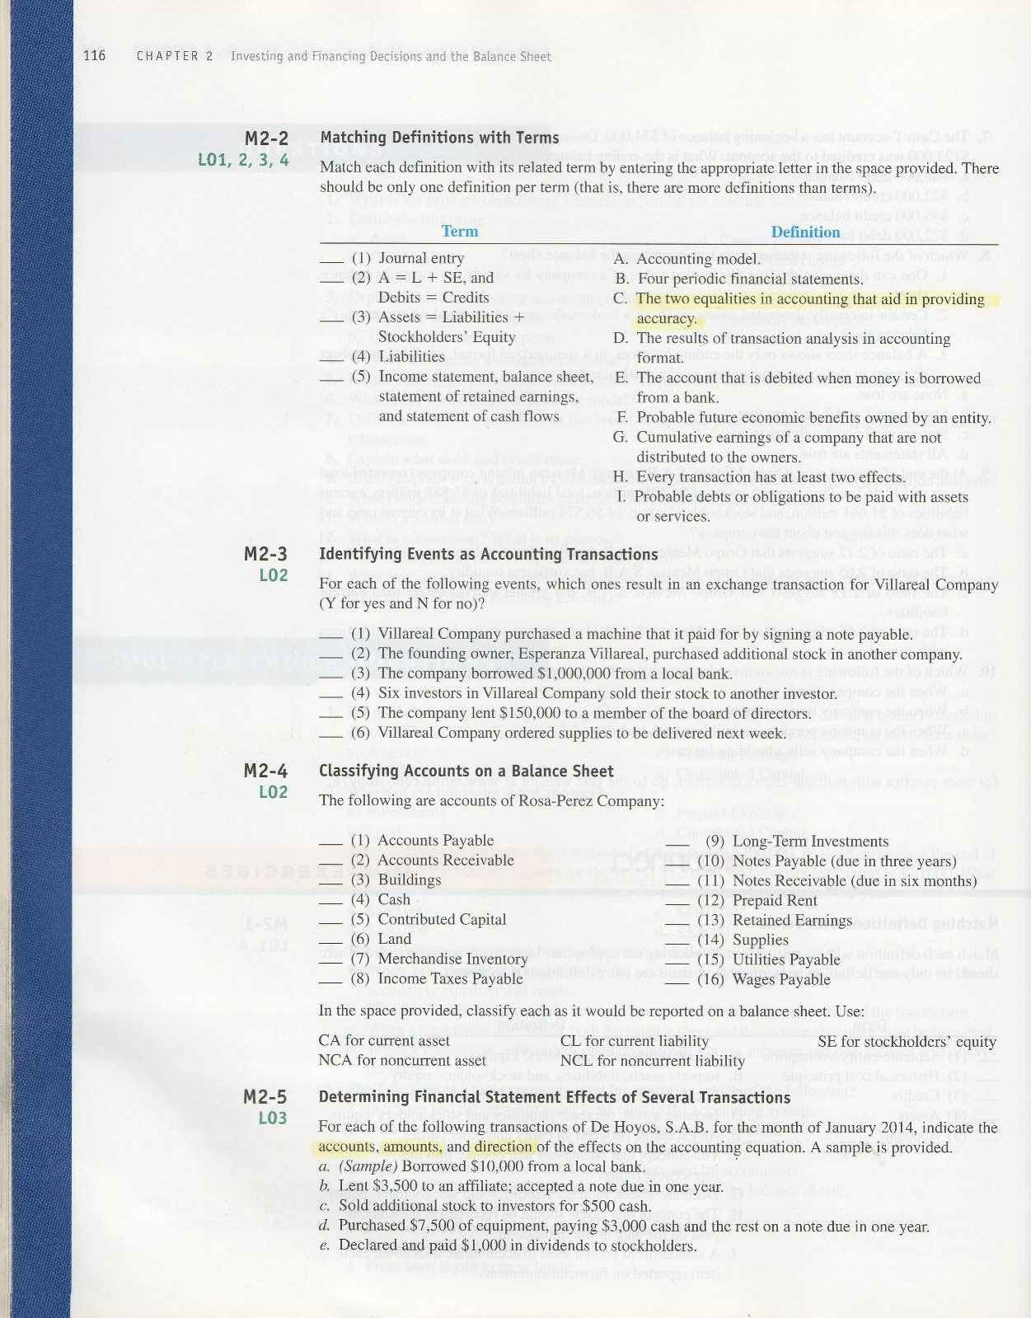

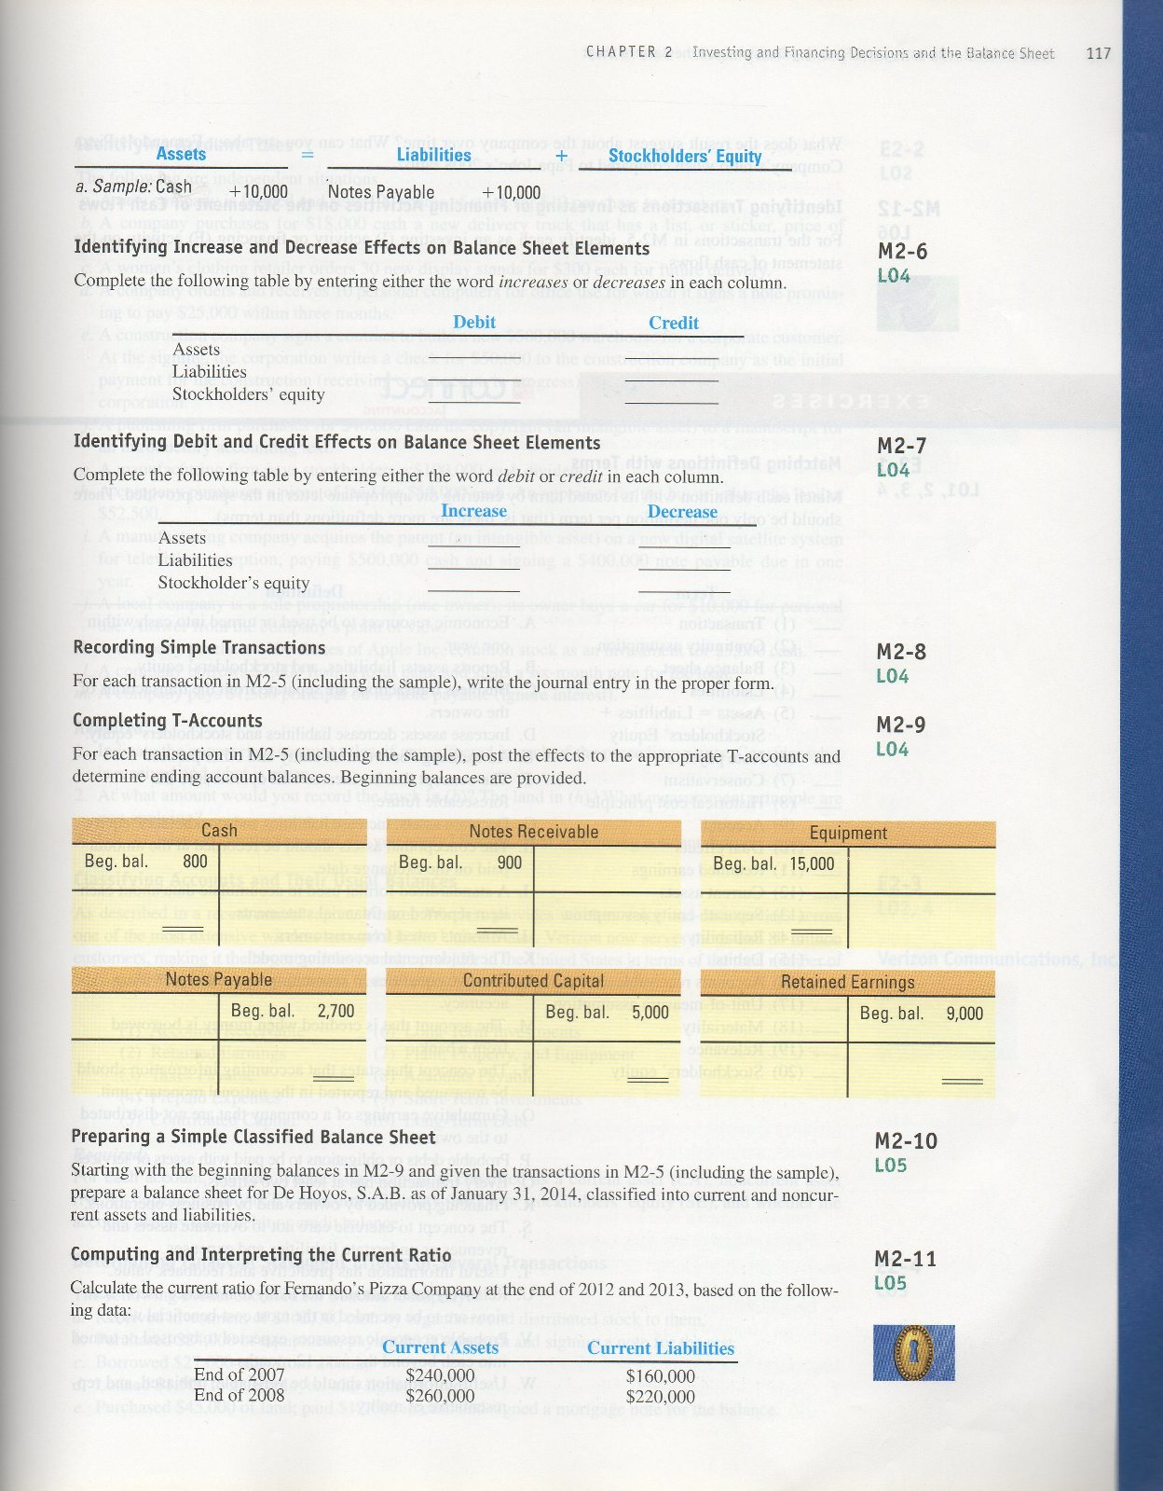

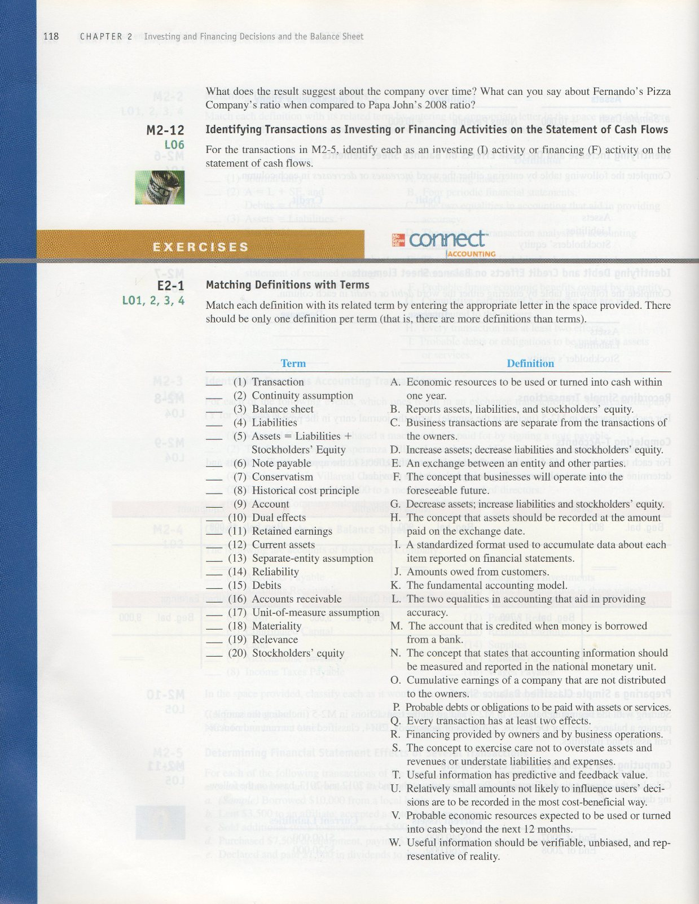

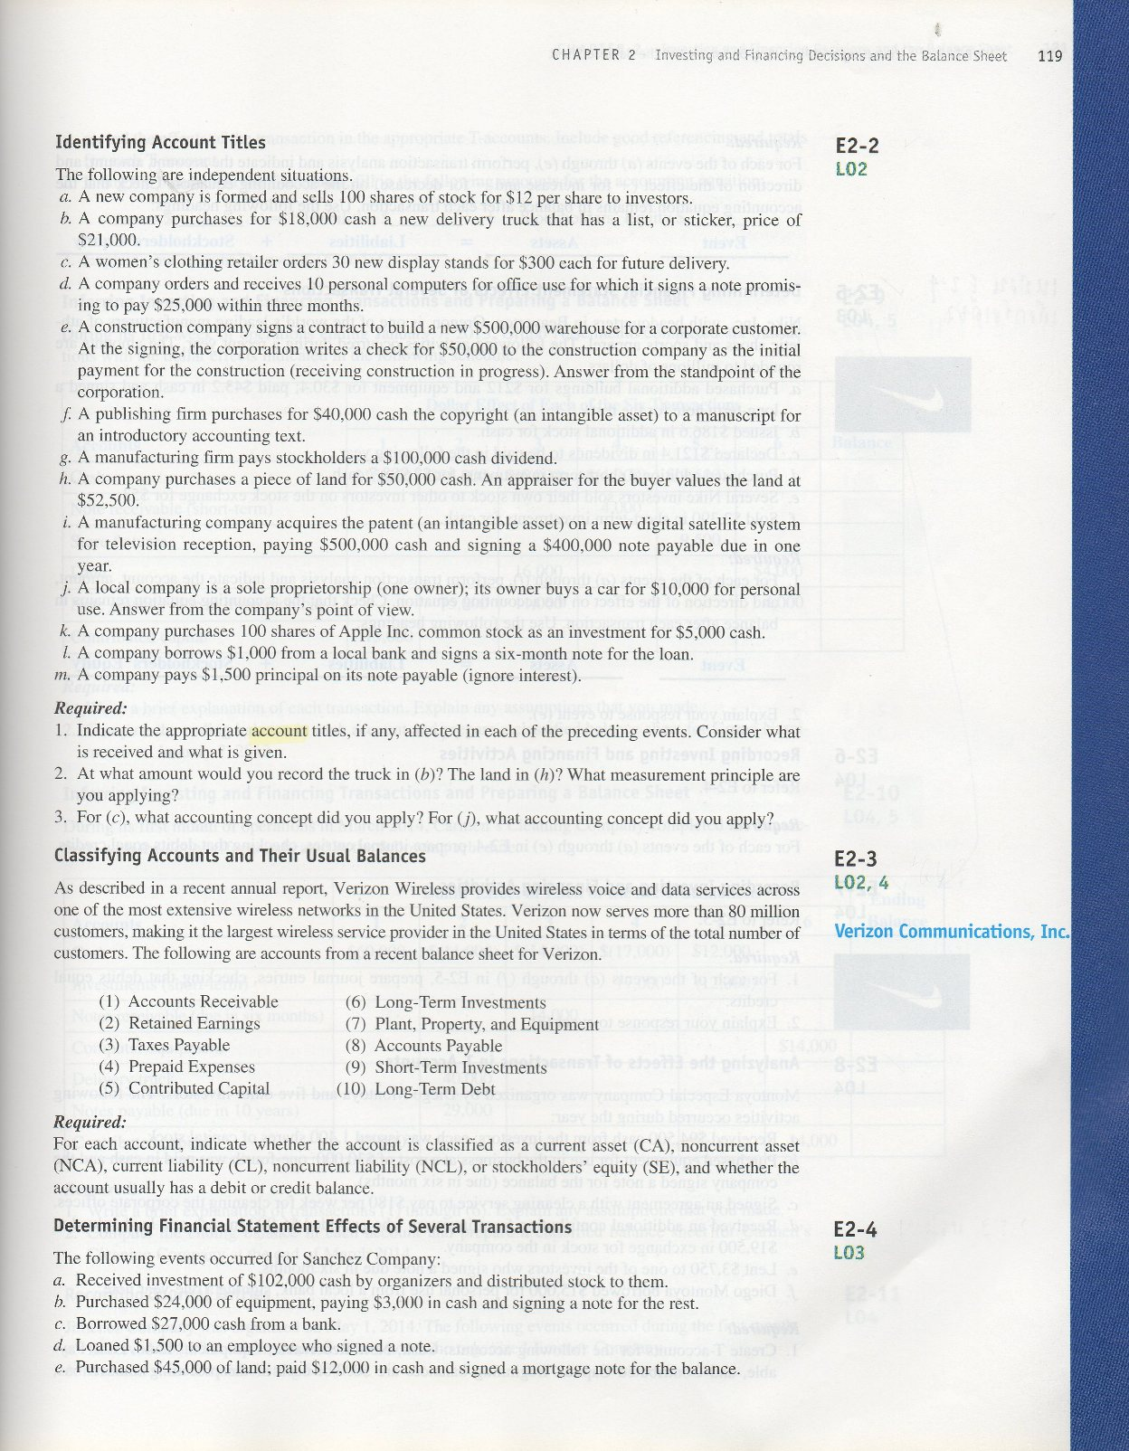

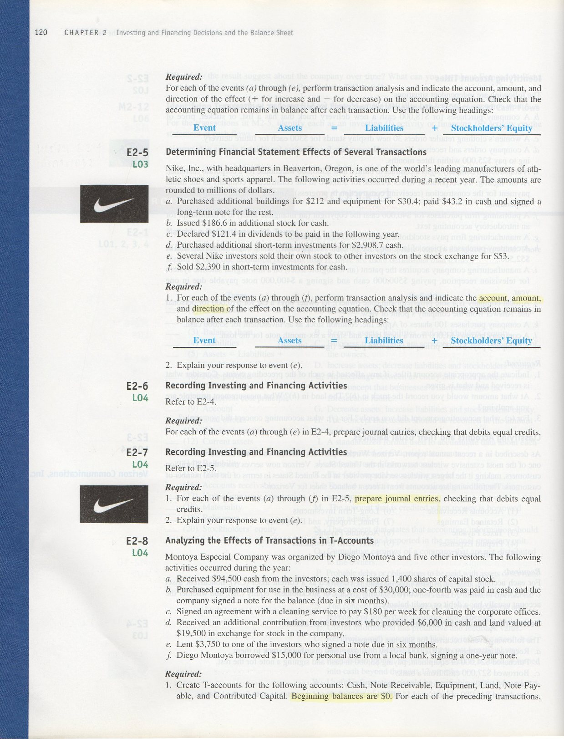

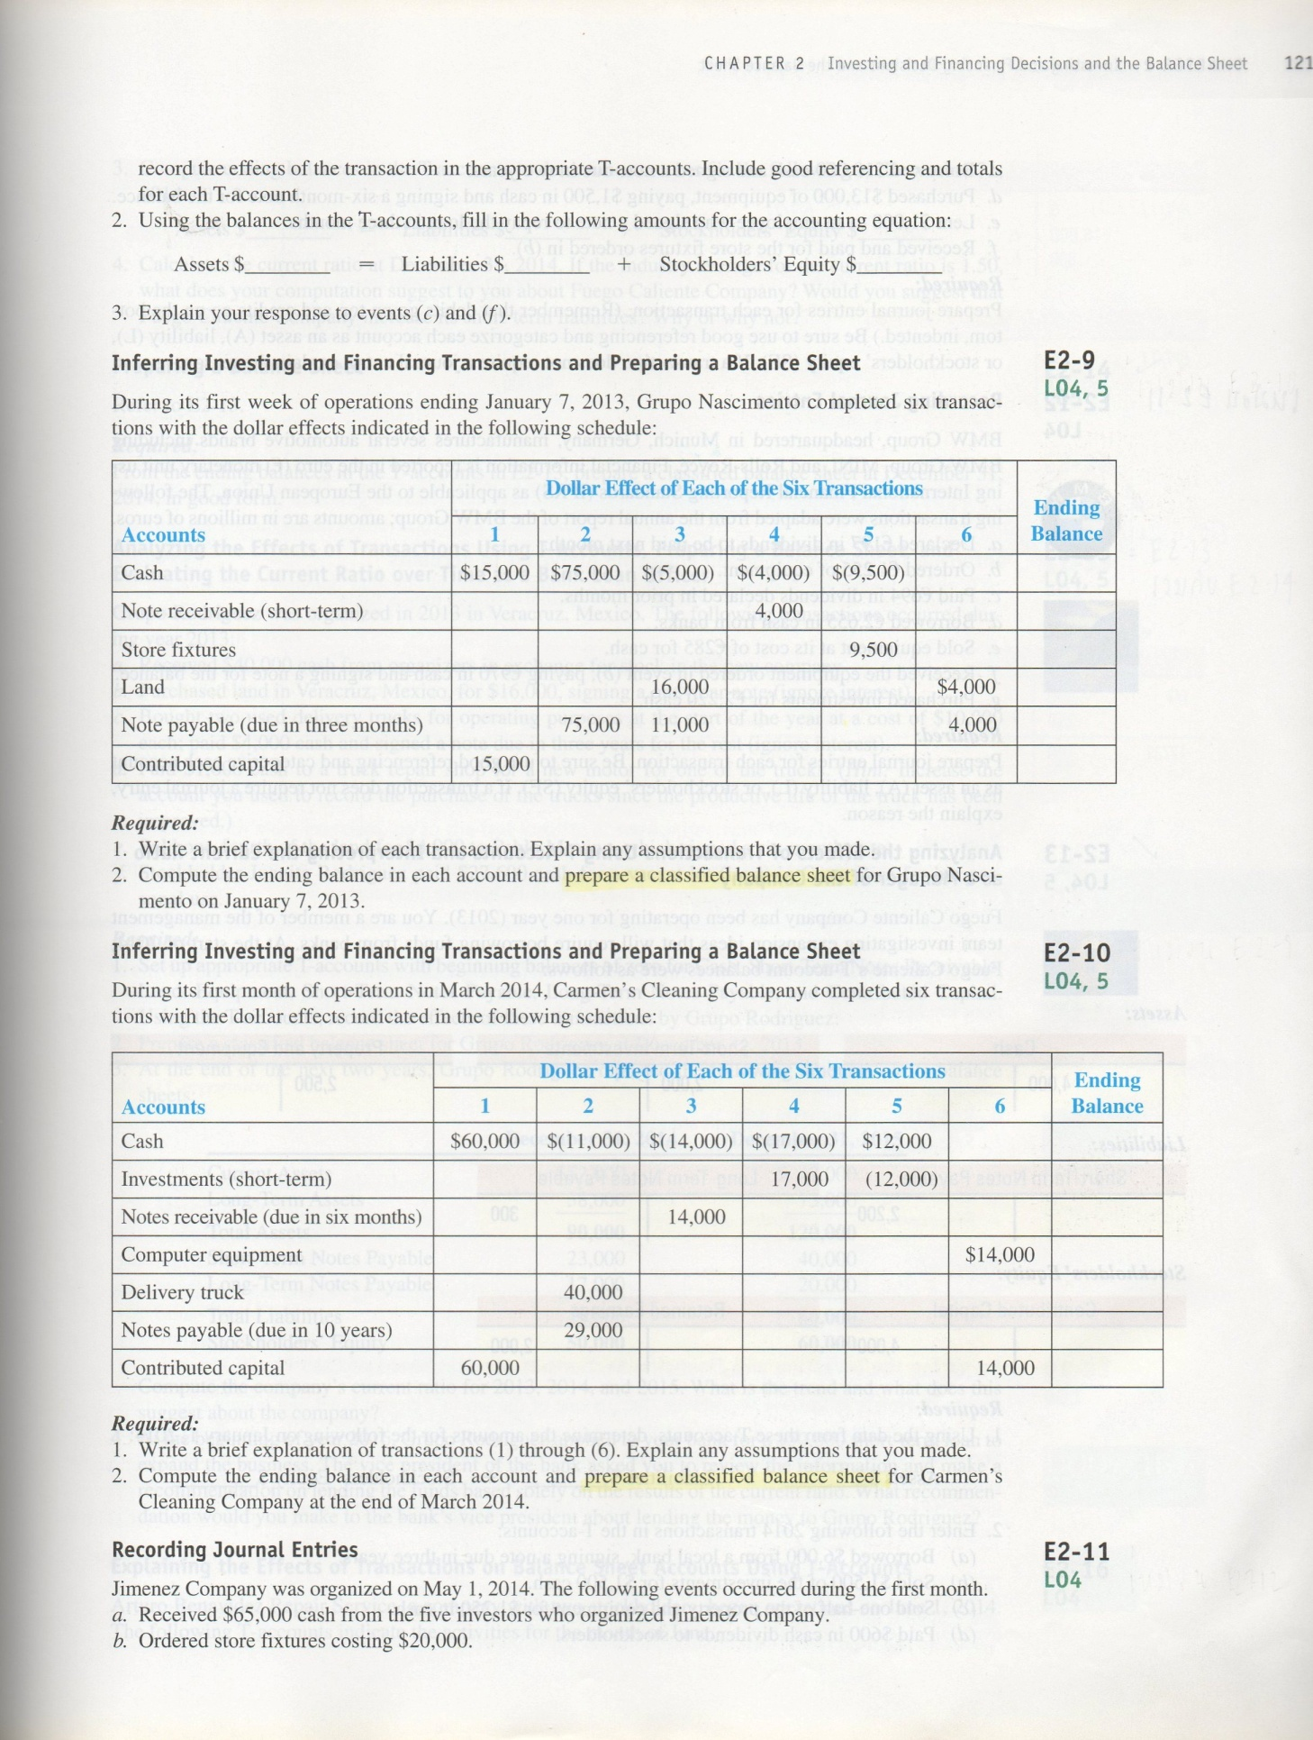

MINI-EXERCISES

M2–1.
C | (1) Separate-entity assumption
H | (2) Historical cost principle
G | (3) Credits
A | (4) Assets
I | (5) Account

M2–2.
D | (1) Journal entry
C | (2) A = L + SE, and Debits = Credits
A | (3) Assets = Liabilities + Stockholders’ Equity
I | (4) Liabilities
B | (5) Income statement, balance sheet, statement of retained earnings, and statement of cash flows

M2–3.
(1) Y
(2) N
(3) Y
(4) N
(5) Y
(6) N

M2–4.
CL | (1) Accounts Payable
CA | (2) Accounts Receivable
NCA | (3) Buildings
CA | (4) Cash
SE | (5) Contributed Capital
NCA | (6) Land
CA | (7) Merchandise Inventory
CL | (8) Income Taxes Payable
NCA | (9) Long-Term Investments
NCL | (10) Notes Payable (due in three years)
CA | (11) Notes Receivable (due in six months)
CA | (12) Prepaid Rent
SE | (13) Retained Earnings
CA | (14) Supplies
CL | (15) Utilities Payable
CL | (16) Wages Payable

M2–5.
 | Assets |  | = | Liabilities |  | + | Stockholders’ Equity
a. | Cash | +10,000 |  | Notes payable | +10,000
b. | Cash | –3,500
 | Notes receivable | +3,500
c. | Cash | +500 |  |  |  |  | Contributed capital | +500
d. | Cash  Equipment | –3,000  +7,500 |  | Notes payable | +4,500
e. | Cash | –1,000 |  |  |  |  | Retained earnings | –1,000

M2–6.
 | Debit |  | Credit
Assets | Increases |  | Decreases
Liabilities | Decreases |  | Increases
Stockholders’ equity | Decreases |  | Increases

M2–7.
 | Increase |  | Decrease
Assets | Debit |  | Credit
Liabilities | Credit |  | Debit
Stockholders’ equity | Credit |  | Debit

M2–8.
a. | Cash (+A) | 10,000
 | Notes Payable (+L) |  | 10,000

b. | Notes Receivable (+A) | 3,500
 | Cash (−A) |  | 3,500

c. | Cash (+A) | 500
 | Contributed Capital (+SE) |  | 500

d. | Equipment (+A) | 7,500
 | Cash (−A) |  | 3,000
 | Notes Payable (+L) |  | 4,500

e. | Retained Earnings (−SE) | 1,000
 | Cash (−A) |  | 1,000

M2–9.
Cash |  |  |  |  | Notes Receivable |  |  |  |  | Equipment
Beg. | 800 |  |  |  | Beg. | 900 |  |  |  | Beg. | 15,000
(a) | 10,000 | 3,500 | (b) |  | (b) | 3,500 |  |  |  | (d) | 7,500
(c) | 500 | 3,000 | (d)
 |  | 1,000 | (e)
 | 3,800 |  |  |  |  | 4,400 |  |  |  |  | 22,500

Notes Payable |  |  |  |  | Contributed Capital |  |  |  |  | Retained Earnings
 |  | 2,700 | Beg. |  |  |  | 5,000 | Beg. |  |  |  | 9,000 | Beg.
 |  | 10,000 | (a) |  |  |  | 500 | (c) |  | (e) | 1,000
 |  | 4,500 | (d)
 |  | 17,200 |  |  |  |  | 5,500 |  |  |  |  | 8,000

M2–10.
De Hoyos, S.A.B.
Balance Sheet
At January 31, 2014

Assets |  |  | Liabilities
Current assets: |  |  | Current liabilities:
Cash | $ 3,800 |  | Notes payable | $ 17,200
Notes receivable | 4,400 |  | Total current liabilities | 17,200
Total current assets | 8,200 |  | Stockholders’ Equity
 |  |  | Contributed capital | 5,500
Equipment | 22,500 |  | Retained earnings | 8,000
 |  |  | Total stockholders’ equity | 13,500
Total Assets | $30,700 |  | Total Liabilities & Stockholders’ Equity | $30,700

M2–11.
Current Ratio =
 |  | Current Assets | ÷ | Current Liabilities
2012 |  | 240,000 | ÷ | 160,000 | = | 1.50
2013 |  | 260,000 | ÷ | 220,000 | = | 1.18

This ratio indicates that Fernando’s Pizza has sufficient current assets to settle current liabilities, but that the ratio has also decreased between 2007 and 2008 by .32 (21%). Fernando’s Pizza’s ratio is higher than Papa John’s 2008 ratio (of .75), indicating that Fernando’s Pizza appears to have stronger liquidity than Papa John’s. However, given its size, Papa John’s is likely to have a strong cash management system that can keep current asset levels low.

M2–12.
(a) F
(b) I
(c) F
(d) I
(e) F

EXERCISES

E2–1.
E | (1) Transaction
F | (2) Continuity assumption
B | (3) Balance sheet
P | (4) Liabilities
K | (5) Assets = Liabilities + Stockholders’ Equity
M | (6) Note payable
S | (7) Conservatism
H | (8) Historical cost principle
I | (9) Account
Q | (10) Dual effects
O | (11) Retained earnings
A | (12) Current assets
C | (13) Separate-entity assumption
W | (14) Reliability
D | (15) Debits
J | (16) Accounts receivable
N | (17) Unit-of-measure assumption
U | (18) Materiality
T | (19) Relevance
R | (20) Stockholders’ Equity

E2–2.

Req. 1
 | Received | Given
(a) | Cash (A) | Contributed capital (SE)
(b) | Equipment (A) [or Delivery truck] | Cash (A)
(c) | No exchange transaction | —
(d) | Equipment (A) [or Computer equipment] | Note payable (L)
(e) | Building (A) [or Construction in progress] | Cash (A)
(f) | Intangibles (A) [or Copyright] | Cash (A)
(g) | Retained earnings (SE) [Received a reduction in the amount available for payment to stockholders] | Cash (A)
(h) | Land (A) | Cash (A)
(i) | Intangibles (A) [or Patents] | Cash (A) and Note payable (L)
(j) | No exchange transaction | —
(k) | Investments (A) | Cash (A)
(l) | Cash (A) | Short-term note payable (L)
(m) | Note payable (L) [Received a reduction in its promise to pay] | Cash (A)

Req. 2
The truck in (b) would be recorded as an asset of $18,000. The land in (h) would be recorded as an asset of $50,000. These are applications of the historical cost principle.

Req. 3
The agreement in (c) involves no exchange or receipt of cash, goods, or services and thus is not a transaction. Since transaction (j) occurs between the owner and others, there is no effect on the business because of the separate-entity assumption.
E2–3.
Account | Balance Sheet Categorization | Debit or Credit  Balance
(1) Accounts Receivable | CA | Debit
(2) Retained Earnings | SE | Credit
(3) Taxes Payable | CL | Credit
(4) Prepaid Expenses | CA | Debit
(5) Contributed Capital | SE | Credit
(6) Long-Term Investments | NCA | Debit
(7) Plant, Property, and Equipment | NCA | Debit
(8) Accounts Payable | CL | Credit
(9) Short-Term Investments | CA | Debit
(10) Long-Term Debt | NCL | Credit

E2–4.

Event | Assets |  | = | Liabilities |  | + | Stockholders’ Equity
a. | Cash | +102,000 |  |  |  |  | Contributed capital | +102,000
b. | Equipment  Cash | +24,000  –3,000 |  | Notes payable | +21,000
c. | Cash | +27,000 |  | Notes payable | +27,000
d. | Note receivable  Cash | +1,500  –1,500
e. | Land  Cash | +45,000  –12,000 |  | Mortgage note payable | +33,000

E2–5.

Req. 1

Event | Assets |  |  | = | Liabilities |  | + | Stockholders’ Equity
a. | Buildings  Equipment  Cash | +212.0  +30.4  – 43.2 |  |  | Notes payable (long-term) | +199.2
b. | Cash | +186.6 |  |  |  |  |  | Contributed capital | +186.6
c. |  |  |  |  | Dividends payable | +121.4 |  | Retained earnings | –121.4
d. | Short-term Investments  Cash | +2,908.7  – 2,908.7
e. | No effects
f. | Cash  Short-term Investments | +2,390.0  – 2,390.0

Req. 2
The separate-entity assumption states that transactions of the business are separate from transactions of the owners. Since transaction (e) occurs between the owners and others in the stock market, there is no effect on the business.

E2–6.

a. | Cash (+A) | 102,000
 | Contributed capital (+SE) |  | 102,000

b. | Equipment (+A) | 24,000
 | Cash (−A) |  | 3,000
 | Notes payable (+L) |  | 21,000

c. | Cash (+A) | 27,000
 | Notes payable (+L) |  | 27,000

d.  e. | Notes receivable (+A)  Cash (−A)  Land (+A) | 1,500  45,000 | 1,500
 | Cash (−A) |  | 12,000
 | Mortgage notes payable (+L) |  | 33,000

E2–7.

Req. 1

a. | Buildings (+A) | 212.0
 | Equipment (+A) | 30.4
 | Cash (−A) |  | 43.2
 | Note payable (+L) |  | 199.2

b. | Cash (+A) | 186.6
 | Contributed capital (+SE) |  | 186.6

c. | Retained earnings (−SE) | 121.4
 | Dividends payable (+L) |  | 121.4

d. | Short-term investments (+A) | 2,908.7
 | Cash (−A) |  | 2,908.7

e. No journal entry required.

f. | Cash (+A) | 2,390.0
 | Short-term investments (−A) |  | 2,390.0

Req. 2

The separate-entity assumption states that transactions of the business are separate from transactions of the owners. Since transaction (e) occurs between the owners and others in the stock market, there is no effect on the business.

E2–8.

Req. 1

Cash |  |  |  |  | Note Receivable |  |  |  |  | Equipment
Beg. | 0 |  |  |  | Beg. | 0 |  |  |  | Beg. | 0
(a) | 94,500 | 7,500 | (b) |  | (e) | 3,750 |  |  |  | (b) | 30,000
(d) | 6,000 | 3,750 | (e)
 | 89,250 |  |  |  |  | 3,750 |  |  |  |  | 30,000

Land |  |  |  |  | Note Payable |  |  |  |  | Contributed Capital
Beg. | 0 |  |  |  |  |  | 0 | Beg. |  |  |  | 0 | Beg.
(d) | 19,500 |  |  |  |  |  | 22,500 | (b) |  |  |  | 94,500 | (a)
 |  |  |  |  |  |  |  |  |  |  |  | 25,500 | (d)
 | 19,500 |  |  |  |  |  | 22,500 |  |  |  |  | 120,000

Req. 2

Assets $ 142,500 = Liabilities $ 22,500 + Stockholders’ Equity $ 120,000

Req. 3

The agreement in (c) involves no exchange or receipt of cash, goods, or services and thus is not a transaction. Since transaction (f) occurs between the owner and others, there is no effect on the business due to the separate-entity assumption.

E2–9.

Req. 1

Transaction | Brief Explanation
1 | Issued capital stock to shareholders for $15,000 cash. (Grupo Nascimento is a corporation.)
2 | Borrowed $75,000 cash and signed a short-term note for this amount.
3 | Purchased land for $16,000; paid $5,000 cash and gave an $11,000 short-term note payable for the balance.
4 | Loaned $4,000 cash; borrower signed a short-term note for this amount (Note Receivable).
5 | Purchased store fixtures for $9,500 cash.
6 | Purchased land for $4,000, paid for by signing a short-term note.

Req. 2
Grupo Nascimento
Balance Sheet
At January 7, 2013
Assets |  |  | Liabilities
Current Assets |  |  | Current Liabilities
Cash | $71,500 |  | Note payable | $90,000
Note receivable | 4,000 |  | Total Current Liabilities | 90,000
Total Current Assets | 75,500
Store fixtures | 9,500 |  | Stockholders’ Equity
Land | 20,000 |  | Contributed capital | 15,000
 |  |  | Total Stockholders’ Equity | 15,000
Total Assets | $105,000 |  | Total Liabilities & Stockholders’ Equity | $105,000

E2–10.

Req. 1

Transaction | Brief Explanation
1 | Issued capital stock to shareholders for $60,000 cash.
2 | Purchased a delivery truck for $40,000; paid $11,000 cash and gave a $29,000 long-term note payable for the balance.
3 | Loaned $14,000 cash; borrower signed a short-term note for this amount.
4 | Purchased short-term investments for $17,000 cash.
5 | Sold short-term investments at cost for $12,000 cash.
6 | Issued capital stock to shareholders for $14,000 of computer equipment.

Req. 2
Carmen’s Cleaning Company
Balance Sheet
At March 31, 2014
Assets |  |  | Liabilities
Current Assets |  |  | Notes payable | $29,000
Cash | $30,000 |  | Total Liabilities | 29,000
Investments | 5,000
Note receivable | 14,000
Total Current Assets | 49,000
 |  |  | Stockholders’ Equity
Computer equipment | 14,000 |  | Contributed capital | 74,000
Delivery truck | 40,000 |  | Total Stockholders’ Equity | 74,000
Total Assets | $103,000 |  | Total Liabilities & Stockholders’ Equity | $103,000

