Thammasat University

Ebola and Corruption

Sarocha Dechakhampoo 6204640723
Tatphong Nuanim 6204641101
Nanthasri Kheankhum 6204641564
Sakditach Rathhanukul 6204641580

Contemporary Economic Issues
EE406
Ajarn Thanasak Jenmana

Abstract

Since 1976, the Ebola Virus disease has been discovered and appears to have several outbreaks and cases in the Africa region, the region with the highest corruption rate. Thus, the key question of this report is that, is the high rate of corruption and the EVD outbreak happens to be linked or it is solely a coincidence. Based on many research reports, we found that the African social and political structure is facilitating the practice of corruption and hence, created the weakened healthcare system and low standard of people's living which eases the spreading of the Ebola virus among the citizens and worsen the situation of the outbreaks. We also tried to examine the key theory and implemented policy to mitigate the situation of corruption and found that no theory could be effective without the social norms and the behavior of society.

Introduction

We are living in an era of advanced technology, more advanced technologies were implemented for fighting countless diseases, the humankind arch-nemesis, such as a newly developed vaccination program. Now, most of the incurable diseases that once wiped millions of the world population, such as Cholera, Yellow fever, or even the Plague can completely be prevented. This is undoubtedly a crucial moment in history. Nonetheless, all of these magnificent breakthroughs and interventions will mean nothing if people could not access them. When a health inequality exists in a system, we always blame that as a consequence form poor planning, effortless, and unorganized implementation. But we never deeply talk about the real challenges of health inequality— Corruption.
According to Transparency International they define corruption as defining corruption as the abuse of entrusted power for private gain. Since the old human history, corruption has been a problem that created an unstable institute and a threat to development. Corruption erodes trust, weakens democracy, hampers economic development, and further exacerbates inequality, poverty, social division, and the environmental crisis. While corruption affects society in many dimensions, it could result in the death of the citizen if the epidemic takes place because the corruption has already weakened society. It may seem that the corruption in the health sector is the only cause of the worsen situation epidemic because it clearly results in a misallocation of public health aids flow and that will further lead to inadequate healthcare facilities and systems. Yet, we believe that corruption, in general, could also cause the woefully situation of the outbreak.
The Ebola outbreak is the outbreak that has a specific region to take place, which is the sub-Saharan African region, the poorest, and the most corrupt region. Our paper’s goal is to identify and examine the possible, direct, and indirect, relationship between corruption and the Ebola outbreak. Analyzing that through both statistical data alongside the past researches specifically on corruption and epidemic itself. We will also analyze the cause and the structure of African countries that facilitate the corruption practice and if there is any possible policy implementation to reduce the practice of corruption.

Figure1: Corruption perceptions index on the world map
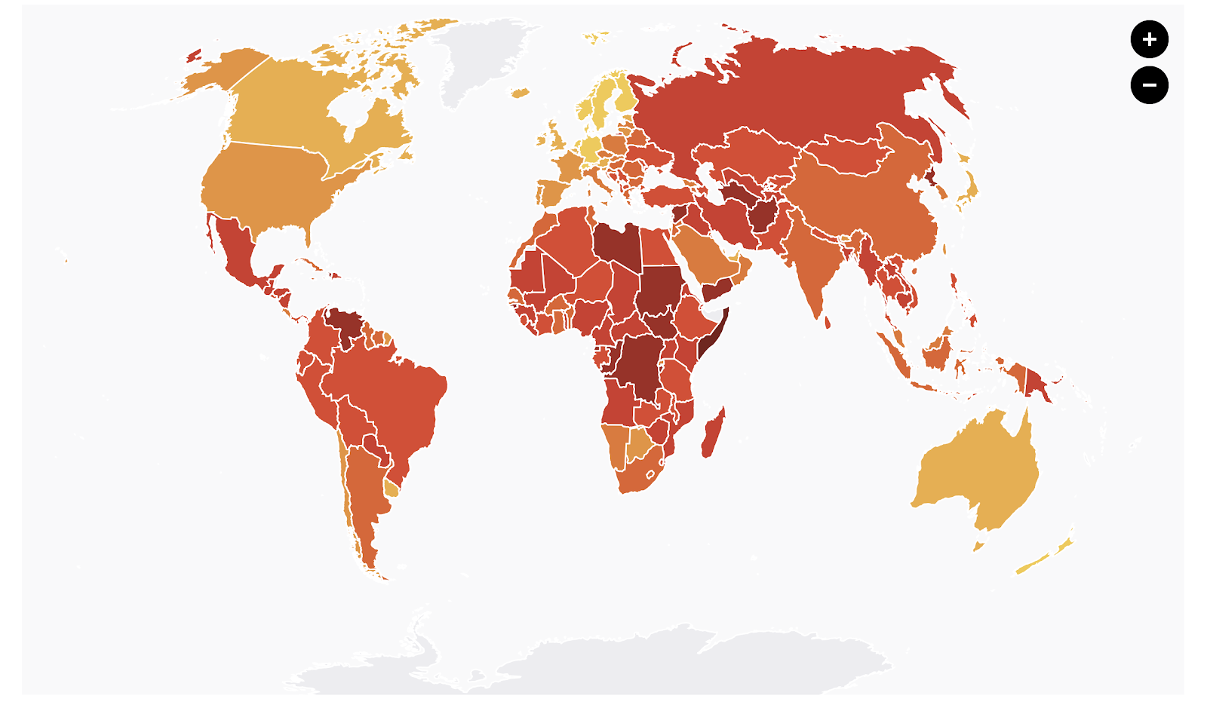
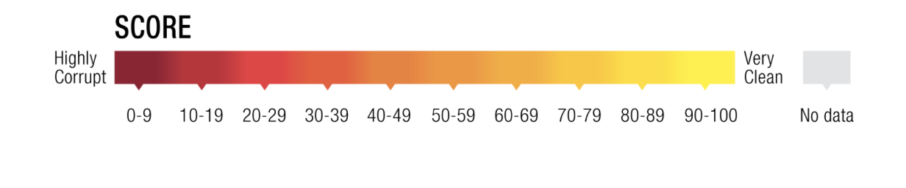
Source: Transparency International, 2019, Corruption Perceptions Index 2019

African is the world’s second fastest growing economy, however, over a million African people are still living in extreme poverty condition with the average income of bottom 41 percent less than $1.9 per day (World Bank, 2015). This is showing there might be some issue behind this. According to the world corruption Perception Index (CPI) 2009, which is calculated by Transparency International, (figure 1) it is apparent that African regions have relatively low average scores at 32; ranking the corruption score from 0-100 with the lowest score of 6 in Somalia. This significant low score across countries shows that there might be similar problems between these countries -the corruption.

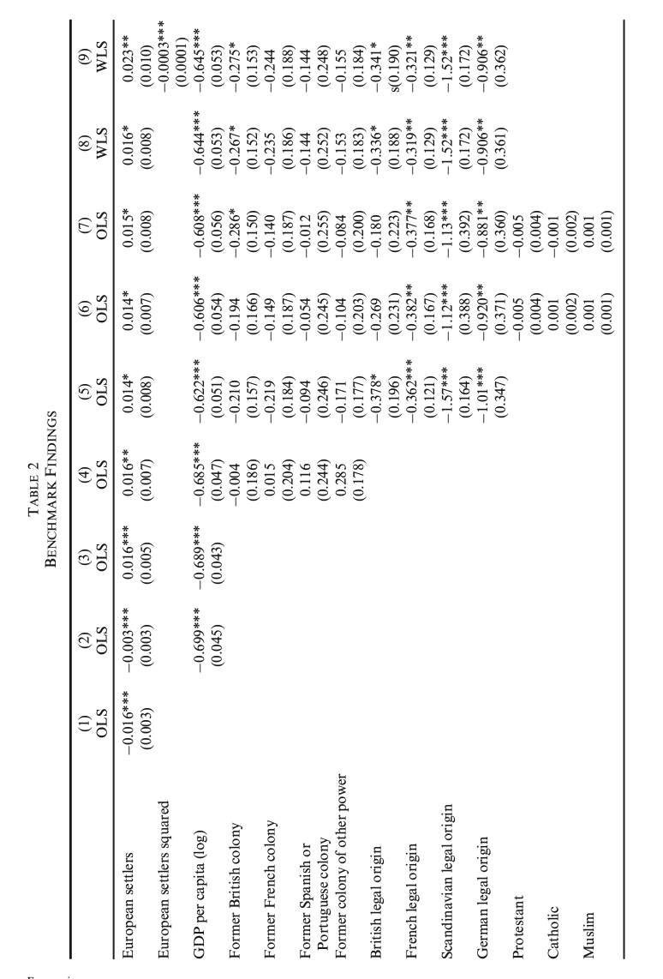
If we look at the historical events, almost every country in Africa was a former colony of western countries, which many research papers suggest that the process of colonization and being colonized has influenced the corrupt practice and that deeply-rooted through the post-colonial. For instance, the means that the taxation was collected by the western colonial was to select an African bureaucrat to collect tax, and to create incentives for them to gain as much tax revenue as possible, the western award them with some part of that income. Colonial chiefs were implicitly encouraged to use their positions to amass wealth and demonstrate thereby that is paid to corporate with Europeans (Leonard, 1991). As the bureaucrats gained financial benefits and became better off, they are more willing to serve the colony, nevertheless, they ignore the fact that they are exploiting their people. Furthermore, there is evidence suggesting that European settlers might have a positive relationship with corruption. From table 1, the third column shows the positive effect of the settlers , and the corruption when the USA, Canada, Australia, and New Zealand, which are the countries that Europeans are the majority of the population, are excluded and this applies to all countries which are colony as the column 4 suggests that the country, whether it is French, British, or Spanish, is irrelevant (Luis and Kyriakos, 2015). The way that the colonies ruled also played an important role in the foundation of corruption. Even though the western, during that period, had a good political structure and government, they never constructed that for African countries for the fact that the sole purpose for these lands in their perspective is to be exploited and oppressed, and that has become problematic when African countries became sovereignty as the people were lack of knowledge about politics and thus, this formed the state with the power owned by only a small group of people. This kind of political power is often accompanied by such dishonest acts since they might tend to careless of the majority of society when they are overwhelmingly powerful.

Table 1
Source : Luis and Kyriakos, 2015
After gaining independence, the countries had to govern themselves and someone had to be appointed to be the ruler. And because the colonization has left what so-called the political elites or a group of people with military power; people such as Joseph Désiré Mobutu. Mobutu, the Democratic Republic of the Congo (DRC) politician, was the former soldier of the colonial army and chief of the national army. He has successfully overthrown the government and became the president of DRC by taking advantage of the power he possessed. Mobutu was very well-known for corruption. He has a very strong incentive to act toward his best interest as he held the major power of the country after his second coup d'etat in 1965. From 1968 to 1984. It was an upturn in the country’s economy and the vast amount of income could save people from poverty; however, it was used for bribery and strengthened his political party (Muzong, 2008). These kinds of people are in almost every country in Sub-Saharan Africa. The structure of politics is to be blamed as it gives power to only the minority who put their advantages over society.

To analyze further how the African political structure facilitates the practice of corruption, we have to examine its structure first. In the past, most of the African political structure was the authoritarian regime, which is the form of government that uses strong power to preserve the status quo. After colonization, some countries were attempted to develop into democracy, however, because leaders hold on to their positions through the distribution of rents and other personal privileges, and clients exchange their political support for rewards that cannot easily be attained through legitimate economic channels (Arriola, 2009), these attempts often resulted in the regime with an incomplete transition. Even when the election was held, the political accountability of authoritarianism is considerably more compromised than in competitive electoral democracies and elections may have the perverse effect of encouraging corruption rather than reducing it (Chang and Golden, 2010). Moreover, for hybrid regimes and authoritarian, the estimates evidence suggest that corruption stabilizes the formal institutions. On the other hand, it has a limited impact on the sustainability of democracy (Hanna and Havard, 2014). Hence, corruption practice is more likely to occur in the hybrid and authoritarian regimes, which are the majority regime among African countries.

Corruption has led to the failure of the state in many dimensions. For example, it caused an unfair distribution regarding both money and welfare which leads to a higher rate of poverty and inequality. Because it affects everyone unequally, poor people are more likely to be more vulnerable than the others. This is the group of people that rely a lot on social security, however, many of them have not found themself better off. In practice, some individuals who have authority over the funds are using some part of it for their own benefit. Corruption has also reduced the government revenue and leads to disproportionate taxation which also plays an important role in the poor welfare distribution and the system failure. This happens as a result of the tax evasion of the people who have some connection with the official. The relation of corruption and the government revenue is illustrated in figure 3, the higher the level of corruption (CI) will lead to negative government revenue (GREV); provided that corruption might not be the only factor causing the decline of government revenue (Jingyoung, 2002). Moreover, such dishonest acts of the government often result in the negative perception of the people toward the government which could turn to be an obstacle in some policies, economic growth, and development of the country.

How does corruption itself bolster the Ebola outbreak?

The Ebola Virus Disease ( EVD) is an epidemic that swept through Africa over the last few years is the deadliest outbreak of disease Africa once experienced in history. According to the Centers for Disease Control and Prevention (CDC), The nature of the virus is an animal-borne with bats or nonhuman primates, meaning that the infected animals can transmit the virus to humans and other animals. It can be spread through body fluid and objects which are contaminated with body fluids of infected people. Those at the risk of the EVD are the health workers and people who have not cared for or been in close contact with someone sick. Ebola outbreaks often took place in the Sub-saharan region, the largest one occurred in the Democratic Republic of Congo (DRC) in 2014-2016 with the highest case fatality rate approximately more than 28,600 cases. Since 2019, the vaccination has been discovered, however, hundreds of thousands of people have been exposed because of the virus, and given that many have fled, the real impact of this deadly epidemic is yet to be realized. Many scholars and experts have pointed to a high degree of government’s low-transparency as an influence of the inadequate and poorly instituted measures of control during the disease outbreak crisis in the region.
The failure of the healthcare system is the clearest consequence of the corruption that leads to the more severe situation of the EVD outbreak. It is result of the low budget in the African healthcare sector, and it happens because of the two main factors, firstly, the corruption of the budget itself. For example, in Liberia, they were fraudulently overpriced supplies, or in salaries for non-existent aid workers and in Sierra Leone, they were corrupted by the fake bills (BBC, 2017). And secondly, high tax avoidance, as people mistrust in the government, has reduced the government revenue. Based on figure 2, among the people who believe there are no corruption practices occurring among the officers view non-payment of taxes as ‘wrong and punishable, however, among those who perceive that all tax officials are corrupt, tolerance for non-payment of taxes increases substantially. This also linked to the commitment to taxation, according to figure 3, people who perceive that the tax officials are honest to have more tendency to pay the tax, on the contrary, taxation avoidance is more likely to happen among people who perceive officers as dishonest.
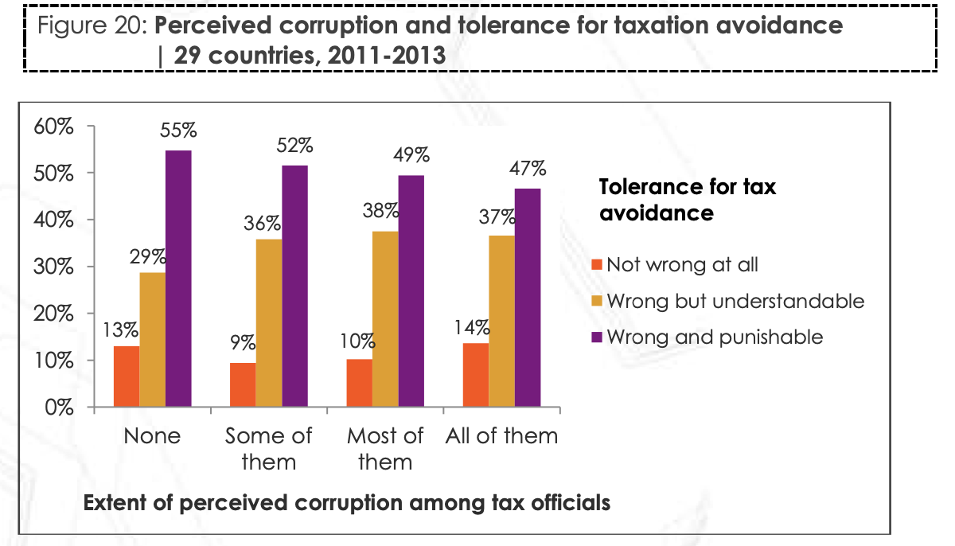
figure 2
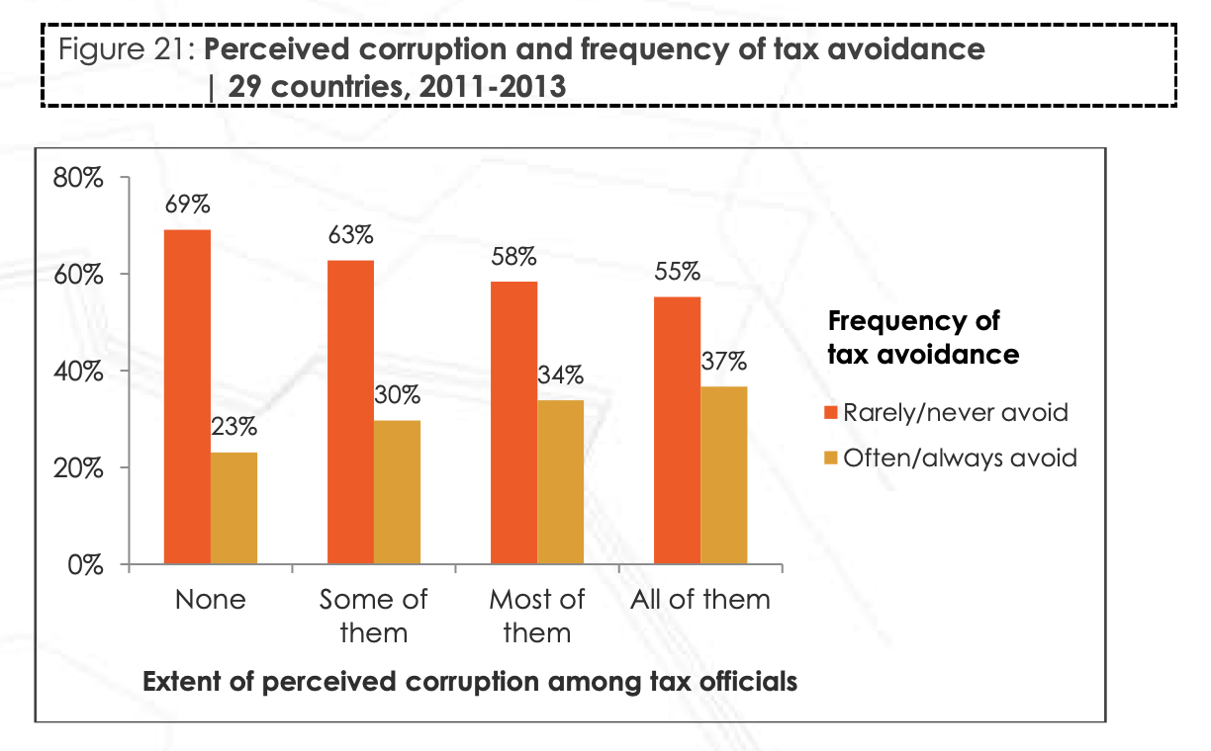
figure 3
Source : Afrobarometer, 2014

Corruption has worsened the situation of the outbreak not only in the direct means through the failure of the healthcare system but also indirectly exacerbate the epidemic by creating a low standard of living for people in the country. According to table 2, Corruption has led to an increase in poverty through unequal land distribution, low level of social spending, low level of growth rate, and education inequality. The figure 4 shows that there is a negative relationship between the income of the bottom 20 percent of the population countries and the level of corruption as one-point an increase in corruption index will result in a decrease of the growth rates of GDP by between 0.75 and 0.9 percentage points per year and per capita income growth rate by between 0.39 and 0.41 percentage points per year, respectively ( Kwabena G., 2001). Increasing corruption will only make rich people become richer and richer, while poor people can only sit and watch their income fly away into the riches’ hands. That is why an increase in corruption results in poor income distribution. To the extent that rapid economic growth increases the incomes of the poor and hence reduces poverty, increases in corruption hurts the poor rather than the rich and powerful ( Kwabena G, 2001).

Figure 4
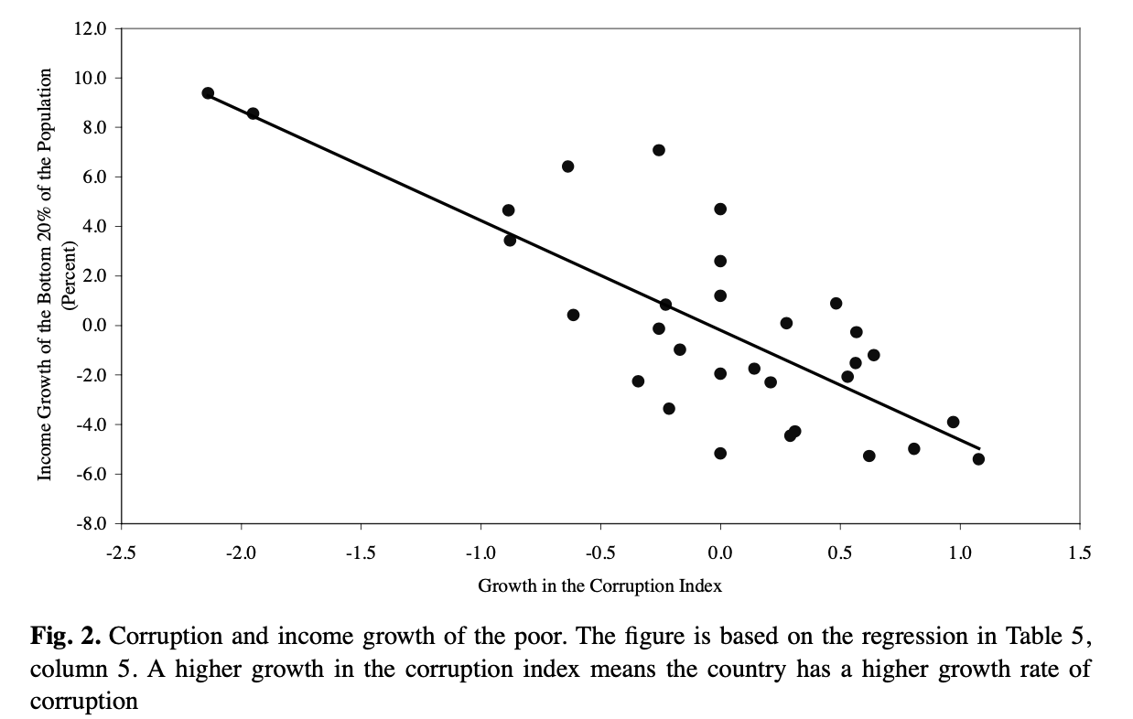

Source : Fallah et al., 2015

Table 2
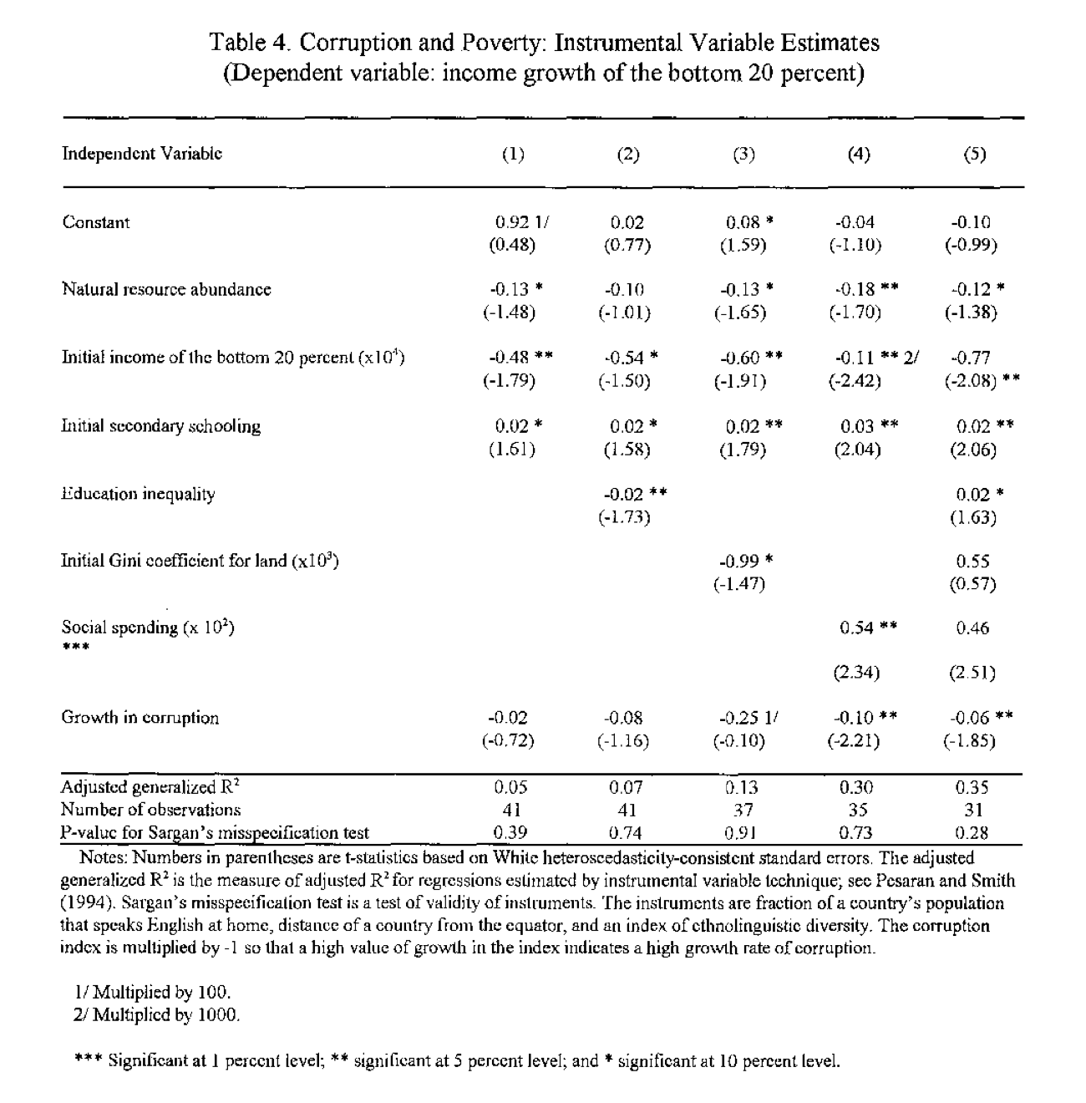
Source : Fallah et al., 2015

The enormous number of affected people of the EVD across the continent is the result of high poverty rates in many countries because as the disease started to spread, people were lacking the cleaned water, food, medical supply, and the good condition habitat and as a result, they are more likely to be exposed to the virus. For example, the research in Liberia provides evidence that among the people with low socioeconomic status, there is a higher tendency for the virus to be transmitted and Ebola sufferers living in shantytowns infected 3.5 times as many people as those living in rich areas and the cases tended to be exported from poverty areas and result in transmission chains across the country. ( Fallah et al., 2015). This also implies inequality among class because the even the virus is equally spread, the condition of people are not. According to table 3, it can be seen clearly that people with low SES have a higher risk ratio at 2.19 in transmission while the middle and a high SES have a risk ratio at only 0.94 and 0.62 respectively.

Table 3.

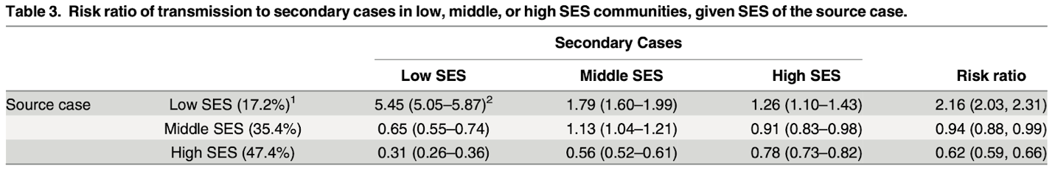

Source : Fallah et al., 2015

The corruption also plays a significant role in contributing to the mistrust in government which affected the country in the first month of the epidemic, low levels of trust have contributed to the spread of rumors in many places in sub-Saharan Africa. From figure 5, it shows that during 2014-2015, people are more confident in the informal institution such as religious leaders more than the government-owned sector. And according to several attitude surveys, African people believe that the authorities are using the Ebola outbreak in order to make money out of it. From the citizen perspective, the more cases, the more income the government will gain from the United Nations aid flow. These rumors create the difficulty to control the further spread of the EVD owning the fact that people were questioned about how the government allocates the money and whether Ebola even exists. They believe that the government had exaggerated or even cooked up the Ebola crisis to gain access to international funding sources that could be pumped out. Going out for personal uses — Affected individuals and communities resist efforts by healthcare professionals to isolate and treat victims, collect information and bodies, and disseminate information on Ebola. While providing significant international aid for Ebola has helped slow the spread of Ebola. But it didn't stop there. One reason is that corruption plays a role in diversifying relief funds and supplies, and in undermining Ebola mitigation measures. In many countries such as Sierra Leone, the Democratic Republic of Congo, Liberia, etc. the people was protesting in front of the Ebola treatment center and demanding to remove all patients from the hospital.

There were also spotted some petty corruption that appeared in many places; one of the burials crews sent to collect the bodies of suspected Ebola victims because it is necessary to burn those body down, as to prevent further contact with the disease, however, when he arrived in the village, the dead’s relative or family try to bribe him to keep the body with them and do the funeral rites instead. Traditional concern among African citizens themselves usually plays a vital role in promoting corruption by taking over an appropriate system. People of Africa tend to rely on their sacred traditions over scientific actions. Usually, when one people was passed away, no matter what causes, their family or relatives will conduct his funeral according to the ancient funeral tradition. African burial ritual has several requirements: must conduct before the sun is about to set, attendants need to sing and dance to honor the soul, etc. All conditions must be met in order for the lost soul to finally inherit his last will and happily join with the god in the next world. All of these complex steps are in contrast with EVD appropriate burial steps. That leaves them no choice but to taking bribes to issue death certificates for their families, saying their family died of another disease, and then they can keep the body to their own. It is a troubling development for an outbreak where corpses are the leading cause of the epidemic, and one suggesting that local corruption could undermine international efforts to contain the virus. This example implies two problems occur from corruption, firstly, when corruption has frequently occurred in the country, people will normalize it and practice it. Traditional concern among African citizens themselves usually plays a vital role in promoting corruption by taking over an appropriate system. Andrew Medina-Marino An epidemiologist at South Africa's Pretoria University, recently in Liberia, assisted in the Ebola response, said he was reported to have paid bribes to the Ebola response team, so, they would look the other way. These bribes have contributed to the challenge of controlling the epidemic that has killed more than 4,000 people. Health and aid workers said they had heard reports of persimmon burials from residents for months and new graves appeared overnight in cemeteries around the capital. The implementation of the corruption problems.

Corruption has many effects on society which are quality of living, education, transportation, and health care. This might sound like not a big deal but this is a root problem of the underdeveloped country as in the Sub-Saharan country. Most countries in Sub-Saharan still have more or less corruption in the past. To examine the importance of the information, the accuracy, and the content of the information can lead to a major change in the decision. Agency dilemma describes the relation of the representative of one party who maximizes self-interest rather than taking into account another party's interest

The implementation of the corruption problems

Principal-agent theory

In a recent period of time, anti-corruption has involved a lot of organization. Sub-Sahara was proverbial corrupt for at least fifty years and tried to reform by following the policy implications stemming from ‘principal-agent theory’. The foundation in this principal-agent theory is about the distinction of the morals hazard and the hidden actions. When the agent has more power in terms of the hidden action or information and the principal doesn’t know how to control. The principal-agent theory is considered the corruption to be as agents which assumed to act for their own benefit and principals, who is favor in public interest and their action would affect to the incentive’s agent to make a various possible way of corrupt, and are generally considered to embody the public’s interest, therefore, a "highly principled subject" (Klitgaard 1988). To illustrate, we set the government in the role of agent and set the people in the role of the principal. In the underdeveloped country, mostly aren’t governed by democracy, some of the information was privy to the public. The government was swindled from the budget of the health system since they don’t show all the relevant information to the public which affects the majority of the population-- the poor-- have difficulty to access medical care. Overall, this theory is particularly effective to control the agent's motivation to seize the corruption’s behavior but can’t stop the agent from corrupting because we can’t control people’s mind.
In terms of adapting the principal-agent theory, Liberia is a good example of trying to control the agent. During Ellen Johnson Sirleaf was the president election, she was promoting the campaign about corruption in the country. Her efforts were supporting the establishment of the Liberia anti-corruption commission and making transparency financial and the budget of the government. Thus, people can assure on and be questioned on the suspicious government’s transaction.

Figure 5 : Control of Corruption: Estimate from 1996 to 2017 in the chart:
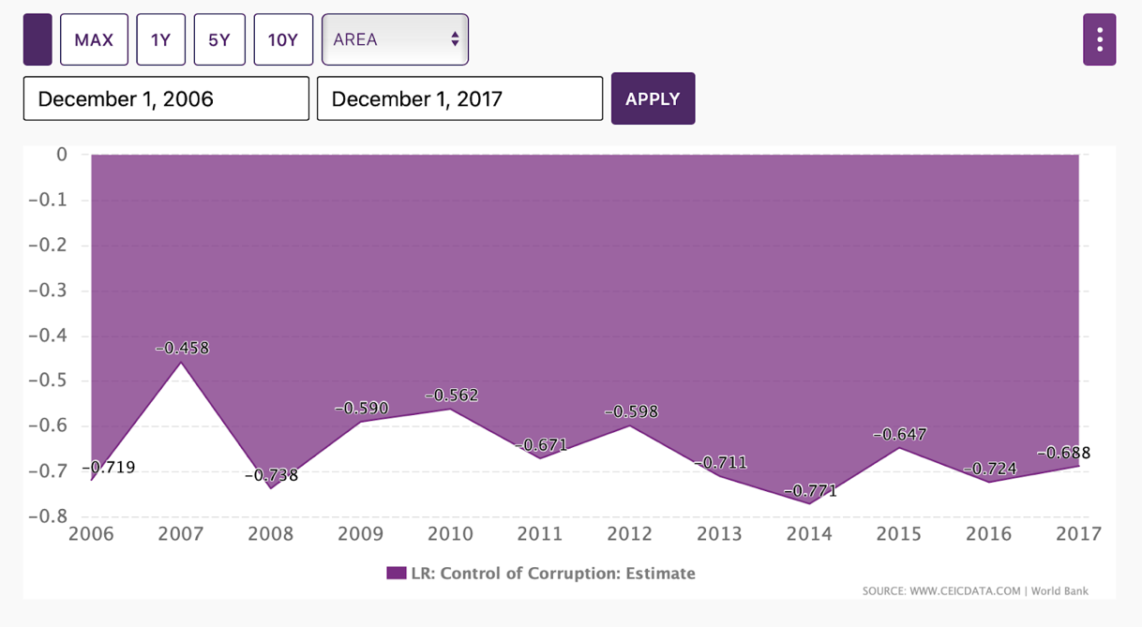
Source : CEIC, 2018

From the figure5, the control of the Corruption index’s Liberia shows that after her vows in 2006 the graph trend rose up as the aspect in 2007 after she fired 17,0000 people who are working in the financial ministry for an investigation about the corruption in ministry. But the control of the corruption index was falling to -0.738 that is lower than the year 2006 when she first used the policy. As in the graph after year 2008, it has the tendency to increase rapidly from -0.738 to -0.590 which is increasing 20.05 percent from year 2008 to year 2009. Because in the year 2009, the government was strongly supported by the Governance and Economic Management Assistance Program (GEMAP). The GEMAP were partnerships with many organizations like the United Nations (UN), the European Union (EU), the United States (US), the International Monetary Fund (IMF), and the World Bank. The purpose of the organization is to improve governance in the peaceful way and the most sustainable in Liberia.

Collective action

Another commonly used theory for anti-corruption is the collective action theory which is the improvement of the past theory’s problem. The collective action implies the connection to individuals’ decision in the group when the collective benefit is not accomplished to its fullest benefit or when the member of the group is not trusting each other within the group. So, they will turn down their group goals and seek personal gain from corruption. Insofar as the act of corruption is such a common behavior for everyone seeking for their interest which can refer to the principal-agent theory that the actor in a group member can be both principals and agents. The collective action is applied with both game theory (prisoner’s dilemma) and related disciplines. The prisoner’s dilemma is emphasized into two levels when considered in a one-shot game. The first-order cooperative is when the actors have two options which are the cooperative or free rider. And the second-order cooperative which has “ four alternative choices are (1) full cooperation, cooperating to produce both the sanctioning system and the public good; (2) hypocritical cooperation, defecting at the first level while urging others to cooperate through participation in the sanctioning system; (3) private cooperation, cooperation at the first level, but defecting at the second; and finally (4) full defection, free riding at both levels.” (Douglas, 1989). The problem in both first and second-order cooperative is the free-rider problem which is the challenge to the anti-corruption operation.

To emphasize more on the collective action, in the government and firm relationship, the private firms have been paid bribes to the government agent to avoid some action. In the case of the company's competitors, they might lose some shares in the market because they have to pay the higher cost of the production (pay imported tax of the material and capital or any general tax). Unwilling to bear the costs, firms will have incentive corruption regarding bribes before they have to shut-down their company. For reducing the size of corruption is to cooperate with the private’s firms and make the transparency of the cooperation.

However, this is impossible to accomplish the goals of the anti-corruption. As in Uganda and Kenya, they both developed comprehensive strategies that have at their core a number of institutional and legal reforms designed to promote good governance and curb malfeasance (Persson et al, 2010). But they are still fighting with corruption. Overall, there is no perfect implementation or any theory for the anti-corruption cause we can’t control the people’s mind. Everyone is seeking for their own happiness which means everyone has incentive to corrupt on their own. The failure of the implementation will create the anti-corruption reform.

Conclusion

To summarize, from our findings, we found a strong relationship between the corruption and the spread of EVD in Sub-saharan region. The corruption has led to worsen spread of the EVD situation in both direct and indirect means. It created the failure of the healthcare system, which made it difficult to effectively treat patients because it means a shortage of medical supply and healthcare professionals. It also reduces the trust of the public in government and created the social norms of such dishonest practice, hence, it is problematic to control the outbreak. Moreover, corruption is lowering the standard of living of people and increased poverty, which makes a large number of African people infected by the virus. Even though corruption is not the main cause of the Ebola outbreak, it did worsen the situation and represents a microcosm of the problems that can emerge from weak extraverted leadership and economic distortions (Robert L, 2020). The corruption practice can be diminished by implementing the principal-agent and collective action theory. However, it is dependent on the behavior of the society.

Reference

- Angeles, L., & Neanidis, K. C. (2009). Aid effectiveness: the role of the local elite. Journal of Development Economics, 90(1), 120–134.doi:10.1016/j.jdeveco.2008.05.002
- Arriola, L. R. (2009). Patronage and Political Stability in Africa. Comparative Political Studies, 42(10), 1339–1362.doi:10.1177/0010414009332126
- Burki, T. (2019). Corruption is an “ignored pandemic.” The Lancet Infectious Diseases, 19(5), 471. doi:10.1016/s1473-3099(19)30178-1
- Chang, Eric C. C.; Golden, Miriam A. (2009). Sources of Corruption in Authoritarian Regimes. SSRN Electronic Journal, (), –.doi:10.2139/ssrn.1339972
- HECKATHORN, D. D. (1989). Collective Action and the Second-Order Free-Rider Problem. Rationality and Society, 1(1), 78–100. doi:10.1177/1043463189001001006
- Hope, K. R. (2010). Liberia’s Governance and Economic Management Assistance Program (GEMAP): an impact review and analytical assessment of a donor policy intervention for democratic state-building in a post-conflict state. South African Journal of International Affairs, 17(2), 243–263.doi:10.1080/10220461.2010.493734
- Jinyoung, H. (2002). A Note on the Relationship between Corruption and Government Revenue. 27(2)
- K.Justesen, M., & Bjornskov, C. (2012). Exploiting the Poor: Bureaucratic Corruption and Poverty in Africa.
- Klitgaard, Robert. 1988. Controlling Corruption. Berkeley: University of California Press.
- Justesen, Mogens K., and Christian Bjørnskov. “Exploiting the Poor: Bureaucratic Corruption and Poverty in Africa.” SSRN Electronic Journal, 2012. Crossref, doi:10.2139/ssrn.2168119.
- Luis Angeles & Kyriakos C. Neanidis, 2015. "The Persistent Effect of Colonialism on Corruption," Economica, London School of Economics and Political Science, vol. 82(326), pages 319-349, April.
- Mackey, Tim K.; Kohler, Jillian Clare; Savedoff, William D.; Vogl, Frank; Lewis, Maureen; Sale, James; Michaud, Joshua; Vian, Taryn (2016). The disease of corruption: views on how to fight corruption to advance 21st century global health goals. BMC Medicine, 14(1), –.doi:10.1186/s12916-016-0696-1
- Maria-Aimee, R. (2016). State Development, Corruption & the Consequences of Colonization: The Case of Mexico and the Philippines, oai:DiVA.org:liu-150083
- Marquette, H.; Peiffer, C. (2015). Corruption and Collective Action . Developmental Leadership Program.
- Peiffer, C., & Rose, R. (2016). Why Are the Poor More Vulnerable to Bribery in Africa? The Institutional Effects of Services. The Journal Of Development Studies, 54(1), 18-29. doi: 10.1080/00220388.2016.1257121
- Persson, Anne; Rothstein, Bo; Teorell, Jan (2010). The Failure of Anti-Corruption Policies: A Theoretical Mischaracterization of the Problem. QoG Institute.
- Principal-agent theory and the structure of science policy. (1996). Science and Public Policy. doi:10.1093/
- Shepler, S. (2017). “We Know Who is Eating the Ebola Money!”: Corruption, the State, and the Ebola Response. Anthropological Quarterly, 90(2), 451–473. doi:10.1353/anq.2017.0026
- Stephenson, M., & &rarr;, V. (2020). Is Corruption Partly Responsible for the Ebola Crisis?.
- Anti-corruption Resource Center. Sub-Saharan Africa: Overview of corruption and anti-corruption. (2020).
- Tamba E. M'bayo. (2018). Ebola, Poverty, Economic Inequity and Social Injustice in Sierra Leone. Journal Of West African History, 4(1), 99. doi: 10.14321/jwestafrihist.4.1.0099
- Kempe Ronald Hope Sr. (2010). Liberia's Governance and Economic Management Assistance Program (GEMAP): an impact review and analytical assessment of a donor policy intervention for democratic state-building in a post-conflict state, South African Journal of International Affairs, 17:2, 243-263,DOI: 10.1080/10220461.2010.493734
- William Reno (2008). Anti-corruption Efforts in Liberia: Are they Aimed at the Right Targets?, International Peacekeeping, 15:3, 387-404, DOI: 10.1080/13533310802058968
- Muzong Kodi. (2008). Corruption And Governance In The DRC. Institute for Security
- Sirleaf, E., 2006, Inaugural address of H.E. Ellen Johnson Sirleaf,

