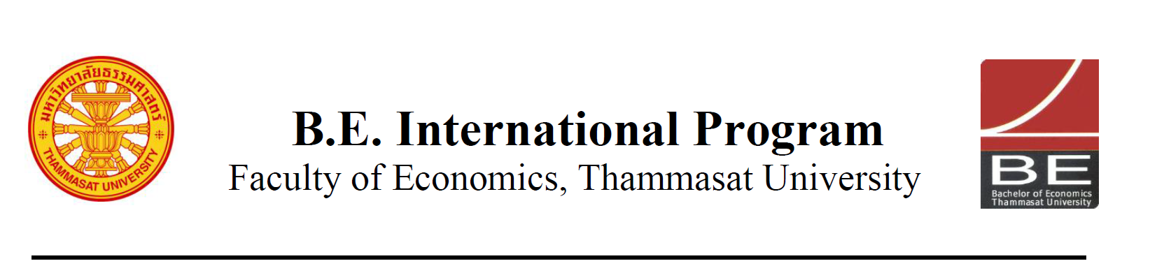

Course Outline
FN 281 Personal Finance (Section 046402)
Semester 2/2016 (January 16 – May 13, 2017)

Number of credits: 3 credits

Lecture Time: Saturdays 1.00 – 4.00 PM
Lecture Venue: Room 303, 3rd floor, Faculty of Economics
Thammasat University,Tha Prachan Campus
Instructor: Chatchai Thisadoldilok CFA FRM
Office Hours: by appointment
Contact Information: chatchat@sec.or.th

Prerequisite: none

Course Description
This course offers study in the area of consumer finance and money management. It examines personal financial management and consumer decision making in today's world. The determination of optimal financial objectives in accordance with various stages of individual life cycle; personal financing and spending, personal financial planning and control, savings and efficient investments, appropriate credit usage, personal tax planning, and income tax payment, benefits of saving and individual’s quality of life: health care, leisure, free-time productivity, financial planning after retirement.

Course Objective
This course aims to increase the students’ understanding of personal finance concepts, also to motivate the students to develop further financial literacy. In particular, they will learn effective money management and practical solutions to investment, credit, insurance, and retirement. The goal is to equip them with knowledge and tools contributing to their healthy financial situation in the future.

Main Textbook
Jack Kapoor, Les Dlabay, Robert J. Hughes, “Personal Finance”. McGraw-Hill/Irwin Series in Finance, Insurance and Real Estate (10th or 11th Edition)
Additional readings to be assigned.
Evaluation
Participation & Quiz 20%
Assignments 40%
Final Exam 40%
Course Outline (15 x 3hr classes)
Session | Date* | Topics | Instructor
1 | Jan-21 | Planning Your Personal Finances | Chatchai
 |  | Personal finance basics and time value of money. Financial aspects of career planning. (ch.1 & 2 of main text)
2 | Feb-04 | Planning Your Personal Finances | Chatchai
 |  | Money management strategy. Planning your tax strategy. (ch.3 & 4 of main text)
3 | Feb-18 | Managing your personal finances | Chatchai
 |  | Financial services: savings and payments. Consumer credits. (ch.5 & 6 of main text)
4 | Feb-25 | Managing your personal finances | Chatchai
 |  | Choosing a source of credit. (ch.7 of main text) Assignment presentation and class discussion.
5 | Mar-04 | Making your purchasing decisions | Chatchai
 |  | Consumer purchasing strategies. The housing decisions. (ch.8 & 9 of main text)
6 | Mar-18 | Insuring your resources | Chatchai
 |  | Property and motor vehicle insurance. Health, disability, and long-term care insurance. (ch.10 & 11 of main text)
7 | Mar-25 | Insuring your resources | Chatchai
 |  | Life insurance. (ch.12 of main text)
8** | Mar-31 | Investing your financial resources | Chatchai
 |  | Investing fundamentals. Investing in stocks. Investing in bonds (ch.13, 14, &15 of main text)
9 | Apr-01 | Investing your financial resources | Chatchai
 |  | Investing in mutual funds. Investing in real estate and alternatives. (ch.16 & 17 of main text)
10 | Apr-08 | Controlling your financial future | Chatchai
 |  | Starting early: retirement planning. Estate planning (ch.18 & 19 of main text)
11** | Apr-19 | Controlling your financial future | Chatchai
 |  | Assignment presentation and class discussion.
12 | Apr-22 | Behavioral economics | Chatchai
 |  | Behavioral biases. Behavioral economics and pension design.
13 | Apr-29 | Pension system in Thailand | Chatchai
 |  | Defined-contribution and defined-benefit schemes. Social security scheme, provident funds, retirement mutual funds, and more.
14 | May-06 | Group works and class discussion | Chatchai
15 | May-13 | Review | Chatchai
* tentatively **make-up class, 16-19pm on weekdays

Important Dates
Class #1: January 21, 2017
Adding and Dropping Course: January 16-30, 2017
Midterm Exam: -
Course Withdrawal with “W”: March 22-27, 2017
Class #15: May 13, 2017
Final Exam Period: May 20, 2017, 13.30-16.30 hrs.

______________________________

