Quiz #1 – Answer key

Game of Chicken. Consider the Game of Chicken depicted in the figure below, in which two players driving their cars against each other must decide whether or not to swerve.

 |  | Player 2
 |  | Straight | Swerve
Player 1 | Straight
Player 1 | Straight | 0, 0 | 3, 1
 | Swerve
 | Swerve | 1, 3 | 2, 2

- Does Player 1 have a strictly dominant strategy? What about Player 2?

  - Player 1 doesn’t have a strictly dominant strategy: when player 2 chooses Straight (in the left column) player 1 earns a payoff of 1 from Swerve which is higher than his payoff from Straight, 0. However, when player 2 chooses Swerve (in the right column), player 1 earns a payoff of 2 from Swerve which is lower than his payoff from Straight, 3.

  - Player 2 doesn’t have a strictly dominant strategy either. The same argument as above applies since players have symmetric payoffs.

- What are the best responses for Player 1? And for Player 2?

  - Player 1’s best responses.

- When player 2 chooses Straight (in the left column), player 1’s best response is Swerve, since his payoff from Swerve, 1, is higher than that from Straight, 0.

  - When player 2 chooses Swerve (in the right column), player 1’s best response is Straight, since his payoff from Straight, 3, is higher than that from Swerve, 2.

- Player 2’s best responses.

  - When player 1 chooses Straight (in the top row), player 2’s best response is

    - When player 2 chooses Swerve (in the bottom row), player 2’s best response is Straight, since his payoff from Straight, 3, is higher than that from Swerve, 2.
  - Intuitively, every player seeks to choose the opposite strategy as his opponent, since otherwise their cars crash into each other! That’s why we refer to this type of games as “anticoordination” games.

- Can you find any pure strategy Nash Equilibrium (psNE) in this game?

  - Underlining the best response payoffs that we found in part (b), yields the following payoff matrix.

 |  |  |  |  |  | Player 2
 |  | Straight |  |  |  |  | Swerve
Player 1 | Straight
Player 1 | Straight | 0, 0 |  |  |  |  |  | 3, 1
 | Swerve
 | Swerve | 1, 3 |  |  |  |  | 2, 2

The cells where both payoffs are underlined indicate that both players are choosing best responses to each other’s strategies (mutual best responses), as required for Nash equilibria to exist. Therefore, the two Nash equilibria of the game are:

NE = {(Straight, Swerve), (Swerve, Straight)}

- Find the mixed strategy Nash Equilibrium (msNE) of the game. [Hint: denote by p the probability that Player 1 chooses Straight and by (1 − p) the probability that he chooses to Swerve. Similarly, let q be the probability that Player 2 chooses Straight and (1 −q) the probability that she chooses to Swerve.]

- Player 1 is indifferent between Straight and Swerve when his expected payoffs from each action coincide, that is,
EU₁(Straight) = EU₁(Swerve)
q0 + (1–q)3 = q1+(1–q)2
which simplifies to
1–q = q

and, solving for q , we obtain
q = $\frac{1}{2}$

In words, when player 2 randomizes between Straight and Swerve with probability 50% (recall that q is the probability that player 2 chooses Straight), player 1 becomes indifferent between choosing Straight or Swerve.

- Player 2 is indifferent between Straight and Swerve when his expected payoffs from each action coincide, that is,
EU₂(Straight) = EU₂(Swerve)
p0 + (1–p)3 = p1+(1–p)2
which simplifies to
1–p = p

and, solving for , we obtain
p = $\frac{1}{2}$

In words, when player 1 randomizes between Straight and Swerve with probability 50% (recall that p is the probability that player 1 chooses Straight), player 2 becomes indifferent between choosing Straight or Swerve.

- Draw a figure with probability in the horizontal axis and probability q in the vertical axis to depict each player’s best response function. Make sure to identify the psNEs you found in part (c) and the msNE you found in part (d).

  - This game corresponds to Exercise #1, Chapter 3, in my textbook “Strategy and Game Theory: Practice Exercises with Answers”, Springer. You can find more information about how to construct the figure below, and how to separately interpret each player’s best response function in that exercise.
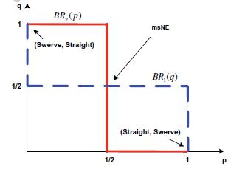

- Consider now that the game is sequential, with Player 1 choosing between Straight or Swerve as the leader and Player 2, observing Player 1’s choice, responds with Straight or Swerve. Find the Subgame Perfect Nash Equilibrium (SPNE) of the game. Interpret why the SPNE of the game differs from the msNE you found in part (d).

  - We first depict the game tree of the sequential-move version of the Chicken game.

 | Player 1
 | Straight | Swerve
Player 2 |  | Player 2
Straight | Swerve | Straight | Swerve
0 | 3 | 1 | 2
0 | 1 | 3 | 2
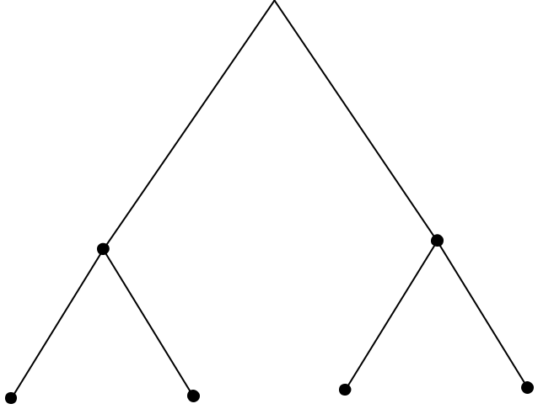

We next circle the subgames in this extensive-form game, where Subgame 1 is the whole game, and Subgames 2 and 3 are initiated after Player 1 chooses Straight and Swerve, respectively.

 | Player 1 |  | Subgame 1
Straight |  | Swerve
Player 2 | Subgame 2 | Player 2 | Subgame 3
Straight | Swerve | Straight | Swerve
0 | 3 | 1 | 2
0 | 1 | 3 | 2
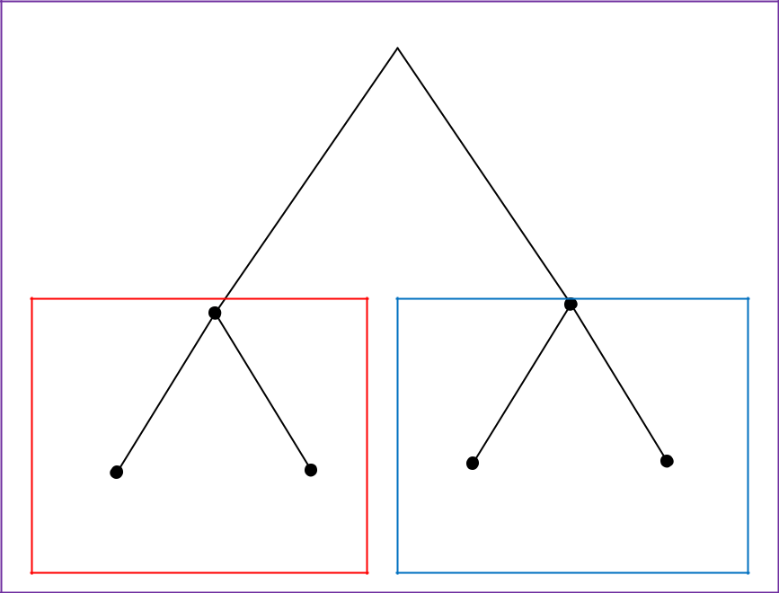

Second stage. Using blue arrows, we depict Player 2’s best responses after observing Player 1’s move:

- Subgame 2. After Player 1 chooses Straight, Player 2 responds with Swerve since its payoff from doing so (1, that is, avoiding a heads-on collision but being humiliated by Player 1) is higher than from Straight (0, implying a heads-on collision). Intuitively, Player 2 observes that Player 1 has already chosen Straight, should choose Swerve, which is better than choosing Straight.

- Subgame 3. After Player 1 chooses Swerve, Player 2 responds with Straight since its payoff from doing so (3, that is, avoiding a heads-on collision and humiliating Player 1) is higher than from

Swerve (2, that is, avoiding a heads-on collision but neither humiliating nor being humiliated by Player 1). Intuitively, Player 2 observes that Player 1 has already chosen Swerve, should choose Straight, which is better than choosing Swerve.

We can see that Player 2 responds by choosing the opposite action as Player 1.

 | Player 1
 | Straight | Swerve
Player 2 |  | Player 2
Straight | Swerve | Straight | Swerve
0 | 3 | 1 | 2
0 | 1 | 3 | 2
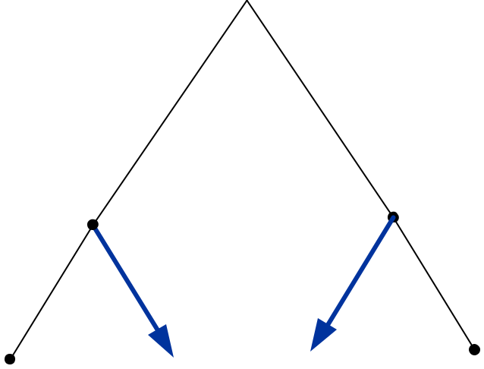

First stage. By backwards induction, Player 1 anticipates that Player 2 will respond with Straight if it chooses Swerve and Straight if it chooses Swerve. Therefore, the game tree can be depicted as the following reduced-form version, where the payoff pairs after Player 1 chooses Straight are (3, 1) since it anticipates that Player 2 will responds with Swerve in Subgame 2. Similarly, payoff pairs after Player 1 chooses Swerve are (1, 3) since it expects that Player 2 will respond with Straight in Subgame 3.

Player 1
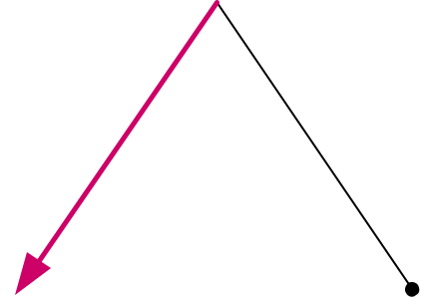

Straight Swerve

3 | 1
1 | 3

Therefore, Player 1 chooses Straight since its payoff from doing so, 3, is higher than that from Swerve,

- In words, since Player 1 anticipates that Player 2 will choose something different from what he chooses, Player 1 is better off choosing Straight than Swerve.

As a result, the strategy profile

SPNE = {Straight, (Swerve, Straight)}

is the Subgame Perfect Nash Equilibrium (SPNE) of this sequential-move Chicken game. The first component of the triplet indicates Player 1’s action in equilibrium, the second element represents Player 2’s response to Player 1 choosing Straight (in Subgame 2), and the third element describes Player 2’s response to Player 1 choosing Swerve (in Subgame 3).

Remark. Note that the equilibrium path is different from the SPNE of the game, as it would only say {Straight, Swerve} which indicates that Player 1 chooses Straight, and Player 2 responds by choosing Swerve (in equilibrium). In the SPNE, however, we list not only the action that Player 2 chooses in equilibrium (that is, in Subgame 2) but also off-the-equilibrium (in Subgame 3, which should never be reached).

Comparing simultaneous and sequential versions of the Chicken game. Equilibrium behavior in the simultaneous-move version of the Chicken game predicts two Nash equilibria in pure strategies where either Player 1 chooses Straight while Player 2 Swerves, or Player 1 selects Swerve while Player 2 chooses Straight. Only the first outcome can be sustained in the sequential-move version of the game where, in equilibrium, Player 1 chooses Straight and Player 2 responds with Swerve. Intuitively, once Player 1 has chosen Straight, Player 2 is better off responding with Swerve than Straight (that is, avoiding a car crash with Player 1!)

