Wanphatu Vilaipun 5604642024
For the past 40 years South Korea, officially known as the republic of Korea economic growth has increased exponentially bringing the country from poor economy to high-income country as classified by OECD. Some even claimed the country as a successful economic development country or referred to the country as one of the fastest growing economy in the world. By facing with a sudden rise in income, the country has developed in many ways such as improvement in welfare, health care and education. However, most people in the country see human capital as essential aspect in further development, many see education as one of the most important tool. Due to the fact that as the economy becomes wider, they require more skilled labor to fulfill the jobs and make further improvement. Education therefore plays an important part in doing so. As a result of that both public and private sectors have participated in. However, in order to maintain the quality of education, the education system in Korea is a centralized system where Ministry of Education takes control of all the education systems along with pressure of people desire for better education system that the Ministry need to fulfill.
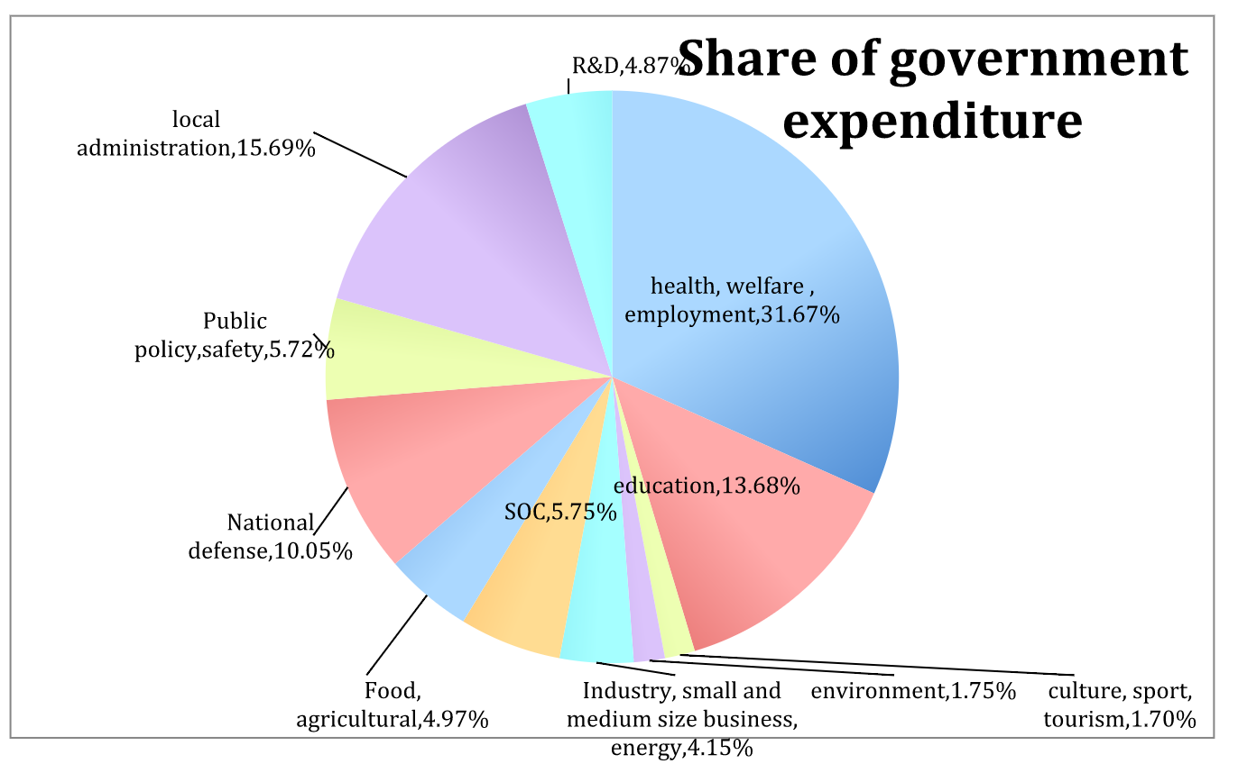
From the pie chart below, it shows South Korea’s government expenditure classified by functions. The pie chart shows that education is considered as one of a primary concern for government, being in the third largest percentage of government’s expenditure. The highest percentage is health, welfare and employment followed by local administration then education. This confirms the fact that Korea’s government uses large portion of its expenditure on education.

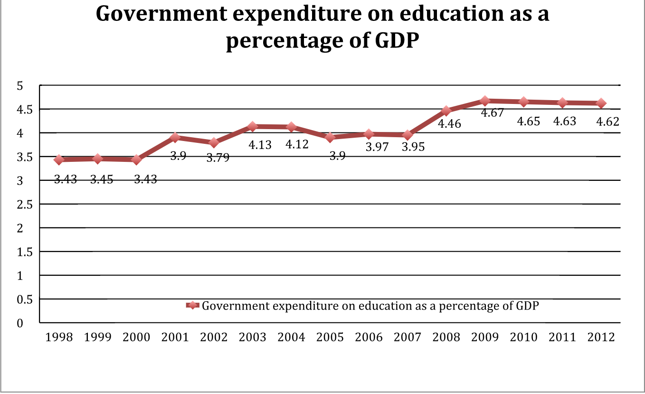
The diagram represents government expenditure on education as a percentage of GDP. The diagram illustrates the fact that South Korea’s government has focused more on education during the past years resulting in an increasing trend from 1998 to 2012.

This again confirms the fact that education is an important and required tool for economic development. Not only a higher percentage of government expenditure on education but also a rise in percentage of the government expenditure on education as a percentage of government total expenditure. This illustrates the fact that Korea’s government has been using larger amount of its revenue on education, mostly to improve the quality of the system which majority of people in the country desired for resulting in a high competition for university entrants in order to get into well established companies such as Samsung, LG. Moreover, one claim that supports this suggestion is that the government’s budget from education in 2012 is 29 billion US dollars which is nine times larger than those ten years ago, implying that education is considered priority to Korean people. The diagram below represents South Korea’s government expenditure on education as a percentage of its total expenditure.
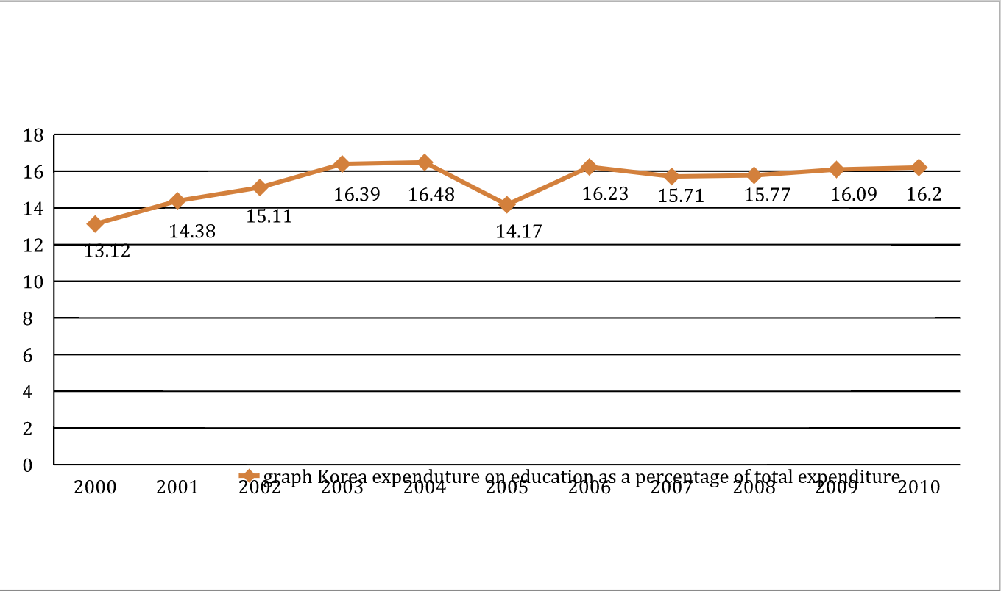

South Korea’s government has developed many education policies in order to achieve its goals. The government’s primary goal is to educate people so that they can use their knowledge to increase the number of skilled labor. Moreover, as they already achieved their target number of students enrolled in primary and secondary school reflecting in all eligible student of an age enroll in elementary school and more than ninety percent participated in secondary school. Rather than the number of students enrolled, the country also concerned about quality of the education system which it enlarge the size class and school hours to achieve the target level leading their students to do well in the Program for International Student Assessment (PISA).
Therefor the government now aims to expand number of students enrolled for tertiary school and to improve the quality of the system, by setting high salary for those who finished tertiary school as well as increase the salary for eligible teacher for the program. By doing so, for the past three years approximately 70 percent enrolled for the program. The diagram bellow shows gross enrolment rate for primary school, secondary school and tertiary school represented for both sexes represented by blue, red and green line respectively. Primary school has the highest gross enrolment rate since all population can access to this level since there are no fees occurred, the same thing apply to secondary school but a slight decrease results mainly from distance to school, children are needed at home and family migration. However, the lowest rate goes to tertiary education since the person has to bear all the cost that incurred.
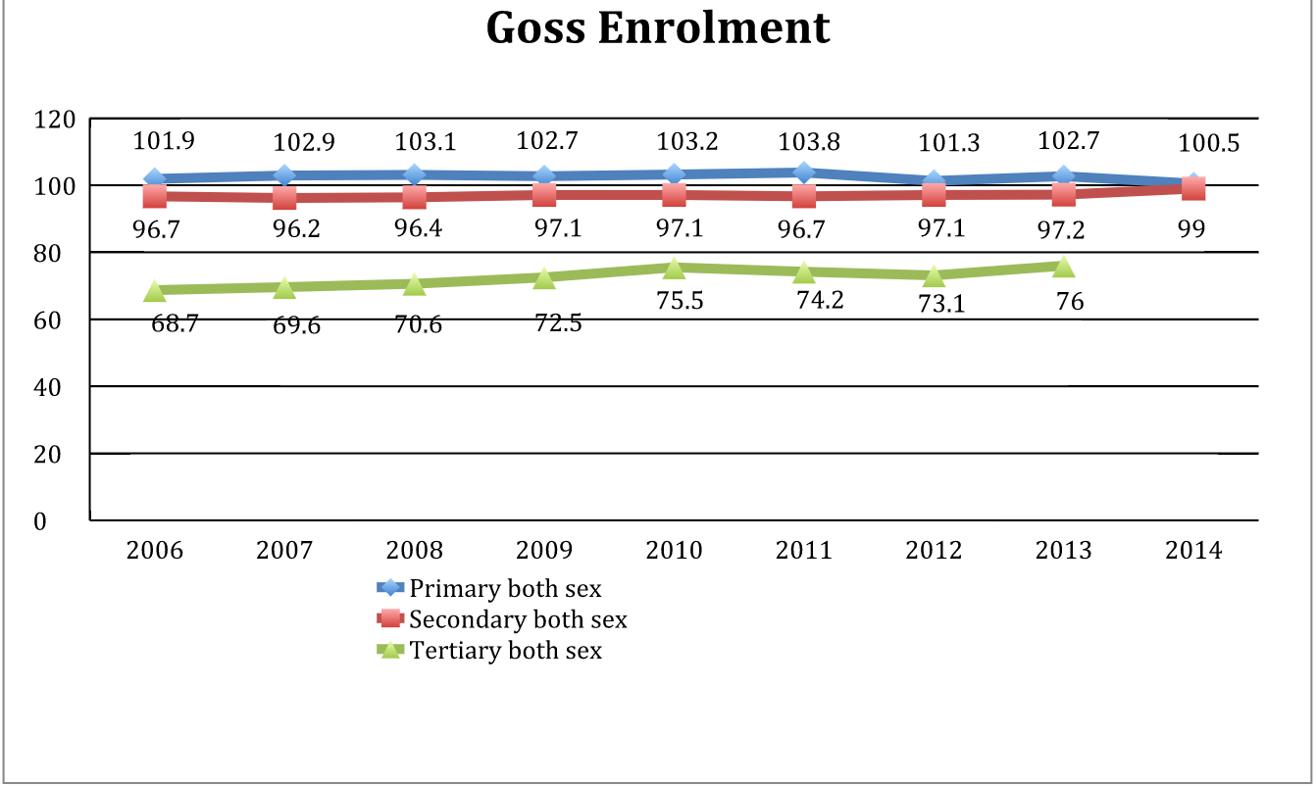

Furthermore, South Korea also adopted lifelong learning as its national criteria. This policy aims to give all the population equal opportunity for learning, in order to improve their lives as well as social development. By adopting these policies, South Korea has shown that its country relied on several international organization such as UNESCO who was the first one to establish these policies. However, the life long learning policy has been successful in terms of providing basic education for the population but it still requires a much more strong policy in order for poor people to get the right to access to all these systems. However, the problem of Korea’s education system seems to be the fact that they are over invested after a long period of heavy human investment, many families have sent their children to attain most of the education levels overseas making the number of country loss in education trade grows. Moreover, the country still lack of skilled labor in particular location which the demand may arise rapidly as a result of a rapid change in technology making the government to provide labor in a mistaken purposes. Other than that, it should be marked that there are no quality in education attainment between the rich and the poor in the country since it should be noted that there are no free education beyond elementary school, which parents need to bear all the cost for that, implying that private sectors have been playing more important role for this. However, for the some households, they might not be able to bear all the cost of enrolling in school, which sometimes also include the cost for extra tutorials as a result of a highly competitive system.

