Assignment 3
Exercise 5.4 No. 5,6
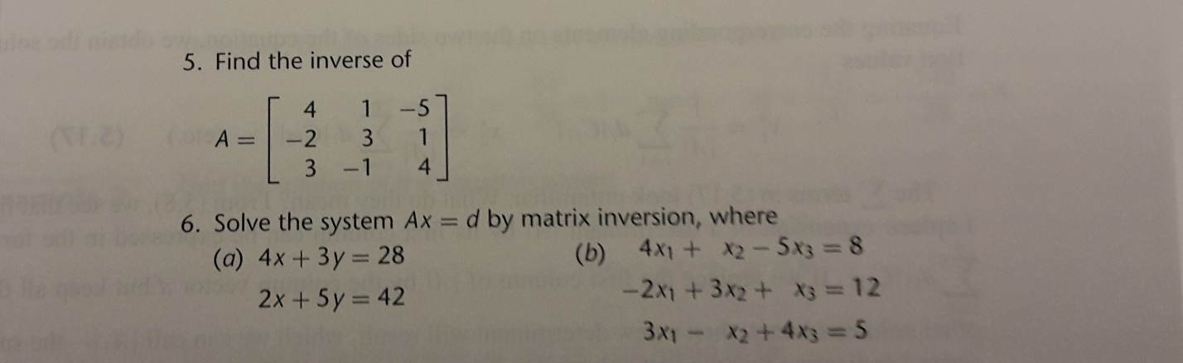
Exercise 5.5 No. 3
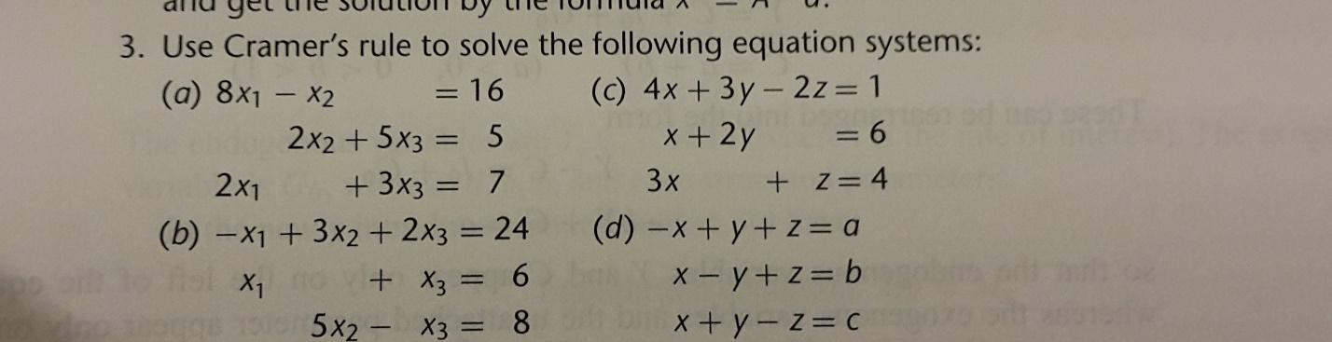
Exercise 5.7 No. 3 (Skip (b))
*** Sorry I was wrong. I mean this one!


