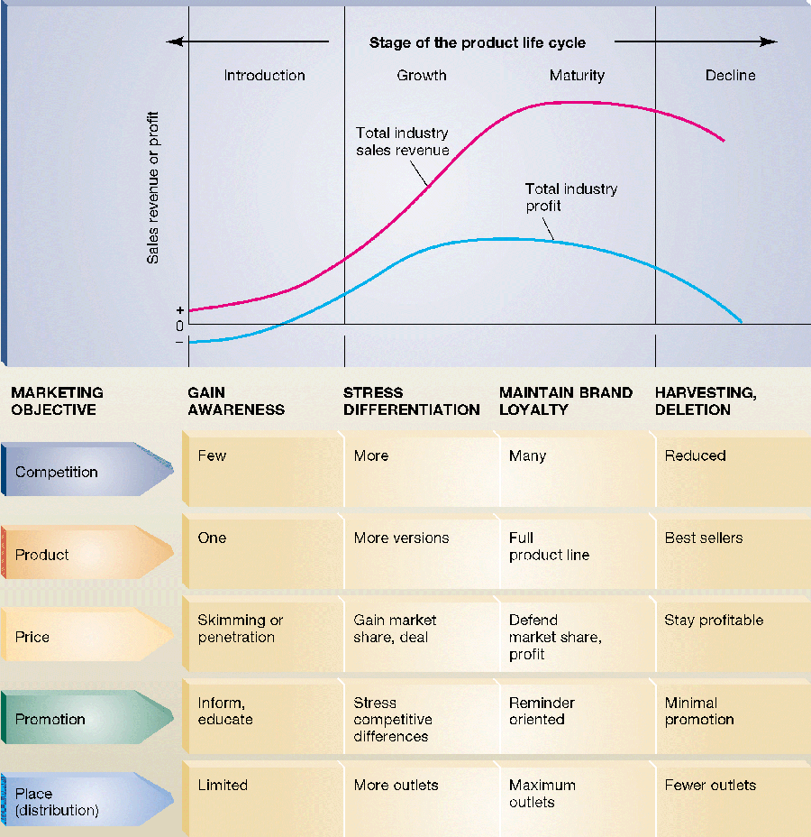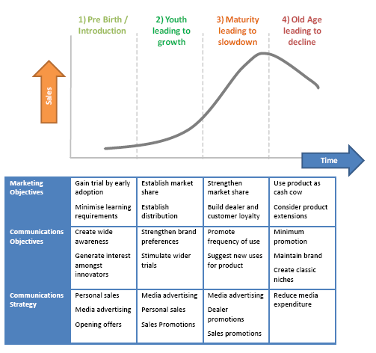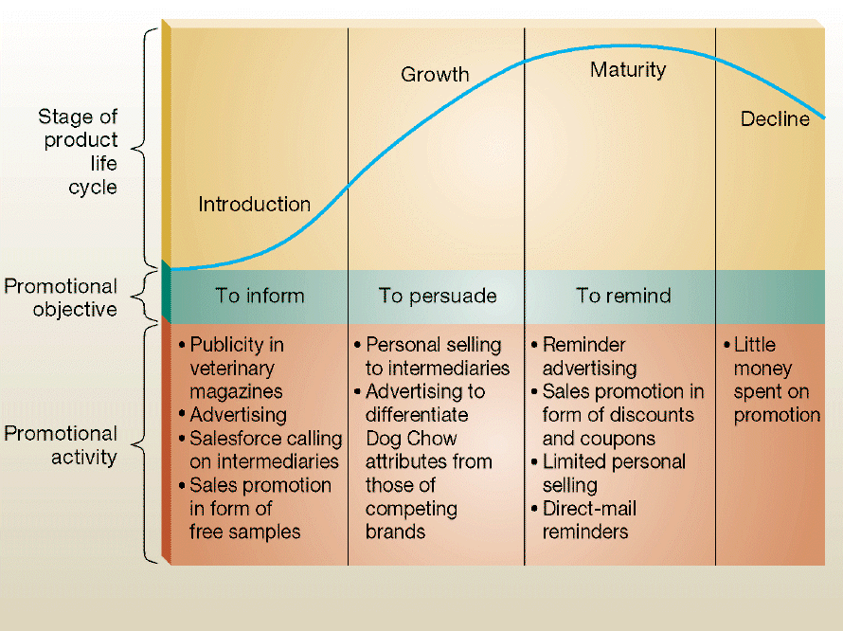

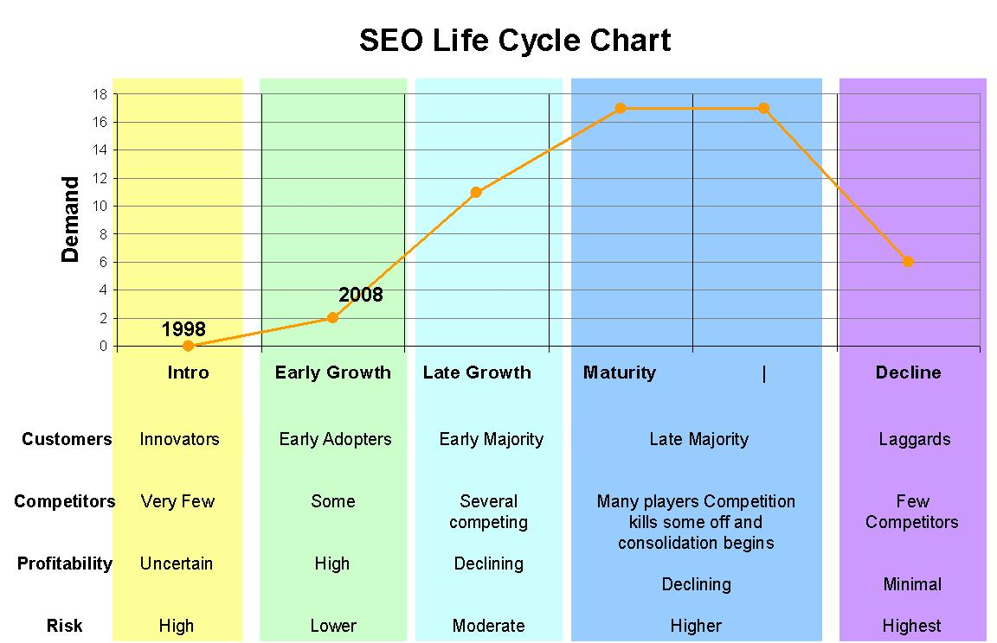
Read more in
http://www.quickmba.com/marketing/product/lifecycle/
http://www-rohan.sdsu.edu/~renglish/370/notes/chapt11/index.htm

