

INFLUENZA PANDEMIC AND ITS IMPACTS ON INEQUALITY IN JAPAN

BY:

ARUNRAT LAPSONGSAKUL 6104640906
PANUWAT CHALEAYSUK 6104640922
INTHAD THASSANEEPHAB 6104641292

THIS STUDY SUBMITTED IN PARTIAL FULFILMENT OF THE REQUIREMENT FOR
FINAL PROJECT IN EE406 CONTEMPORARY ECONOMIC ISSUES
FACULTY OF ECONOMICS (INTERNATIONAL PROGRAM)
THAMMASAT UNIVERSITY
ACADEMIC YEAR 2020

ABSTRACT

This paper aims to study the nature of the pandemic of influenza in Japan and its impact on Japan's economies, attempting to understand the way that pandemic results are diverse. The recent cases will be discussed, in order to address what variable was driven behind the problem, for example inequality between genders during and after the pandemic. Furthermore, we will argue the effective plans and policies to prepare or to possibly prevent the outbreak in future.

TABLE OF CONTENTS

ABSTRACT 2
TABLE OF CONTENTS 3
CHAPTER 1 3
INTRODUCTION 3
CHAPTER 2 4
2.1 JAPANESE SOCIAL STRUCTURE 5

2.2 INFLUENZA IN JAPAN 5
2.2.1) Spanish Influenza in Japan (1918-1919) 5
2.2.2) Asian Influenza in Japan (1957-1958) 6
2.2.3) Hong Kong Influenza in Japan (1968-1969) 6
2.2.4) Seasonal influenza in Japan (2009) 6

2.3 THE ECONOMIC EFFECT OF INFLUENZA 7
2.3.1 INCOME INEQUALITY 9
2.3.1.1 Comparing Gini Index During the Novel Influenza Outbreak With the World Economic Effect Of Influenza 11
2.3.2 LEVEL OF EDUCATION 11
2.3.3 AGE GROUP 12
2.3.4 JAPANESE SOCIAL STRUCTURE 12

2.5 PLAN AND STRATEGY 13
CHAPTER 3 15
REFERENCES 16
APPENDICES 18

CHAPTER 1

INTRODUCTION

Influenza, or flu, is a contagious disease that is transmitted through the respiratory system which is caused by influenza virus. This virus is different from common cold as the virus can lead to serious health problems such as pneumonia or sometimes can lead to death. Influenza is divided into 4 strains: A, B, C, and D. The most infectious strains are influenza A and B which causes 560000 dead per year and already infected over 5 million people around the world. As influenza can easily be infected by tiny droplets, the disease was rapidly spread to the entire city once the outbreak was started. In this report, we will analyze the impact of influenza on poverty and inequality by analyzing several influenza pandemics cases that happen throughout history such as Asian influenza, Spanish flu, and Hongkong influenza, and novel influenza.
The issue of the impact of the pandemic outbreaks (or aftershocks) can vary. However, there should be a characteristic of the aftershocks. According to “the global economic effect of pandemic influenza” by George Verikios et al, (2011), The model that this paper uses data to analyze economics shock based on four types of shocks: increase in demand of medical service, lost workdays, reduction in inbound tourism, and permanent reduction of labor force or deaths. These economic impacts will be used to analyze the increase in poverty and inequality.
In addition, in this paper, we will go through some of the pandemic cases that occur in Japan and around the world which we will extract some information from each pandemic in order to create the conceptual framework.

CHAPTER 2
BODY

2.1 JAPANESE SOCIAL STRUCTURE

Japan is a unique society that derived from isolation and separation from the international for centuries. Japan is known for the world’s leading unique cultures, such as films, arts, Manga, fashions and animations. This paper provides brief aspects of Japan by using Hofstede Insights analysis throughout the six different factors, including power distance, individualism, masculinity, uncertainty avoidance, long term orientation, and indulgence. The result shows that Japanese are highly conscious about hierarchical positions in the society, and
are more private and reserved than most other Asian nations. Then, we found that Japan has Feminine society, meaning that they are caring for others and quality of life; the society is driven by competitions, achievements, goals, and successes. Japan is one of the most uncertainty avoidance countries, since they are constantly threatened by natural disasters, and is always adapting to modern trends to prepare for the future. Japan has been experiencing a consistently low birth rate, and is also the fastest aging population in the world. The rate of immigration into the country per national population has been stable.
Hara (2011) defines inequality in Japan into two sections, changes in inequality of possession and changes in inequality of opportunity. Inequality of possession refers to disparity in distribution of the tangible and intangible products, for example income, assets, information and social privilege. Based on the Gini coefficient, which is an index of the household income inequality, a value of zero shows perfect equality and a value of one show perfect monopoly. Inequality of opportunity refers to inequality, which opportunity that is leading to the possession of goods are available, for example personal ability, personal desire and effort are factors that could bring you to opportunities for higher education and employment.

2.2 INFLUENZA IN JAPAN

Epidemics in the past of Japan include Spanish Influenza (1918-1919), Asian Influenza (1957-1958), Hong Kong Influenza (1968-1969), Novel Influenza A (H1N1) (2009-2010). As the virus spreads all around the world and many people acquire immunity against the novel influenza virus, it becomes seasonal influenza. H1N1 Influenza (2009) is now treated as seasonal influenza since April 2011.

2.2.1) Spanish Influenza in Japan (1918-1919)

In 1918-1920, the Spanish has started to ruin Japan. As using the data acquired from the Ministry of Home Affairs, Government of Japan, unexpectedly the government has already prepared some piles of data and information of the discovery of influenza virus before the outbreak. States in the document that the epidemic occurred in three waves, which the first wave occurred during August 1918-July 1919, October 1919-July1920 during the second wave, and August1920-July1921. The total count of the patients that have been confirmed infected in the three waves were 21,168,398;2412,097; and 224,178, accordingly with 257,363; 127,666; and 3,698 deaths during each wave. Fatality rates of this epidemic are 1.22z, 5.29z, and 1.65z respectively during each wave.

2.2.2) Asian Influenza in Japan (1957-1958)

Asian flu has entered Japan during 1957-1958 which occurred when the baby boomer’s generation were born in 1947-1949 which are in the school age, and many school outbreaks occur. Assume from the information acquired from the Japan Public Health Association, Asian Influenza started its outbreak during May 1957, starting from the spread in primary schools located in Tokyo and Kyoto. After only 2 weeks, the epidemic has started to spread to 25 districts. The result came by School closings one after another. Information stated that in June 19,1957, more than 5,000 schools were affected and approximately 1,750 schools were temporarily shut down. The fatality rate of this epidemic is 0.8z, half of the japanese population were expected to have been infected by the Asian flu.

2.2.3) Hong Kong Influenza in Japan (1968-1969)

As published by Japan Public Health Association, Hongkong influenza has its entry to Japan by the Israeli crew on a cargo ship during August 1, 1968. September 5 is when the first Japanese case of the infection occurred in Osaka, Tokyo, and Nagoya. The patient numbers began to rise at the beginning of October, and the outbreak lasted until January of the following year. An outbreak of influenza B that continued during the early phase of the Hong Kong flu epidemic followed the Hong Kong flu epidemic.

2.2.4) Seasonal influenza in Japan (2009)

In April 2009, pandemic H1N1 influenza cases were first recorded in Mexico. The virus spread quickly in the United States and Canada afterwards, and then became a global concern. In response to the World Health Organization's elevated pandemic warning level, initial countermeasures were adopted by the Japanese government, including extensive fever screening at ports of entry.

A pandemic H1N1 influenza outbreak occurred in Hyogo and Osaka prefectures in May 2009 in the Kansai region of Japan and was contained by the end of the month. The virus appeared again after the beginning of July and spread across Japan. As shown in the table, the infected numbers are divided by age group.

Figure 2.1
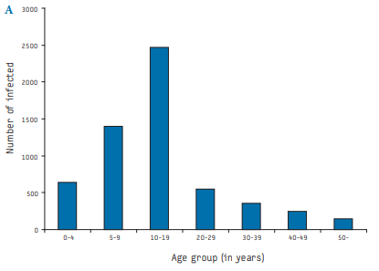
Source: H. Yasuda, K. Suzuki

2.3 THE ECONOMIC EFFECT OF INFLUENZA

According to George Verikios et al, (2011), There were four economic shocks that apply to the research: increase in demand of medical services, loss of workdays, deaths, and reduction of inbound tourism. In this paper, we will use these shocks to analyze the impact on poverty and inequality. George Verikios et al, (2011) stated that the countries that have greater economic integration with the world economy, which mostly by international trade, tend to get more affected by the pandemic. Japan is also one of the economic integration countries that rely on exporting electronic goods.

Figure 2.2
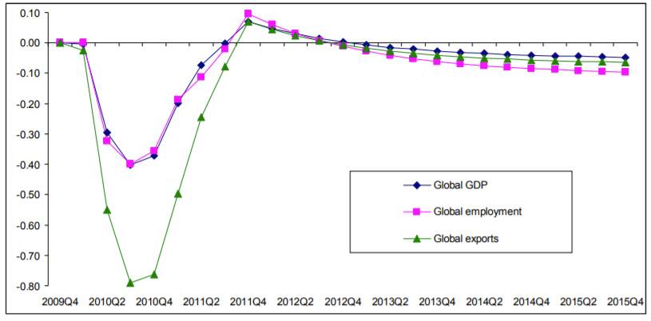
Source: static.rms.com

In the first illustration, it depicts the impact of influenza on Global GDP, employment rate, and exports. The graph shows that after the pandemic in 2009, many countries faced a recession with the decreasing rate of GDP, employment rate, and global export which all have the highest decreasing rate in the middle of quarter 2 in 2010. The reduction in GDP, employment, and export rate were the result from analyzing the shock

Figure 2.3
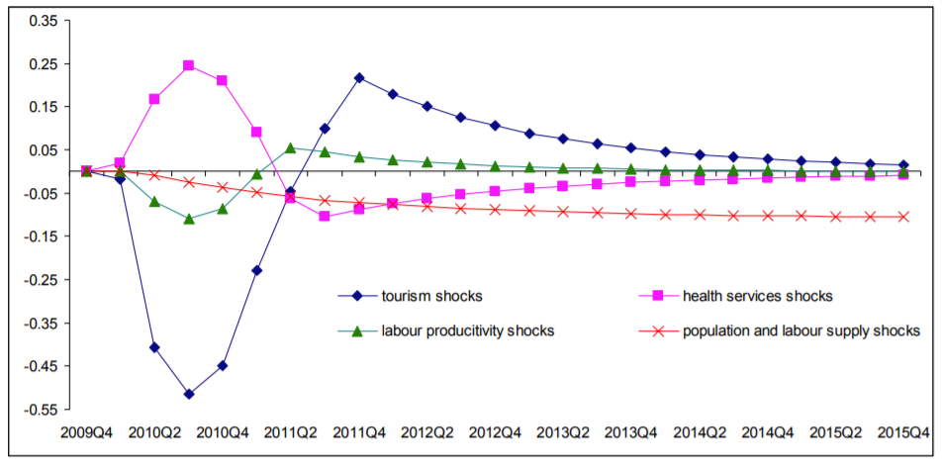
Source: static.rms.com

As we can see from the graph, there were only 3 shocks that followed the trend in decreasing rate of GDP, employment rate, and exports: tourism shocks, health services shocks, and labor productivity shocks. However, population and labor supply shocks were shown the sign in the long-run. From all of the information we have, we can create the following conceptual framework.

Figure 2.4
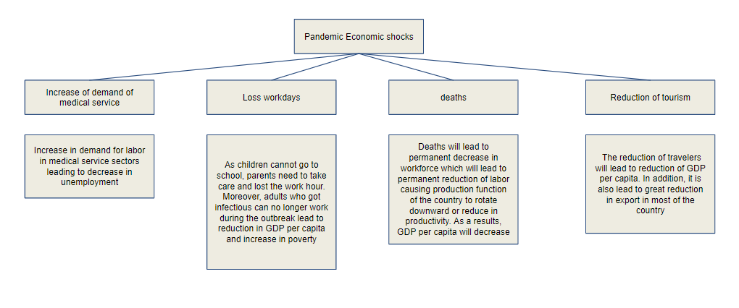

Firstly, with the increase of medical services, it will lead to increase in demand for labor in medical service sectors leading to the decrease in unemployment rate which will yield a positive impact to the shock. Secondly, the loss of workdays occurs as the children can no longer go to school and parents need to take care of their children. Moreover, loss of workdays also occurs as a result of infection of the virus. This will result in a lack of income which makes some household income per day may lie below the poverty line. As a consequence, GDP per capita will fall after the pandemic occurs. Thirdly, deaths will lead to permanent decrease of labor force which causes the reduction in productivity. Lastly, the reduction in transportation and traveling industries lead to reduction of GDP per capita and causing the decrease in export goods which significantly affect the GDP per capita. We can conclude that the pandemic can cause poverty to occur as some individuals can no longer generate the income during the outbreaks.

2.3.1 INCOME INEQUALITY

There are several determinants that drive the inequality in Japan. In this paper, we will discuss only some factors that are driven behind. We would like to use the Gini coefficient to determine the inequality in the past pandemic. This coefficient presents the movement of income distribution within a country from a particular timeline, so that we may see changes whether increase or decrease of inequality. However, to measure growth of a country, we should not conclude a country’s economic performance from Gross Domestic Product, or GDP standard measure only, since we may have to include the equally distributed income and the poverty gap into the consideration as well.

Figure 2.5
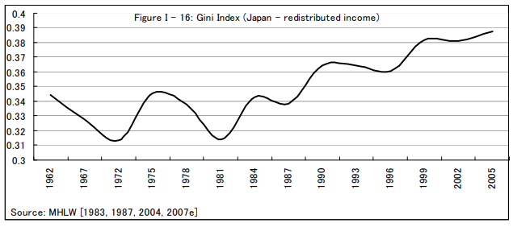
Source: MHLW

Figure 2.5 shows changes in the household income disparity from 1962 to 2005. There is a significant drop from 1962 to 1970, which is a period after the Asian Flu Pandemic, the Japanese government started a vaccinate school children program and resulted in reducing transmission of the influenza. From the figure, we can see that the inequality in Japan began to decrease, then gradually reducing in 1967, and finally to 1972. However, this downward trend of income distribution mainly contributed to the aging of the population of Japan, since elderly people tend to have the biggest income disparity, and we found that Japan inequality was not affected by the pandemic.

2.3.1.1 Comparing Gini Index During the Novel Influenza Outbreak With the World Economic Effect Of Influenza

Figure 2.6
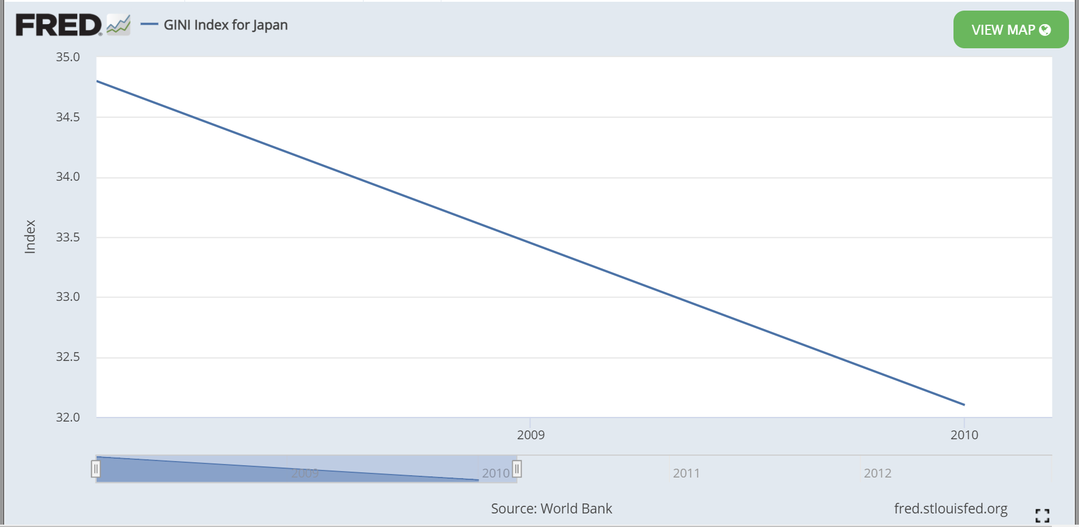
Source: World Bank

According to the illustration, we did not find any significant correlation between influenza pandemic and GINI coefficient. The illustration stated that since the beginning of the outbreak of the novel influenza pandemic until the end, the GINI coefficient of Japan did not increase. In other words, the GINI coefficient, which measures the inequality of income distribution, cannot be used to determine the level of impact of pandemic on inequality. However, we will use another measurement in order to focus on the inequality between individuals in Japan: by using the vaccination rate that varies amongst the receiver group through the healthcare system. For instance, we will illustrate the vaccination rate amongst different levels of educational attainment of individuals.

2.3.2 LEVEL OF EDUCATION

To identify the effect of the influenza pandemic, level of education should be included into the consideration. Plus, education may help individuals to develop skills, improve their social status and gain access to networks that could lead to enhanced social outcomes, independently from the effect of education on income. Chinzorig et al, (2019) found the reasons for receiving vaccination between the different age groups. For the population aged 20 to 64 years old with a higher degree of education and being “Managed by school or company” is associated with higher influenza vaccination rate as people who have attained higher levels of education are generally more likely to have more access to information than those with lower levels of educational attainment. However, for people aged more than 65 years old, there is no relationship discovered between level of education and vaccine coverage. In addition, the level of education will result in better income and better workplace which will affect the healthcare policy inside the company that individuals work. In other words, with a higher level of education, you will receive a high chance of getting free vaccination.

2.3.3 AGE GROUP

More than 20 percent of Japan’s society consists of an aging population ranging over 65 years old or older, which respectively comes from the increase in the proportion of the elderly in the total population and the slow growth of the population that derived from the overall declining fertility rate of Japan. These aging populations may further result in soaring health care costs for the Japanese government. There are many recent studies that discover social inequalities during the distribution of influenza vaccination in Japan. Shanks and Brundage (2012) state that during pandemics, particularly young children, the older population and in general people who are already ill are vulnerable. Wang et al. (2015) also agree that “adult men tended to have higher risks of excess hospitalization associated with seasonal and pandemic influenza than adult women, except that women of reproductive age and older age had higher risks of excess hospitalization associated with pandemic influenza than men.” However, all Japanese citizens aged more than 65 years old are covered by the Japanese Immunization Act that provides local governments to partially subsidize influenza vaccination coverage.

2.3.4 JAPANESE SOCIAL STRUCTURE

Japan is a unique society that derived from isolation and separation from the international for centuries. Japan is known for the world’s leading unique cultures, such as films, arts, Manga, fashions and animations. This paper provides brief aspects of Japan by using Hofstede Insights analysis throughout the six different factors, including power distance, individualism, masculinity, uncertainty avoidance, long term orientation, and indulgence. The result shows that Japanese are highly conscious about hierarchical positions in the society, and are more private and reserved than most other Asian nations. Then, we found that Japan has Feminine society, meaning that they are caring for others and quality of life; the society is driven by competitions, achievements, goals, and successes. Japan is one of the most uncertainty avoidance countries, since they are constantly threatened by natural disasters, and is always adapting to modern trends to prepare for the future. Japan has been experiencing a consistently low birth rate, and is also the fastest aging population in the world. The rate of immigration into the country per national population has been stable.

Hara (2011) defines inequality in Japan into two sections, changes in inequality of possession and changes in inequality of opportunity. Inequality of possession refers to disparity in distribution of the tangible and intangible products, for example income, assets, information and social privilege. Based on the Gini coefficient, which is an index of the household income inequality, a value of zero shows perfect equality and a value of one shows perfect monopoly. Inequality of opportunity refers to inequality, which opportunity that is leading to the possession of goods are available, for example personal ability, personal desire and effort are factors that could bring you to opportunities for higher education and employment.

2.5 PLAN AND STRATEGY

Firstly, we will talk about the plan and strategy to deal with the economic recession due to the reduction of labor force, productivity, and tourism. In order to sustain the economies, we need to implement the policy that will result in increasing the GDP per capita which are increase the government spending, encourages foreign investment, and encourage domestic consumption. Considering the three aspects mentioned earlier, we should impose a monetary policy that will encourage domestic consumption. In other words, we should encourage domestic tourists to travel inside their own country. For instance, the government should impose discount coupons for individuals to travel wherever they want. Moreover, the government can also decrease the consumption taxes temporarily in order to increase the consumption level inside the country. Moreover, the nation bank should also decrease the interest rate which will encourage investment inside the country. As a consequence, the economy should recover from the recession.

In order to solve the problem of inequality of healthcare distribution, when there is a future pandemic situation, the government should set up a new unit that takes care of pandemics, consisting of people who are specialized in a particular area. Governments impose a policy to equally distribute information to people shall be taken into consideration.

Previous proof and studies have shown that vaccination in recent years schoolchildren have been the answer to reducing transmission of influenza in the United States also in Japan. In the past, Japan 's policy to combat influenza has been to vaccinate schoolchildren on the basis of the idea that influenza epidemics could be minimized by vaccinating schoolchildren. A special program for school child influenza vaccination started in 1962, but the Japanese government discontinued the program in 1994, due to a lack of evidence that the spread of influenza in the population had been reduced. The program granted a 36% reduction in adjusted mortality to Japanese seniors, equivalent to 1,000 senior deaths. During the time when the Mass School Child Vaccination Program was in place, Japanese schoolchildren acted as a shield against the influenza. Moreover, the US Centers for Disease Control and Prevention (CDC) has recommended annual influenza vaccination for all individuals aged ≥6 months without contraindications.

CHAPTER 3
DISCUSSION

According to our research, we find that the influenza pandemic does not impact income inequality. However, it does have an impact on the economy by causing the permanent and temporary decrease in workforce which will result in reduction in productivity and output of the country. Most importantly, the pandemic also caused the travel restrictions resulting in the reduction of export goods and tourists. As a result, we suggest that the government should impose the policy that will 1. increase government spending 2. encourage investment in the country 3. encourage domestic consumption.
Next, we use the vaccination rate to illustrate the inequality amongst different groups of individuals such as different age groups, different levels of education attainment. The government should find a replacement unit to require care of pandemics, composed of individuals who are trained in an exceedingly specific field, so as to handle the difficulty of healthcare distribution disparity when there's a possible pandemic. Governments are expected to require under consideration a method to allocate knowledge fairly to individuals.

A brand-new unit should be formed by the government to require treatment for pandemics, composed of people who are qualified in a very specific area, to deal with the challenge of inequality in healthcare distribution when there is a potential pandemic. Governments are required to require a system under consideration to equally distribute information to people.

REFERENCES

Alcorta, J. (2009). Neoliberal cycles and solidarity economies: a comparative study of Argentina and Japan.

Chinzorig, T., Sugiyama, K., Aida, J., Tsuboya, T., & Osaka, K. (2019). Are social
inequalities in influenza vaccination coverage in Japan reduced by health policy?
Preventive Medicine Reports, 16.

Eshima, N., Tokumaru, O., Hara, S., Bacal, K., Korematsu, S., Tabata, M., Karukaya,
S., Yasui, Y., Okabe, N., & Matsuishi, T. (2011). Sex- and Age-Related Differences in
Morbidity Rates of 2009 Pandemic Influenza A H1N1 Virus of Swine Origin in Japan.

Fukumi, Hideo. (‎1959)‎. Summary report on the Asian influenza epidemic in Japan, 1957. Bulletin of the World Health Organization, 20 (‎2-3)‎, 187 - 198. https://apps.who.int/iris/handle/10665/265333

Hara, Junsuke. (2011). An Overview of Social Stratification and Inequality Study in Japan: Towards a `Mature' Society Perspective. Asian Journal of Social Science. 39. 9-29. 10.1163/156853111X549821.

Longini, I. M. (2005). Strategy for Distribution of Influenza Vaccine to High-Risk Groups and Children. American Journal of Epidemiology, 161(4), 303–306. doi:10.1093/aje/kwi053

Norio Sugaya (2014) A review of the indirect protection of younger children and the elderly through a mass influenza vaccination program in Japan, Expert Review of Vaccines, 13:12, 1563-1570, DOI: 10.1586/14760584.2014.951036

Raymond A. Strikas, Gregory S. Wallace, & Martin G. Myers. (2002). Influenza Pandemic Preparedness Action Plan for the United States: 2002 Update. Clinical Infectious Diseases, 35(5), 590-596. Retrieved November 26, 2020, from http://www.jstor.org/stable/4462133

Rice, G., & Palmer, E. (1993). Pandemic Influenza in Japan, 1918-19: Mortality Patterns and Official Responses. Journal of Japanese Studies, 19(2), 389-420. doi:10.2307/132645

Shanks, G.D., Brundage, J.F., 2012. Pathogenic responses among young adults during the
1918 influenza pandemic. Emerg. Infect. Dis. 18, 201–207. https://doi.org/10.3201/
eid1802.102042.

Sugaya, N. (2014). A review of the indirect protection of younger children and the elderly through a mass influenza vaccination program in Japan. Expert Review of Vaccines, 13(12), 1563–1570. doi:10.1586/14760584.2014.951036

Yasuda H, Suzuki K. Measures against transmission of pandemic H1N1 influenza in Japan in 2009: simulation model. Euro Surveill. 2009;14(44):pii=19385.

Yoshikura H. Spanish flu, Asian flu, Hong Kong flu, and seasonal influenza in Japan under social and demographic influence: review and analysis using the two-population model. Jpn J Infect Dis. 2014;67:245257.

APPENDICES

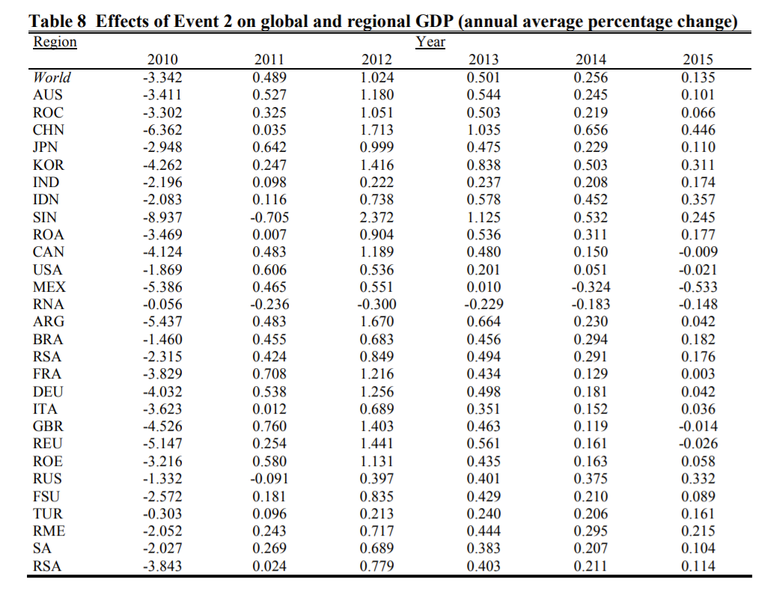
Source: static.rms.com

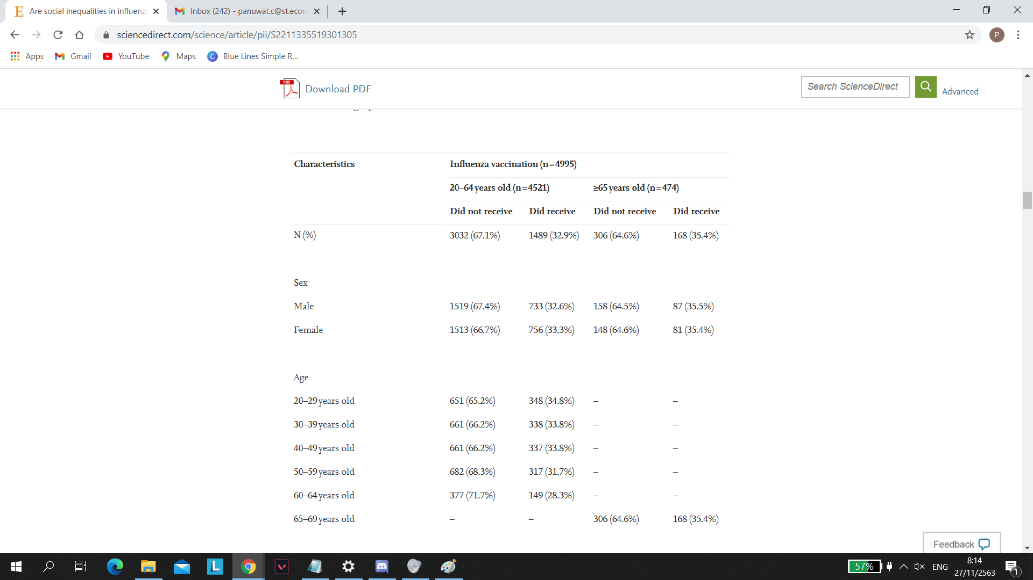
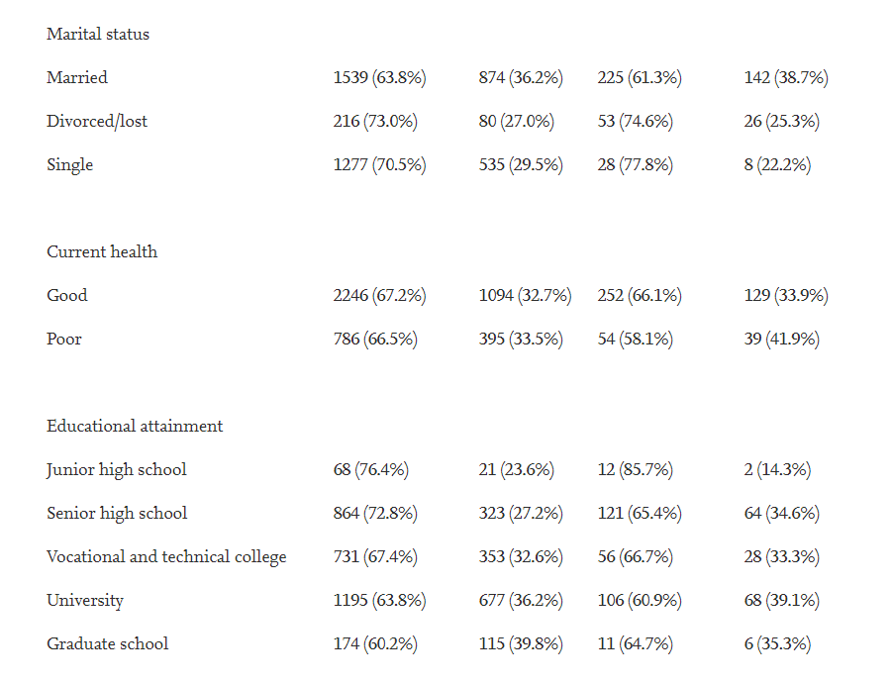
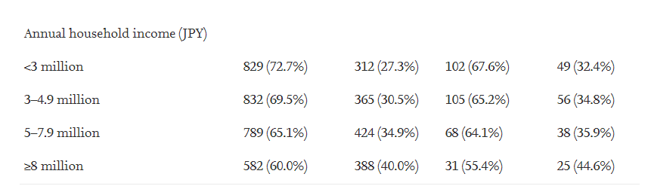
Sources: Chinzorig, T., Sugiyama, K., Aida, J., Tsuboya, T., & Osaka, K. (2019). Are social
inequalities in influenza vaccination coverage in Japan reduced by health policy?

