Natchalin Iwsakul
6104640153

Assignment3

- Estimate the model assuming that the probability function is (a) cumulative normal probability distribution function and (b) logistic probability distribution function. Interpret your estimated result (overall test, individual test, pseudo R 2 , counted R 2 ).
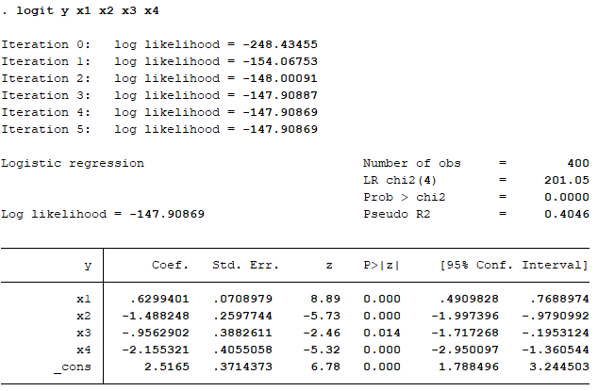

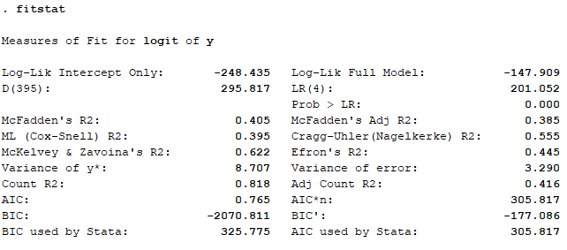

The first two Stata’s tables are for Logit estimation model. The overall test (Prob > Chi2 = 0.000) shows us that, with 95% confident level, H₀: β₁ = β₂ = β₃ = β₄ = β₅ = 0 is rejected as 0.000 is less than 0.05 significant level. The individual tests, which is P- value of Z-score, on each β are all less than 0.05 significant level. Thus, we also reject H₀: β_{i} = 0. Pseudo R² can be calculated by $1-\frac{logL_{ur}}{logL_{u}}$ or equal to 0.4046. And, counted R² is calculated $\frac{No. of correct prediction}{Total No, of observation}$ or equal to 0.818.
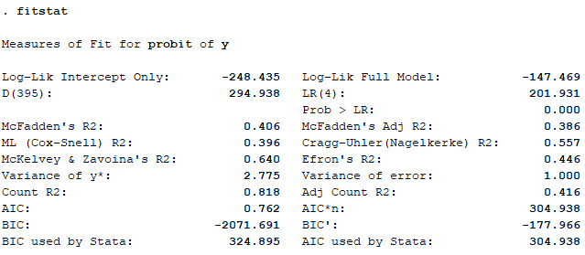
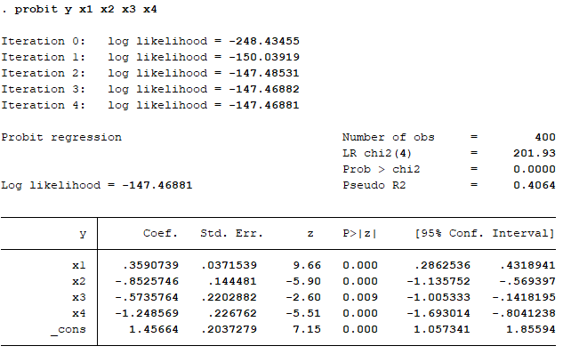

The last two Stata’s tables are for Probit estimation model. The overall test (Prob > Chi2 = 0.000) shows us that, with 95% confident level, H₀: β₁ = β₂ = β₃ = β₄ = β₅ = 0 is rejected as 0.000 is less than 0.05 significant level. The individual tests, which is P- value of Z-score, on each β are all less than 0.05 significant level. Thus, we also reject H₀: β_{i} = 0. Pseudo R² can be calculated by $1-\frac{logL_{ur}}{logL_{u}}$ or equal to 0.4064. And, counted R² is calculated $\frac{No. of correct prediction}{Total No, of observation}$ or equal to 0.818.
- Make comparison of the goodness of fit of the two models –
Pseudo R² of Probit’s model is a little higher than Logit’s model’s (0.4064 > 0.4046.) Thus, Probit’s model fits a bit better than Logit’s model.
- From Probit model, show how to compute Overall LR-test –
To compute LR-test, $2(lnL_{ur}-lnL_{r})$. From Probit’s fitstat above, 2(-147.469-(-248.435)) = 201.93
- From Logit model, compute predicted value of index value and predicted probability of being bad loan by using mean value of all Xs. –

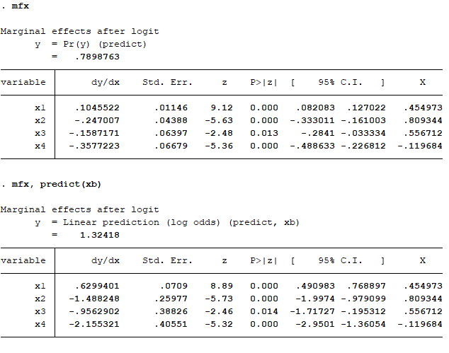

The index value (Ihat) is equal to 1.32418 as stated in “.mfx, predict(xb)” command. And, predicted probability of being bad loan by using mean value of all Xs is equal to 0.7898763 or Phat value stated in “.mfx” command.

- Compute marginal effect at mean and at median for Logit model –
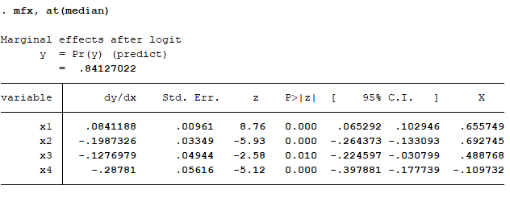
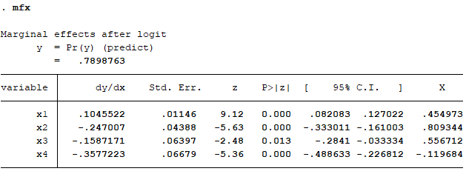

To get marginal effect of Logit model, p̂(1-p̂)β̂. For marginal effect at mean, remember that β̂₁ = 0.6299401 from above Logit model, 0.7898763(1-0.7898763)0.6299401 = 0.10455 which is the marginal effect at mean. For marginal effect at median, change p̂ to 0.84127022, you will get 0.084 as marginal effect at median.
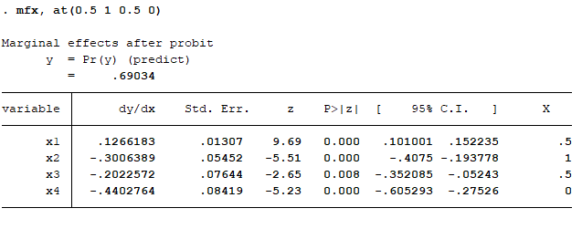
- Compute marginal effect at the value of X1=0.5, X2=1, X3=0.5, X4=0 for the Probit model. –

Thus, 0.69034(1-0.69034)(0.359) = 0.0767 as a marginal effect at the value of X1=0.5, X2=1, X3=0.5, X4=0 of Profit model.

- Determine counted R2 using the threshold of predicted value = 0.5 for Logit models.
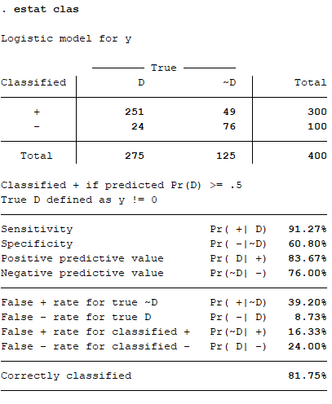
The counted R² using the threshold of predicted value = 0.5 for Logit models is equal to 0.8175 or 81.75%.

- Determine counted R2 using the threshold of predicted value = 0.7 for Logit models.

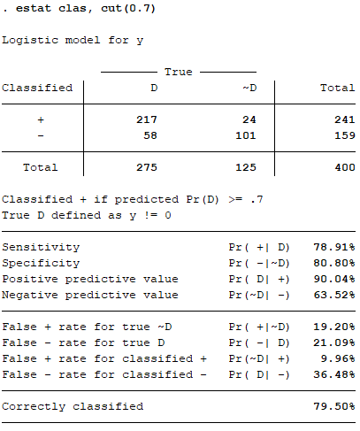
The counted R2 using the threshold of predicted value = 0.7 for Logit models is equal to 0.795 or 79.50%.

